- Alternative Technical Concepts (ATCs)

What is it?
ATCs is a procedure for procurement where the STA issues a request for proposal that contains basic project configurations, design and construction criteria. Proposing firms then develop and submit alternative ideas, or concepts, based on their industry expertise. The STA then reviews the received proposals and the concepts. The concepts gain approval on a pass-fail basis. If a concept is accepted, then the proposing firm can incorporate this concept into the technical and price proposal. This approach fosters a best-value solution that allows firms to submit innovative concepts and solutions that increases the value to the public (1).

Why use it?
The main advantage of ATC provisions is that they allow for innovation and flexibility during the procurement process (2, 3). Additionally, ATCs help STAs to determine the true best-value proposals.

What does it do?
ATCs help STAs finding the best-value proposals. This is a result of the general requirement that an ATC needs to be deemed to provide a project that is “equal or better” on an overall basis than the project would be without the proposed ATC (4).

How to use it?
First, the STA needs to set up the ATC process in the request for proposals (RFP). Here, important specifications are setting deadlines for ATC requests as well deadlines for the STA to issue a decision on the ATC requests. ATCs are confidential requests (4), and the STA should secure mechanisms to secure confidentiality of the requests such as one-on-one meetings.
The ATC process starts after the STA issues the RFP. Upon issuance of the RFP the STA generally holds one-on-one meetings with proposers to discuss potential ATCs (3, 4). Proposers submit ATC requests to the STA before submitting their technical proposals. These requests should include at a minimum a narrative of the description and conceptual drawings of the of the technical approach is applicable (5). Upon receipt, the STA reviews each ATC and responds. The Minnesota Department of Transportation (MnDOT) for instance, issues one of the following responses (3):
- ATC is approved
- ATC is not approved
- ATC is approved with conditions
- ATC does not qualify as an ATC, but may be included in the design-build team technical proposal
- ATC does not qualify as an ATC and may not be included in the proposal

When to use it?
The Federal Highway Administration reports that ATCs have been cost effective on large design-build projects where the scope is significant and the STA believes that a best-value selection depends on the degree of innovation in the solutions offered by the proposers (1).
The Code of Federal Regulations title 23 636.209(b) allows for the use of ATCs in design-build projects. It establishes that STAs “may allow proposers to submit alternative technical concepts in their proposals as long as these alternative concepts do not conflict with criteria agreed upon in the environmental decision making process. Alternative technical concept proposals may supplement, but not substitute for base proposals that respond to the RFP requirements”. However, there are no corresponding regulations for the use of ATCs in design-bid-build projects (1).

Limitations?
According to Missouri Department of Transportation’s ATC website (6), the ATC process can create potential issues, such as:
- Increase in the overall design costs for the project as the number and complexity of submittals may create multiple suitable alternatives, all of which could require additional design expense.
- The ATC process must be accounted for in the timeline for project delivery, which means there is a potential for longer or more complicated delivery timeframes for a specific project.

Who uses it?
California, Colorado, Florida, Louisiana, Maryland, Michigan, Minnesota, Mississippi, Missouri, Nevada, Texas, Utah, Virginia, and Washington

Examples
Example 1) Maryland State Highway Administration
The Maryland State Highway Administration (SHA) used the ATC process in its procurement of multiple design-build contracts for the $2.5 billion, 19-mile, InterCounty Connector (the ICC) highway in the Maryland suburbs north of Washington, D.C.(7). The SHA obtained a formal waiver of the requirement in connection with its procurement, under FHWA's Special Experimental Program 14 (SEP-14).
The SHA used a best value procurement process to select its design-builders. As a part of procurement process, the SHA offered proposers the opportunity to ask the SHA to pre-approve proposed deviations from certain design requirements and performance specifications, with the goal of encouraging proposers to incorporate innovation and design flexibility into their proposals. The ATC was only approved if the SHA determined that the proposed end product with the proposed deviation was equal to or better than the end product without the proposed deviation. Proposers were permitted to incorporate any pre-approved ATCs into their final proposals.
Seven proposers submitted a total of 130 ATCs, with almost half of which were approved. The approved ATCs minimized the impact on the environment, improved the overall technical quality of the final product, and helped decrease the cost of the project. In addition, approval of ATCs allowed proposers to develop their project design and construction schedules. By maintaining the confidentiality of the ATCs submitted during the proposal process, the SHA encouraged proposers to differentiate their proposals by developing creative and innovative ATCs. Proposers received innovation credit for approved ATCs, which improved their technical ratings in the best value evaluation. ATCs also allowed proposers to decrease their costs.
Specific ATCs included:
- Reconfiguration of an interchange on the western end of the project, which required additional environmental approvals and the purchase of additional right of way. The reconfiguration helped to reduce the successful proposer's price proposal and improved the proposal's technical rating. The revision also provided several benefits to the project, including:
  - Reducing the interchange from a three-level interchange to a two-level interchange, which minimized the visibility of the interchange to neighboring communities;
  - Reducing the number of bridges in the interchange, thereby decreasing future maintenance costs; and
  - Improving lane continuity on the InterCounty Connector.
- Reduction of the mainline median width within the most environmentally sensitive area of the ICC, which was conditionally approved, pending design verification that the RFP requirements and commitments could be met and permitting agency approvals could be obtained. The successful proposer had to demonstrate that the reduced median meets these commitments, the reduction in median will lead to a reduction in costs due to earthwork and constructability, as well as several environmental benefits, including reduced forest, stream and wetland impacts and movement of the highway further from adjacent homes.
Additional ATCs included replacing long bridges over wash ponds with at-grade roads on improved soils, thereby removing over 300,000 square feet of bridge deck from the RFP plans, eliminating the need to relocate an existing electric transmission main crossed by the ICC, and relocating many of the planned storm water ponds to eliminate impacts to existing streams, tributaries and wetlands in the area. These and other ATCs helped to reduce the estimated cost of one of the contracts by approximately $20 million, which represented a cost savings of nearly 5 percent.
Example 2) Missouri Department of Transportation
The Missouri Department of Transportation has devised a process to use ATCs on Design-Bid-Build projects. The following example is a replication taken from http://epg.modot.org/files/4/4d/147.3.1.pdf. This outlines the guidelines and procedures for the ATC process used in the replacement of the Hurricane Deck Bridge (8).
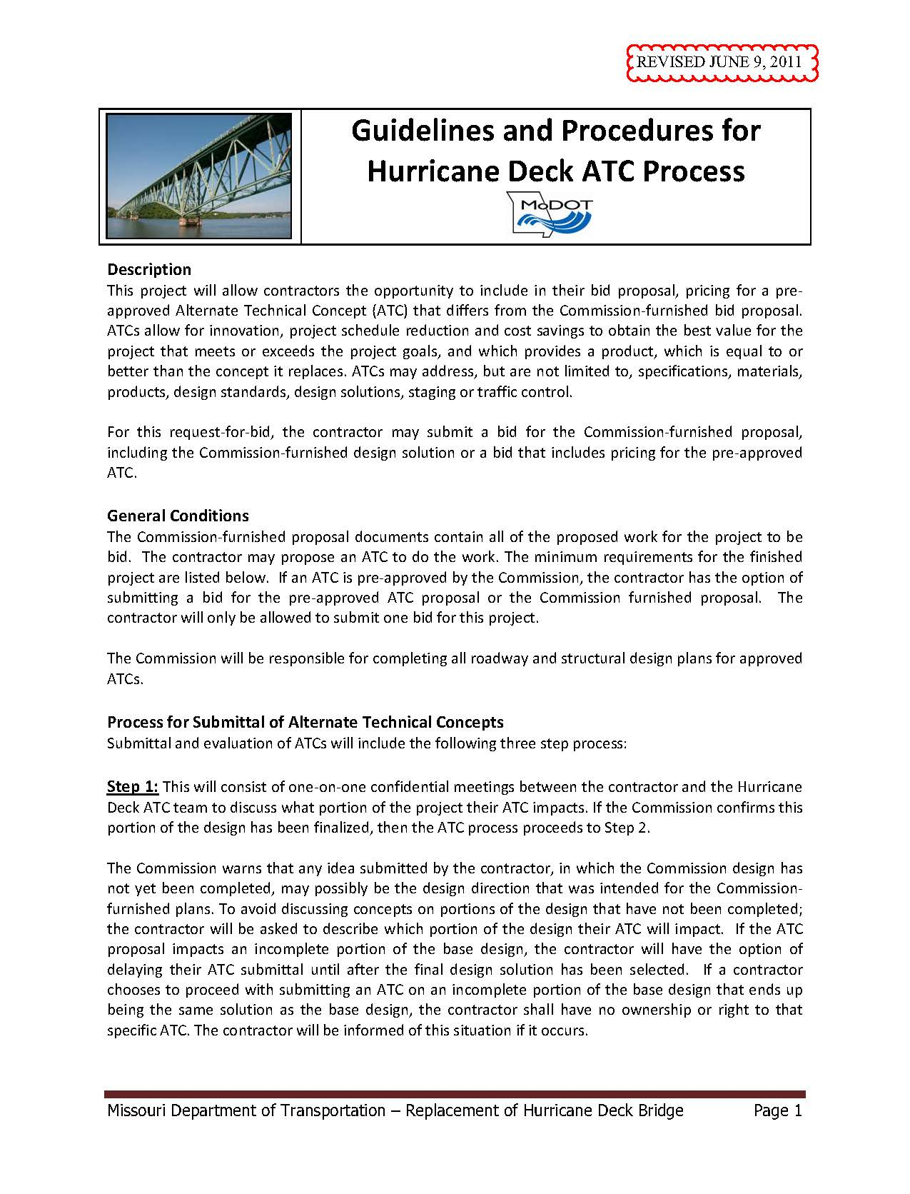
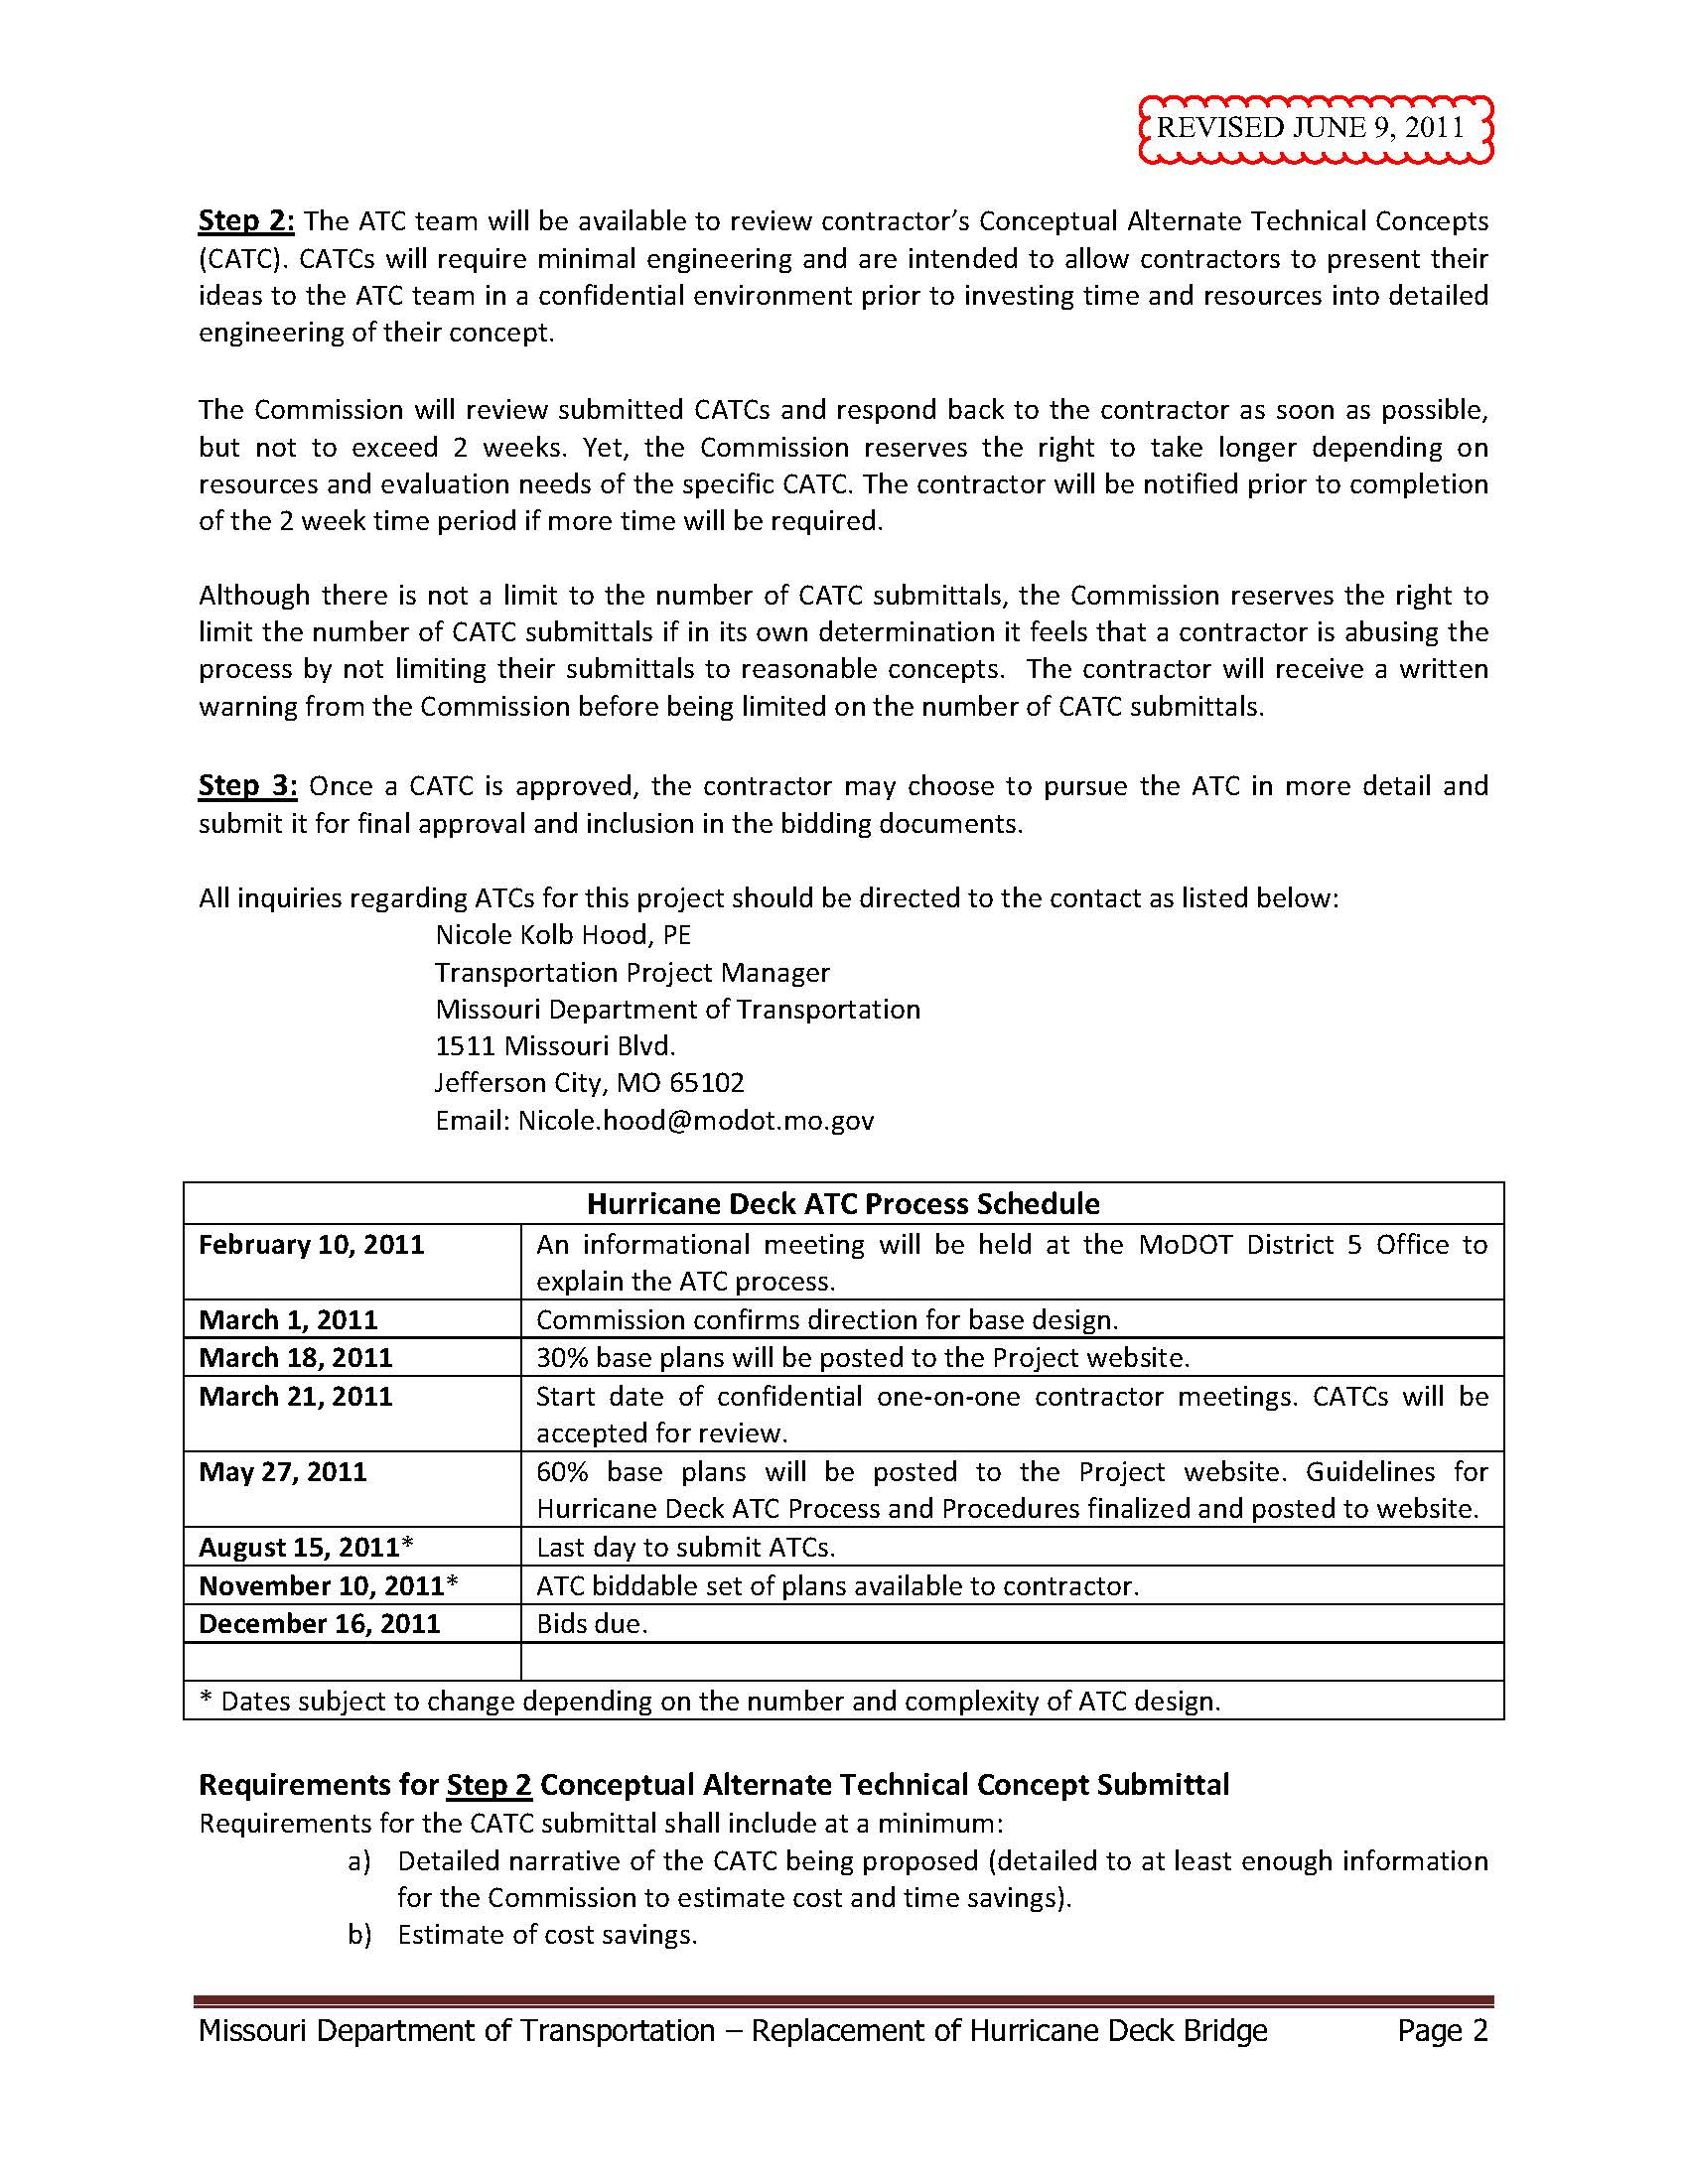
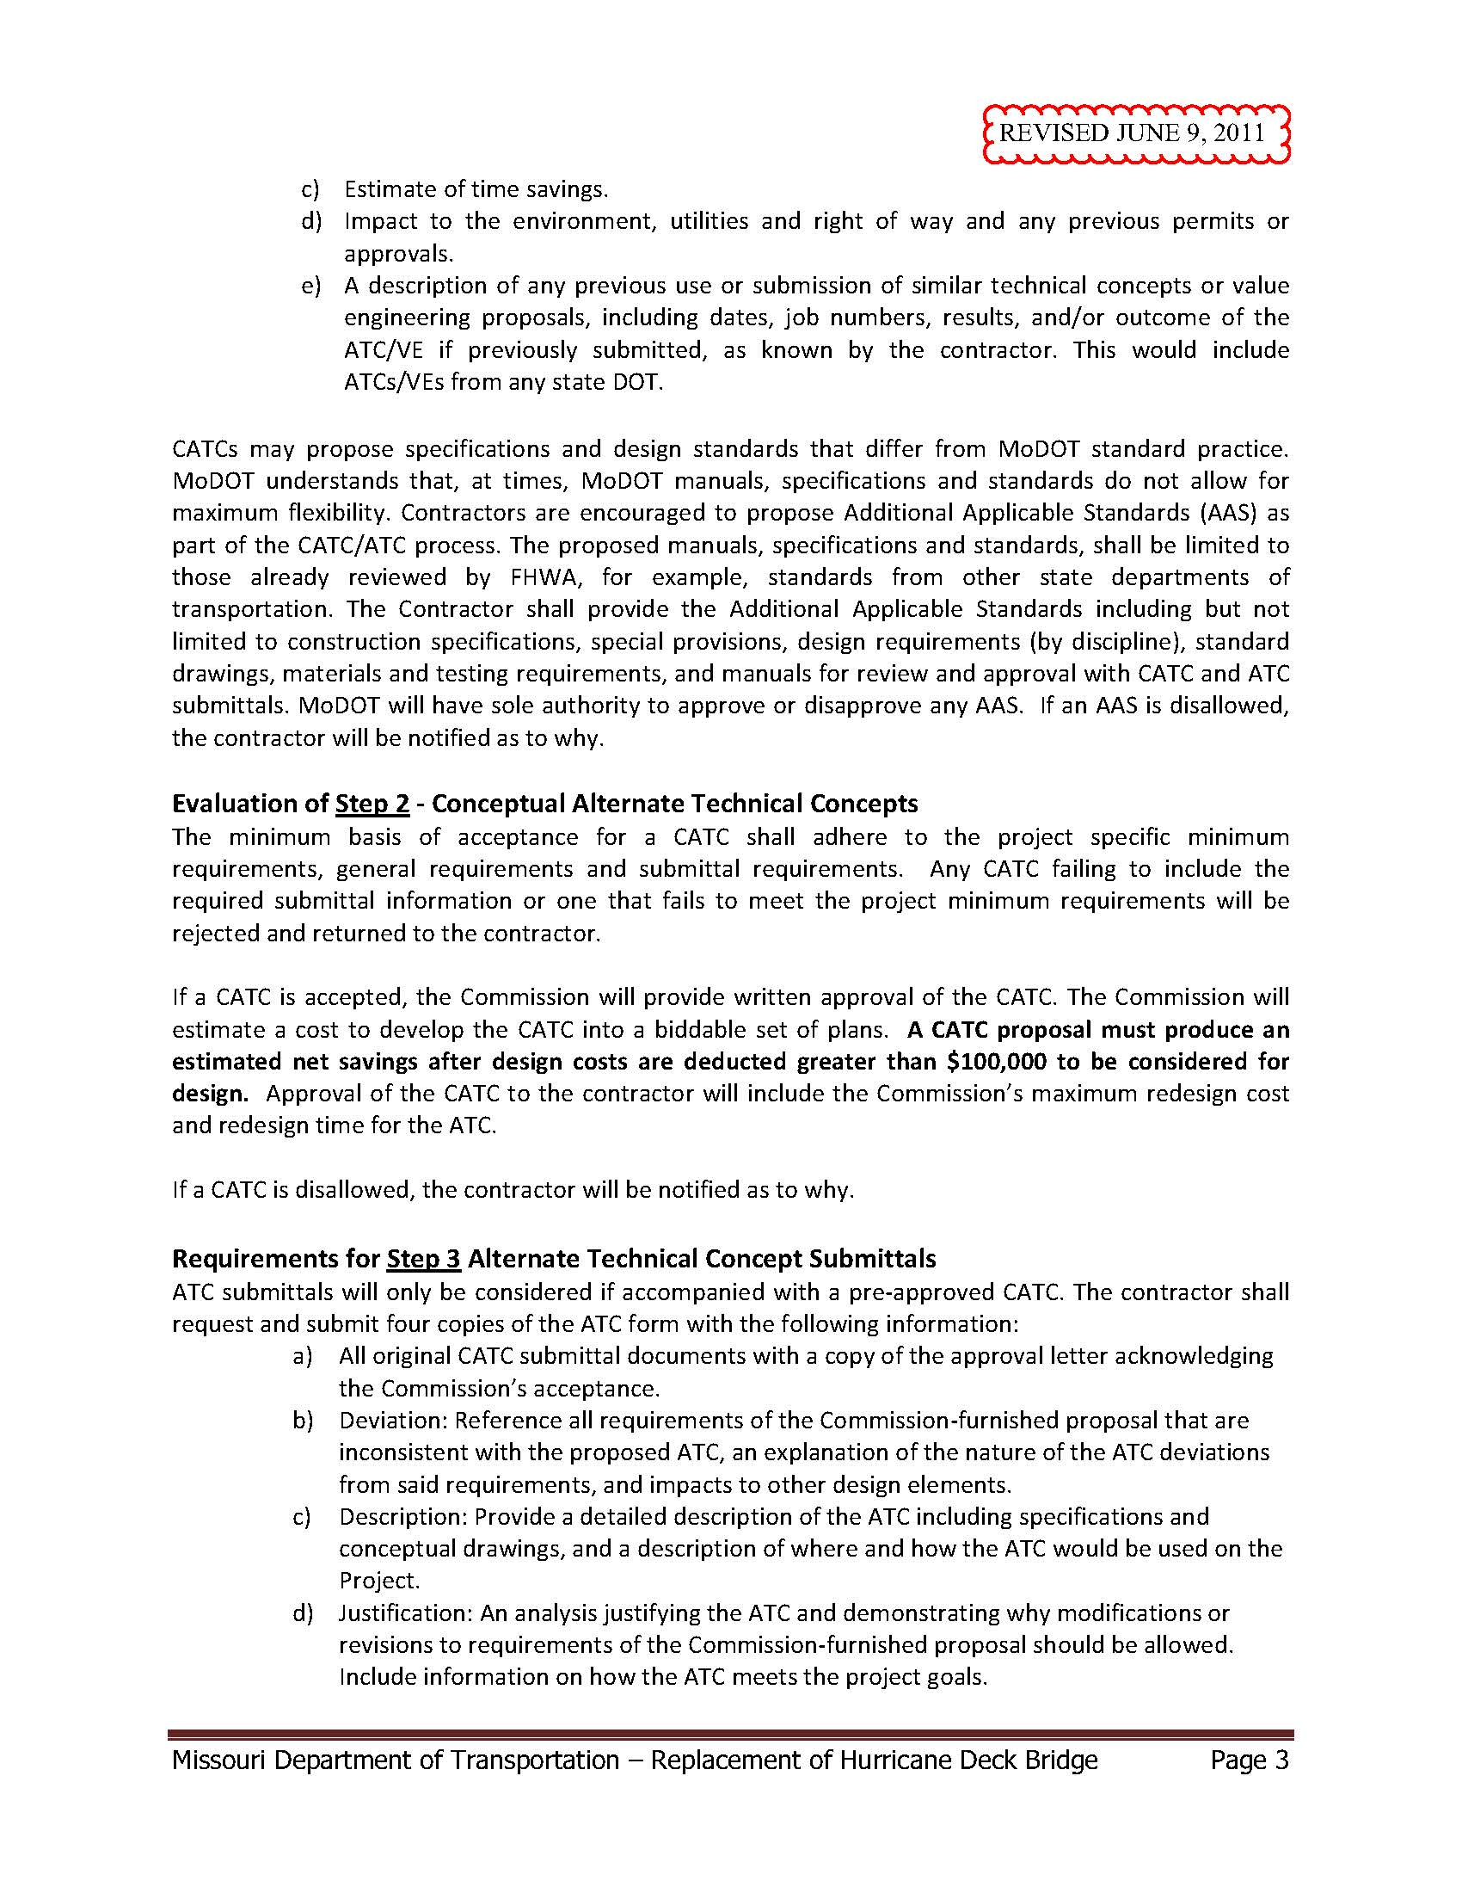
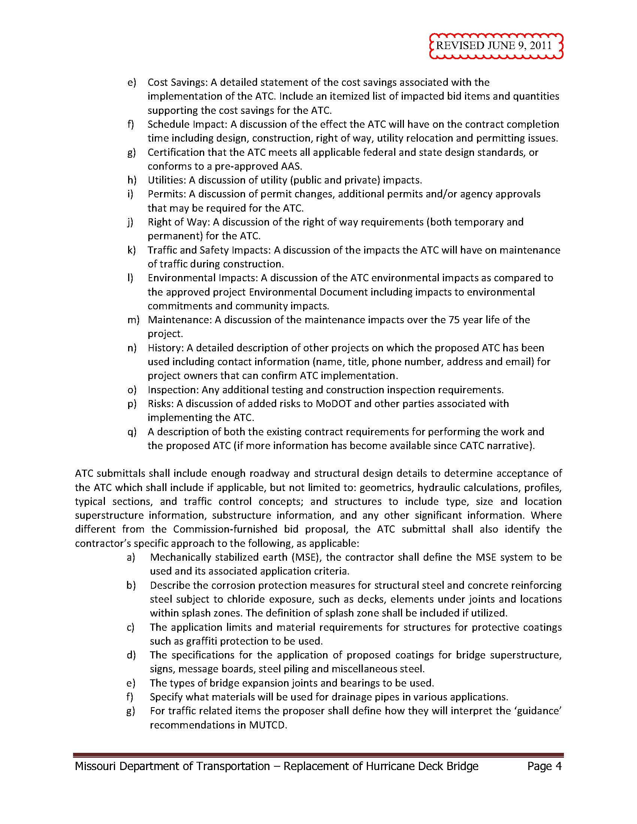
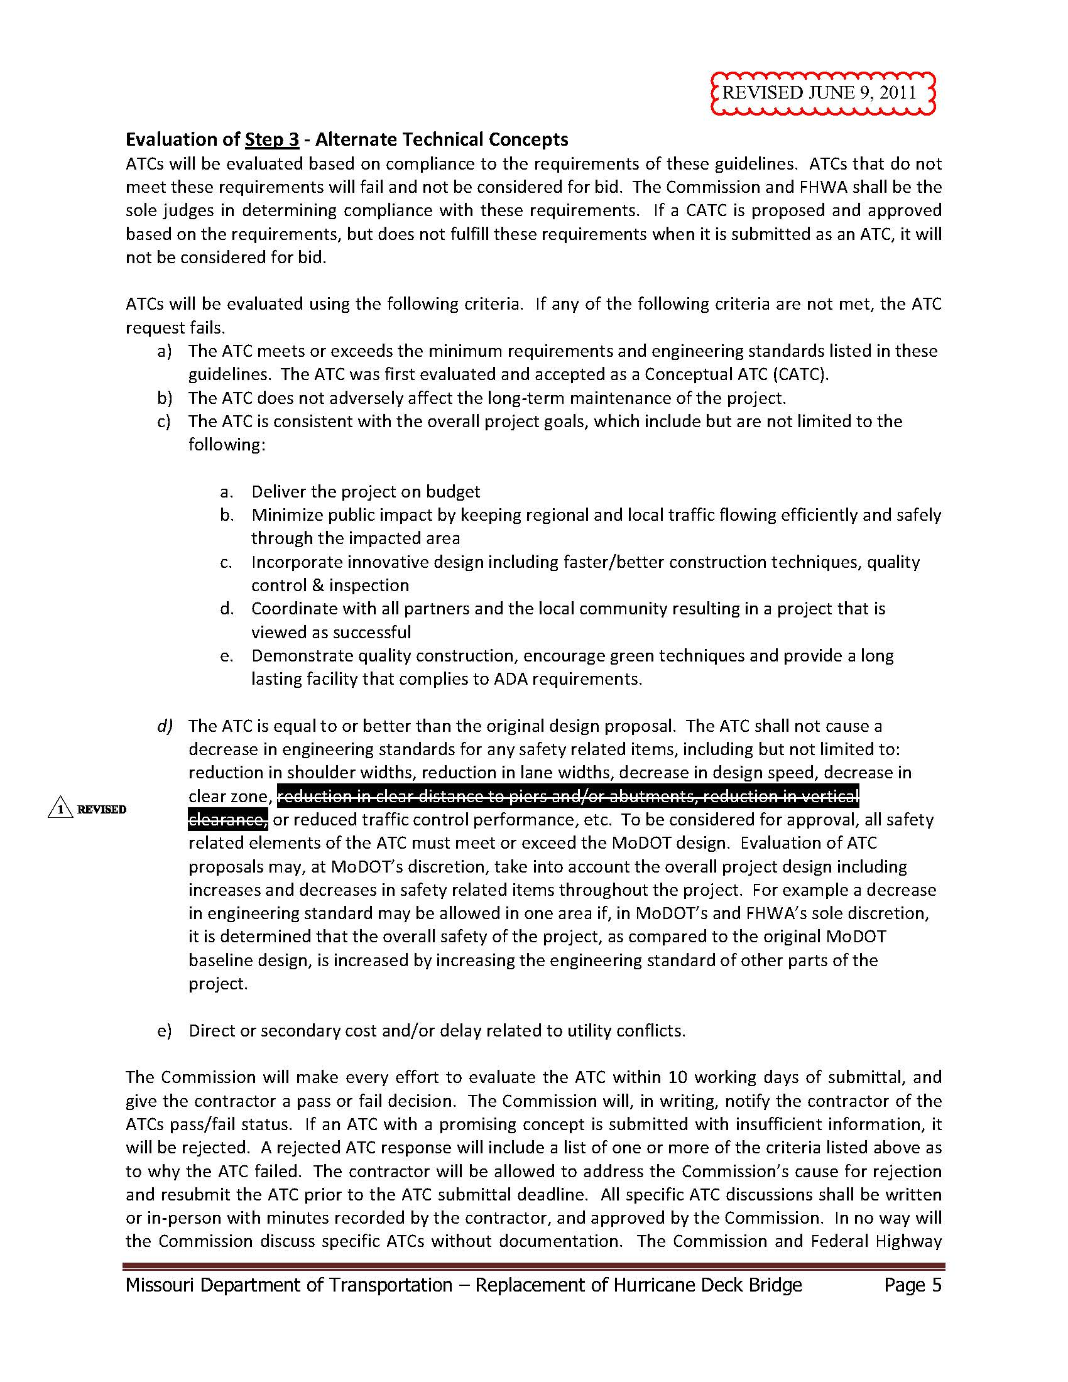
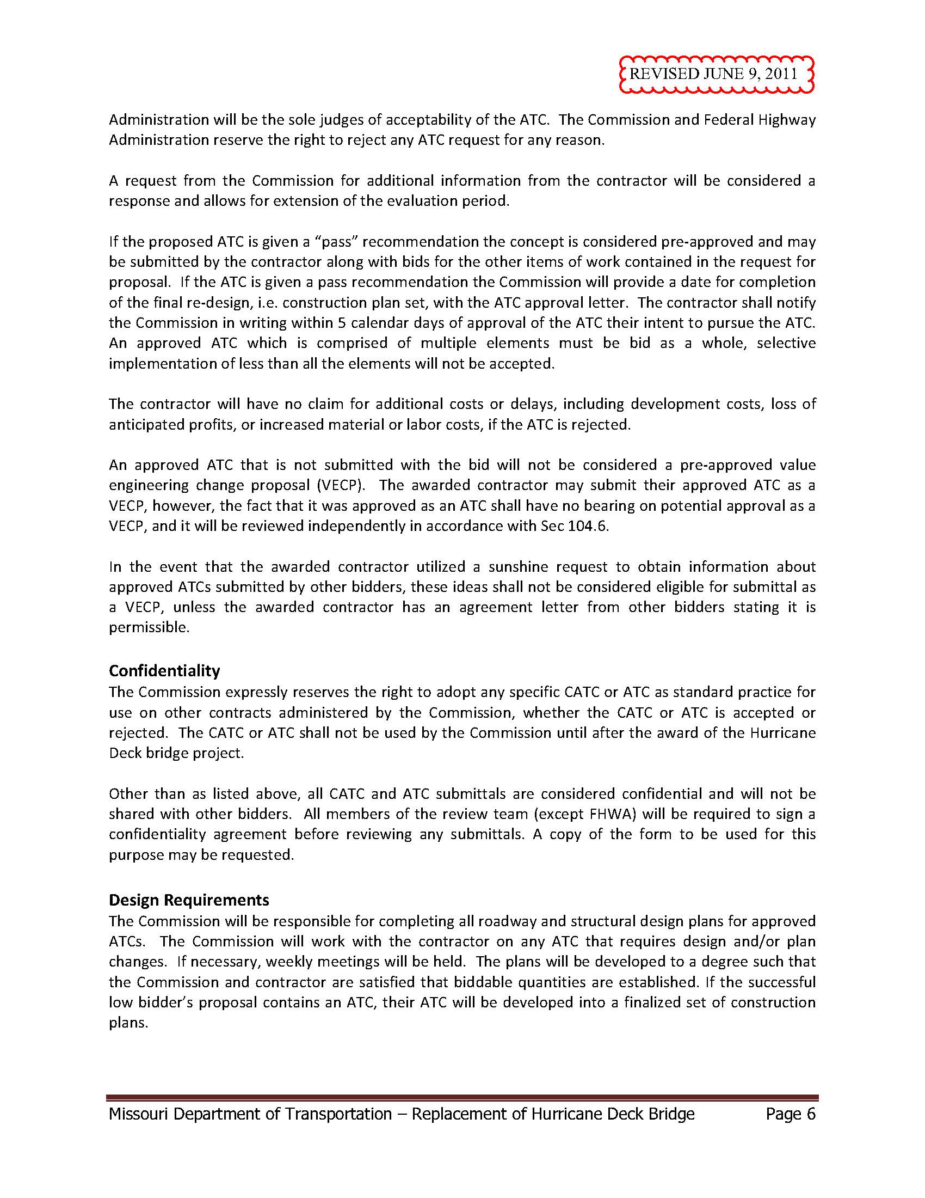
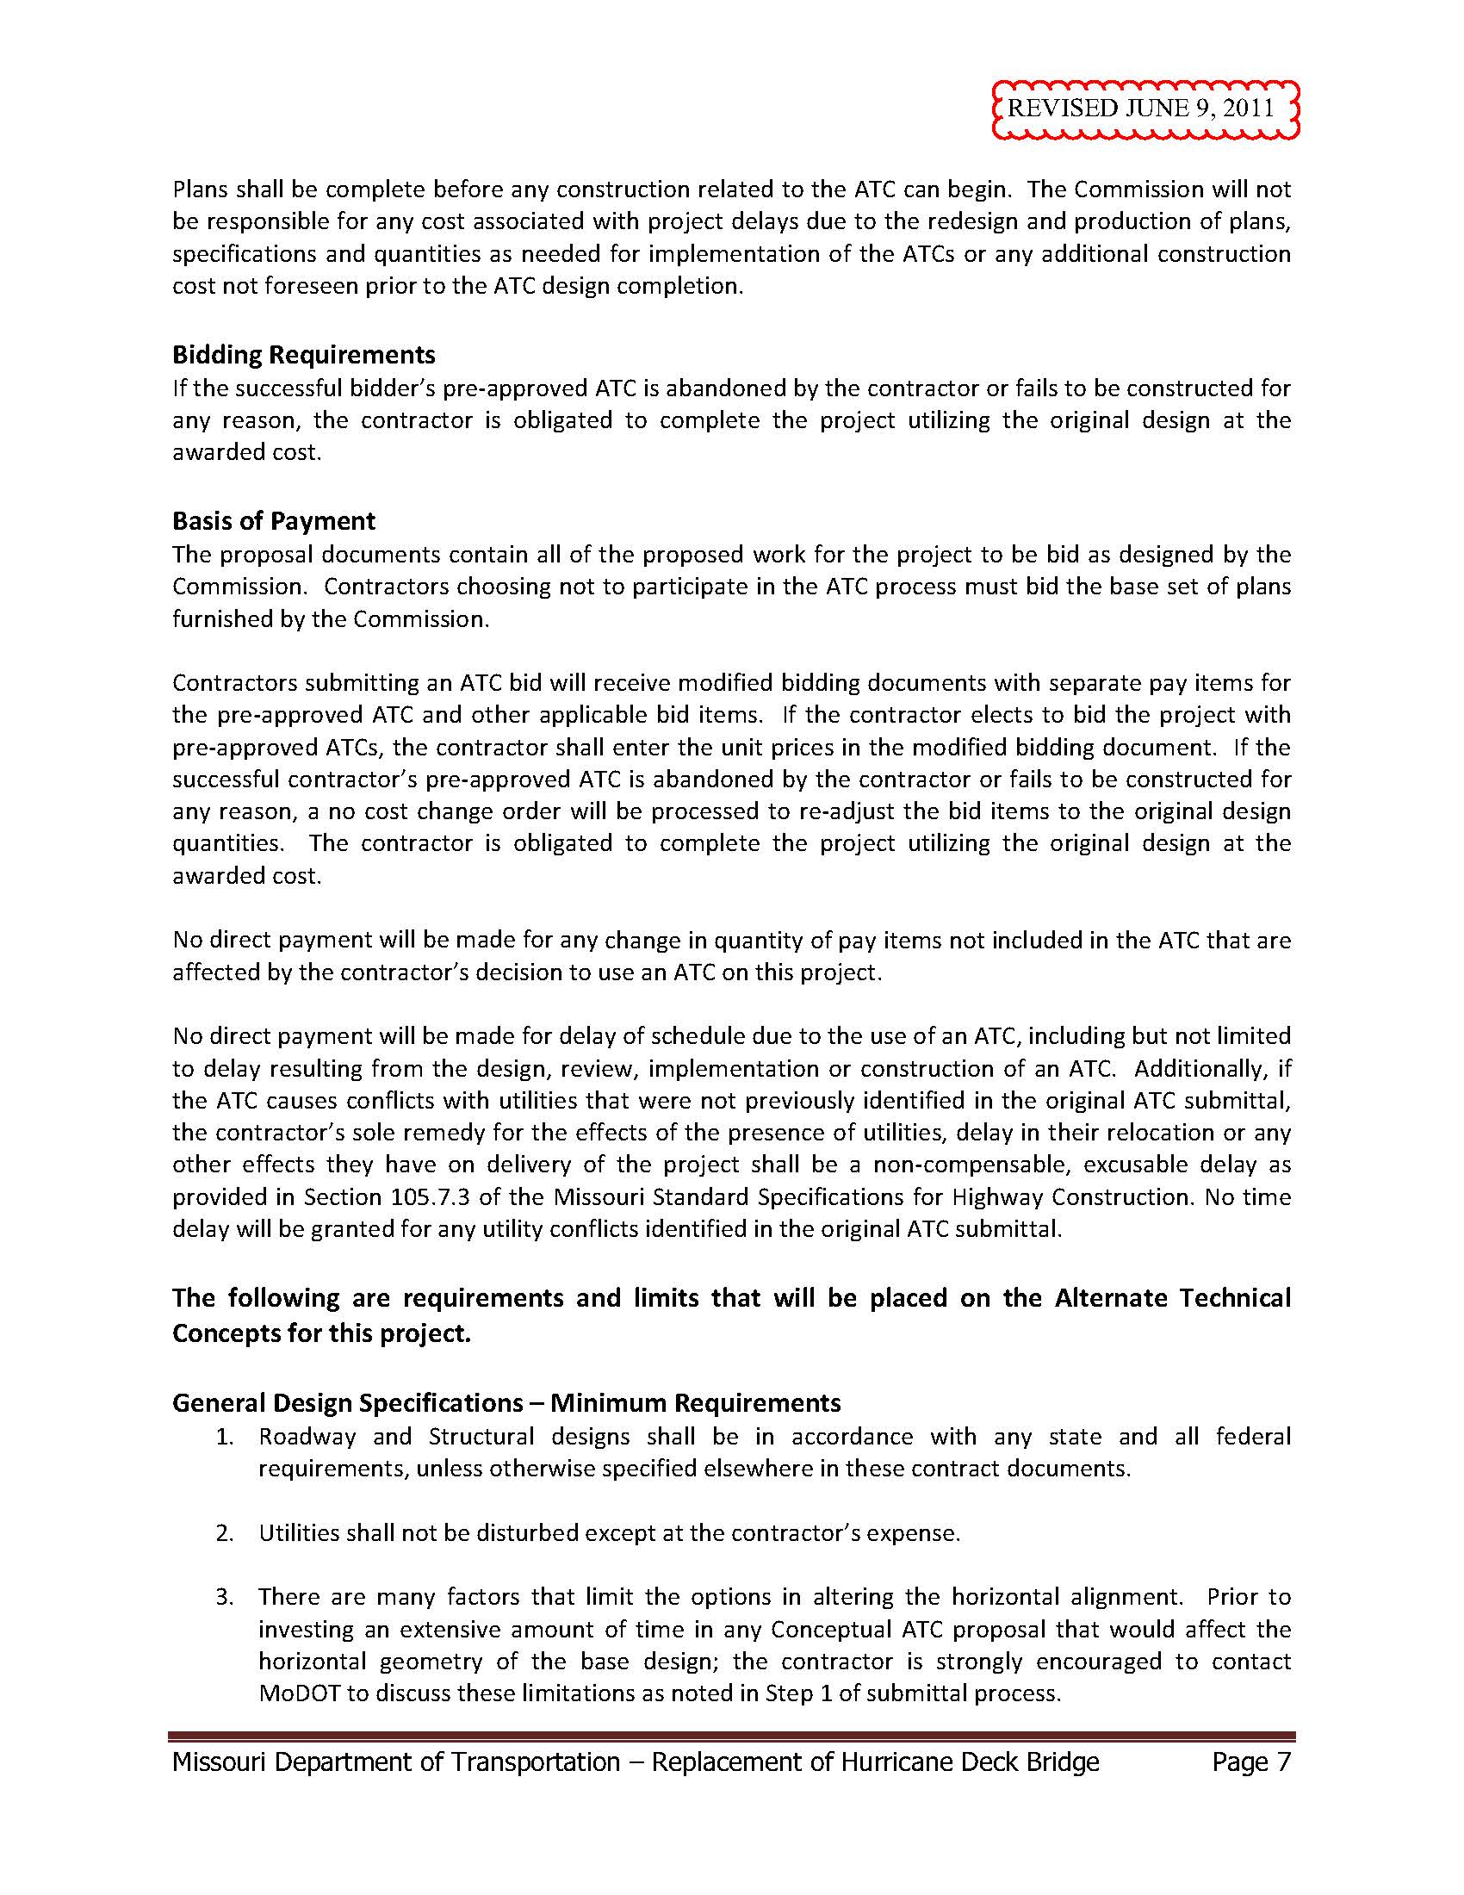
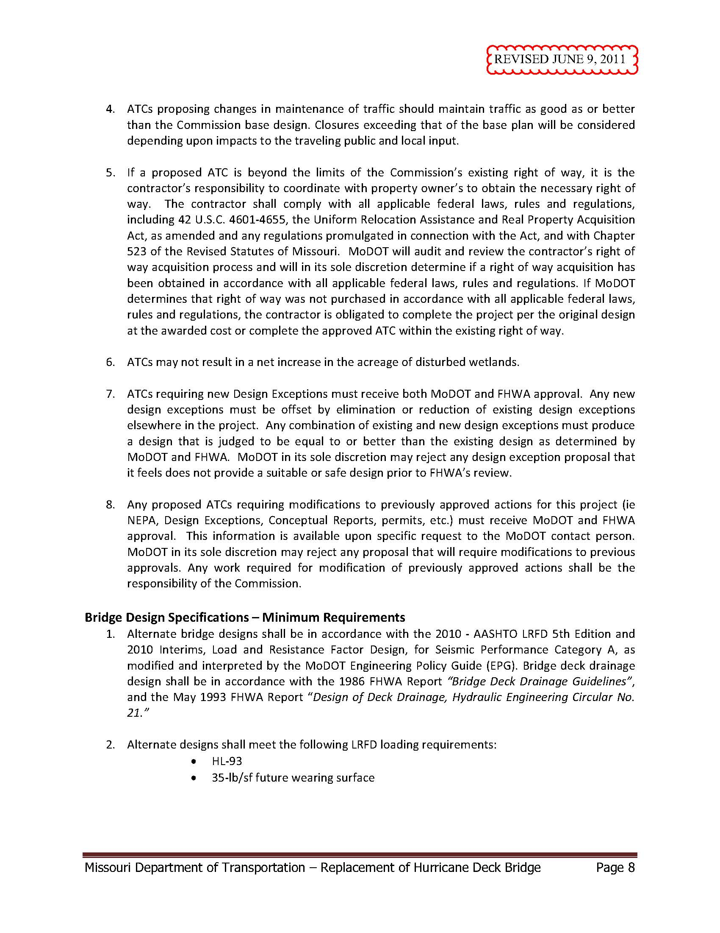
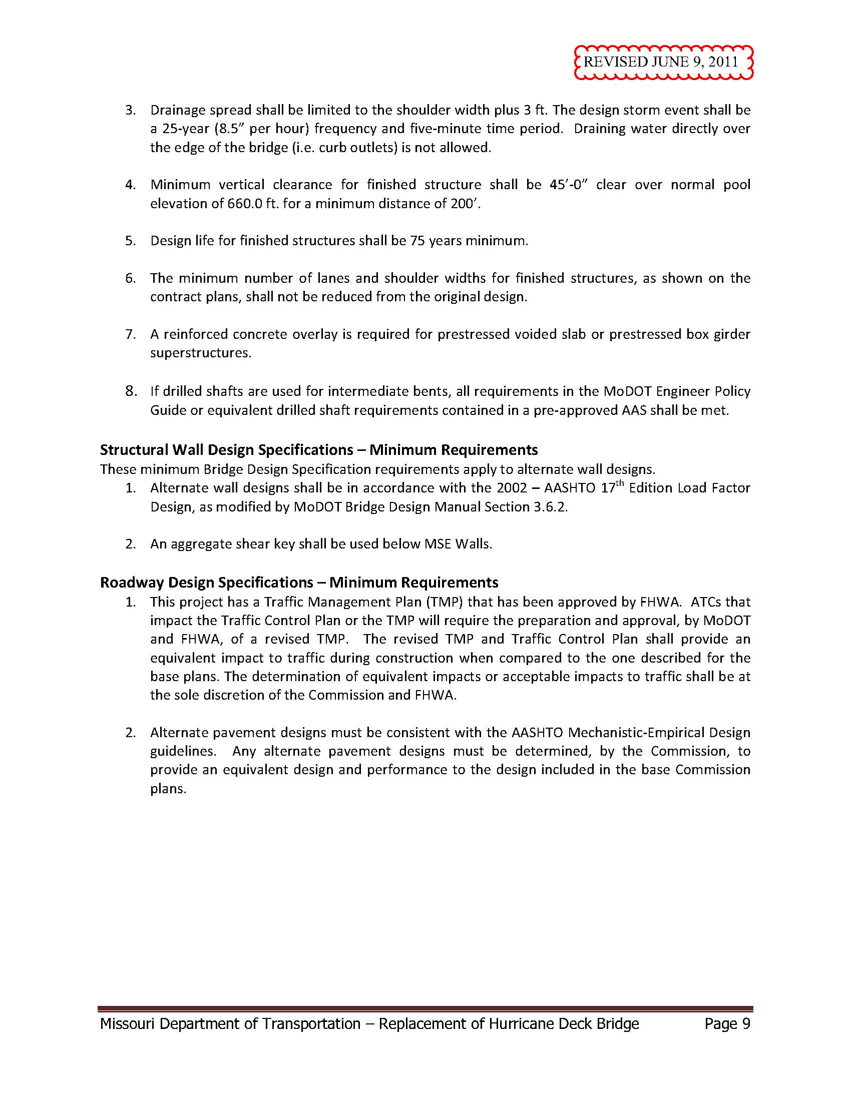

References
- Federal Highway Administration (FHWA). Construction Program Guide: Alternative Technical Concepts. United States Department of Transportation, http://www.fhwa.dot.gov/construction/cqit/atc.cfm [Accessed Feb. 5, 2014].
- Gransberg, Douglas D. Applying Alternative Technical Concepts to Construction Manager/General Contractor Project Delivery. TRB 93rd Annual Meeting, Transportation Research Board of the National Academies, Jan. 2014
- Minnesota Department of Transportation (MnDOT). Design-Build Manual. Office of Construction and Innovative Contracting, St. Paul, MN, Aug. 2011.
- Washington State Department of Transportation (WSDOT). WSDOT Design-Build Project Delivery – Guidance Statement – Alternative Technical Concepts. http://www.wsdot.wa.gov/NR/rdonlyres/27A54B86-9825-4E81-9DEE-138823B4ED86/74991/DesignBuildATCMOU.pdf [Accessed Feb. 5, 2014]
- Colorado Department of Transportation (CDOT). Design-Build Manual. Innovative Contracting and Design-Build, Apr. 2014.
- Missouri Department of Transportation (MoDOT). 147.1 Alternative Technical Concepts. Engineering Policy Guide for MoDOT. http://epg.modot.org/index.php?title=147.1_Alternative_Technical_Concepts [Accessed: April 5, 2014].
- Papernik, Brian G. Using Alternative Technical Concepts to Improve Design-Build and PPP Procurements. March 2009. http://www.nossaman.com/using-alternative-technical-concepts-improve-designbuild-ppp [Accessed: April 5, 2014].
- Missouri Department of Transportation (MoDOT). Guidelines and Procedures for Hurricane Deck ATC Process, June 2011. http://epg.modot.org/files/4/4d/147.3.1.pdf [Accessed: April 5, 2014].

