Student Health Insurance Requirement
Academic Year 2025-2026

Changes to the Health Insurance Enrollment Process
Important Update for the Fall 2025
A significant change for this year is that students will now use the Care26 platform instead of eWaive for Student Health Insurance Plan (SHIP) enrollment. The platform is still run by Academic Health Plans. Additionally, to create an account in Care26, students must be enrolled in at least one graduate-level credit hour—a notable change from previous years.
- Students become eligible to enroll in SHIP through Care26 as soon as they are officially enrolled in fall classes.
- It is strongly recommended that students complete SHIP enrollment before August 1.
- If enrollment is completed by August 1, coverage will begin on 08/01 with no interruption.
- Class enrollment is essential - students cannot access SHIP enrollment through Care26 until their fall registration is confirmed.
- Students who enroll in SHIP after August 1 will have their coverage backdated to 08/01, but they may experience a delay of up to ten days before accessing their insurance card through Anthem.
Enrollment in Care26:
Click the link here: https://colorado.medicatconnect.com/clinic.aspx
This link will take them to the student health portal.
Students need to click “Health Insurance Requirement” (at the top of the screen)
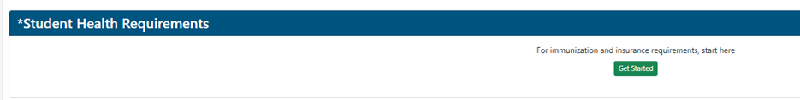
Then select Enroll or Waive:
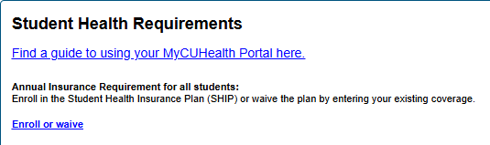
Then create there account through Care26 with their student email. They should land on this page Care26 Student
Once a student has created an account in Care26 they will have to enroll in Anthem Gold Ship
Current Status of the SHIP Enrollment Process
- The deadline to enroll in or waive the Student Health Insurance Plan (SHIP) is September 19. (Note: The website will be updated to reflect this change, removing the previous August 22 deadline.)
- After September 19, any student who has not waived coverage will be automatically enrolled in Anthem, and the corresponding charge will remain on their Bursar account.
- Students who enroll in the SHIP plan are currently experiencing a 5–10 business day processing period before gaining access to their Anthem insurance card. Please note that coverage will be retroactively effective as of August 1.
- For students with immediate healthcare needs, we are able to expedite (flash add) SHIP enrollment to provide quicker access to insurance coverage.
  - Graduate students must be enrolled in classes (at least one credit hour)
  - Create a Care26 account (See instructions above)
  - Enroll in Student Health Insurance (Gold Ship) through Care26
  - Students can then request to be flash added to the SHIP plan by emailing studentinsurance@colorado.eduand including the information in this table below . The subject line should be FLASH ADD – CU SHIP
School Name
First Name
Last Name
Date of Birth
Sex (M/F/U)
Student ID Number
Email
Address
Phone

- The SHIP brochure on the website is currently being revised by Anthem to correct several inaccuracies and will be updated shortly.

Dental Insurance Information Updates:

Graduate Student Dental Insurance | Health & Wellness Services | University of Colorado Boulder

Dental plan enrollment
CU Boulder graduate students on a graduate appointment of 20% or greater are automatically enrolled in the Graduate Student Dental Insurance Plan once their tuition waiver is entered into Campus Solutions.
Graduate Students on select “full-ride fellowships” may also be eligible for dental coverage. Contact patty.stanfield@colorado.edu with any questions regarding eligibility and enrollment process for fellows.
Notification of enrollment will be sent directly to students within 5 business days of the tuition waiver being entered. If students do not receive notification of their enrollment, they should first check with their employer to make sure the tuition waiver has been entered correctly, and they meet the criteria for eligibility.
Please note: Students insured through the CU Anthem Gold Student Health Insurance Plan (SHIP) are eligible for a $150 annual credit by submitting a dental services invoice (exam, cleaning, or X-ray) to studentinsurance@colorado.edu. This is replacing the previous benefit associated with PerfectTeeth. For low-cost options for dental services, you can visit Low Cost Dental Options. Graduate students on appointment will be automatically enrolled in the Graduate Student Dental Insurance and are not eligible for the $150 credit.

Important Websites:
Student Health Insurance Website – Gold Health Insurance Plan : Anthem Gold Student Health Insurance Plan (SHIP) | Health & Wellness Services | University of Colorado Boulder
How to Use your Gold Insurance Plan : How to use your Anthem Gold Student Health Insurance Plan (SHIP) | Health & Wellness Services | University of Colorado Boulder
Waive Health Insurance Instructions: Private Insurance | Health & Wellness Services | University of Colorado Boulder
FAQ’s about Health Insurance: Frequently Asked Questions: Insurance | Health & Wellness Services | University of Colorado Boulder
Graduate Dental Plan: https://www.colorado.edu/health/graduate-student-dental-insurance

