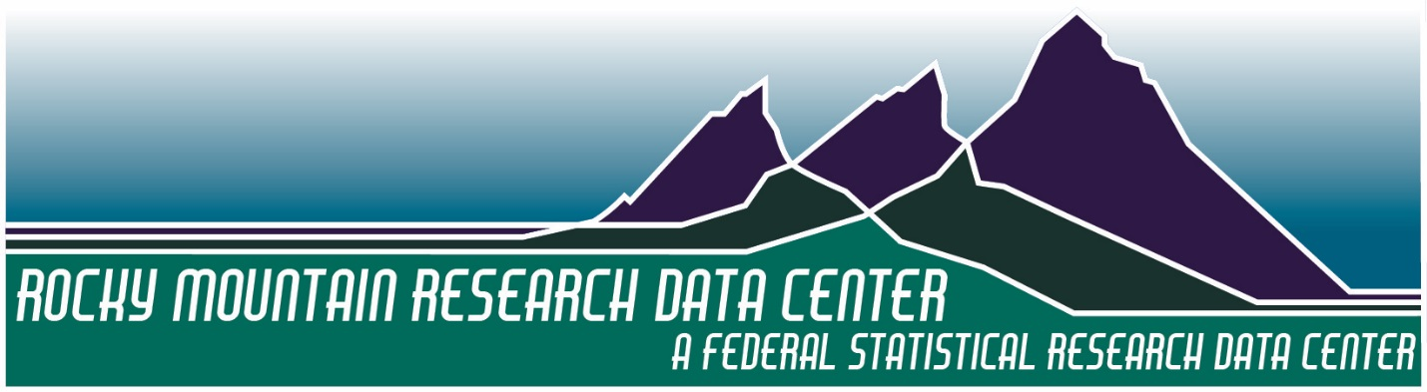
Proposal Development Workshop
11:00am – 4pm, Wednesday, January 4th, 2017
Institute of Behavioral Science, Rm 155A
1440 15th Street
University of Colorado Boulder
http://www.colorado.edu/rocky-mountain-research-data-center/

Agenda

11:00am–11:30am Session I: Welcome, Overview of RMRDC Programs/Resources
Overview of the national RDC network and research opportunities in RDCs. Review of the resources, programs, and services available at the RMRDC. Jani Little, Director RMRDC
11:45am–12:15pm Lunch
12:30pm–1:15pm Session II: Scouting RDC Projects and Data
Review examples of RDC projects and how to learn about them. Scouting restricted data sets available in RDCs. Overview of preparing proposals to use NCHS data sets. Katie Genadek, Administrator RMRDC; Bethany Desalvo, Administrator Texas RDC; Rick Rogers, Faculty Associate RMRDC
1:30pm–3:00pm Session III: Writing Proposals for Projects Using Restricted Data
Review the Census perspective on the RMRDC-Census Bureau collaboration. Scouting and developing project ideas. Elements of successful RDC proposals and projects. Preparing/submitting Census RDC proposals. Planning project timelines. Bethany Desalvo, Administrator Texas RDC
3:15pm–4:00pm Session IV: Individualized Project Development and Consultations
Discuss a form for people to fill out and send to us with proposal ideas and data requirements. This will be an opportunity for open Q&A, followed by one on one conversations. Katie Genadek, Administrator RMRDC; Bethany Desalvo, Administrator Texas RDC; Jani Little, Director RMRDC

