Urja Shrestha

Professor Feldman

WRTG 3040

28 Feb. 2020

Newari Language Extinction

*JoJo Lapa* ‘Hello’ in Newari would be *Namaste* in Nepali.

Language is an essential part of a culture and tradition; preservation of language is what keeps the tradition going and passes down over generations. There are many different languages spoken all around the world; however, there are few languages that are valued and spoken more, for example, English. Language is equivalent to an identity of people in that culture; therefore, the preservation of language should be valued. Out of the many different languages, this paper focuses on Nepal and a specific language in that country which is “Newari”. Nepal is a small landlocked country located in Asia and it’s a very diverse country; there are a little over 120 ethnic groups and the majority have their language that represents their caste. This paper focuses on the Newari language which is a specific language spoken by the Newar castes who are inhabitants of Nepal. Newari is slowly starting to disappear as a language due to globalization, and more demand for people who can speak the main language, Nepali, and an internationally recognized language: English. Due to these reasons, minor languages like Newari are at high risk of becoming extinct. In this generation, fewer people value the language, as children do not think it is of any use to learn Newari as it is not considered to be valued language. This paper will focus on the endangerment of the Newari language and the reason for its disappearance, the trend of learning languages and how it impacts minor languages such as Newari, and how lack of not learning minor languages like Newari affects the tradition negatively, and what can be done to make the language sustainable.

Nepal is a small but diverse country; there are many ethnic groups in the country, which therefore means that there are many different languages in Nepal. However, most of the minor languages are disappearing or have already disappeared due to fewer and fewer people speaking the language. “The percentage of Newar speakers in the Kathmandu Valley dropped from 75% to 44% from 1952 to 1991” (“Newar Language”). This shows a huge drop in the number of people speaking Newari 20 years ago, but now it is even more problematic than before. According to UNESCO, one of the reasons for the disappearance of the Newari language is because “the majority of the Newar live in urban areas, especially the Kathmandu Valley, where the influence and use of Nepali are all-pervasive in daily life, through education and the media”. Living in the city does have a negative impact on minor languages like Newari because the official language of Nepal is Nepali; hence, everything is promoted in Nepali, so, therefore, living in the valley means you must know Nepali and majority of the children being born and raised in the valley are not interested in learning Newari due to its insignificance in communicating outside of their own home. Newari has also been listed as being “definitely endangered” by UNESCO.

Birendra Bhaila, in his report on Language Death, discusses many reasons as to why Newari is becoming endangered such as people not wanting to learn the language, most adults in Nepal fluent in Newari are in their 30’s which mean that Newari as a language has a higher chance of disappearing in about 30-40 years; this is because the life expectancy in Nepal is about 60 and if adults aren’t teaching their children Newari, it means that soon the language will be extinct. Bhaila also discusses the use of Newari and the reason for its lack of popularity. Newari is only used at home or in small groups of people; therefore, when you leave that bubble and go out in the real world, Newari is not used at all. Because of the diversity in Nepal, many people are not from Newar ethnic background; hence, they do not know Newari, and the official language of Nepal is Nepali, so therefore, everybody knows and speaks Nepali. Another reason discussed by Birendra in his report for the disappearance of Newari language is because of inter-caste marriage (Bhaila). Marrying someone from a different caste means different languages between the couple; hence, the language barrier is created and therefore, using the official language is the only solution, and/or English. This results in children learning Nepali and English and excluding the ethnic language from both their parents, which also creates a barrier between grandchildren and grandparents, as some of the older generations are not fluent in Nepali and majority don’t understand English; therefore, communication is lacking within the household.

Currently, due to globalization, more and more children are being taught English so that they can communicate with tourists, which is useful if children want to go abroad to study and also due to status in the society. Currently in the capital city, being fluent in English is said to make you of ‘higher’ status because it shows that you have the resources to learn the language. Due to globalization and the constant change and influence from the western world, people in Nepal are forgetting about their ethnic language and caring more about western culture and adapting to it. This is causing a language barrier between younger and older generations; nowadays, the majority of the young people cannot communicate with the older generations who can only speak their ethnic language, thereby creating barriers between different generations and most importantly within the family. Tension within the family is more prominent now due to discussion about language; older people are not very familiar with English and younger people are not familiar with Newari. In my family, my paternal grandmother was not very good at Nepali and didn’t know any English. Therefore, when I was young we were not very close as we couldn’t communicate with each other. I can understand the language a little; however, I am not able to reciprocate, so I would reply in Nepali. Eventually, both of us were able to communicate better as she started understanding Nepali a little better and I started understanding Newari a little better. In my family, rather than causing tension and arguments, we started getting more distant as older generations want the language to be sustainable whereas younger people are caring less about their ethnic language, risking endangerment and care more about enriching themselves in the western culture.

My maternal grand-parents can communicate in Nepali as well as English; however, my grandmother was always adamant in having us communicate in Newari as she wanted the language to pass down the generations. When I was younger, she didn’t allow us to speak in English in front of her as she wanted us to learn how to speak Newari. Until today, she doesn’t like it when I talk to my sister or cousins in English because she is scared that we will forget not only Newari but also Nepali. My younger cousins are less familiar with Newari as for them Nepali is already difficult to speak and understand, which shows how Newari is slowly starting to disappear from households. My grandmother tries to say a few words in Newari every time we talk so that at least my sister and I can still understand. Even though I am unable to reply to her in Newari, she tries to teach me now and then and reiterates how important Newari is for our culture.

Impacts of the endangerment of Newari language is more than causing tension and being distant within the family; it also impacts the entire country and culture. People are caring less about the culture like Newari clothing, festivals, and food due to being immersed in western culture and media, which have a huge part in the influence of western culture. Nowadays, most shows contain few English words or sometimes are entirely in English; therefore, this is making people want to learn and understand western culture. There are very few Nepali TV channels and even fewer Newari or other ethnic language channels. 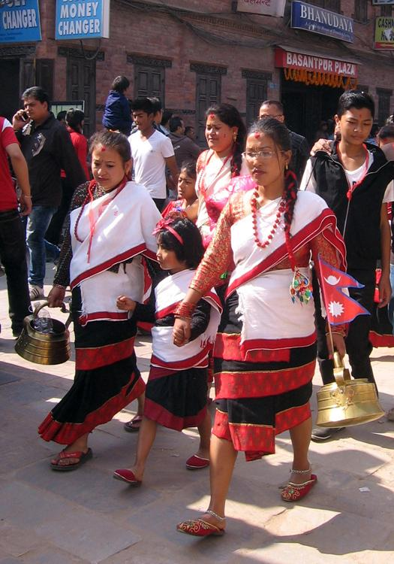

Along with language, Newari culture such as food, clothing and festivals are also disappearing, young people nowadays are caring less about traditional clothing known as *Hakupatasi* which is a clothing item worn by Newari women. Due to immense influence by western culture, western clothing causes fewer people to wear traditional clothing or learn about it.

Likewise, traditional festivals are seeing fewer people involved compared to many years ago as young people are more influenced by the western lifestyle, celebrating western holidays more compared to the traditional ones. *Jatra* is one of the biggest road festivals, where Newars gather wearing traditional Newari clothing to sing and dance. There are different types of jatra and every jatra is a celebration for different purposes. Indra Jatra is a celebration “in honor of Indra: a deity known as the King of heaven in Hinduism” (Indra Jatra). The significance of this festival is in honor of Lord Indra; however, it is also “celebrated in memory of the family members who were deceased in the past year. People go around various temples with incense sticks and light butter lamps in their memories” (Indra Jatra). This festival consists of masked dances and music and later on, a chariot with a living goddess named Kumari, is pulled by people in the crowd. Nowadays, there are fewer people involved in jatras; therefore, not many young people are in the crowd to pull the chariot. The significance of the festival is not understood by younger generations due to lack of interest in Newari culture by the youth.

When I was young, my grandparents would always take me and my sister to these festivals so that we are aware of our culture. I remember feeling frightened by the masked dances as the mask was not an ordinary mask; it was a big scary looking mask that terrified me as a kid. Looking back, I am glad that I was able to be part of such festivities because nowadays there are fewer people involved or have desires to be involved in such festivities. The joy of being in the crowd watching masked dances, and witnessing people wearing traditional clothes and singing in Newari was a good experience as that made me appreciate our culture. As a kid, my grandmother always made sure to involve us in many traditional cultures as possible such as cooking Newari food, taking us to traditional festivals, and speaking Newari. Out of all the traditions slowly disappearing, Newari food is one tradition that seems to be holding the Newari culture together in society today. Food is a huge part of not just Newari culture but Nepali culture as a whole; therefore, people are aware of Newari cuisine such as *samay baji* which is a set that consists of beaten rice, beans, vegetables, meat, pickles, lentil pancake, garlic, ginger, egg, and many more; however, the main component of the dish has to be *aaila,* which is a homemade rice wine; a must-have for every Newar household. It is traditionally served in a banana leaf or in a *bota,* shown above in the picture, which is a container made by leaves.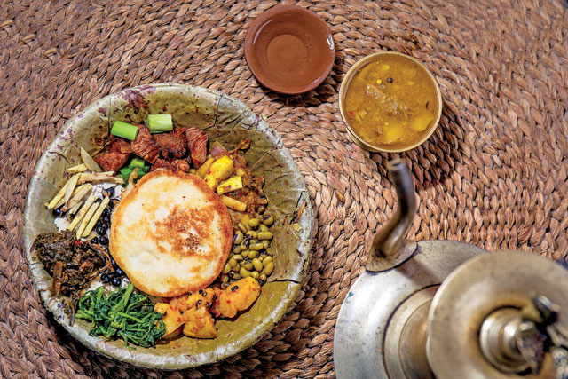

Preservation of Newari culture, especially Newari language is very important to be sustainable because language is one one of the key components in showcasing different cultures. The ways in which it can be sustainable is through other components such as food, clothing which will help bring attention to Newari culture hence, attracting people to the language. Media has a huge part in determining how the public views certain things like trends; therefore, if the government puts in an effort by focusing on adding programs to attract the Newari language on the TV or social media, this can help preserve the Newari language. Celebrities have a huge impact on the public; therefore, speaking up about issues like language extinction or bringing in other components of Newari culture like food, and clothing can help with the preservation of language as well. Designers incorporating Newari culture into their designs will help spread awareness about the culture, as most fashion shows are participated in by celebrities and they are broadcast on TV. Seeing designers and famous people wear and talk about the culture can make the public aware about Newari culture and language. Private companies are also seen putting in effort to preserve culture as there is a food channel that showcases different food items that can be found all around Nepal. The presenter trying the food and giving their feedback makes the public want to try it out; therefore, going to traditional places where they sell Newari food can be showcased which would attract people to want to go to those places, spreading awareness about Newari culture. Additionally, the government could build language institutions where different minor languages can be learnt without a fee or at a very affordable price which can attract the public and make them want to take advantage of it. Building language institutions and promoting on social media or media will be beneficial as most teenagers are active on social media. The government or any private company can build language institutions in cities and places where the Newar community is large; location is very important as that will determine if it will be a success or not. The government can not make Newari a part of the primary school curriculum because of the diversity in Nepal, as everybody is not from a Newar background. However, adding after school language clubs will give all children opportunity to learn their ethnic languages, hence making the language sustainable.

Works Cited

Bal Gopal Shrestha. “The Newars” Jan 1999,

http://www.thlib.org/static/reprints/contributions/CNAS_26_01_04.pdf

Birendra Bhaila. “Language Death- Case of Newari Language” Feb

2017, Dialogos, <http://id.nii.ac.jp/1060/00008586>.

“Newar Language.” *Wikipedia*, Wikimedia Foundation, 10 Jan.

2020, en.wikipedia.org/wiki/Newar_language.

Sueyoshi, Tobaet Ingrid. “Diversity and Endangerment of

Languages in Nepal.” *PDF.js Viewer*, 2005,

unesdoc.unesco.org/in/documentViewer.xhtml?

“The Newari Festival: Indra Jatra: The Culture and Festival of Nepal.”

*Trekking Company Based in Kathmandu, Nepal*,

www.jrntreks.com/indra-jatra/.