1330 CARR 203 APT 124

Gurabo, Puerto Rico

March 2, 2019

Dear Professor Feldman,

September 20, 2017 is a date that for the majority of the people is a typical date, but to the population of Puerto Rico it is otherwise. On this date, the catastrophic category five hurricane María made landfall in the island of Puerto Rico. After this hurricane, many news outlets in the mainland were sharing information that was taken out of context and gave the American people the impression that the Puerto Rican people were helpless and dependent on the help of the United States government. In this paper, I will discuss that this was the total opposite of what really happened and I will use testimonies and my own pictures to show you as my reader that what was covered on the news was not accurate to the reality.



Guillermo J. Reyes Martínez

Guillermo J. Reyes Martínez (109226224) Dr. Feldman

WRTG 1150-802

February 25, 2019

Puerto Rico: La Verdad Después De María

September 20, 2017 is one day the Puerto Rican community will never forget due to the presence of the natural demon in disguise named María. This category five hurricane caused thousands of deaths, such as the heart attack of a man that was left floating on the streets. Although it brought destruction during that one day stay, it brought, unintentionally, the humbleness that was thought to be lost inside the Puerto Rican community. People in the mainland and across the world thought they knew exactly what was happening and the humanitarian crisis we (yes we, because I was there) were living. Some people like President Trump said at a press conference in Puerto Rico covered by CNN, “the effect of hurricane Katrina in New Orleans on August 29, 2005 was worse than what Puerto Rico went through (President Trump).” This comment from President Trump’s part was based on untrue data from Puerto Rico’s government officials showing a premature death toll of only 64 deaths caused by the hurricane when in reality, according to a study from *The New England Journal of Medicine*, (Kishore, et al.) “4,645 deaths were hurricane related”, which is 72 times what was first calculated. Others thought the Puerto Rican people were helpless and weak, when in reality the Puerto Ricans helped each other to rise up from this crisis. Due to this misinformation, I will address the effort from the Puerto Rican community side using my experience as a victim of the natural phenomenon called María. I will also bring up testimonies from psychologists I worked

with after the hurricane so you as my reader understand that in reality, a life testimony says more than what you hear on the news.

On September 28, 2017 a CNN reporter, Jill Disis, released an article sharing that officials suggested that the aftermath of the hurricane may set back the economy for decades. In addition, Disis shares that the result of this catastrophe caused a significant amount of the population to move out of the island and the majority left were the ones that were too poor to move elsewhere. The writer also says that this catastrophic event left the Puerto Rican community “scrambling for food, water, fuel, and cash.” Lastly, she comments about the

different cost of damages caused by the hurricane such as, “Moody’s estimates a 40 billion dollar loss in economic output because of impassable roads and lost power.” Disis ends the article by saying that the sum of the damages could be close to a total of $95 billion for the island to fully recover. Another article published by writer of NPR, Adrian Florido, on August 9, 2018 shares that the government of Puerto Rico submitted a report to Congress in which it summarizes a total of $139 billion for a full recovery from the aftermath of hurricane María. Florido says that the damage on the island was enormous with destroyed bridges, roads, and other infrastructure. Furthermore, he adds that the hurricane tore off the roofs of thousands of homes. Other articles reported the crisis the island was going through such as one, which starts by describing a picture of a man riding a bicycle on an empty road in Toa Alta. The writers from this article, Lisa

Segarra and Kim Bubello, later mentioned that the island was already devastated from hurricane Irma that had passed two weeks before and many deaths were reported. Segarra and Bubello also interviewed the mayor of Cataño, Felix Delgado, and quoted him when he said: “Months and months and months and months are going to pass before we can recover from this”. Moreover,

there was an article from the time (María’s destruction across the Caribbean) that used several pictures showing the crisis such as people collecting water from creeks and people sleeping on cots inside the coliseum Roberto Clemente. Lastly, a press conference covered by the *Washington Post* where the mayor of San Juan, Carmen Yulín Cruz discussed the inefficiency of the US government in distributing the relief supplies to the island. Yulín Cruz also says on the border of tears “We are dying here.” Yulín Cruz said that the island will make it through with or without the help of the United States government. Yulín Cruz also uses her time to respond to

President Trump’s comment on twitter. Trump’s accusations were “Totally incompetent mayor of San Juan.” She responds that some of the supplies destined for San Juan were shared with other municipalities across the island. These articles represent my main concern, which is that out-of- context interviews make people believe that the Puerto Rican community was helpless and weak to rise up after the hurricane. In the case of the first two articles that talk about the sum of damages, they make the people believe we were helpless because the writers of the articles say that due to the hurricane, a significant amount of the population left the island and the majority left were too poor to leave. This kind of wording causes the wrong impression in people in the mainland and that is what I am trying to change with this essay. The article from time used pictures of people collecting water from creeks, people sleeping on cots inside a coliseum, and the picture of a man riding a bike on a desert street which makes people believe that the island is under an extreme crisis, which is true, but making the people of Puerto Rico look weak is untrue. The last article from the *Washington Post* that uses the expressions of San Juan’s mayor, Carmen Yulín Cruz, during a press conference is an article that shows my precise point of view, that Puerto Rico will make it through with or without the help of the United States government.

However, she also mentions the phrase “We are dying”, and not surprisingly that was the headline in the newspapers. Instead of the media showing how the Puerto Rican people are overcoming the disaster, the only thing mentioned is the thing where we look weak to the world. This out-of-context material is the one I will prove false across my paper.

This paper would not use the typical interview process in which I ask the same questions to several people that lived the experience because it would not be personal enough, and what I want to show is the individuality behind what people would like to share. Instead, I will use the testimonies from people I helped while working as a volunteer inside the mental health clinic from the University Carlos Albizu. Additionally, I will make use of my own pictures to represent: the aftermath of the hurricane the day after, while working inside the mental health clinic, and pictures of the motivation behind some citizens to keep working on the hurricane relief task. In addition, I will also address one picture that travels around all social media that made people

think that we were helpless.

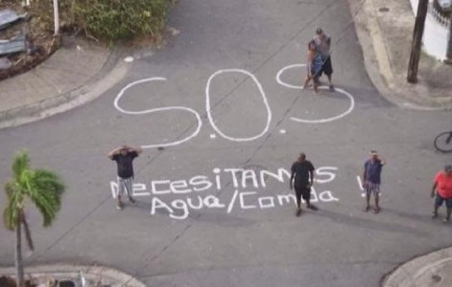

Fig. 1. Written message asking for food and water in Spanish (Díaz).

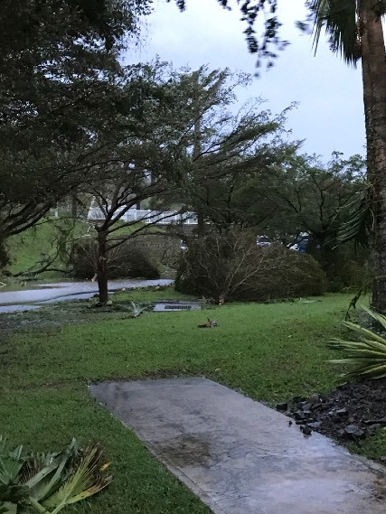

Fig. 3. Trees that fell due to the strong winds of hurricane María. (09/20/2017)

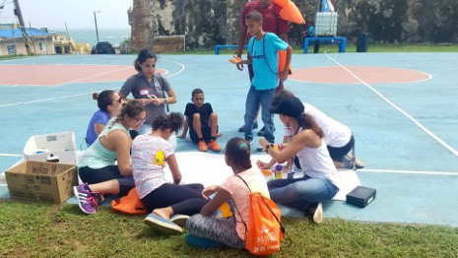

Fig. 5. Activity for children to distract them from the catastrophic event. (10/19/2017)

Fig. 2. Day after the hurricane and an image of the deforestation caused by it. (09/20/2017)

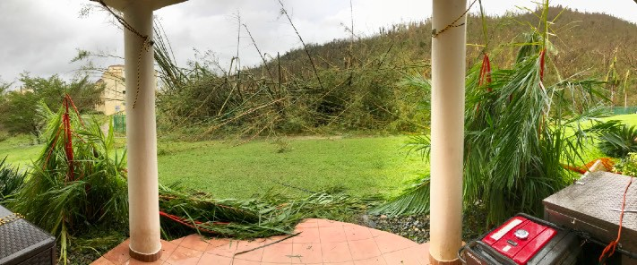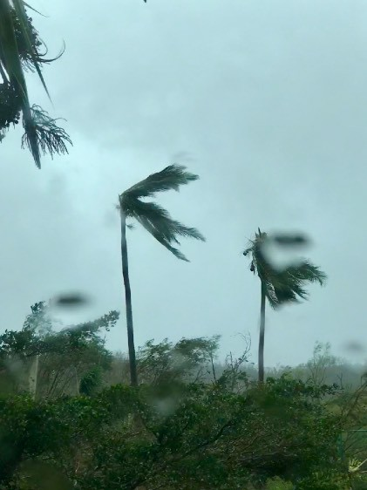

Fig. 4. The way palm trees moved in the middle of the Hurricane. (09/20/2017)

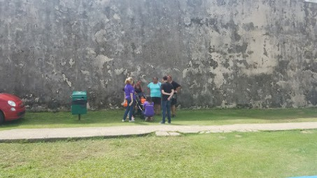

Fig. 6. Conversation with people from the community of La Perla to understand how they managed the first rough weeks after the hurricane. (10/19/2017)

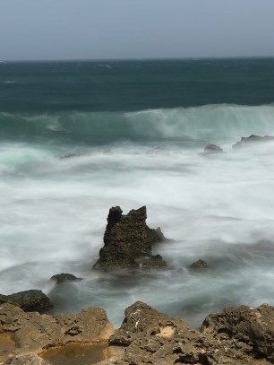

Fig. 7. Waves shot from La Perla, showing how the beauty island of Puerto Rico was not completely lost. (10/19/2017)

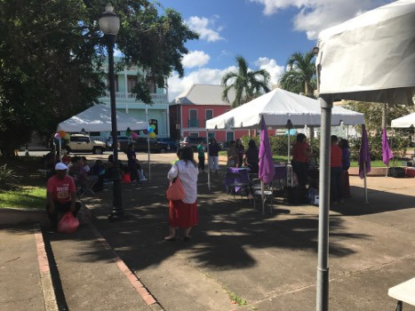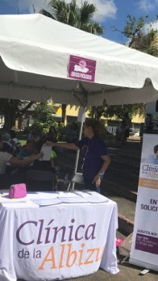

Fig. 9. Caravana Violeta, activity made for women from Puerto Rico and República Dominicana to distribute food, medical care and offering of psychological services. (11/2/2017)

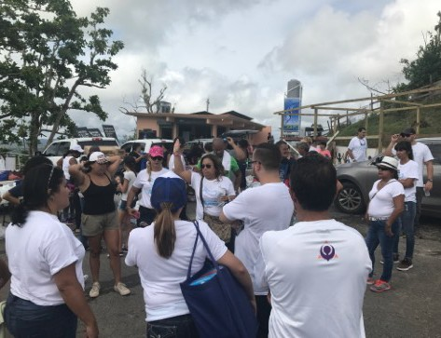

Fig. 11. Organization of the mental health staff before the arrival of the community. (11/19/2017)

Fig. 8. Caravana Violeta, organization before the arrival of women. (11/2/2017)

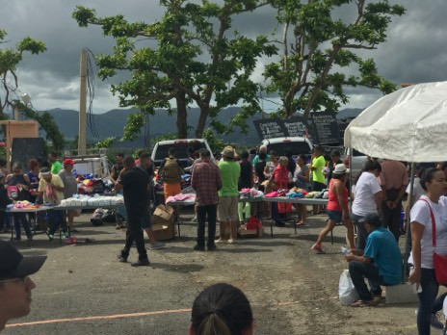

Fig. 10. Distribution of supplies in Barrio

Mariana. (11/19/2017)

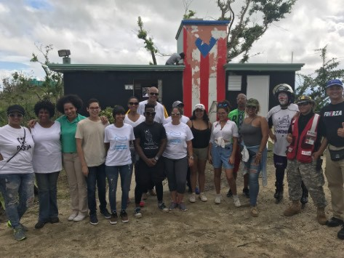

Fig. 12. Main representatives of institutions that made the activity happen. (11/19/2017)

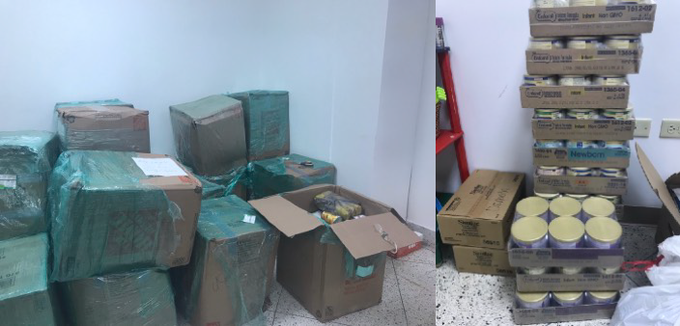

Fig. 13. Arrival of supplies for a different community in the municipality of Yabucoa. (02/23/2018)

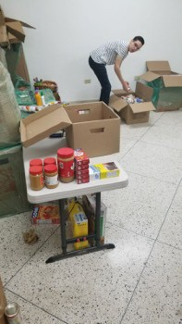

Fig. 14. Organization of supplies received. (02/23/2018)

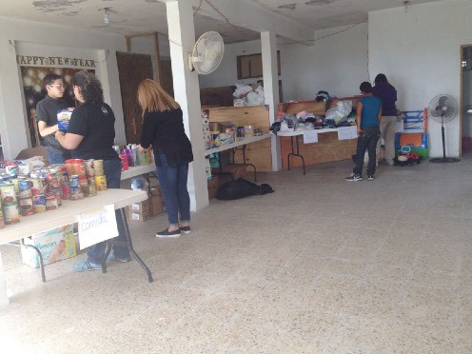

Fig. 15. Organization of supplies in the facility used for distribution. (02/24/2017)

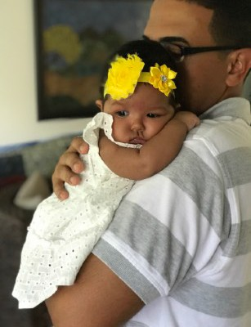

Fig. 16. The birth of Dr. Gilda Rodríguez Díaz and Rafael Martínez’s daughter weeks before hurricane María and Irma, gave them the motivation to work harder in the hurricane relief task to give her a childhood with no necessities.

Fig. 17. Seven months after the hurricane and William Reyes Laboy (works for the island’s power company) used my mom’s love and support to keep working in the reestablishment of power in the island. (05/12/2018)

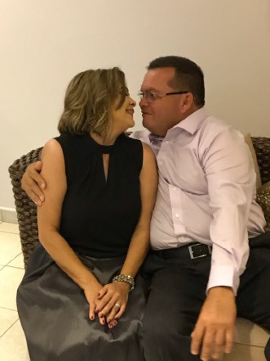

To begin with, the part that you probably heard in the news regarding the destruction and the force of hurricane María (Figure 4) was true. However, the news outlets only focused on the destruction and made it seem as if the whole country was suffering by spreading pictures (figure

1) instead of showing the labor of Puerto Ricans inside the island to rise again. This is seen more clearly on a press conference Yulín Crúz, mayor of San Juan, gave to the *Washington Post* because this newspaper used as their headline a phrase of the mayor that said “We are dying here”, instead of quoting what she said last “We will make it through, with or without the help of the United States government” which makes the citizens of Puerto Rico seem hard-working people instead of people dependent on government relief. The truth is that the majority of the communities in Puerto Rico helped themselves and did not wait for the federal government. My community is an example of it because, after the hurricane, my apartment complex neighbors

and my family did not wait inside our apartments for help to come. Instead, we as a community organized ourselves to get rid of the debris surrounding our neighborhood and blocking our streets (Figure 2 and 3). Our community gave their best to make our community look as it was before the hurricane. That so that my neighbor, Gisela de Jesús Jiménez, with the help of other neighbors used a machete to cut down the trees that fell in figure 3 and then replanted them again to allow them to regrow. After they were done, we got together and enjoyed a nice cup of hot cocoa with bread at our apartment. The day after, everyone went to their respective companies to figure out if the stores were open because there were not any cell towers up yet so driving was

the only and risky option because gas stations were not open yet.

Although some companies were not open the task that awaited my dad, William Reyes

Laboy, boss of a few employees in charge of power line operations for the power company of

Puerto Rico, was harder than you would expect. The island power system was 100% down and even concrete poles fell, blocking the streets. Due to the lack of materials, Reyes Laboy had to improvise to fix the system in his district. He spent from 17 hours a day working to restore the system with no breaks. He took one month to solve the outage in his district, which was incredible because his district, Caguas, was one of the first districts to fix their system. Although he fixed the system, the central power plants were still weak and the lines connecting to the district were too, so power outages were common. This caused him to have to go to every sector all over again to restore power. The director of the islands’ power company was surprised with his efficiency given the lack of materials and gave him a raise which was as the leader of an elite group that will work around the island to bring power to every district he was assigned to, but this time was in a set time frame no matter the cost.

Although his task was very important, there was another person that made a big

difference and that was my aunt, Dr. Gilda Rodríguez Díaz, a clinical psychologist that works for the Program for Victims of Sexual Abuse and their Families (PAF). She offered me the opportunity to join her in the journey of distributing supplies and the offering of psychological services across the island. There were a few heartbreaking cases encountered such as the one in which children did not want to get close to any water source because they had a water phobia caused by the experience seeing their homes get flooded while they were still inside. Another

case encountered was in an activity called "Caravana Violeta", that was organized to provide women with medical services and psychological services (Figure 8). In this activity, a tired old woman approached our tent (Figure 9) and Dr. Rodríguez Díaz treated her. After the activity ended, I asked Dr. Rodríguez Díaz why that woman looked down. She responded that the patient

was most likely under the effect of antidepressants. I asked her how she knew that if she never asked and she explained to me her method. First, you cannot ask a patient if they are under the influence of medical substances, and instead, use key questions. Rodríguez Díaz told me that she noticed that she was speaking Spanglish so her hypothesis was that she was not from the island. Then, to prove her hypothesis, Rodríguez Díaz asked her if she remembered when hurricane George and Hugo (late 1980s) passed through the island. The patient confirmed that she was there, so Dr. Rodríguez Díaz rejected her hypothesis. Then, she asked more questions regarding hurricane María’s aftermath and she told her that she lost everything she had. Rodríguez Díaz got to the conclusion that she was under some kind of antidepressant medication because the

majority of the people she treated in the past few weeks showed some kind of emotion (laughter or crying) when asked to open up about their experience during and after the hurricane. I asked Dr. Rodríguez Díaz why she kept asking questions if she was under the influence and she told me that in this kind type of cases of post-traumatic disorder (PTSD) what is best is listening to the patient because that makes them feel heard and important which is a key point in helping them

get back to normal. I used her method in another activity we participated in the municipality of Yabucoa, inside the sector Mariana. In this activity, we gave out medical supplies, clothes, and meals (Figure 10). The clinic organized the staff (Figure 11) to help in different ways; some were assigned to register the people that came in and see if they needed psychological services.

Others, myself in this case, had the task of helping senior citizens with the supplies they

collected in every station and ask them friendly questions and give them psychological support if needed. One case that was very touching was while I was helping an old woman carry her belongings to her car, she was telling me about how worried she was because she has not heard

from her adult children since the day before the hurricane. In talking, she mentioned something that some may consider as insignificant for treatment and that was the way she kept praying to God for their safety. Given that she mentioned God, I knew that I could use religion to help her. So I told her that God is always with them and that she does not have to worry when he is around because he will take care of them as if they were his children. After I said that, she gave me a tight hug and we kept walking to her car talking about nice things we have lived after the hurricane. This activity was a complete success because I had the chance of sharing things with the most needy and helped them rise up with me. This labor was recognized in a press

conference for the office of the first lady thanking all the institutions that made that happen, and in that conference, I was chosen as the main representative of the clinic (Figure 12). This press conference never saw the eyes of U.S news, which is a shame because it shows how the people of Puerto Rico after a big tragedy can rise up together.

Talking was not the only method the clinic used to help people; sometimes we used drawing and game activities. We went to a community in Old San Juan, La Perla, and instead of asking questions we gave the children the task of drawing a mural of what they considered to make Puerto Rico beautiful (Figure 5). In the case of adults, we offered them board games to distract them because we understood that it is stressful being at home all day figuring out how to distract their children. Some adults preferred to talk about their feelings and we gave them the opportunity (Figure 6). After the activity, the community offered to give us a tour of the community and they showed us the wonders of La Perla. At the tour, I had the chance of noticing that although hurricane María was a category 5 full of power, it did not have the power to eliminate the beauty of Puerto Rico (Figure 7).

Lastly, although we were a mental health clinic, Dr. Rodríguez Díaz coordinated the arrival of first aid supplies, baby food, clothes, hygiene articles, and canned food to distribute to a very poor community located in the central part of Puerto Rico (Figure 13). For this task I was in charge of organizing the supplies received and classifying those in several categories so when we arrived at the destination, the distribution was easier (Figure 14). Once we got to the place

where the activity took place, we organized everything in different stations (Figure 15) to make it easier for the distribution. On this activity, I was in charge of registering the people that came in and calling them up to pick up the supplies. Although we were distributing supplies, the owner of the locale we used had the kind gesture of making food for the people that came in. This represents how among a tragedy, kindness is not lost and we see each other as equals.

The labor of William Reyes Laboy and Dr. Gilda Rodríguez Díaz for their island may never be known outside the island of Puerto Rico due to the coverage of news outlets in only showing how the federal government was taking care of the aftermath, but inside the island, their job is being recognized with awards. Their job involved a lot of pressure because literally, the island depended on them to recover. In the case of William Reyes Laboy, he had the pressure of giving power to certain sectors of the island in a set time frame which is stressful. Also given that Reyes Laboy was working 17 hours a day without break, his situation was hard mentally and physically because he is in charge that none of his employees die by electrocution. However, his wife Johan Martínez Massa, a retired X-Ray technician, understood his situation and took more responsibilities in the household to make him more comfortable when he came to the household to get his five hours of sleep, such as the maintenance of the industrial backup batteries that gave the apartment 24 hours of power and the maintenance of the power plant. Johan Martínez Massa

did not only help her household, but she also used her privilege of having power 24 hr and refrigerated neighbors’ perishable meals. On the other hand, Dr. Gilda Rodríguez Díaz’s contribution is admirable because she had a baby weeks before hurricane María and although her baby needed her the most at that time, she left for work because she wanted to give her child an island she could be happy and live without necessities (Figure 16). Dr. Rodríguez Díaz’s

husband, Rafael Martínez who is an executive employee in the island’s power company in charge of distributing materials to island districts, took care of the baby when his wife was working in

the activities described before. However, his job was very important, so they sometimes left the

baby with Johan Martínez Massa while they worked for their island. In summary, this tragedy brought destruction but never brought the weakness the media was interpreting and spreading around the United States. As a matter of fact, this tragedy brought people together and got rid of the superiority some people had and brought back the sense of community that was thought to be lost. Even though some may consider María’s aftermath is over, the economic problem of the billions of dollars that were lost due to this hurricane has not been resolved yet and that is the next step to take care of, but that is something that is out of my power and should be taken care

of by both the federal government and the government of Puerto Rico.

Works Cited

Bubello, Kim and Segarra, Lisa. *MARÍA’S DESTRUCTION ON ACROSS THE CARIBBEAN.*

[Accessed 2 Mar 2019. http://time.com/hurricane-maria-destruction-photos/](http://time.com/hurricane-maria-destruction-photos/)

Díaz, Andrea. *Puerto Rico town’s desperate plea for help is finally answered.* Accessed 9 Mar

[2019. https://www.cnn.com/2017/09/27/us/plea-for-help-in-puerto-rico-gets-answered/](http://www.cnn.com/2017/09/27/us/plea-for-help-in-puerto-rico-gets-answered/)

index.html

The CNN article Díaz wrote talks about the help plea a community drew with a big SOS on the road asking for food and water which was answered by the government and they took care of the situation by going to the community and giving them water and food.

This source is useful in the way it shows how the media interpreted the narrative causing their readers to think that the Puerto Rican people were really weak and useless.

I will be using this picture as a way to demonstrate how the way the news narrative

affected how the people saw the situation in Puerto Rico.

Disis, Jill. *Hurricane María could be a $95 billion storm for Puerto Rico.* Accessed 2 Mar

2019. https://money.cnn.com/2017/09/28/news/economy/puerto-rico-hurricane-maria- damage-estimate/index.html

Florido, Adrian. *Puerto Rico Estimates It Will Cost $139 Billion To Fully Recover From Hurricane María.* [Accessed 2 Mar 2019. https://www.npr.org/2018/08/09/637230089/](http://www.npr.org/2018/08/09/637230089/) puerto-rico-estimates-it-will-cost-139-billion-to-fully-recover-from-hurricane-m

*Major Hurricane Maria - September 20, 2017*. [Accessed 22 Feb 2019. https://www.weather.gov/](http://www.weather.gov/)

sju/maria2017

Nishant Kishore, Domingo Marqués, Ayesha Mahmud, Matthew Kiang, Irmary Rodriguez, Arlan Fuller, Peggy Ebner, Cecilia Sorensen, Fabio Racy, Jay Lemery, Leslie Maas, Jennifer Leaning, Rafael Irizarry, Satchit Balsari, Caroline O. Buckee. *Mortality in Puerto Rico after Hurricane Maria. New England Journal of Medicine.* Accessed Mar 4 2019. https:// [www.nejm.org/doi/full/10.1056/NEJMsa1803972](http://www.nejm.org/doi/full/10.1056/NEJMsa1803972)

Sánchez, Ray. *How Puerto Rico's Death Toll Climbed From 64 To 2,975 In Hurricane*

*María.* [Accessed 22 Feb 2019. https://www.cnn.com/2018/08/29/us/puerto-rico-growing-](http://www.cnn.com/2018/08/29/us/puerto-rico-growing-) death-toll/index.html

Walsh, Kelsey. *Trump calls San Juan mayor 'totally incompetent' amid flap over Hurricane Maria.* Accessed 2 Mar 2019. https://abcnews.go.com/Politics/president-trump-calls-san- juan-mayor-totally-incompetent/story?id=57767633

Yulín Cruz, Carmen. *‘We are dying here.’ San Juan mayor makes a passionate plea for help.*

[Accessed 2 Mar 2019. https://www.washingtonpost.com/video/national/we-are-dying-](http://www.washingtonpost.com/video/national/we-are-dying-) here-san-juan-mayor-makes-a-passionate-plea-for-help/2017/09/29/8efe49a8-a556-11e7- b573-8ec86cdfe1ed_video.html?utm_term=.ecfc45deeca6

In this press conference the governor of San Juan addressed the federal government about their lack of hurricane relief response. Yulín Cruz talks about the way her municipally had shared supplies with other communities and she finishes by saying the phrase “We are dying here” and that Puerto Rico will make it with or without the federal government.

This press conference is important because the *Washington Post* used the phrase “We are

dying here” as their headline which makes the Puerto Rican people sound weak instead of

making “we will make it” as the headline which shows an audience that the island is resilient and does not let a natural phenomenon get in the way of success.

In this paper I will use this interview as evidence that the media only used the part of the story that sounded tragic, which for them is a benefit because those outlets will gain more viewers, but it affects the real story, and defunding an untrue story could, over the years, be part of a history book and after many generations the real truth will disappear.