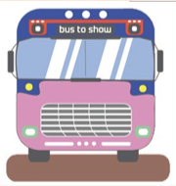
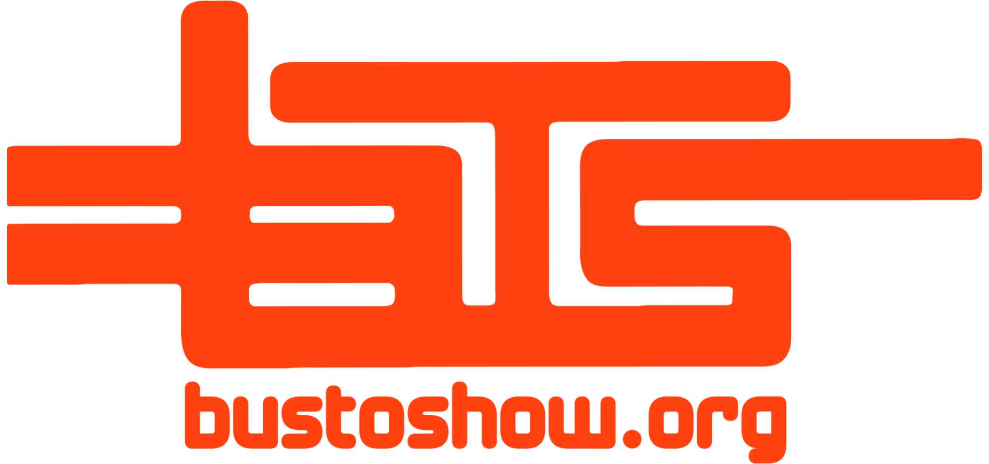

Bus to Show
Concert Transportation Specialists
To AARP Livable Communities,
On behalf of Bus to Show, we are happy to apply to your RFP for a non-profit organization to improve local communities.
Bus to Show is a non-profit transportation service providing rides to thousands annually. We are delighted to get the opportunity to continue community improvement through the support of local businesses as well as safe practices.
Bus to Show has already contributed exceptionally positively to the Boulder and Denver communities. Through partnering with local businesses, our bus stops generate plenty of foot traffic and revenue to restaurants and shops in the area. Our main mission overall, however, is to make the community safer. Our low prices have allowed us to maintain a large and diverse clientele. The more people we can reach, the more people we can keep off the roads and travel safely from concert venue to home. With Boulder being a college town it comes with the large issue of drunk driving. Our services increasingly cut down the risks of this problem.

The AARP 2021 Community Challenge is especially well suited to Bus to Show’s endeavors as we intend to cover many of the achievable outcomes in the following ways:

- Supporting local Coronavirus recovery. Bus to Show will be working with restaurants and facilities that have not had nearly the concentration of business that they had prior to the pandemic. We intend to uphold our local beloved businesses that give our community the character we appreciate and miss. We also will directly be employing a great deal of bus drivers and maintenance people.
- Delivering transportation to increase mobility and connectivity. Having a system of transportation to get large quantities of potentially intoxicated people to and from large events is crucial to the safety of their surrounding peers. Keeping concertgoers off the roads is imperative to making the Denver area a safer place for people of all demographics.
- Creating vibrant public spaces. Our buses are pieces of art. We hire local artists to display their artwork so it can be seen from Denver to Boulder. Our buses stand out and add to the eclectic aesthetic of our beautiful community. Our buses are also more environmentally conscious than rideshare and other similar services. Lowering emissions is imperative to maintaining our precious Colorado landscape-- something that the Front Range values primarily.

We have an extensive team including executive director Amandine Aubertot as well as our beloved bus drivers. Everyone at Bus to Show is hands on and contributes to all operations, especially the drivers. Due to COVID, operations have been shut down for over a year now, and we will have to consider the expenses that will incur to train drivers who previously obtained a CDL class B license.

We look forward to hearing from you regarding this opportunity. Bus to Show is eager to resume operations after being halted for this duration. Our team is dedicated to serving AARP’s livable community needs!
Table of Contents

Summary ………………………………………………… 4
Introduction ………………………………………………… 5
Statement of need ………………………………………………… 6
Goals and objectives ………………………………………………… 7
Demographics ………………………………………………… 8
Timeline ………………………………………………… 9
Outcomes ………………………………………………… 10
Budget ………………………………………………… 11
Evaluation ………………………………………………… 12
Works cited ………………………………………………… 13

Summary
Bus to Show is a 501(c)(3) fiscal sponsorship non-profit organization with a mission to improve the lives of everyone in the Front Range community by reducing fatal accidents due to intoxication. We offer transportation to and from popular concerts at venues such as Red Rocks Amphitheatre and 1stBank Center. By offering transportation for, on average, $25 a person as opposed to upwards of $50 a person prices offered by for-profit commercial entertainment transportation services, we can reduce the amount of people getting behind the wheel after possibly consuming alcohol or other substances. Not only is it cheap and saves lives to ride with us, it is also fun and helps the environment by saving on fuel consumption per person. Our buses are fully equipped with PA Speakers, a DJ table, and premium leather seats. During the summer of 2018, Bus to Show made 1,347 trips and carried a total of 34,318 passengers.
In order to get our buses back on the road, we will allocate any grant funds towards hiring drivers, training drivers, and any maintenance costs that might be incurred to keep our buses up to regulation standards. We estimate that a minimum of 10 drivers will be needed as our services are re-established, but a maximum of 20 drivers could be recruited by the end of the year depending on how often our services are reserved.
Seeing as we will be resuming operations after a year of inactivity, we will have to be looking for entirely brand new drivers. This means that we will have expenses to do checks on credentials and possibly entirely fully train the drivers. Not only will our drivers be needing a lot of our training, but since we have been completely inoperable since last March we will also be needing to do a lot of maintenance on the buses. Drivers also must be trained on bus maintenance in order to ensure driver and customer safety.
In order for Bus to Show to uplift the community as we normally do, we are going to need rehabilitation of our exposure as well. We intend to hire a few people to help us with web design as well as media coverage. Our online presence has been muted this past year and it is imperative to our functionality that we inform people that along with concerts reopening that we will be operating.
All funding will aid in negating the time we have lost. It is imperative for the survival of our mission that all of the above is accomplished. To maximize safety we have to follow these maintenance steps to move further. Bus to Show cannot continue to help the Front Range community how it has without such precautions.

Introduction
Intoxicated driving is a major problem in the US and Colorado. Between 2011 to 2017, the amount of deaths by motor vehicles has increased by 14% nationwide. In Boulder, the amount has stayed relatively constant but still high. Bus to Show was founded to reduce the number of accidents and deaths due to intoxication in Boulder and other Colorado cities/towns we service.
Since Bus to Show was founded in 2009, the amount of arrests made for DUI’s has consistently dropped. When large gatherings are once again allowed in Colorado, it is unknown if this trend will hold up or increase. Although the majority of DUI arrests are on individuals in the age range of 19-27, all ages are affected by impaired driving. Accidents involving senior citizens aged 65+ have higher mortality rates and more severe injuries than those that occur to younger drivers. Not only is it more severe, but there has been a 60% increase in the amount of accidents involving senior citizens in the US since 2000. Our goal is to make the roads a safer place for everyone; senior citizens should not feel as at risk when being on the road regardless if they are driving or not.
Not only was Bus to Show created to reduce traffic accidents due to intoxication, it was also created to help the environment by reducing emissions. One of our buses can hold 48 passengers per trip and consumes about 14.5 gallons of gas per trip to Red Rocks Amphitheatre. A standard car making the same trip with only one passenger uses about 1.8 gallons per trip. That means that our buses cost about 0.3 gallons per person per trip while a standard car is still 1.8 gallons per person per trip. If 48 people chose to ride with us instead of taking a car to a venue, a grand total of 1868.3 gallons of fuel would be saved. That is enough fuel for one of our buses to bring the same amount of people to Red Rocks Amphitheatre 128 times!
Over the past 4 years, our non-profit organization has grown immensely in response to positive local reception and growing need to make a change in the community. We originally started out with 50 total riders in 2009 and had expanded to 30,937 riders in 2018. That is 46 thousand gallons of gas saved in the year 2018 alone!
Bus to Show is intent on being the safest, cheapest way to get to Red Rocks Amphitheatre as well as other venues in the Front Range. Operations have halted one hundred percent since the pandemic hit and we are trying to get back out and make people feel even safer. With vaccination requirements at venues we have always and will always ensure that people feel comfortable riding with us. We are looking forward to a new and hopefully bright beginning where we can all let loose a little again while protecting the communities we love so dearly.
Statement of Need
Due to the Covid-19 pandemic, our operations have been temporarily halted with the absence of large concerts and limited seating due to social distancing. With the vaccines starting to roll out, Red Rocks Amphitheatre and other venues have already begun scheduling future concerts for the year of 2021. As a result of this temporary pause of operations, we have exhausted our capital and can not get our buses on the roads. It is important to the well being of the Boulder community that our services become available around the same time that high density concerts are happening.
We currently have around 30 buses that can be fully operational after a maintenance check, however our goal is to get 10 in a fully operational status by July 2021. Other than the buses themselves, we need to hire new drivers along with potentially recruiting past drivers at a reduced cost. We estimate, through research into reliable sources on the subject such as The Schneider Guy, that it could cost around $3360 to train a new driver that does not already have a CDL class B license and around $570 to give a training course customized to Bus to Show’s needs for drivers that have already obtained a CDL class B license. Since training a driver without a CDL class B license is costly and has little to no advantage over training someone who already has a CDL class B license, we will solely be focusing on recruiting drivers who already have a CDL class B license. To administer such a course, we would need the funds to bring back a driver who worked with us in the past who is well trained and authorized to train others.
Another aspect that needs to be addressed for our services to flawlessly integrate back into the community is our online presence. Currently, our website is not complete and cannot be used to reserve a bus. As a non-profit organization, we will ask for the help of volunteers to help with the design and functionality of our website, but it will still cost an estimated $500 - $1,000 to maintain. As well as having a website, we want local residents of Boulder and other neighboring cities to become aware when our buses are back in operation. To do this, we will mainly rely on social media posts to popular platforms such as Instagram, Facebook, and Twitter to spread word. We will need to commission a local designer willing to create an artistic and informative social media post at an estimated cost of $100 - $200 per post. With enough awareness, Bus to Show can start saving lives again by July 2021.

Goals and Objectives
Bus To Show stands out from other transportation companies because of our nonprofit status and company-wide attention to the wellbeing of our patrons and others living in their area. Since beginning our ride service back in 2009, it has been our goal to place an emphasis on improving our community. This has included facilitating harm reduction through reducing the potential for DUI related accidents, aiding the effort to reduce carbon emissions, and promoting a positive atmosphere for all members of the community. Whether members of the Front Range community choose to ride with us or not, we strive to benefit them by keeping them safe and contributing to the preservation of the environment around them. We feel that our mission to reduce the negative effects of impaired driving and fuel consumption while fostering a positive relationship with our community aligns perfectly with the AARP Community Challenge’s request for projects that deliver inclusive solutions in the areas of transportation to increase connectivity and mobility, creating vibrant public spaces, and supporting local Coronavirus recovery. In order to achieve these goals, we have outlined the following objectives.
- Training Bus Drivers: An important aspect of supporting local Coronavirus recovery is reintroducing jobs to the workforce. Bus to Show will aid in this effort by providing skilled positions and training for its drivers.
- Improving our Online Presence: Generating a larger audience will allow us to offer our inclusive transportation strategies to a larger amount of the community, and thus have a greater impact on Coronavirus recovery, whether it it be for our riders, our local business sponsors, or even the non-riding members of our community that benefit from our safety and eco-friendly ideals. Given the opportunity, we plan to make improvements to our website and increase our emphasis on social media marketing.
We believe that after implementing these changes, backed by funding from the AARP Community Challenge, Bus To Show will be able to have an even greater impact on the Front Range community than before the pandemic. By reintroducing our buses into circulation we will not only offer new skilled jobs into the workforce, thus stimulating the economy, but will also once again offer a safe and fuel efficient alternative to individual, potentially reckless, driving to our community. With an expansion of our presence online through our website and on social media, we will be able to promote a safe, affordable, and wholesome environment for returning to social activities to a larger audience. This will be mutually beneficial for expanding our nonprofit and providing safe and reliable transportation to our community.

Demographics
Every year, during normal operations, popular concert locations in the Front Range area including Red Rocks Amphitheatre, 1st Bank Center, and Dick’s Sporting Goods Park see hundreds of thousands of visitors. This introduces a larger logistical problem regarding how these concert goers will get to and from their destinations. Since its inception, Bus To Show has transported an increasing and significant portion of this crowd, and in 2018, saw a ridership of over 30,000 people. With the increasing number of community members relying on Bus To Show’s services, we have a responsibility to maintain this level of support as concerts begin to happen again. All members of our community have something to gain from Bus To Show increasing its outreach over the next few months and in the years to follow. This is especially evident with respect to our measurable and positive impact on the safety of drivers during at risk times and on the environment through reduction of fuel consumption.
Regarding improving the safety of our community on the roads, there are a few important statistics to take into consideration. The first, and most evident is the fact that since 2006, the Front Range has seen a 45 percent decrease in DUI’s. Bus To Show’s increasing ridership during at risk times has definitely made an impact on this excellent statistic. The second is even more prevalent for the betterment of the AARP community. Unfortunately, according to the Center for Disease Control and Prevention, in 2018 almost 7,700 adults aged 65 years and above were killed in car crashes and more than 250,000 were treated in emergency departments for crash related injuries. This means that, each day, more than 20 older adults are killed and almost 700 are injured in crashes daily. Combine this with the fact that driving conditions are often much more dangerous at night after concerts, when many drivers may be intoxicated, it becomes evident that removing these dangerous conditions is highly beneficial to others on the roads, especially for groups such as the elderly that are already at risk.
In addition to improving driving conditions for everyone involved, we must also consider the positive impact that Bus To Show has on the environment through reducing fuel consumption due to decreasing the number of cars on the road. Assuming that without our ride service people would carpool to concerts in groups of three on average and that all 30 buses were running at the time, on any given round trip ride from boulder, we would collectively save almost 300 gallons of fuel. Combine this with the fact that according to statistics taken from 2009 to 2018, Bus To show saw a 40 percent annual ridership increase before the pandemic. It is evident that Bus To Show is making a significant contribution to the reduction of carbon emissions. Clearly, all the positive effects of Bus To Show’s business can be enjoyed by every member of our community, especially those already at the most risk, such elderly adults.

Timeline
The following is a timeline of completion for each of the various endeavors that will occur to bring Bus to Show back on the road. The assigned completion date is November 10th, 2021, but our peak operation time is the summer months between July and August because of the popularity of Red Rocks Amphitheater during this time. For this reason, we have set a premature completion date to July 28nd to compensate for any and all unforeseeable delays that may take place and to make the most out of our impact to the community.
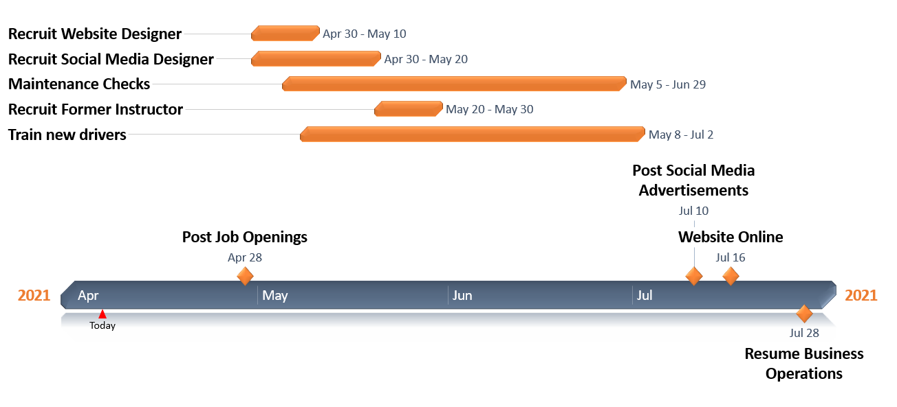
We are only giving ourselves ten days for recruiting a former driver because we already are in contact with potential instructors. For this reason, bringing them up to speed on their duties will not take long. We expect recruiting a web designer and social media designer may take more time because we will start this application process from scratch. However, due to our excellent networking web we have with local residents in Boulder and Denver, we are confident that we will receive a sufficient number of promising applicants that believe in our message at Bus To Show. Additionally, we will not make the applications a difficult process.
Social media advertisements will be posted a little under two weeks before operations begin generating hype and anticipation around our services, and the website will be up and running shortly after so local residents can start making their reservations. After some preliminary research into the topic, we are confident that giving a web designer about two months to work is enough time to complete the expected website modifications.

Outcomes
Ideally the outcomes would be to resume to normalcy as soon as possible. Most of our post COVID recovery will be taking place in the summer after general population vaccines are distributed and concert venues open again. As you can see from the timeline we will begin by getting word out and then starting all of our maintenance upkeep. We should also be moving into a functional lot as our buses are in a smaller, non-operational lot currently.
Our desired outcome in resuming operations is to contribute to these pre-COVID statistics as well as having these qualities:
- Have a group of drivers ready to go-- Within our timeline we hope to get a trustworthy group of drivers that can help us get us back on track. We need a dependable and consistent crew that will help us make it all possible. These people will be making sure the buses are running okay
- Minimizing the number of vehicles on the road during a show-- Bus to Show requires around 26 buses to transport close to 1200 people. Using carpooling or rideshare would require over 300 vehicles to transport that many people along with no guarantee of these drivers being safe. Having the certainty of Bus to Show ensures a safer community.
- Minimizing fuel consumption-- Bus to Show consumes a little over 300 gallons to transport 1200 people. Carpooling with three other people requires 500 gallons to transport 1200 people, and everyone driving alone requires over 2,000 gallons of fuel. A happy environment makes a happy community, so choosing a transportation method such as us is the most eco-conscious option.
- Minimizing DUI rates-- Since Bus to Show was founded, DUI rates have halved according to the Center for Disease Control. Providing a safe environment for people to consume alcohol in is a preventative measure that should be implemented everywhere. We would like to continue to lessen the DUI rates and therefore minimize deaths and potentially save lives as we have done in the past.
- Promote diversity-- It is imperative that we are still able to keep ticket prices cheap. Rideshares to Red Rocks go for over $50 as well as other bussing services. There are no public buses that go to these venues and for the safety of the community this has to be accessible. Customer financial backgrounds hold a lot less gravity than saving lives and stopping DUI’s.
The grant will strictly be used for bus maintenance, driver pay, and overall recovery, but the outcomes are far greater than that. As listed above, possibilities for what Bus to Show can do with regular operation standards are extensive. Historically we have been an integral part of our community and would like a chance to resume. There are many people that Bus to Show impacts on a daily basis. Concerts occur every day of the week and therefore we operate the same. Every day Bus to Show is able to produce promising outcomes, and promote both local artists’ and our business. As operation becomes possible again, these positive outcomes will be continued.

Budget
In order to get our buses back on the streets, the following actions will need to be completed:
 | Action | Quantity | Estimated cost to complete
 | Train bus drivers | 10 | $5,700
 | Instructor wage | 2 | $1,600
 | Bus maintenance | 10 | $2,000
 | Website construction and maintenance | 1 | $1,000
 | Social media marketing | 5 - 10 posts | $2,000
 | Fuel Cost per bus (per 6 months) | 10 | $18,000
Total cost |  |  | $30,300
How these costs were calculated:
- We offer a wage of $15 per hour for newly hired drivers. For a full time week long course, the cost per driver is around $570. For ten drivers, this comes down to around $5,700.

- The wage for an instructor will be about $25 per hour. To teach a full time week long course, the cost per instructor will be around $800. For two instructors this cost will be about $1,600.

- We estimate that it should cost no more than $2,000 total to bring our buses up to regulatory standards. Buses underwent a maintenance check prior to being stored and are estimated to still be in good condition.

- Our services will be rendered useless without a website for people to reserve a bus. As a non-profit, we will get the help of volunteers to help design our website, but it is estimated that $1,000 in costs will be incurred to keep the website online.

- We will hire student designers to help create social media posts letting the Boulder community know we are back in business. We expect to spend around $200 per post until November 2021, with an estimated 5 - 10 posts made for a total of $2,000.

- It costs around $45 per 100 mile round trip in fuel. Assuming we make 400 trips by the end of the year, it will cost $18,000 in fuel.
Evaluation
In order to ensure long term success in Bus to Show the following will be done:

- Measurement of success rates through calculated data
  - Traffic accident rates are directly correlated to what we do at Bus to Show-- recording these rates on Bus to Show pick up days compared to nights Bus to Show is not serving a venue could give sound numerical quantities of the effectiveness of the program within the community through local accidents and inhibited driving statistics.

  - Local business growth-- using the data we receive from the community on how our local businesses are performing on Bus to Show pick up days where we log significant amounts of people we can tell just how beneficial it is to have a populated bus in these areas. Similarly to seeing accident rates, we can compare community revenue rates on days that Bus to Show is working in the area and days when we are not. This would be a rough estimate, but still worth observing.

  - Rider frequency growth-- keeping track of how many riders ride our busses receive over a period of time can provide a basis of understanding on how well the community is attracted to our services.

- Community promotion
  - Local artists-- most of our buses are decorated with artwork from local artists. With the redesign of our web page we can include a page of the talented folks who help keep our brand beautiful, as well as showing off their excellent designs.

  - Couponing and promotion-- partnering with our local businesses leaves room for opportunities to increase business and therefore maximize safety even more through couponing. We have also previously had some of our favorite restaurants painted on the sides of our buses which is great exposure for the both of us.

- Maintaining client satisfaction
  - Liz M.: “Used Bus to Show from Fort Collins to Red Rocks, our driver Michael Thomas was above and beyond!!! Such an amazing driver and so kind to us. He offered to stop on the way for us to take a [bathroom] break and get snacks!!! He also did this on the way back! Super amazing time, the bus was more fun than the show! He helped me connect to the AUX and we danced on!!! Thanks Michael!”
    - Maintaining this attitude of respectable drivers and happy times makes riders more likely to promote our success. The search for drivers this summer will take this into consideration.

  - Dawn W.: “Took bus to show for the One Republic concert. Toni was an awesome driver letting my daughter play her music playlist and we were able to have a few beverages on the way to the concert. Made new friends on the bus from other states and arrived in plenty of time for the show. This was a great deal and safe way to go to and from the Red Rock.”
    - Dawn’s quote emphasizes the importance of our drivers again as well as the safety involved in participating in Bus to Show. Punctuality, safety, and driver relations will help maximize our future.

Much of what we do to ensure the continued success of Bus To Show is maintenance of the organization within. By revitalizing our image, hiring the most experienced drivers, and continuing to offer an entertaining experience both for those who choose to ride with us and those who don't, we are confident that Bus To Show will thrive upon resuming operations. In conclusion, it is imperative that we return from our hiatus during the pandemic in order to continue offering support to the senior community in our area through promoting environmental conservation and keeping them safe on the roads. With funding from the AARP Community Challenge, Bus To Show will be in an excellent position to make a larger positive impact than before the pandemic.

Works Cited
Belcher, Shane. “Pricing.” NOCO Party Bus, 8 July 2020, www.nocopartybus.com/pricing/.
“Boulder, Colorado DUI Statistics, Drunk Driving Facts, Arrest History.” Boulder Criminal Defense Lawyer, 13 May 2020, www.boulderdefenseattorney.com/boulder-colorado-drunk-driving-statistics/.
Headden, Henry. “Annual Mini Bus Maintenance Costs.” Carpenter Bus Sales, 23 Mar. 2016, www.carpenterbus.com/2015/01/annual-mini-bus-maintenance-costs/.
“How Much Does Digital Marketing Cost in 2021?” Digital Marketing Pricing, WebFX, 1 Mar. 2021, www.webfx.com/digital-marketing-pricing.html.
McGee, Lerer & Associates. “Elderly Driving: Is It Dangerous?” HG.org Legal Resources, McGee, Lerer & Associates , 2021, www.hg.org/legal-articles/elderly-driving-is-it-dangerous-25386.
“Older Adult Drivers.” Centers for Disease Control and Prevention, Centers for Disease Control and Prevention, 7 Dec. 2020, www.cdc.gov/transportationsafety/older_adult_drivers/index.html#:~:text=In%202018%2C%20there%20were%20more,a%2060%25%20increase%20since%202000.&text=In%202018%2C%20almost%207%2C700%20older,emergency%20departments%20for%20crash%20injuries.
“Paying for CDL Training.” Paying For CDL Training & Sponsored CDL Training, CDL.com, 2021, www.cdl.com/cdl-truck-driving-schools/truck-driving-school-resources/paying-for-cdl-training.
The Schneider Guy. “How Long Does It Really Take to Get Your CDL?” Schneider Jobs, Schneider, 12 Oct. 2018, schneiderjobs.com/blog/how-long-does-it-take-to-get-cdl.
Wilson, Meghan. City Releases Latest Report on Crash Trends, Identifies Actions to Improve Safety, Vision Zero, 2019, bouldercolorado.gov/newsroom/city-releases-latest-report-on-crash-trends-identifies-actions-to-improve-safety.

