**Resuming Operations Proposal**

**Alexa Hugenberg & Katie Deng**



March 16, 2021

1212 W Cedar Ave.

Denver, CO. 80223

Dear Ms. Aubertot,

Bus to Show is committed to serving the community in an enjoyable environment. Like many other organizations, the COVID-19 pandemic has taken a toll on your mission of reducing carbon emissions and event-based DUIs. As the development and distribution of vaccines continues, the time has come to draw up a detailed plan on how to resume Bus to Show’s operations.

We believe that our proposed twelve month plan will be able to jumpstart your organization’s activities. Being in the same age group as your target audience, we provide valuable insight on how a company like yours will be able to garner the trust of consumers. As college students, we are able to understand certain conditions that would make young adults partake in a public event-based transportation service. Additionally, our team members have first hand experience with restarting operations according to COVID-19 protocols as their families own current running businesses. With this in mind, the following are the short term objectives we propose in order to further Bus to Show’s strategic plan:

1. Restarting services to provide riders with a satisfactory transportation experience and to ultimately reduce carbon emissions and event-based DUIs.
2. Hiring a part-time mechanic to help maintain a certain baseline level of activities.
3. Stocking up on frequently used bus parts to maintain a consistent inventory of operational buses.
4. Creating an efficient equipment storage and repairment system by building an auto parts shed on the bus lot.

To accomplish these goals, we have also devised three initiatives that use social media and online branding as practical methods of resuming operations. Our year-long plan for continuing Bus to Show’s activities will not only allow for your organization to initiate a comeback but for it to grow in the future as well. We look forward to hearing your thoughts.

Sincerely,

 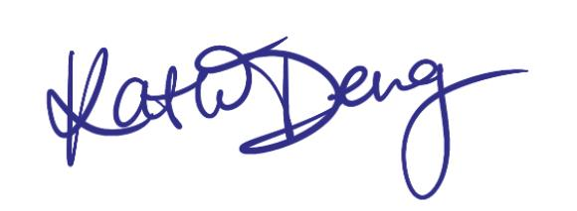

Alexa Hugenberg Katie Deng

**SUMMARY**

This proposal lays out the guidelines on how Bus to Show will be able to restart operations as the COVID-19 pandemic gets under control. To do so, your organization will meet the following goals within a twelve month period: resuming transportation services, hiring a mechanic, stocking up on frequently used bus parts, and building a mechanics shed on the bus lot. These four objectives will ultimately further Bus to Show’s overarching mission of reducing carbon emissions and event-based DUIs. We also detail steps on how to accomplish the four listed checkpoints: increasing Bus to Show’s presence online, providing both customers and employees skills and resources on how to safely partake in the recommencement of public events, and to recruit staff members to help maintain the functioning of the organization. Various KPIs will be used to measure the progress being made towards these benchmarks goals. As activities pick up, the number of riders will increase from month to month. The financial cost of the following plan falls under the budget of $10,000.

**INTRODUCTION**

The purpose of our operational proposal is to provide an outline of steps and procedures to restart your organization's activities amidst the slowing of the COVID-19 pandemic and to utilize existing resources to create a solid operational base for the growth of your company and mission. Our plan is broken down into four subset goals and corresponding initiatives that will be carried out within a twelve month period in order to reach your five year long-term goals outlined in the strategic plan. The first and most important goal for your company is to support the community by adequately servicing the needs of your riders and employees. In order to ease back into operations and meet the demand of resuming operations as early as May, the second goal is to hire a part-time mechanic. The third goal is to make enough profit in order to build a shed on your bus lot. The final goal is to have a stock of the most frequently used parts for your busses available and conveniently placed in the newly built shed. These last two goals are to be achieved near the end of the yearly plan as the organization and the community transitions back into an open and social state.

We propose 3 initiatives that will lead to the fulfillment and achievement of all four of the goals presented. The first initiative is to create and implement a marketing/advertising plan. This plan will be geared towards reaching the community as well as potential employees providing them with updated information about the organization's current status and plan for reopening this coming season. The second initiative is to construct COVID-19 operational procedures and guidelines for both riders and employees to follow and implement. This will be crucial for your company to get certified to operate and it will create organization within your workforce. You will also gain trust with potential and returning community riders by informing them that you have taken every precaution to ensure their safety and wellbeing. The final initiative is to hire and train new and existing employees. Your business can not run smoothly without professionally trained and experienced employees. Our initiative will outline the best ways to start searching and recruiting workers as well as the specific rules and regulations to follow regarding hiring during the pandemic.

**EVALUATION / METRICS**

In order to measure the progress and success of your organization towards our twelve month proposition, we present a series of possible key performance indicators (KPIs) to help quantify your company’s performance. The goal to enhance Bus to Show’s current marketing/advertising — primarily through social media platforms — can be measured through online audience engagement. A minimum of weekly posts will keep your organization relevant on numerous social media feeds and the number of likes and comments on each post can be recorded for progress. Engagement can be compared on a quarterly basis and adjustments to your presence on social media can be made accordingly. In addition, the number of followers provides a good indication of growth to the organization. To maintain consumer satisfaction, a follow up email to consumers will be sent out after each event. A simple rating system on the event can be used to quantify the customer’s experience. The feedback can be reviewed quarterly as well and changes to Bus to Show’s operations can be made.

To measure the success of COVID-19 protocols implemented throughout your organization, the number of contracted cases within the company can be measured. To ensure the best quality of service, COVID-19 cases in relation to Bus to Show should stay below a 5% threshold of total personnel (employees and customers) involved in the organization’s activities. Employee health checks will be mandatory but in order to track customer cases, a voluntary feedback form can be used to follow up with customers. This can be sent out with the consumer feedback form. Customers should respond within a week after their event with Bus to Show as that is the average timeframe in which COVID-19 symptoms develop. The 5% benchmark is the typical statistics significance level (alpha, ⍺) used to measure whether results have any meaningful impact. The statistic is used to evaluate the probability of rejecting the null hypothesis: a statement of no significant difference. Smaller significant values are possible, but require more sample evidence in order to reject the null hypothesis (Frost). One possible null hypothesis that can be used to assess Bus to Show’s efforts in maintaining an environment free of the virus is: Bus to Show’s COVID-19 protocols and number of contracted cases *are not* related. An alternative hypothesis can be Bus to Show’s COVID-19 protocols and number of contracted cases *are* related. The data gathered will be used to compute a p-value, the probability that the sample will have an extreme effect *if* the null hypothesis is true (Frost), that will be then compared to the ⍺-value, and ultimately determine whether the null or alternative hypothesis is rejected.

Lastly, to gauge the effectiveness of recruiting and training employees, Bus to Show will aim to have 50% of its staff consistently working year long. It is projected that by July 2021, the general public population in the U.S. will be vaccinated and by March 2022, your organization will be close to full operation as concerts and events will have increased. Although events will pick up within the next year, Bus to Show’s most active months are August and September, with March to May being the time period in which most of the recruitment will occur. Given that there will be ongoing activities five out of the twelve months of the year, having half of the staff actively on call will help Bus to Show maintain its operations. To evaluate employees, quarterly training reviews will be conducted with increasing numbers of individuals passing.

**GOALS AND OBJECTIVES**

The year long goals of resuming transportation services, hiring a part-time mechanic, building an auto parts shed and stocking up on frequently used bus parts can be achieved with our three proposed initiatives. The first initiative is to create and implement a marketing/advertising plan. Since we have now transitioned into a society that is heavily reliant on technology for day to day news and information, building a strong online presence is pivotal for your organization to reach community and non-community members about your mission and plan moving forward. This initiative will help your organization reach the first goal of supporting the community.

**Rebrand Website**

With that said, we believe the first substep of the marketing plan is to update and rebrand your website. Building a captivating and user friendly website that is well organized and easy to navigate gives a great first impression to potential customers. The current website does have good flow and aesthetic on a mobile device, but it does not work well on a computer or laptop. Your website should be versatile in order to service all types of people with varying access to technology. As for the desktop interface, the current main page has great graphics and visual aspects of your brand. However, the background image is cut off at the bottom of the page which could potentially distract and lose consumer interest. The *Ride with Us* button should be the call to action but it is small and hidden near the bottom of the page. As for the Informational Events page, the layout is confusing and there is no guidance for how a customer would linearly navigate through steps to purchase tickets for an event. Additionally, some of the text is small and hard to read. To resolve these details, we suggest using free and easy to use brand building website companies such as Wix or WordPress to work towards a more cohesive website.

**Social Media Strategy**

The next substep is to create a social media strategy. Having strong photography, graphics and videos help engage potential customers and grab the attention of scrolling users on digital platforms such as Instagram, Twitter, and Facebook. Within the time from now until concerts start back up again in May, you will need to increase your activity on all of your current social media platforms. Posts must detail the new protocols and safety measures in place to protect riders as well as information about new and exciting upcoming events. You also need to use all social media platforms to advertise job postings and employee benefits. Other useful media tools such as Facebook polling would help your organization receive recommendations from different audiences about returning this season. Learning about what would make your customers feel confident when riding your buses and taking their input into consideration is key to overall success.

**COVID-19 Operational Procedure**

The second initiative is to construct COVID-19 operational procedures and guidelines to ensure a smooth transition back into the service market and to provide riders with a feeling that they are safe and well protected. If riders do indeed feel safe, they are more likely to continue using your buses in the future and recommend other people to do the same. This funnels more money into the organization to be able to eventually reach the goals of building a shed and having frequently used mechanical parts for the busses available. Creating an outline with specific steps to follow will also help you build a sense of structure and organization amidst the hectic world around us today.

According to the Center for Disease Control and Prevention (CDC), the COVID-19 virus is most commonly contracted through person-to-person contact. Specifically, the virus travels through respiratory droplets which coughing, sneezing, talking, or breathing can produce (“How COVID-19 Spreads”). Based on these findings, regulations such as maintaining six feet distance, wearing masks, regularly washing your hands, and avoiding crowds (“Guidance for Wearing Masks”) has been implemented throughout the country and will continue to be enforced as Bus to Show resumes operations. With these conditions in mind, although a big characteristic of Bus to Show is the upbeat atmosphere through music, eating and drinking, these activities will have to be prohibited to prevent the spread of respiratory droplets until COVID-19 has been successfully contained on a national scale. To compensate, you may look to other resources to preserve the positive mood by handing out party accessories such as glow sticks that riders can use to dance to the music with.

Within the COVID-19 procedures and guidelines, there must be a detailed instruction manual for how employees clean and disinfect buses after each service. The CDC states that at a minimum, commonly touched surfaces must be cleaned and disinfected inside the vehicle at the beginning of each shift and between transporting passengers (“Cleaning and Disinfection”). Non-porous surfaces within the interior of the vehicle such as arm rests, door handles, seat belt buckles, light and air controls, doors and windows, and grab handles, should be cleaned with detergent or soap and water if the surfaces are visibly dirty before applying the disinfectant. Soft or porous surfaces such as fabric seats should be cleaned with the appropriate fabric cleaner indicated and disinfected with an EPA-approved disinfectant that is suitable for porous surfaces. Furthermore, when disinfecting the vehicle, doors and windows should be open to provide adequate ventilation. Employees should wear disposable gloves if needed as well as any other PPE required according to the manufacturer’s instructions (“Cleaning and Disinfection”).

**Cleaning and Social Distancing Practices**

To protect your employees, the importance of good cleaning and social distancing practices should be posted and executed throughout the bus lot and on the individual buses. Employees will be required to wear masks at all times on duty. If they are showing any symptoms, signs of sickness, or have been in contact with known positive cases, it should be mandatory for them to stay home (“Guidance for Businesses”). Hand sanitizer, wipes, and disposable masks should be readily available and stocked on buses for employees to use. Customers should also be provided hand sanitizer upon entering the bus (“Guidance for Businesses”). Printed out signage detailing social distancing and mask laws should be posted on multiple windows on the bus and should be sent to each rider prior to arriving at the pick up location. According to the recently amended Executive Order, all people in Colorado over the age of 10 are required to wear a mask when entering and within any public indoor space as well as when waiting to use public transportation services (“Public Health Requirements”). Extra masks should be stocked on each bus in the case that a customer does not have one. If the customer does not have a mask and refuses to use one provided by your organization then by the Executive Order, the bus driver must refuse service to the customer. Provided in the graphic below is a sample script for employees to follow when encountering a customer not wearing a facemask.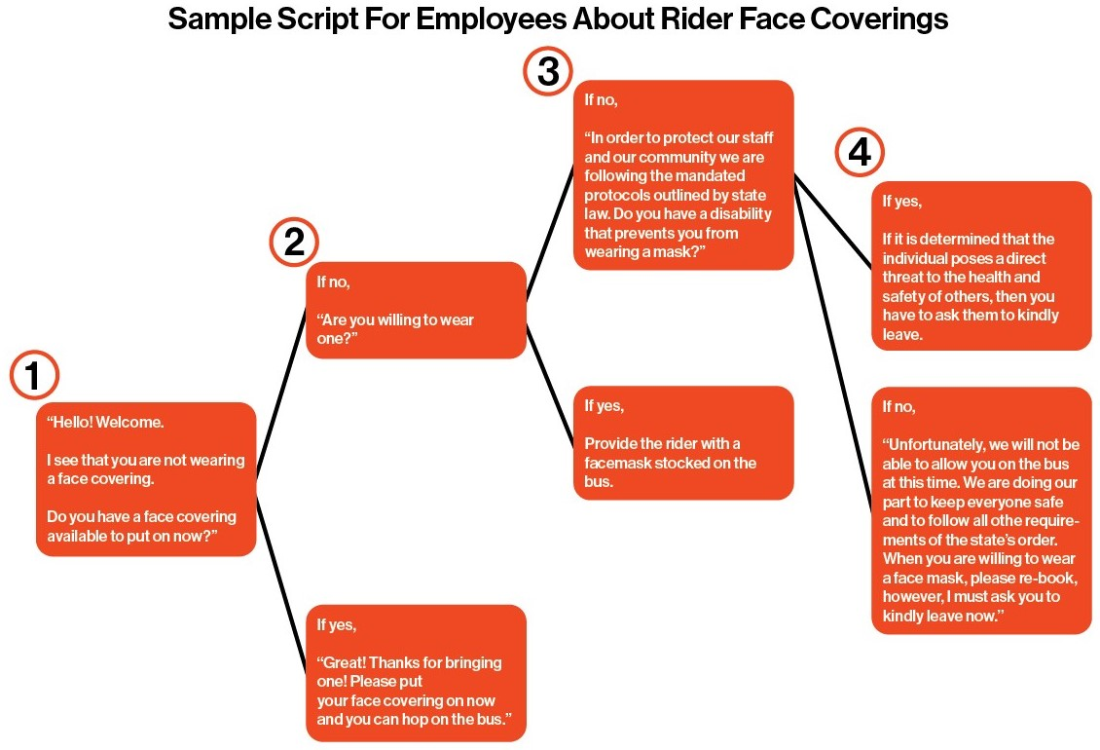

**COVID-19 Prescreening Form**

Another way to ensure the safety of riders and employees is to implement a COVID-19 prescreen form that you send out via email to riders along with the receipt for their tickets prior to their scheduled event date. You can create a free online Google questionnaire that automatically updates responses and submissions to a Google spreadsheet. You can then embed the document URL to a QR code for riders to quickly and efficiently scan on their mobile devices. You must inform the rider that they have to completely fill out the form before arriving at the pick up location. If they have not filled out the form, you can provide a printed out QR code for them to scan before entering the bus. The graphic below is a sample form that you can use, build off of, and edit based on the needs and guidelines of the current COVID-19 laws.

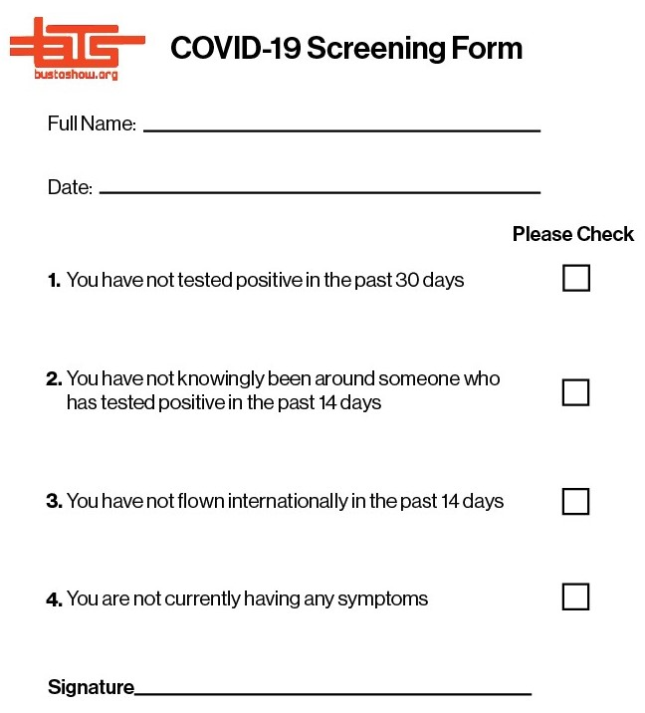

Since your organization is based on traveling to and from multiple different counties in the state of Colorado, frequently checking the updated COVID-19 dial dashboard is important in making sure that you are following and performing all of the required guidelines and procedures throughout each area. Currently, both Denver and Boulder are Level Yellow status whereas Jefferson County is Blue Level status. Therefore, when traveling to and from these three counties, guidelines and capacity restrictions that are outlined under the Level Yellow status must be followed.

The final initiative is to create a plan for hiring and training employees. Having a substantial number of drivers that are available will increase the number of bus trips and events your organization can service and thus increase your funds and reduce carbon emissions. Both goals of building a shed and stocking important replacement parts contributes towards this goal. To achieve this, one of the best ways to advertise a job opening is to take advantage of online job sites such as Indeed and ZipRecruiter. Another effective way to reach out to potential employees is to post job application information on social media networks. The driver hiring infographic created during the first client project would be especially effective on social media and on your website, or they can be on printed posters and banners. As far as hiring during the pandemic, the few principles you are allowed to implement are outlined in a document called “Pandemic Preparedness in the Workplace and the Americans with Disabilities Act” provided by the U.S. Equal Employment Opportunity Commission. It states that an employer can delay the start date of an applicant who has COVID-19 or corresponding symptoms (“Pandemic Preparedness”). It also states that an employer can take an applicant's temperature as part of a pre-employment exam. You may also require ADA-covered employees to provide a doctor's note certifying fitness to return to work who have been away from the workplace for an extended period of time (“Pandemic Preparedness”). These are the main principles that you can take as you begin recruiting and hiring new employees.

**TIMELINE**

Our proposal is strategically planned over a twelve month period. Within these twelve months, each of the four goals proposed will be met. Statistics directly sourced from IBISWorld point towards an approximate 42.6% increase in online event ticket sales revenue from 2020 sales (O'Connor). According to Rolling Stone Magazine, 83% of fans have held on to their tickets for rescheduled shows (Millman). Our timeline, as seen in the graphic below, is strictly structured on this information which signifies the fact that people are eager to get outside and attend events again.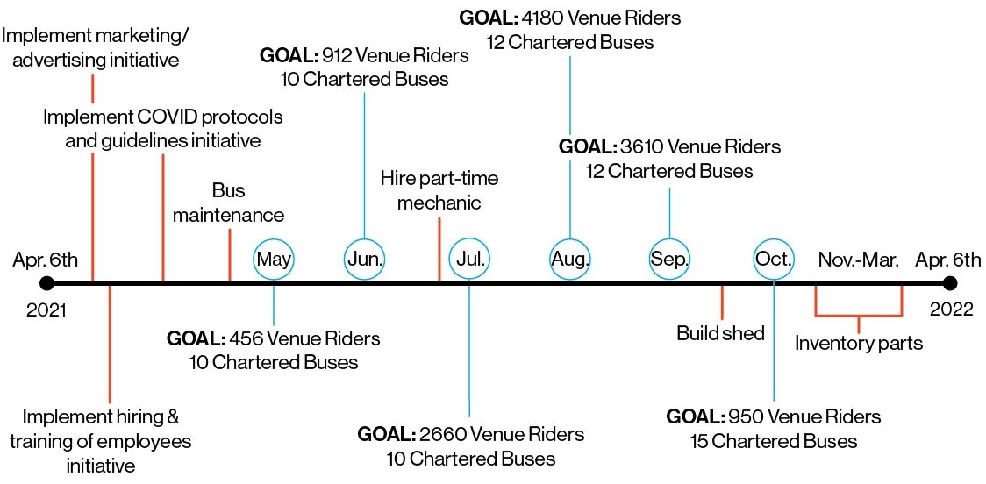

**BUDGET**

In order to meet our four proposed goals by the end of the year, we believe the organization should focus all efforts on servicing riders to Red Rocks as well as providing chartered bus runs**.** To createthe budget, we first looked at the current Red Rocks schedule for the next 6 months and determined how many busses per month your organization would need to service with a goal of 80% capacity or 38 people on each bus. We then approximated the number of charted bus events each month. Below is a table displaying this information.

|  |  |  |  |
| --- | --- | --- | --- |
| **Month** | **# of scheduled concerts** | **# of chartered events** | **# of busses in use** |
| April | 6 | 10 | 2 |
| June | 8 | 10 | 3 |
| July | 20 | 12 | 4 |
| August | 22 | 12 | 5 |
| September | 19 | 12 | 5 |
| October | 5 | 15 | 5 |

All overhead costs are fixed except for core administration salaries. We budgeted $6,000 for core administration in May and June and increased the budget to $9,000 in July. As a step towards having a full time mechanic, the budget allows for a part-time mechanic at $3,000 a month starting in July. Costs for materials and supplies for COVID-19 protocols and safety measures were then determined per round trip, at $3.

As each bus is introduced into use, the following COVID supplies would be stocked on board: one 50 pack of face masks, one small 16 oz hand sanitizer of which would be mounted on the railing at the bus entrance, and a canister of wipes containing 160 individual wipes. The amount of time each of these items would approximately last is detailed below in the table. The large 1 gallon hand sanitizer would be used periodically to refill the 16oz bottles as they run out.

|  |  |  |  |
| --- | --- | --- | --- |
| **Nature of Expenditure/Item** | **Quantity** | **Cost** | **Timeframe** |
| Materials & Supplies |  |  |  |
| Masks ([Boca Terry](https://bocaterry.com/face-mask/)) | 50 pack | $14.50 | 2 per trip + extras: 20 round trips |
| Hand Sanitiser SM ([Amazon](https://www.amazon.com/Superfy-Sanitizer-Washer-Alcohol-Quick-drying/dp/B089ZK89CR/ref=sr_1_5?dchild=1&keywords=hand+sanitizer+8+pack+16+oz&qid=1617470384&sr=8-5)) | 8 pack, 16 oz | $35 | 3 weeks |
| Hand Sanitiser LG ([Amazon](https://www.amazon.com/Artnaturals-Sanitizer-Alcohol-Infused-Alovera/dp/B085FXRHH4/ref=sr_1_5?crid=162TFP9X42XYE&dchild=1&keywords=1+gallon+hand+sanitizer&qid=1617470418&sprefix=1+gallon+hand+sa%2Caps%2C232&sr=8-5)) | 1 gallon | $20 | 1.5 months |
| Rejuvenate/Disinfectant Wipes ([Universal Companies](https://www.universalcompanies.com/collections/rejuvenate/products/rejuvenate-disinfectant-wipes-160-count)) | 12 canisters | $109 | 16 wipes per cleaning, 120 cleanings, ~ $1 per cleaning |

The following is our balance sheet for the months of May through October 2021 detailing the overhead, operating costs and income.

|  |  |  |  |
| --- | --- | --- | --- |
| **Overhead** |  |  |  |
|  | Admin Costs | Financial Services | $1000 |
|  |  | Core Admin | $1200 |
|  |  | Payroll Expense | $1000 |
|  |  | Payroll Taxes | 35/person |
|  |  | Business Phone | 80 |
|  | Bus Insurance | General Liability | $1100 |
|  |  | Workers Comp | $1850 |
|  |  | Health | $4000 |
|  | Rent | Bus Parking | $1500 |
|  | Utilities |  | $1200 |
| **Total Overhead** |  |  | **$17,730** |

|  |  |  |  |  |  |  |  |  |
| --- | --- | --- | --- | --- | --- | --- | --- | --- |
| **Operating** |  |  | May | June | July | Aug | Sept | Oct |
|  | Driver Payroll | 200/concert run | $2,400 | $4,800 | $14,000 | $22,000 | $19,000 | $4,000 |
|  |  | 20/hr min $100 | $1,200 | $1,200 | $1,440 | $1,440 | $1,440 | $1,800 |
|  | Fuel | 10 miles gallon/ $3 per gallon | $330 | $510 | $1,230 | $1,830 | $1,605 | $525 |
|  | Auto Insurance | 1500/per bus | $3,000 | $4,500 | $6,000 | $7,500 | $7,500 | $6,000 |
|  | Emissions | 500/per bus/per year | $83 | $125 | $167 | $208 | $208 | $208 |
|  | Vehicle Inspection | 100/per bus/per year | $17 | $25 | $33 | $42 | $42 | $42 |
|  | Mechanic Payroll |  | $ - | $ - | $3,000 | $3,000 | $3,000 | $3,000 |
|  | Vehicle Maintenance | 6000/per bus/per year | $1,000 | $1,500 | $2,000 | $2,500 | $2,500 | $2,500 |
|  | Covid Support | 6000/per bus/per year | $33 | $66 | $193 | $303 | $261 | $55 |
| **Total Operating** |  |  | **$8,063** | **$12,726** | **$28,063** | **$38,823** | **$35,556** | **$18,130** |
| **Total Expenses** |  |  | **$25,793** | **$30,456** | **$48,793** | **$59,553** | **$56,286** | **$38,860** |

|  |  |  |  |  |  |  |  |  |
| --- | --- | --- | --- | --- | --- | --- | --- | --- |
| **Income** |  |  | May | June | July | Aug | Sept | Oct |
|  | Red Rocks | Assuming busses are 80% full | $11,400 | $22,800 | $66,50 | $104,500 | $90,250 | $19,000 |
|  | Chartered | Avg $1100 per charter | $11,000 | $11,000 | $13,200 | $13,200 | $13,200 | $16,500 |
| **Total Income** |  |  | **$22,400** | **$33,800** | **$79,700** | **$117,700** | **$103,450** | **$35,500** |
| **Profit/Loss** |  |  | **-$3,393** | **$3,344** | **$30,907** | **$58,147** | **$47,163** | **-$3,360** |

Works Cited

“Cleaning and Disinfection for Non-Emergency Transport Vehicles.” *Centers for Disease Control and Prevention*, Centers for Disease Control and Prevention, 2020, [www.cdc.gov/coronavirus/2019-ncov/community/organizations/disinfecting-transport-vehicles.html](http://www.cdc.gov/coronavirus/2019-ncov/community/organizations/disinfecting-transport-vehicles.html).

Frost, Jim. “How Hypothesis Tests Work: Significance Levels (Alpha) and P Values.” *Statistics By Jim*, 15 July 2020, statisticsbyjim.com/hypothesis-testing/hypothesis-tests-significance-levels-alpha-p-values.

“Guidance for Businesses.” *Colorado COVID-19 Updates*, 2020, covid19.colorado.gov/guidance-for-businesses.

“Guidance for Wearing Masks.” *Colorado COVID-19 Updates*, 2020, covid19.colorado.gov/mask-guidance.

“How COVID-19 Spreads.” *Centers for Disease Control and Prevention*, 7 Jan. 2021, www.cdc.gov/coronavirus/2019-ncov/transmission/index.html.

Millman, Ethan. “If the U.S. Can Get Vaccinated by Summer, When Do We Get Concerts Back?” *Rolling Stone*, Rolling Stone, 5 Mar. 2021, www.rollingstone.com/pro/features/vaccine-concerts-live-music-2021-1131665/.

O'Connor, Claire. “Online Event Ticket Sales.” *US SPECIALIZED INDUSTRY REPORT OD5447*, Mar. 2020, my-ibisworld-com.colorado.idm.oclc.org/us/en/industry-specialized/od5447/about.

“Pandemic Preparedness in the Workplace and the Americans with Disabilities Act.” *Pandemic Preparedness in the Workplace and the Americans with Disabilities Act | U.S. Equal Employment Opportunity Commission*, www.eeoc.gov/laws/guidance/pandemic-preparedness-workplace-and-americans-disabilities-act.

“Public Health Requirements for COVID-19.” *Boulder County*, 9 Mar. 2021, www.bouldercounty.org/families/disease/covid-19/public-health-requirements/#cleaning-illness-outbreaks.