Keep Bees, Sans Beekeepers
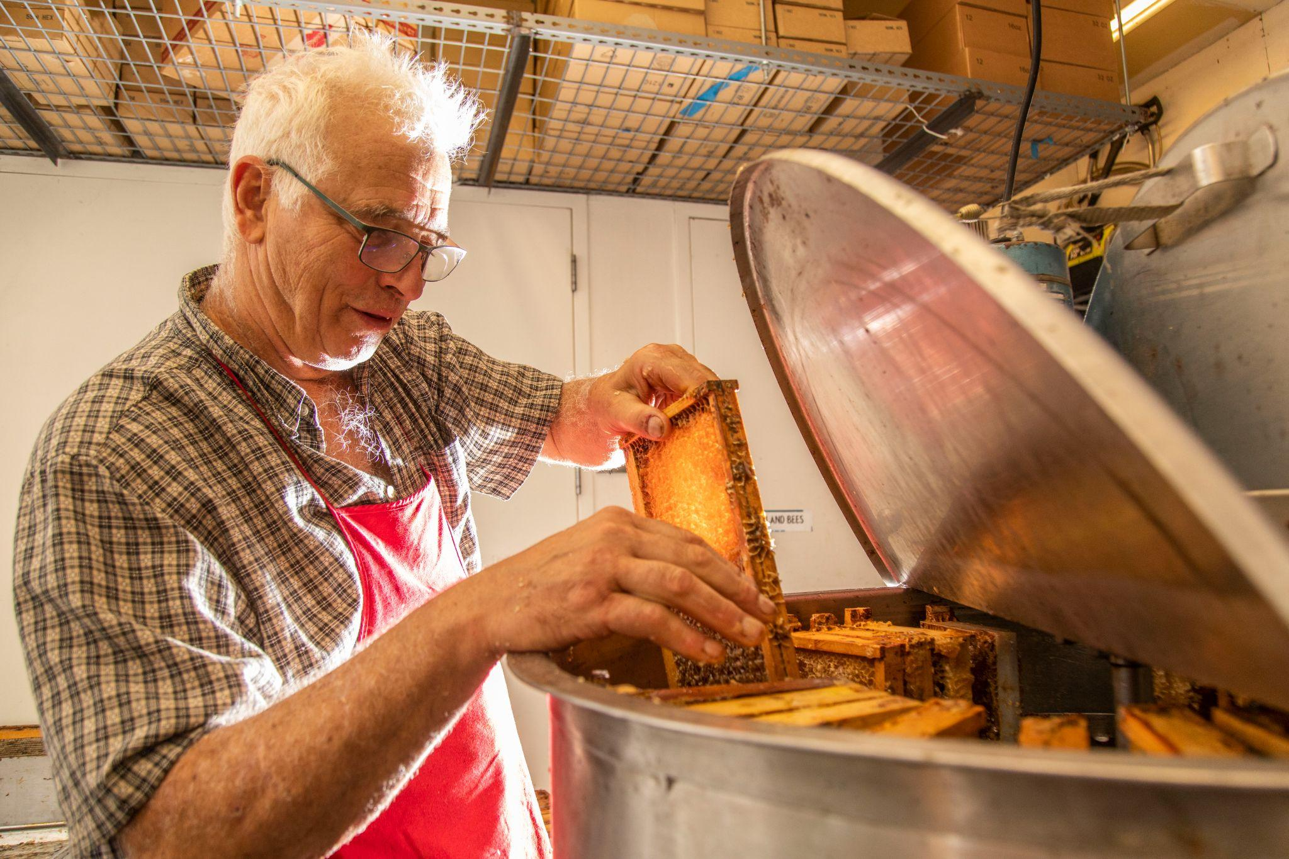
I left my interview with renowned Colorado beekeeper Tim Brod pleasantly surprised by his hysterical, yet powerful eloquence. “Keeping bees alive today... It's easier to take care of your aging parents who have Alzheimer’s and an autoimmune [disease]... Much easier. And if you think going by once a week to your parents’ house, providing them milk and cookies, and filling up their pills is helpful, then you’re at best yourself myopic,” remarked the white-haired, honey-scented beekeeper who would later become my good friend. As the owner of Highland Honey, Tim spends most of his Saturdays at the Farmers Market in Boulder, Colorado selling honey and educating the public about pollinators. I was fortunate enough to land a summer job working for him, where his infectious personality was more than enough to wake me up at 7am on Saturdays. In all of my Farmers Market mornings, I shared my own beekeeping knowledge and Tim’s wisdom answering more or less the same questions: What in the world is going on with pollinators, and what’s the best way to help?
Fall 2021 - Tim Brod harvesting honey in his Longmont, CO shop.
- The Origin of “Save the Bees”
Beekeepers are experiencing an uncomfortable amount of beehive demise. I know this firsthand because (note: for your sake, I have refrained from using “beecause”) of my many sad days as a beekeeper discovering the death of a hive. I’ve kept bees for nine years, and experience doesn’t make it any less emotional. In any average year prior to 2006, beekeepers lost about 10 percent of their hives over the winter. From 2006-2011, annual losses spiked to a stunning 33 percent (Weeks). Since then, annual losses have been consistently at or above 30 percent. In 2006, the unfamiliar cause for hive loss was given the name “Colony Collapse Disorder” (CCD) because of the character for colonies to collapse entirely instead of dying off slowly. With reports of some beekeepers losing up to 90 percent of their hives in a year, scientists and the media buzzed into action (Jones and Sweeney-Lynch 77).
The search for the cause of CCD went everywhere from cell towers to sunspots. The popular explanation that many scientists still investigate has to do with a class of insecticides called neonicotinoids. In a 2017 study, scientists found that neonicotinoids increased worker bee mortality and were also associated with declines in social immunity and queen health. In addition, the researchers found that toxicity of certain neonicotinoids doubles when bees encounter a common fungicide in addition to the insecticide (Tsvetkov et al.). The problem with bees in relation to pesticides is that a worker bee’s physiology is built mostly for pollen and nectar intake. In order to reproduce, plants need bees to have easy access to these substances. As an evolutionary result, bees have very few defense mechanisms to keep unwanted chemicals out of their system when foraging (Hanson 192). Some scientists have considered that neonicotinoids have an impact on pollinator health, but others question the legitimacy of studies involving neonicotinoids and bees.
In a 2018 journal article in Current Biology written by Chris Bass and Linda Field, the researchers note “...the impact of neonicotinoids on bee health in the field has been much more difficult to determine [than expected] as well-controlled field experiments are much more challenging and expensive to perform. Of the field studies performed to date, some have reported adverse effects on bee fitness, while others have found no discernible impact.” They explain that it’s much harder to control variables in a honeybee experiment than lots of other experiments. There’s no easy way to limit where the bees go, as a worker bee can fly six miles or more from the hive to forage. Even then, studies that have somewhat managed to control forage present mixed results that are often contradicting. Most scientists today agree with Bass and Field -- bees cannot be controlled well enough to nail down neonicotinoids as a specific cause for anything, and there must be other factors at play.
Oddly enough, in the height of CCD research, hives stopped showing large amounts of CCD. No clear cause was ever revealed, and conservation biologist Thor Hanson explains, “After more than a decade and hundreds of peer-reviewed research papers, the phenomenon is still best described as a disorder--no clear ‘smoking gun’ has emerged as the driving factor” (187). Today, beekeepers still lose over 30 percent of their hives annually, likely due to a combination of what beekeepers call the “four Ps”: parasites, poor nutrition, pesticides, and pathogens. These factors are a result of the extensive research that was done in the height of the CCD scare. Even with the decline in CCD cases, there is still a significant problem with bee decline.
Losing a third of all beehives every year, regardless of why, is a cause for extreme concern. It is often said that we have bees to thank for about one third of our crops. However, this disregards the fact that many plants used to feed animals require pollination to produce seeds. Without seeds to grow food for animals, animal crops will be on the decline as well. Our diet and natural landscape without bees would be bland, colorless, and much lower in nutrition. In order to understand the picture even better, let’s briefly take a look at the state of modern beekeeping.
- Beekeeping: A Family Activity
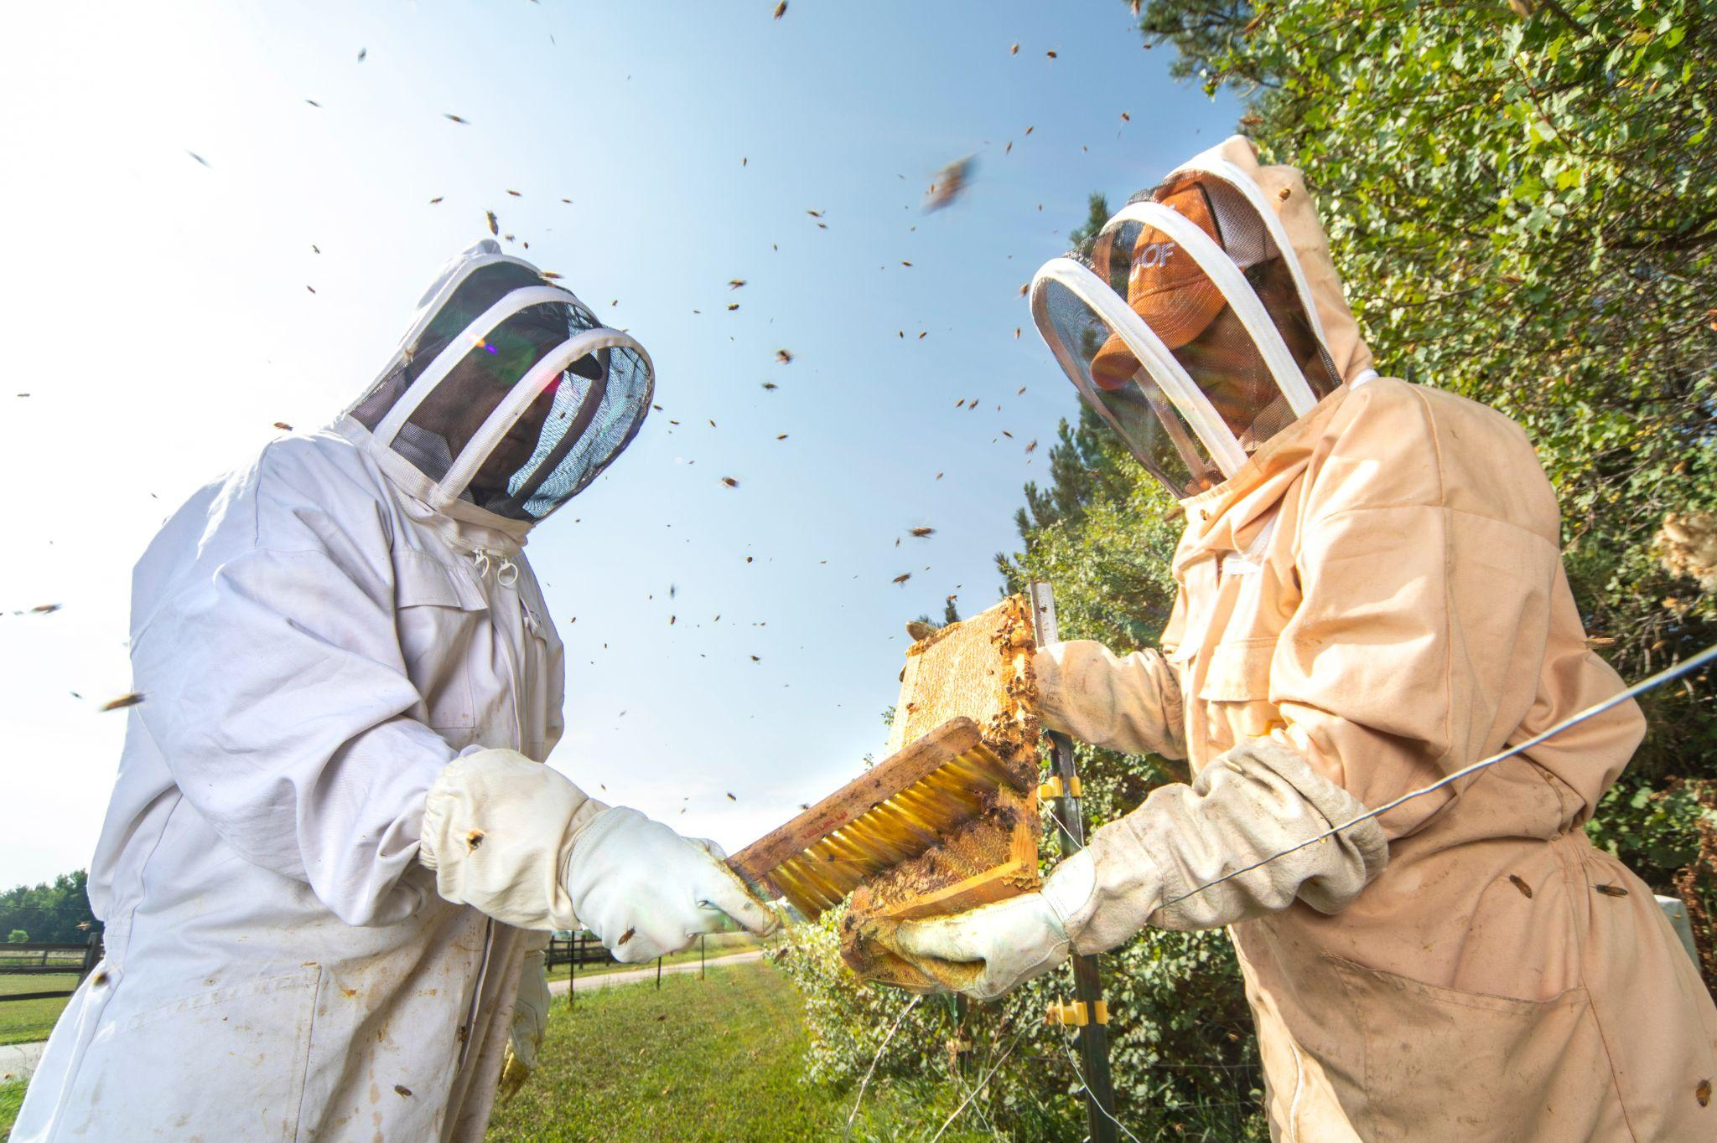
Throughout the past millennium, general beekeeping methods have changed very little. The majority of beekeepers keep their bees in wooden boxes, with about ten frames for honeycomb on the inside. Some improvements have been made to beekeeping equipment, but most tools are the same as they were 100 years ago; the only thing that has changed drastically is the difficulty of keeping bees alive. Or, that was the case, until Australian beekeepers Cedar and Stu Anderson launched an Indiegogo crowdfunding campaign in February 2015.
Summer 2021 - My parents at our hives using a bee brush, a standard beekeeping tool.
The Flow Hive was the fastest product to reach $2 million on Indiegogo, the most successful Indiegogo campaign ever launched, and the most successful crowdfunding campaign ever launched outside the United States. The Flow Hive is a beehive that costs about $630 (compared to about $150 for a conventional beehive), and it aims to make honey harvesting easier on the bees and the beekeeper. Its frames of honeycomb are designed so that the comb is opened from the inside, allowing the honey to flow out of the cells via gravity. This, in theory, harms fewer bees and is much easier on the beekeeper than the traditional honey harvesting process, which involves taking out each frame, removing all bees, and basically centrifuging the honey out of the cells. Today, there are more than 75,000 of these hives around the world (“About Us”).
At first glance, this is a great invention. It reduces harm to bees, makes honey extraction easier, and it’s gotten a lot of people excited about beekeeping. The last point is where the beauty of this product stalls -- it’s inspired a lot of people to dive headfirst into a honey fountain of unforeseeable complexities -- it’s sticky, and not as sweet as you might think.
The Flow Hive isn’t the only thing inspiring a wave of new beekeepers. Beepods, another beehive company, preaches “Beekeeping has been proven to be great for your mental health. Working with bees is calming and the amount of time spent outside is a great way to get some Vitamin D” (Cull). Like many other modern-day agricultural practices, beekeeping has been marketed as a way to improve health. Websites like these fail to mention the hundreds of hours of practice that beekeeping requires before it starts to make sense. Personally, I went to classes, made beekeeping friends, read books, and (honey)combed through countless YouTube videos on my beginner beekeeping journey. It’s also worth mentioning that getting stung too many times and becoming afraid of your beehives, which is not uncommon, isn’t exactly great for mental health.
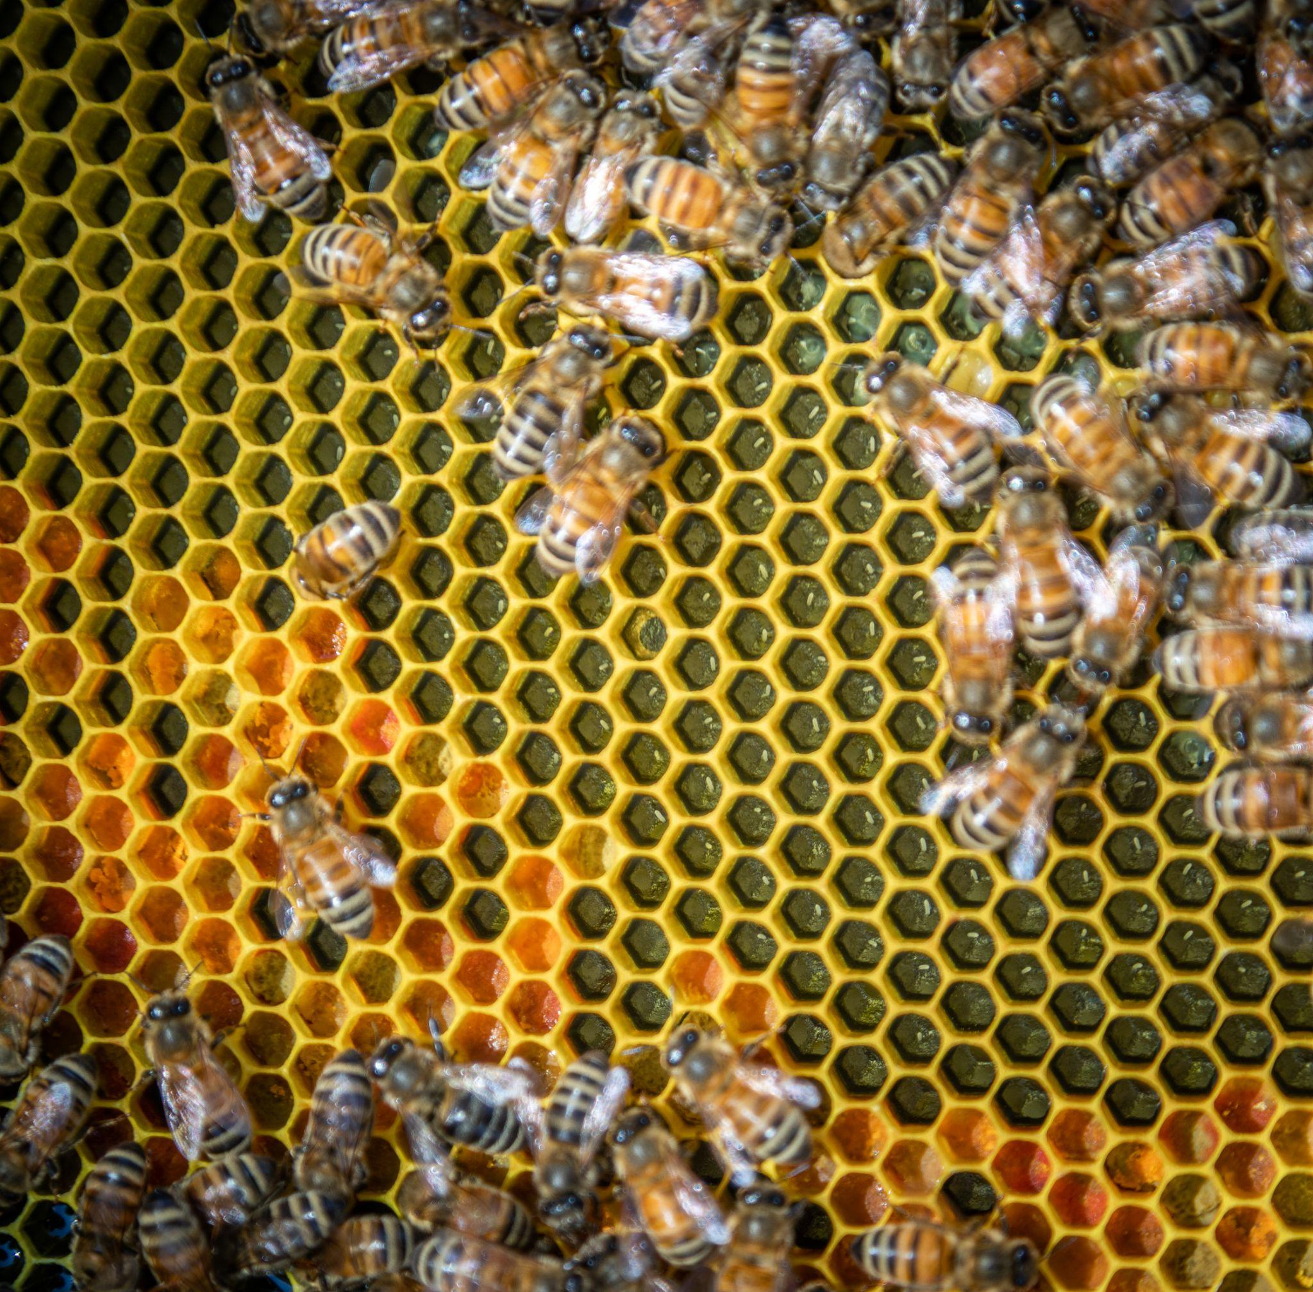
There’s a sickening feeling that washes over my sweaty, mesh-shadowed face when I look through my beehive and can’t find any eggs. This is a sign that there’s no queen, which is incredibly detrimental to a hive considering that she lays up to 1,500 eggs each day in the summer (Jones and Sweeney-Lynch 99). The unfortunate reality is that while the queen’s health is my main priority in a hive inspection, it’s easy to have no idea what’s really going on in a beehive. Seeing thousands of bees and plenty of honey is far from an indication of a healthy hive, and it takes many hours of reading and practice to understand that. However, bees aren’t doing well, so isn’t it a good thing that so many people are interested in keeping them? Aren’t products like the Flow Hive a net benefit to the pollinator world, even if a lot of people don’t know what they are getting themselves into?
Spring 2020 - Look closely, can you spot the bee eggs?
- Forget Driver’s License, How About A Beekeeping License?
There’s one thing that Tim Brod would say in his deep, buzzing voice at least once every Farmers Market weekend that always left me puzzled in thought. Customers would ask him how he recommends they should start beekeeping, and he would reply with something only he would say like “First of all, you need to tell me if a chicken has lips or not. Second of all, I don’t think you should get bees. Take a class and read, then ask me.” I still don’t know whether a chicken has lips (Tim is famous for asking this wacky question way too often), but I certainly know his perspective on the increasing popularity of beekeeping. His point stems from many years of experience teaching beekeeping classes and selling beehives. Of all people to discourage beekeeping, you wouldn’t think it would be him.
“There’s a constellation of reasons as to why bees are crashing and dying everywhere, and it is not because we don’t have enough well-intentioned, naive people who may think that having bees is helpful,” remarked Tim, with a hint of resentment, later in our interview. The simple problem that Tim, and many other beekeepers, have with beekeeping is that too many people are killing bees--and not just theirs--rather than keeping them. Whether it’s treating for Varroa destructor, the particularly destructive (as the name suggests) principal parasite affecting bees, or simply feeding bees in times of low nectar flow, novice beekeepers often underestimate the required attentiveness of beekeeping.
It doesn’t stop at novice beekeepers killing their own hives. A journal article by Eleanor Anderson explores the state of “saving the bees'' in our current geologic era, and she explains, “...many beekeepers are trying to pioneer innovative approaches, experimenting with what is variously called ‘treatment-free,’ ‘apicentric,’ or ‘natural’ beekeeping.” Beekeepers who use treatments out of necessity to combat pathogens and parasites argue that this method of beekeeping is essentially letting bees suffer. It’s similar to the vaccine situation in human society: taking the more “treatment-free” anti-vaccination approach in raising children puts them at risk for pathogens that could easily be prevented. In turn, the unvaccinated children put others at risk. This parallels the beekeeping world, where hobbyist beekeepers can afford to lose a few hives and move on, maybe even lose interest if they deem bees to be too complex. Commercial beekeepers, however, suffer greatly from disease that is running rampant in hives that are kept by unknowing, “alternative” beekeepers. Anderson sounds just like current COVID-19 vaccine advocates when she writes, “So, at worst, the new beekeepers look well-meaning, but also clueless and even dangerous as they ignore a hard-won scientific consensus about what the main honey bee health problems are.”
People can have children, pets, and grow all sorts of dangerous things without a license, so I’m not going to argue that a license should be required to keep bees. However, I will agree with Tim Brod, that I don’t think people should get bees. Instead, they should go take a long class, read a book, then read it backwards (okay, not really, but read another one), and then go talk to a beekeeper. Better yet, shadow a beekeeper before getting bees, and see if you can imagine yourself keeping as calm as them while about 5,000 stinging insects create a tornado around your head. If the reasoning behind becoming a beekeeper is to help pollinators, there are at least a hundred other ways to do that that involve less time, less money, and fewer days in a hot cotton suit in 100+ degree weather.
- Native Bees and Other Pollinators
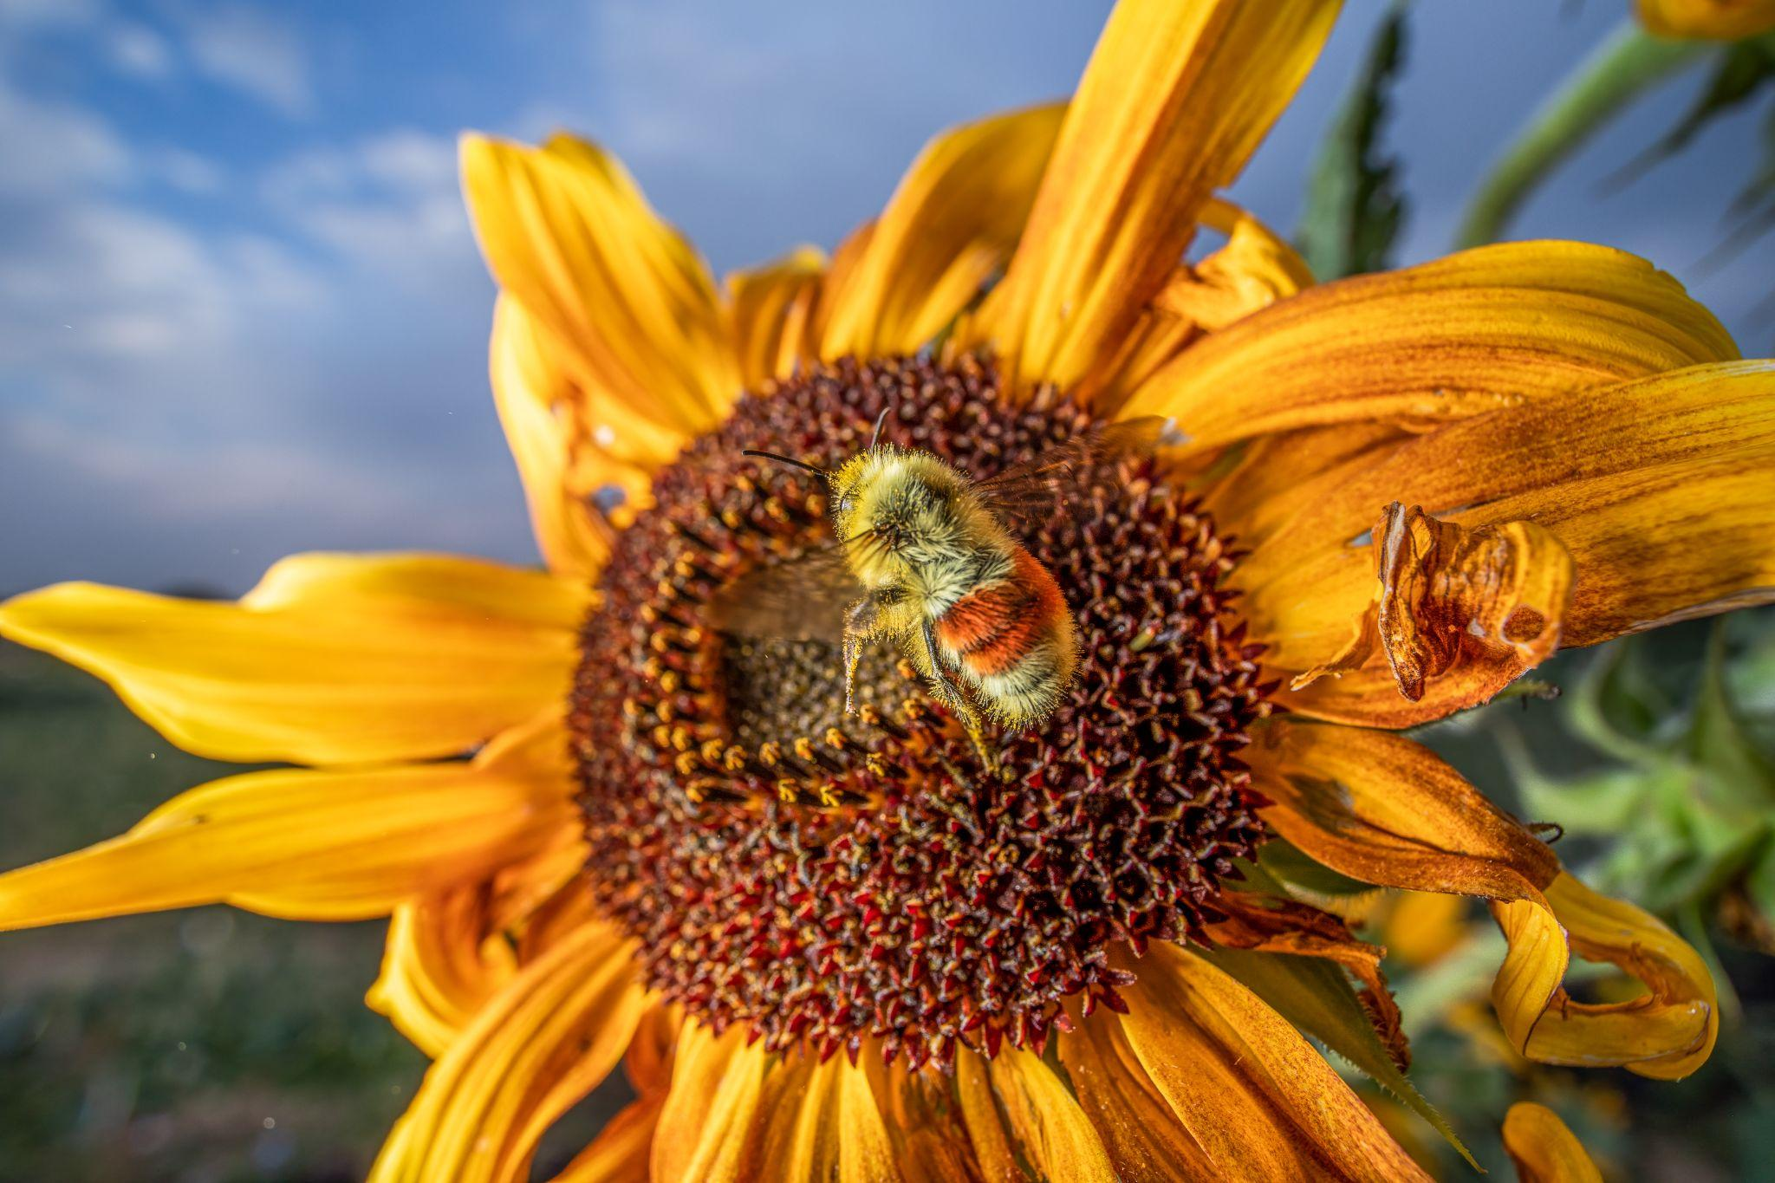
“Most of the population shouldn’t be keeping bees, but they should be doing things to promote native bees and to promote habitat,” advised Tim Brod in our interview. $15.99 on Amazon (or a similar sum at your local garden store, which I recommend) will buy a native bee habitat that can house somewhere around 20-30 native bees. If you have a drill, a $2.99 block of wood from Home Depot will do the trick. A native bee habitat is essentially a piece of wood with a bunch of holes in it, where native bees will lay their eggs and nest throughout the season. Native bees are vital to the pollinator economy, because they often pollinate crops that honey bees cannot pollinate due to their size and physiology. Instead of getting a honey bee hive, those interested in helping pollinators should learn about native bees and their fascinating life cycles. “High densities of honey bee colonies increase competition between native pollinators for forage, putting even more pressure on the wild species that are already in decline,” writes Allison McAfee for Scientific American. McAfee argues that becoming a honey beekeeper can actually impact native bees in a negative way by creating competition for forage.
Fall 2021 - Hunt’s bumble bee (a native bee) on a sunflower in Boulder, CO.
$12.99 on Amazon will buy you a red hummingbird feeder, and with a little bit of sugar water, you can have my favorite bird visiting your backyard and providing pollination services daily. They’re incredibly fun to watch, and even more fun for the environment. According to the Audubon Society, about 8,000 plants in North and South America are reliant on hummingbirds for pollination (“Hummingbird Pollination Practice”). Their long beak allows them to reach places that some insects cannot. Additionally, if you’re into photography like I am, hummingbirds are fantastic subjects. To keep bees, you need to learn how to make sugar water to feed them when flowers are scarce, which accounts for maybe 1% of the learning you need to do. To help hummingbirds, learning how to make sugar water is essentially 100% of the learning you need to do.
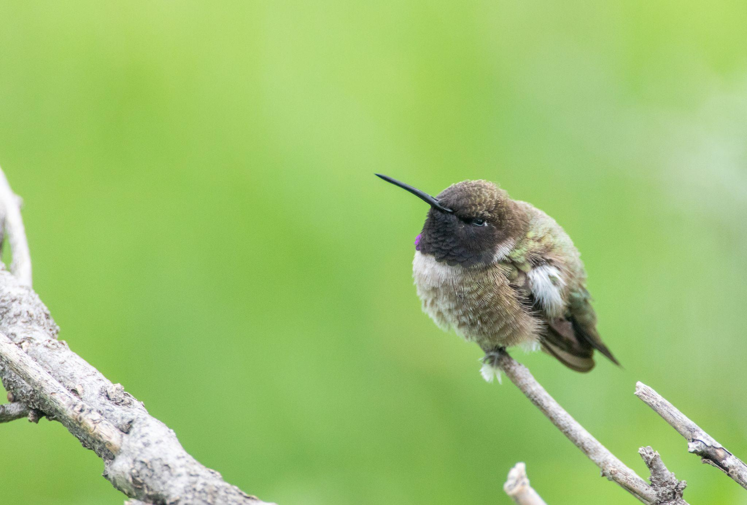
Spring 2019 - Black-chinned hummingbird in my backyard, a rare species in Colorado.
$5.99 on Amazon (or free if you walk outside on a fall day in the right area) will buy you milkweed seeds, which is the host plant for the monarch butterfly. With beautiful pink blossoms and very low water requirements, there’s no reason not to have this plant in your front lawn. Monarch butterflies will lay their eggs on milkweed, feed on the nectar from the flowers, and their caterpillars will feast on the leafy greens when they hatch. In fact, while you’re at it, there are a few other things you should plant to help all pollinators with very low cost and a beautiful benefit.
- Bee The Change
In addition to native pollinator tips, here’s how you can actively help the pollinator problem.
- Put on your garden pants and fill the world with plants.
If we left all our dandelions to grow and go crazy, wouldn’t the sea of yellow be a neon welcome amongst an often-drab landscape? If you want to help bees, hummingbirds, bats, beetles, and even the value of your home, plant some flowers and let flowering “weeds” grow! Visit pollinator.org/guides and enter your zip code to receive a planting guide, complete with colors, water requirements, sun requirements, and more, that is specific to your area.
- Reduce pesticide use, it’s dangerous juice.
Pesticides and herbicides aren’t necessary for your backyard. If you must get rid of plants, pull them yourself or help the economy by hiring someone to do it for you. If you’re getting rid of pests, try natural methods such as diatomaceous earth. My mom and I used to go out to our kale plants and pluck moth caterpillars off of them one by one and relocate them. It helped, and we avoided using pesticides. It was pretty fun, too. While studies concerning pesticides and herbicides and pollinators are a mixed bag, there is enough evidence to suggest that pesticides and herbicides play some role in pollinator decline, even if it’s not the only factor.
- Whaddaya know, water is rare, yo!
Pollinators need water just like you and I do. We use frisbees -- place a frisbee full of water outside on a hot day. Put some rocks in the water so that if insects fall into the water, they can easily get out. Bees, for example, work extremely hard to keep their hive at optimal temperature and humidity for honey production, so they use a lot of water in their cooling and humidifying processes.
- Use your money, buy some honey (and have a conversation with a local beekeeper).
Visit a beekeeper like Tim Brod at a Farmers Market or craft fair. If you can’t tell by the number of times I’ve quoted Tim, beekeepers have a wealth of information and they’re usually really happy to talk about bees. It gets pretty lonely talking to creatures that only buzz back all day, so us beekeepers will jump at the opportunity to chat! In all seriousness, buy some honey while you’re there, too. Beekeepers work hard and their products have a great number of benefits more than just a sweet treat. Supporting beekeepers directly supports those who look after pollinators in the best way.
- Read, then do a good deed!
Read papers like this one that you’re just about done with, novels like Thor Hanson’s Buzz, or even pick up a copy of a beekeeping book. Although I’ve discouraged beekeeping, I was a beginner once and with enough education and practice, beekeeping can be educational, rewarding, and just plain fun. Don’t get me wrong, it’s an incredible amount of work and I still haven’t figured out how to stop from overheating in my bee suit.

One of my favorite pictures of myself, which I’ll put below, shows a somewhat false calm and happy side of beekeeping. The truth to this image is that this was an early-spring hive, and most young hives like this are docile and problem-free. This hive quickly turned into a complicated pandemonium. Don’t let companies like Flow Hive or Beepods fool you: beekeeping is not a simple or immediately rewarding task. The amount of knowledge and experience that beekeeping demands is far beyond what most people imagine, something I know because beekeeping has been one of the steepest learning curves I’ve ever come across. Uneducated beekeeping can be more detrimental than helpful to the pollinator world, and we must rethink the way we go about helping pollinators. In a world buzzing with environmental tragedies, keeping bees and other pollinators alive is something everyone can do without becoming a beekeeper.

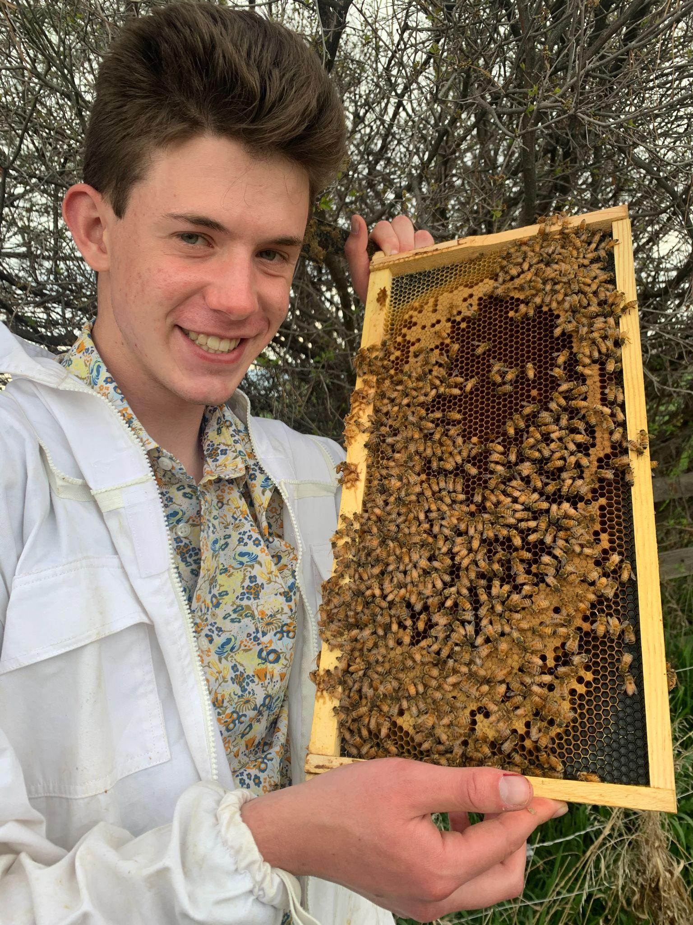
Spring 2021 - These bees did not take any interest in my floral shirt.

Works Cited
“About Us.” Flow Hive US, https://www.honeyflow.com/pages/about-us.
Andrews, Eleanor. “To Save the Bees or Not to Save the Bees: Honey Bee Health in the Anthropocene.” Agriculture and Human Values, vol. 36, no. 4, 2019, pp. 891–902., doi:10.1007/s10460-019-09946-x.
Bass, Chris, and Linda M. Field. "Neonicotinoids." Current Biology, vol. 28, no. 14, 2018, pp. R772-R773.
Brod, Tim. Personal interview. 26 Jan. 2019.
Cull, Monica. “Why Beekeeping Has Become so Popular and Why It's Time You Jumped on the Bandwagon.” Why Beekeeping Has Become So Popular And Why It's Time You Jumped On The Bandwagon, 11 Mar. 2021, https://www.beepods.com/why-beekeeping-has-become-so-popular-and-why-its-time-you-jumped-on-the-bandwagon/.
Hanson, Thor. Buzz: The Nature and Necessity of Bees. Basic Books, 2019.
“Hummingbird Pollination Practice.” Audubon Society, 22 Apr. 2020, https://www.audubon.org/news/hummingbird-pollination-practice.
Jones, Richard, and Sweeney-Lynch, Sharon. The Beekeeper's Bible: Bees, Honey, Recipes & Other Home Uses. Abrams, 2011.
McAfee, Alison. “The Problem with Honey Bees.” Scientific American, Scientific American, 4 Nov. 2020, www.scientificamerican.com/article/the-problem-with-honey-bees/.
Tsvetkov, N., et al. "Chronic Exposure to Neonicotinoids Reduces Honey Bee Health Near Corn Crops." Science (American Association for the Advancement of Science), vol. 356, no. 6345, 2017, pp. 1395-1397.
Weeks, Jennifer. "Pesticide Controversies." CQ Researcher, 5 June 2015, pp. 481-504, library.cqpress.com/cqresearcher/cqresrre2015060500.

