The Insulin Crisis in America
America is struggling with insulin prices. This is one woman’s take on how it has affected her.

By Isobel Feiges
April 27, 2021
Eleanor (right) and I skiing in 2017
I first met Eleanor Chalstrom when we were 14 in band class after she moved to my hometown of Sioux City, Iowa. We bonded over skiing and other outdoorsy activities that most people in our town did not do and quickly became best friends. At the time Eleanor was struggling with juvenile rheumatoid arthritis and asthma. Up until junior year of high school her health problems were present and annoying but did not affect her lifestyle greatly.

The summer going into our senior year of high school, Eleanor noticed changes in her wellness. She was tired all of the time, drinking an excessive amount of fluids, and could barely get herself out of bed. Her mother noticed these changes and immediately took her to the doctor. At first the doctor thought it could be mono or possibly leukemia, but after a couple blood tests the doctor noticed her blood sugar was dangerously high. Her blood sugar was over 300 when the normal range should be around 140. Because of this, she was quickly put in a medical helicopter and airlifted to the children’s hospital in Omaha, Nebraska.

Eleanor was diagnosed with type 1 diabetes and had to stay in the hospital for 3 days. While there she had to learn all of the different ways that her lifestyle would change. It would no longer be eating whatever whenever, exercising would be difficult, and having to keep her immune system healthy as it would no longer be functioning the same. Not to mention constant finger pricks and injections. From that moment forward, Eleanor knew her life, and her bank account, would never be the same.

Why Do Diabetics Need Insulin?
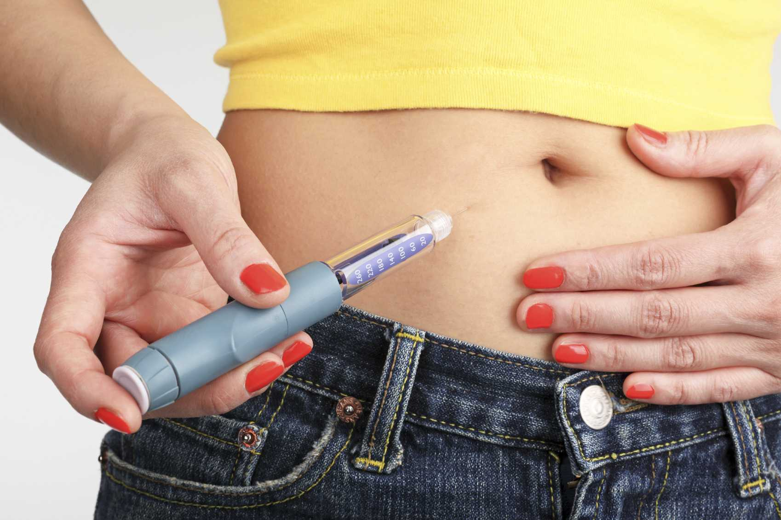
Insulin is the main treatment option for diabetes. According to Michael
Injecting insulin into the stomach region
Dansinger, a nationally recognized expert in dietary and lifestyle coaching for weight loss and disease prevention, when insulin is injected into the body, it will lower blood sugar levels, letting it enter into cells instead of hanging out in the bloodstream. Diabetics usually have to inject insulin before every meal or snack that they eat. If they do not, their insulin levels will skyrocket which can lead to ketoacidosis—what Eleanor experienced when she first was diagnosed. Ketoacidosis is when the body starts breaking down fats too fast, the liver processes the fats into ketones, and ketones cause blood to become too acidic. If left untreated, ketoacidosis will cause death.
The type of insulin pump Eleanor uses

Eleanor has a type of insulin pump called a Novolog. Before every meal, she has to bolus her insulin. She also gets little douses of it throughout the day. During her interview, Eleanor made it a very strong point that she needs insulin to survive. Her welfare is completely dependent upon it. This is true of anyone with type 1 diabetes.

Why Is America in an Insulin Crisis?
Anyone with type 1 diabetes or who knows someone with type 1 knows that insulin in the United States is outrageously expensive. In a study composed by Tara O’Neill Hayes who is the director of human welfare policy at the American Action Forum, she found that diabetes cost the United States $327 billion in 2017. This made diabetes the most expensive chronic illness in the country. According to her study, insulin was 6.3 percent of those costs. Before rebates, insulin added up to 20 percent—or $48 billion—of the total price. In the same study, O’Neill Hayes also states that the driving up of prices is due to new and improved insulins on the market. The most common used insulin’s today are rapid-acting and long-acting insulin. Eleanor uses a long-acting insulin. Because these types of insulin are more advanced and better acting, they cost more to make.

In a study led by Jing Luo, an assistant professor of medicine at the University of Pittsburgh and board-certified internist, he states that another cause for the steadily increasing price of insulin is the fact that there are only three major companies that make the drug: Eli Lilly, Sanofi Aventis, and Novo Nordisk. Consider how many painkiller brands there are. Advil, Motrin, Aleve, any convenient store brand, and many more. Now consider how most bottles are under $10 for over 100 pills. This is because there is so much competition for this type of drug, unlike insulin. With only three major companies producing the drug for around 3 million adult Americans, it’s no surprise that prices are so high.

Unlike other countries, the United States does not offer generic insulins to patients. A generic drug is an off-brand version of a drug. Going back to the painkiller comparison: one can find a usually cheaper Target brand painkiller versus spending more on name-brand Advil. That is an example of a generic drug. With insulin though, it can only be purchased from the three major brands mentioned earlier. According to DiabetesMine, a team of writers on diabetes under the Healthline website, a reason for this is the U.S. patent system. The big pharmaceutical companies will consistently change little things about their insulin in order to change the patent. This makes it almost impossible for smaller drug companies to produce insulin as they cannot keep up with all of the changing patents.

While generic insulin might seem like the hero that could save the day and make diabetes patients rejoice, it is not just because the big drug companies want to stay in power. Insulin costs a lot to copy. This is because insulin is a biologic. A biologic is a category of medicines that contain complex molecules that are made from material that comes from living things. This causes other drug companies to steer clear as it costs almost as much to produce a new drug as it does to find a way to copy insulin.

How Insulin Prices Have Affected Eleanor’s Life
Eleanor has to refill her insulin prescription every 1-2 months. Luckily for her, insurance covers a good chunk of the cost taking it down to $70. Without insurance she would be paying $200 per vial. Eleanor is much luckier than others. A lot of American type 1 diabetics have to pay full price and more for their insulin.

When I asked Eleanor if she had ever had to choose between purchasing something she wants or pay for insulin her answer surprised me. Her answer was not an item, but instead a big life choice. She told me that she had to go to college in-state because if she had not her tuition bills would have been too expensive which would then cause her to not be able to afford her insulin. Ever since I first met Eleanor, she had big dreams of going to an out-of-state college. These dreams had to be put aside so that she can, essentially, survive.

After all is said and done, Eleanor and many other type 1 diabetics around America have had the insulin crisis affect them personally. A person’s life should not be put on the line because they cannot afford the medicine that is needed to keep them alive. As of right now, the insulin crisis’ end is nowhere near the end, but hopefully in the next couple of years things will start to look up and prices will go down.

References
Dansinger, M. (2019, November 25). What does insulin do? WebMD. Retrieved March 23, 2021, from https://www.webmd.com/diabetes/qa/what-happens-when-theres-lack-of-insulin
DiabetesMine Team. (2020, July 20). Why Is There No Generic Insulin? (M. Gifford, Ed.). Healthline. Retrieved March 23, 2021, from https://www.healthline.com/diabetesmine/why-is-there-no-generic-insulin
[Insulin being injected]. (n.d.). Diabetes.co.uk. https://www.diabetes.co.uk/insulin/diabetes-and-injecting-insulin.html
[Insulin pump]. (n.d.). Continuum Innovation. https://www.continuuminnovation.com/en/what-we-do/case-studies/insulet-omnipod-insulin-management-system
Luo, J., Avorn, J., & Kesselheim, A. S. (2015, October). Trends in Medicaid Reimbursements for Insulin From 1991 Through 2014. JAMA. Retrieved March 23, 2021, from https://jamanetwork.com/journals/jamainternalmedicine/article-abstract/2429536
O'Neill Hayes, T., & Farmer, J. (2020, April 2). Insulin Cost and Pricing Trends. American Action Forum. Retrieved March 23, 2021, from https://www.americanactionforum.org/research/insulin-cost-and-pricing-trends/

