The Earth Holds on to Memories the Body Cannot

I spread my feet across the grass. The roughness beneath me is magnified. The blazing sun shines down on my pale skin as the warmth surrounds me. The sun looks over me, a brisk rush of air sails across my body, calming me from my scalp to my toes. A strong, smoky smell creeps up my nose. It’s the familiar smell of a nearby neighbor grilling up dinner. Birds chirp in all directions, landing on my ears in the perfect harmony. The occasional Sunday evening stroller passes, but I am unbothered.

I sink my toes deeper into the grass and embrace the soft sharpness that begins to consume them. I feel my body warm from the rays of the sun; my skin tingling from the sizzling heat. The wind flushes down my body, covering me like a powerful wave embraces an inexperienced surfer. I follow my breath along to each puff of air that flows over me, mimicking the pattern of the wind itself. I feel the overgrown grass hug each part of my body. I shift my focus to the dirt below me, and deeper ground myself to the earth. With the ground pressed against my bare skin, I allow the earth to nourish my body. The earth’s natural energy flows through me, balancing my mind and body. This balancing energy silences the mental chatter in my mind and I focus clearly on the sensations surrounding me. The firmness of the ground beneath me is no stranger to my soul. The roughness pries open the essence of my being, allowing me to enter a familiar space. A
space that I do not often access, a space nearly forgotten:

Memories of my childhood spent at my grandparents cabin.

I lay my body out to expand the connection between the earth and my skin. I embed my body deeper into the dirt as I allow these memories to flow through me. The distance between my present self and the years spent at my grandparent’s cabin is over a decade long and hundreds of miles away. Yet, as the Earth holds me on a few square feet of her vastness, I am transported back to this time of simple pleasures and closeness to my family.

Thoughts of the future flee my mind as I allow the present to carry me away into the past. The doors that these memories are stored behind are not hard to open, and the recollections that greet me are comforting. I approach them as an old friend, one that embraces me with a childlike joy. It’s been years since I’ve experienced anything similar, as the happiness a child feels before the world makes its mark on them is hard to come by. It’s a freeing feeling.

My brain downloads and processes the sensations surrounding me. A whiff of the smoke from the neighbor’s dinner allows my mind to delve deeper into the other sights around me. The brain has a beautiful way of recalling memories in a cascade style, with one sensation triggering the next. These memories are dispersed within the folds and grooves of my cerebrum, but the domino effect of memory recollection summons them to the core of my mind. Here in the hippocampus, the sensations surrounding me compose themselves into a coherent movie, giving me the ability to relive these moments. I am filled with the freeing sense of exiting reality; I press into these memories.

For a few moments, I am free. I pursue this feeling of childhood joy.

The sun beating down on me today is the sun that burnt my cousins and I to crisps during a long day playing games down at the creek.

The winds that rush over me are as refreshing as they were when they blew through my hair as we took turns riding the four-wheeler.

The smell of my neighbor grilling reminds me of the smoke that would fill the air as my grandpa helped us cook hotdogs and smores over the fire he built.

The itch of the grass against my feet transports me back to the days of playing in the dirt with my cousins, before our grandma realized we were outside without bug spray on.

The songs of the birds around me take me back to the time we spent fishing at the lake, rarely ever catching anything.

It’s all different now, but it feels the same.

These memories seem far, but they’re closer than I think. The ground pressing against my body is a continuation of the grounds we played on as children, no matter how far the distance. My body is a mountain compared to the hill I was at the time, but it’s the same body I would bruise up after my cousin pushed me on the swing set so hard I would fly out of the seat. My soul is older now, and has taken a few hits along the way. I don’t giggle like I used to when my grandma brings me pancakes with candy cooked inside them. Nor do I cheer as loud as I did when my grandpa would run outside to kill the snake that was hanging around our playground. Somewhere along the way, this joy slipped through my fingers. But for a few moments on this Sunday evening, I felt it all again as I lie out in the overgrown grass.

And in this moment I realized:

The Earth holds on to memories the body cannot.

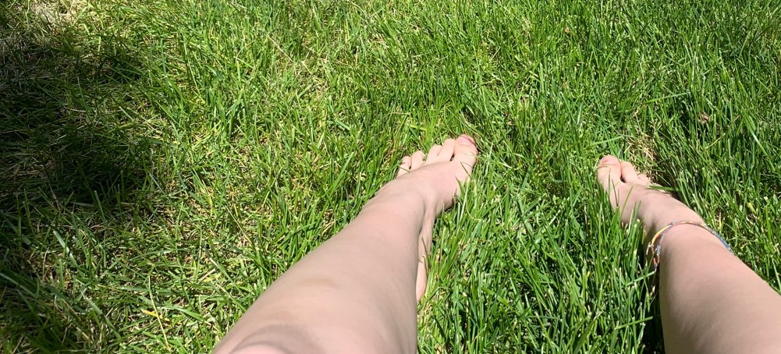

Chevalier, Geatan. “Healing with the Earth: Benefits of Reconnecting the Human Body to the Earth's Electrical Activity.” CHI, 19 Feb. 2021
Edwards, Darryl. “Reclaim the Joy of Childhood.” Primal Play, Primal Play, 30 Apr. 2021
Griffiths Doctoral Researcher, Benjamin J, and Simon Hanslmayr University of Birmingham. “How Memories Are Formed and Retrieved by the Brain Revealed in a New Study.” The Conversation, 27 Apr. 2021
Hopkin, Michael. “Link Proved between Senses and Memory.” Nature, 2004, https://doi.org/10.1038/news040524-12.

