To Be Like the Sun
Isaac Radin
There are times in life when it can feel as though there is a sort of invisible blanket between the world and one’s consciousness; it is almost as if everything feels a bit foggy, clouded, muted. Grief, trauma, loss, change, and transition can all be factors in causing this feeling of internal disconnect. For me, grief represents my blanket, the thing that is preventing me from being fully present in my own life. Back in August, I broke up with my girlfriend for college. We had dated for three years. It was always her decision, and we were and are very much so in love. We have hope for a future together, yet everything feels quite nebulous. It is an incredibly complex situation, making it both more beautiful as well as more painful; painfully wonderful, if you will. This blanket of confusion, hurt, grief, and uncertainty that now covers my life has felt smothering for the past 6 months. In this writing, I hope to explore methods of pulling this blanket away, or at least lifting the corners to allow some light in.
One of the primary self-care methods that I utilize is weekly visits to Chautauqua Park to watch the sunset. Thus, I found it fitting to take my photos up at Chautauqua for this piece.
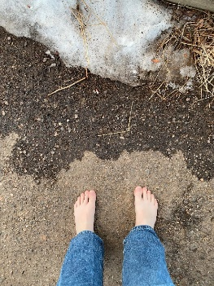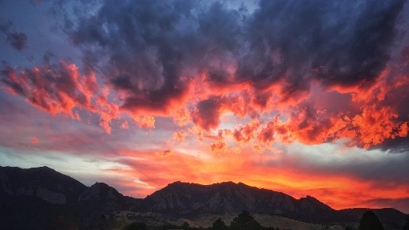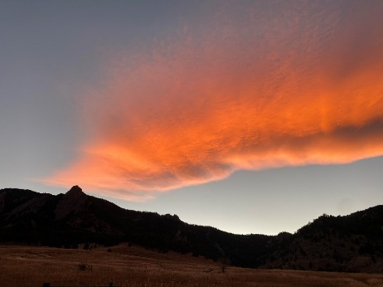
Chautauqua is always a very peaceful place, and thus the experience of being in that place for me is calming. Chautauqua smells like nature. That is the best way to describe it. It smells like dirt, and grass, and mountains, and it smells like the sunset. I could hear ambient noise, people talking in the parking lot, cars passing on the street; I could also hear my own thoughts becoming quieter, my anxieties becoming smothered, my fears becoming hushed. I had taken my shoes off to take some pictures of my feet in this special place, and my bare feet felt shockingly cold on the pavement in contrast to the rest of my bundled-up self. I focused on this feeling of contrast until my feet started to get numb and I had to put my socks and Crocs back on. My body always feels some sense of release when visiting this special place; almost as though all the hard feelings and stressful emotions that I had been feeling before were a little less hard, a little less stressful. There are some days where the sunset is more spectacular than others, and on the gloomier days I sometimes find myself feeling disappointed and even let down by nature. These gloomy days have become very symbolic for me; a reminder that not every sunset is spectacular, just as not every day is a happy one.
Chautauqua has become a place of meaning for me over the past couple of months. When I watch the sunset, I feel a sense of release; almost as if the orange and pink and red-tinted clouds are saying to me “It is okay”. I become hyper aware of sensation; the wind on the back of my neck, the smell of snow and dirt and the unblemished clarity of Flagstaff Mountain. I often find myself observing the grass swaying in the breeze, bending but never breaking, and wish that I could be more like the grass. I find myself looking at the enormity of the mountain and being struck by the timelessness of something so ancient and persistent. That mountain has weathered countless storms, yet still it stands. I hope to be more like the mountain. I find myself looking to the sun as it sinks down behind the mountain and feeling thankful that the sun will rise yet again, and that I will rise with it. In a time of such uncertainty in my life, the unwavering certainty of the grass, the mountains, and the sun provide a feeling of hope.
Ever since I started visiting Chautauqua, I have started to pay more attention to the impact of the outdoors in general on my emotional state. I have begun to realize that very often, the worst days are also the days that I do not have as much time to spend outside. Even just stepping out onto the front deck on a hard night and looking at the sky and the trees can be such a transformative experience. There is something about breathing fresh air that is so relieving and comforting. Experiencing this depth of emotion during my weekly nature outings and during general outdoor sessions has made me start to wonder about the science behind nature’s impact on physical and emotional well-being.
One of the most common methods of connecting with nature is called “shinrin-yoku”, or forest bathing. It is just about as simple as it sounds; one needs only to walk into a forest and remain there for some amount of time. Researchers have found that forest bathing can significantly improve both physical and psychological health factors (Wen et. al., 2019). This can include everything from immune health to cardiovascular health to emotional well-being to feelings of depression. As a result, forest bathing is even becoming part of medicinal considerations. The idea that walking in a forest for half an hour could replace some sort of antidepressant medication or even simply alleviate feelings of misery is such a fascinating one. I believe this is important knowledge not only for people like myself who are going through a difficult period, but also for everyone who is even remotely interested in integrating nature into their everyday lives.
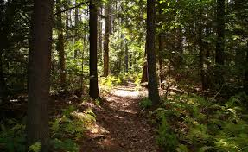
While forest bathing has been shown to be a highly effective method of improving both physical and mental health, not everyone always has access to a forest; for me, I am even more interested in the impacts of simply being outside on physical and mental health. Renowned health researcher Ming Kuo conducted a fascinating comparative analysis of many different studies examining the impacts of the outdoors on overall health. Kuo found that even views of nature can have significant impacts on health (Gladwell et. al., 2012). In other words, simply being near a window with a view of the outdoors can have noticeable impacts on things like overall emotional state. In terms of the being in the greater outdoors, plants have been found to give off antimicrobial compounds that can do everything from lower blood pressure to benefitting overall immune health (Li et.al., 2006). For me, the most fascinating and applicable part of this comparative analysis is the research surrounding the parasympathetic nervous system. The parasympathetic nervous system plays a crucial role in calming the body down during a stress respond or any kind of difficult respond to a hard stimulus. Brown et. al. (2013) found that simply showing someone pictures of nature can trigger an increased level of parasympathetic activity. This aspect of nature’s impact on the physical body is highly applicable to my situation; in fact, after reading this research I would even go so far as to say that the feelings of release and calming that I feel when outside are a result of my parasympathetic nervous system being activated.
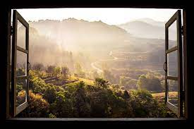
Finding evidence that nature truly does have real impacts on physical and mental health is incredibly validating to my experience. For months, I was never able to identify exactly what about watching the sunset was so powerful. After all, it is not like watching the sunset magically solved all my problems or made my hard emotions go away. Learning about the role that nature plays in physical and mental health, and specifically in the activation of the parasympathetic nervous system, makes me realize just how crucial my weekly sunset excursions are to my well-being.
After watching the sunset, I often find myself with an increased ability to confront hard emotion in an effective and self-respecting way. It is empowering to learn the extent to which being “one with nature” can influence my sense of self and my emotional state. I often find myself subconsciously running from emotion, even months into this process. Being embodied through nature can help me with all sorts of aspects in terms of my emotions; my anxiety and fear about the future, my feelings of despair, my feelings of hope and uncertainty and loss and grief. As I continue my journey, I want to use this new knowledge as an opportunity to cultivate my understanding of self, respect for self, and love for self. Creating intentional moments of serenity is certainly something I will pursue. I want to take a more active role in my inner peace; I do not want to simply allow moments of peace to happen, but also be intentional about the ways that I create them.
So many of us are struggling with something right now. I think my perspective and my search for inner peace and self-love through the lens of nature could be something that my readers are not only inspired by, but also are partaking in at the same time as me. I hope that my writing will open an exploration of what it means to love oneself, and what it means to find inner peace. Stepping into nature allows us to not only take a brief step away from hard mental loops, but also to take a step towards self-love and inner peace. For a long time, I have thought that inner peace is simply a lack of hard emotions, but I am starting to wonder if it is also the presence of something. Maybe what we are all searching for is not a lack of hard emotions, but rather learning how to approach these hard emotions. Learning how to be more like the grass, to bend and flex and adapt as emotion evolves. Learning how to stand firm like the mountain and not run from any storms. Most of all, I think we are all learning how to be more like the sun, rising again and again as the world spins on, even when it feels like our own world stops.
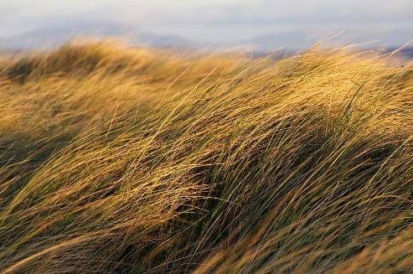

Works Cited
Daniel K. Brown, Jo L. Barton, and Valerie F. Gladwell Environmental Science & Technology 2013 47 (11), 5562-5569
DOI: 10.1021/es305019p

Gladwell, V.F., Brown, D.K., Barton, J.L. et al. The effects of views of nature on autonomic control. Eur J Appl Physiol 112, 3379–3386 (2012).
https://doi-org.colorado.idm.oclc.org/10.1007/s00421-012-2318-8

Kuo, Ming. “How Might Contact with Nature Promote Human Health? Promising Mechanisms and a Possible Central Pathway.” Frontiers in Psychology, vol. 6, Aug. 2015, p., doi:10.3389/fpsyg.2015.01093.

Qing Li, Ari Nakadai, Hiroki Matsushima, Yoshifumi Miyazaki, Alan M. Krensky, Tomoyuki Kawada & Kanehisa Morimoto (2006) Phytoncides (Wood Essential Oils) Induce Human Natural Killer Cell Activity, Immunopharmacology and Immunotoxicology, 28:2, 319-333,
DOI: 10.1080/08923970600809439

Wen, Ye et al. “Medical empirical research on forest bathing (Shinrin-yoku): a systematic review.” Environmental health and preventive medicine vol. 24,1 70. 1 Dec. 2019, doi:10.1186/s12199-019-0822-8

