Arielle Lawton
WRTG 3010
From Amyloid Fibers to Super Silk:
A Study on the Reprocessing of Scientific Research Articles for Popular Distribution
Link to Scientific Paper
Microbially Synthesized Polymeric Amyloid Fiber Promotes β-Nanocrystal Formation and Displays Gigapascal Tensile Strength
Links to Popularizations
https://interestingengineering.com/artificial-spider-silk-is-stronger-than-the-real-thing
https://www.futurity.org/lab-made-spider-silk-polymeric-amyloid-fiber-2602842/?utm_source=rss&utm_medium=rss&utm_campaign=lab-made-spider-silk-polymeric-amyloid-fiber-2602842
Introduction
When we think of translation, we often imagine a specialized process performed by language experts, perhaps decoding ancient texts or arduously recording ten language options for the latest global hit show. However, many people engage in subtler forms of translation on a daily basis, often without fully realizing they are doing it. As information is passed along between different audiences, there are alterations that must be made – the tone softened or harshened, the vocabulary simplified for clarity or dressed up to impress. The greater the differences in audience, the greater the magnitude of the necessary translations. If the original audience for the message is assumed to have specialized knowledge uncommon to the average layman, this translation is fully essential when the audience shifts. We see this exemplified in the process of sharing scientific research with the public, but often consumers of the popularizations are ignorant of the vast differences between the colorful article they read over breakfast and the dense original text written by the scientists responsible for the research. In her 1986 article Accommodating Science: The Rhetorical Life of Scientific Facts, author Jeanne Fahnestock identifies and breaks down the many changes that carve the gulf between scientific publication and the resulting popularization [1].
Almost immediately in her article, Fahnestock mentions a recent “explosion of scientific popularization” and questions the degree to which the scientific information may be oversimplified or confused in the popularizations. Although a valid concern in 1986, the landscape of today’s public media consumption renders the question of factuality and clarity in the popularizations not only interesting, but essential. With the rapid adoption of social media, easy access to online publications, and the resounding impact of recent global health crises, the public has been more exposed to, and engaged in, the discourse around scientific research than ever before. Thus, the importance of striking a balance between creating a marketable article that will be easily understood and preserving the integrity of the scientific research has only increased since Fahnestock first examined the subject.
The main themes in the translation between research paper and population that Fahnestock identified were the genre shift, changes in information, and application of stasis theory. The genre shift as described by Fahnestock draws upon Aristotle’s classifications of oratory discourse. Fahnestock argues that the original research article usually follows a structure and tone associated with forensic discourse, that which is associated with a discussion of past events. By highlighting the importance of the “Materials and Methods” and “Results” sections of the rigorously structured scientific article, Fahnestock points out the primary importance of communicating the observations of the research. By contrast, Fahnestock argues that the popularizations primarily follow the form epideictic discourse, that which instead celebrates a judgement of the current situation. Frequently these judgements are positive, following an optimism that excites the reader to the relevance or potential of the scientific research. However, recent years have also seen the integration of a potential negative viewpoint as well, one which works to instill a fear of the unknown possibilities in the reader as a way to promote the rapid propagation of the article or incite a public outcry against research deemed unethical or premature by the population.
The second main theme identified by Fahnestock is that involved in change in information provided by the articles. Again, this results in the vastly different intended audiences and the expected technical expertise and vocabulary associated with each group. Additionally, Fahnestock argues that the popularizations additionally insert an element of certainty not present in the original publications. Scientists frequently soften their language and avoid outright claims, instead employing language such as “the evidence might indicate” and “this could imply”. The expectation with the research articles is that the experimental data and observations will speak for themselves, and the scientist should be cautious in making any strong claims lest their reputation be put on the line. Fahnestock shows that, in contrast, the popularizations revel in absolutes. The pressure on authors to make claims that are assuredly correct is greatly reduced and language that implies utter confidence in the findings is prevalent.
Finally, Fahnestock explores stasis theory as an additional lens through which to view the rhetorical differences of the scientific and popular publications. Fahnestock explains that stasis theory provides a structured format for questions that can be used to analyze the intentions and content of the paper and asserts that the original versions mostly dwell in the realm of the first stasis while the accommodations for the public lead to rhetoric using the next stases.
In this paper, we explore the validity of Fahnestock’s analysis and the magnitude of the changes in recent scientific and popular publications through the examination of rhetorical methods used in a highly technical and recently published research article, Microbially Synthesized Polymeric Amyloid Fiber Promotes β-Nanocrystal Formation and Displays Gigapascal Tensile Strength, and that employed by two of the resulting popularizations [2].
Technical Prowess: The Rhetoric of the Scientific Paper
Before the reader even has a chance to dive into the text of the scientific article, several noticeable rhetorical tools signature to the standard research paper stand out. The wording of the title, Microbially Synthesized Polymeric Amyloid Fiber Promotes β-Nanocrystal Formation and Displays Gigapascal Tensile Strength, acts almost as a gatekeeper to warn away the unitiated. The highly technical vocabulary, note “amyloid fiber” and “β-Nanocrystal Formation” immediately implies that the article will most certainly require proficiency, or at least base knowledge, of the topic under discussion. Directly below the title, displayed prominently, are the names of the authors. This establishes a necessary accountability, showing that the data, assumptions, and conclusions in the paper can be clearly attributed to these people, and thus, the responsibility for any errors can also be quickly assigned. The third key feature that instantly grabs the eye is the inclusion of a list of keywords. This list serves two purposes for the article: first, it allows discerning researchers to better find the article via internet search, second, it further establishes the vocabulary and, to a degree, the scientific context of the research.
Next of interest in the research article is the overall structure of the text. A classic trademark of the scientific paper is the clean breakdown of sections – affording the reader a clear roadmap of where to go to find information in the dense text. The sections are listed in the order of abstract, introduction, results and discussion, conclusions, materials and methods, supporting information, author information, acknowledgements, and finally, references. This skeleton illustrates what information the authors deem most important to the reader. The abstract, time-saver extraordinaire, allows the reader to spare only a glance and determine if the article is covering a topic they are interested in enough to invest the time needed to fully read the text. The methods and materials section, previously featured after the introduction, has instead been relegated to a position after the conclusions. This allows the researchers to cohesively present their hypothesis, observations, and conclusions without interrupting the reader with an extensive and highly specialized passage detailing the process. This is perhaps a step in the direction of making the article more directly accessible to the casual reader. Of particular interest in this piece is the inclusion of the supporting and author information sections. The supporting information includes a multitude of additional figures, long strings of the DNA sequences discussed, and more details on the results. This need to include an additional section just to detail all of the necessary information highlights the required transparency of the scientific paper – the authors must provide as much relevant information as possible to support their study and claims. This is further reflected in the author information section, where the institutions the authors are associated with are recorded alongside a listing of the responsibilities of each researcher in the project. The breakdown of responsibilities holds the authors individually accountable, and thus further instills a sense of confidence in the integrity of the content.
The references section is its own testament to the reliability of the information. With a total of 80 references, all pointing to equally technical reports, the authors assert their position in an extensive community of research. The references give credit where due, but they also paint a picture with a small blank space, which the authors of the article fit their own research into with an elegant finesse. Returning to the introduction of the article, we see thirty reference links in three short paragraphs. The authors call forth previous research with these references, but then transition with a bold sentence which highlights the essential “gap” in the research. By pointing out this gap, the authors create a motivation for their own research and render the reader more engaged by the satisfaction of filling in a missing piece. This sentence is thus immediately followed by the author hypothesis and elegantly transitions the reader into the results and discussion.
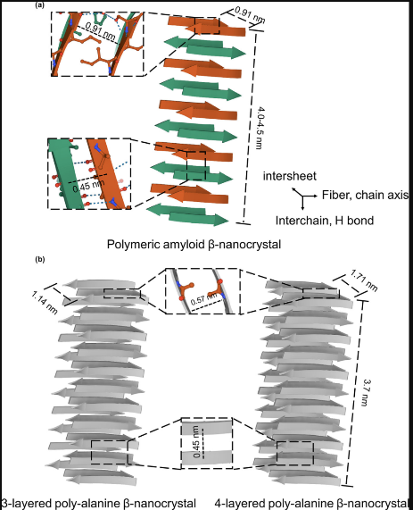
Although the casual reader may be lulled into a false sense of comfort by the brief, clear abstract and introduction, the article shatters any misconceptions with the results and discussion section. The language is highly technical throughout, and the frequent incorporation of technical names such as “16xKLVFFAE fibers” makes the reading slow and choppy. To break the text up, and provide alternate ways of conveying information, the authors incorporate and interesting series of figures throughout the section. These are divided into two categories: illustrations which help the reader visualize a detail, and graphs or pictures which simply present the results.
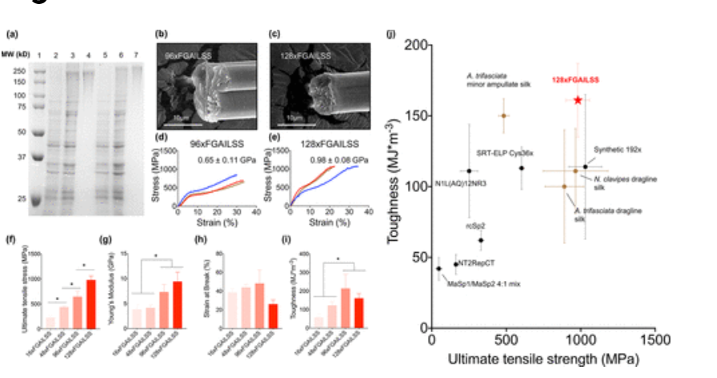
Figures 4 and 5 from the scientific article [2]. Figure 4 (left) is an example of an illustration which provides a helpful visual. Figure 5 (right) conversely is a simple presentation of results, providing visual support to author claims.
The wording of the section supports Fahnestock’s expectation of forensic rhetoric. The sentences revolve around the straightforward reporting of results and how they differ from past research and findings. However, as we transition to the conclusions, we see a slight deviation from the rhetoric observed by Fahnestock. The authors assert their conclusions with strongly confident language, “our results proved”, and avoid the careful hedging seen in the example pieces Fahnestock analyzed. At the same time, Fahnestock’s conclusions still hold with the lack of hopeful discussion on the applications of the research. A small statement is included on the potential for expanding the work to other amyloid sequences, but never transitions to an epideictic hypothetical on the wondrous applications that could impact the reader.
Awe & Application: The Popularizations
Moving on from the dense and highly technical scientific article, the colorful and brief popularizations seem at first glance to hardly discuss the same research. A search on the topic reveals a series of bold, exciting titles that vie for reader attention. This competition is entirely contained within the popularizations. Since the scientists are responsible for the original research, and generally receive funding from grants prior to the research, they generally avoid the need to market and employ “clickbait” titles to gain attention. In contrast, the popularizations are produced by a variety of authors, all of whom are counting on user attention for financial support. Thus, we can partially attribute many of the differences to a change in economic models as the original research is adapted for popular reading. In this section, we examine two of these flashy articles. First, we look at Lab-Made Spider Silk Beats Steel and Kevlar, by author Brandie Jefferson-Wustl, and then move on to an analysis of Artificial Spider Silk Is Stronger Than the Real Thing, written by Chris Young [3],[4].
Even before diving into the text of our first popularization, we see a number of stark stylistic differences from scientific article. As mentioned above, the title shifts drastically from one which contains as many technical key terms as possible, to one which contains as many excitement-inducing terms as possible. The scientific article never once mentions steel or Kevlar, but the author of the popularization found the opportunity to incorporate common materials which, already familiar to the reader, will convey the concept of super-strength and invoke comparisons for application possibilities. The heading also prominently features a photo, shown below, which was only a minor component in a flowchart figure in the scientific article.
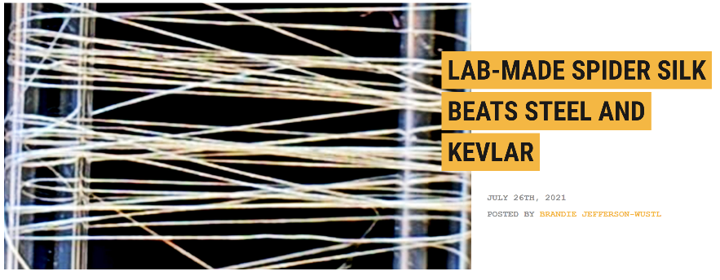
Heading for the popularization [3]. Note bold title and engaging “product” photograph.
Starting the article with this picture grants the author two affordances. First, it provides “proof” to the reader, indicating that the research did manage to create something. Next, it gives the reader a clear picture of the product, allowing a mental image to capture the reader’s imagination as they read through the article. Another new element in the popularization is the inclusion of the cheerful series of icons near the top of the page. These icons are universally recognized symbols for popular social media sites and clearly encourage the reader to share the article with friends and colleagues as a source of free proliferation for the author, thus further supporting the popular dispersal of the article via online methods. This is a new development since Fahnestock published her analysis, which existed in the time of primarily paper news, but further supports the need to transform the scientific format into one which can be understood and shared by all.
Social Media Icons [3].
Rather than transition with a clear set of standardized section headings, the article clearly undergoes a genre shift as it is structured in only one section, with quotes and key statements highlighted in dramatic colors. Included in these highlighted terms and phrase are “natural counterpart”, “stronger”, and “Kevlar”. This method of drawing a reader’s attention is interesting not only due to the colorful impact on the article design, but also because these terms indicate what the author thinks the readers will care most about. In theme with Fahnestock’s conclusions, we do see in these terms a trend of invoking comparisons which lead to emotional responses. By highlighting how this research not only produced a new material, but a material which is better, the author captures the awe of the reader. This awe is further incited by quotes from author interviews, in which the scientific researchers themselves venture to make claims that are entirely left out of their research articles. For example, we see in the Futurity article a quote from author Zhang in which he says: “This demonstrates that we can engineer biology to produce materials that beat the best material in nature.” This language is in no way echoed in Zhang’s scientific writing, and provides further evidence for Fahnestock’s findings that, when not faced in with the knowledge of a peer review, the author will speak much more boldly and make assertions they would not dare in the technical report.
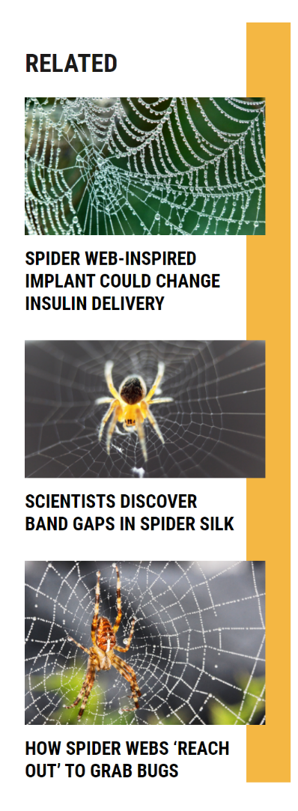
Another step clearly made by Jefferson-Wustl in their translation of the scientific piece is the alteration of the technical language into terms more clearly understood by the casual reader. There is still some specific language, note “beta-nanocrystals” and “amyloid fibers”, but the popularization attempts much more to include explanations when needed and simplified language where possible. This removes the “gatekeeping” seen in the scientific report and renders the uninitiated more capable to understand the scientific findings. Also in a move to accommodate the casual reader, the popularized article contains no mention of the methodology utilized by the researchers. This allows the author to avoid clogging the reader’s attention with forensic methodology and keep the article focused instead on the wonder of the results.
Eye-catching advertisements [3].
A final note on the Jefferson-Wustl article is on how it fits in with the rest of the website. In the scientific piece, we saw a plethora of citations that tied the research to other reputable findings that supported the author’s goals. In the popularization, we see no citations and instead are faced with a sidebar of illustrated links with loosely related research on spiders. These links have similarly fascinating titles and aids the author in maintaining traffic on their website, and thus increasing revenue.
In our second popularization of interest, we see many of the same rhetorical shifts employed. The title includes a comparison to spider silk to orient the reader and establish the category of material research. Immediately following is the supporting subtitle: “Spider silk is one of the strongest, toughest materials on Earth. Or at least, it was.” This is an incredibly effective hook for capturing reader interest and awe, and clearly indicates the difference in expected audience. Scientific readers want to be convinced by meticulously gathered data, but for the casual reader, even bold statements are accepted without question. The design of inducing of wonder is further carried by the generic, yet beautiful, picture of a dew-coated spiderweb. This image is hardly related to the investigation of mechanical properties which make up the bulk of the research article, but the author of the popularization included it as a visual trigger for readers who follow the “a picture is worth a thousand words” media trend.
Awe-inducing stock photo used in the popularization [4].
The structure of this article is even farther from the rigid scientific structure, as the author breaks up the text with unrelated video and text advertisements. As with the Futurity piece, there are also social media icons featured for ease of sharing.
Even more extensive icons for sharing [4].
If anything, this article strays farther from properly conveying the scientific results, trading technical information instead for a cluttered webpage teeming with distracting icons and advertisements. The author must be given credit for mentioning in the body of the article that this project is a follow-up from previous fiber research, but amongst the sea of links for nonrelated stories, the existence of a link or citation for these previous works is noticeably absent.
It is also interesting to note with this article that the website it is posted on is an engineering-focused site. Thus, there is some expectation that the audience for the article will have some preliminary interest and technical language proficiency. Despite this, the language of the text is still highly simplified. Most obvious is the emission of the technical names for the “the fiber”, which is frequently referred to with the nigh unreadable string of characters, such as “378 kDa 128xFGAILSS”, in the scientific article.
Conclusion
Through the examination of Microbially Synthesized Polymeric Amyloid Fiber Promotes β-Nanocrystal Formation and Displays Gigapascal Tensile Strength and two of the corresponding popularizations, we analyzed the changes made as highly technical scientific reports are translated for consumption and dissemination by the public. In her 1986 essay, Fahnestock laid the groundwork for recognizing these changes, particularly in the areas of genre shift, the changes in information contained, and the application of stasis theory in the rhetoric design.
Our investigation primarily supported Fahnestock’s findings as we saw a clear shift from forensic to epideictic rhetoric between article types. However, with the changes made in article format, namely the explosion of purely online articles designed to be accessed and shared on the internet, we see an additional shift not present in Fahnestock’s time. The altered economic system of free and easily accessed articles supported by in-site advertisements has caused the authors to incorporate a new series of links, advertisements, and in-text references designed to pull reader attention and keep them on the website for as long as possible, even to the detriment of the article being viewed. Additionally, the advent of clickbait culture has further encouraged authors to go for the flashiest titles and keep their articles as short as possible in order to cater to the limited attention spans of today’s readers. Thus, the positive impact of rendering scientific popularizations made more available to the public is tempered by the inclusion of overly dramatic language and omission of many details which the original scientific article deemed important. As this fast-paced culture, so different from the world as Fahnestock saw it, continues to grow, we hope that future generations of writers find a balance between the scientific and the stunning so as to both inspire awe and accurately inform readers of scientific advances.
References
[1] Fahnestock, Jeanne. (Reprint 1998, originally published 1986). Accommodating Science: The Rhetorical Life of Scientific Facts. Written Communication. DOI: 10.1177/0741088398015003006. Available at http://wcx.sagepub.com/content/15/3/330.
[2] Jingyao Li, et al. (2021, July 12). Microbially Synthesized Polymeric Amyloid Fiber Promotes β-Nanocrystal Formation and Displays Gigapascal Tensile Strength. Yaguang Zhu, Han Yu, Bin Dai, Young-Shin Jun, and Fuzhong Zhang. ACS Nano. 11843-11853.DOI: 10.1021/acsnano.1c02944.
[3] Jefferson-Wustl, Brandie. (2021, July 26). Lab-Made Spider Silk Beats Steel and Kevlar. Futurity. Retrieved November 9, 2021, from https://www.futurity.org/lab-made-spider-silk-polymeric-amyloid-fiber-2602842/?utm_source=rss&utm_medium=rss&utm_campaign=lab-made-spider-silk-polymeric-amyloid-fiber-2602842.
[4] Young, C. (2021, July 21). Scientists created silk that's stronger than steel and tougher than Kevlar. Interesting Engineering. Retrieved November 10, 2021, from https://interestingengineering.com/artificial-spider-silk-is-stronger-than-the-real-thing.

