Resources for Proctoring & Testing Accommodations
(Updated Fall 2026)
Below are the proctoring procedures for instructors, TAs, and proctors…
- Reserve a room: When you have a student who needs a testing accommodation (often 1.5 time or a smaller testing environment), please schedule a testing room using the EMS room scheduler.
To get to EMS, go to https://ems.colorado.edu/ and sign in with your IdentiKey username and password.
Click on "CREATE A RESERVATION", scroll down to "PSYCH Testing and Learning Hub Room Scheduling” and click the "book now" button. Select the date and time, then click the “Search” button to search for a room. There are seven rooms labeled Special Needs Testing Rooms that you can book with room cap listed. Click the green plus sign to select a room.
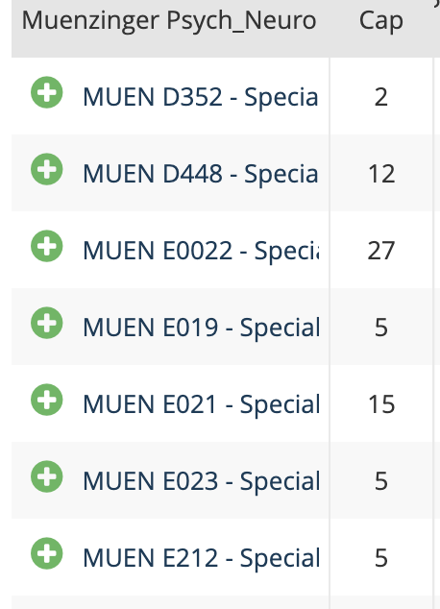

Then click the "Next Step" button. Fill in the fields and please use this format for the Event Name:
“Testing (your name) (# of students)(Class)”
Example: Testing (John Smith)(3)(PSYC 2012)
Then click the "CREATE A RESERVATION" button. You will get a confirmation email once your room has been scheduled.
It’s important to include the number of students so that a large room can be used for multiple exams. Depending on the room size, proctors can either sit in the room or outside in the hall.
2. Arrange where you would like to meet the student (in the main office Muenzinger D244 or the testing room). Be sure to have a copy of the exam for each student.
3. At the time of the exam, whoever is proctoring must obtain a key from the front office Muenzinger D244, unlock the testing room, and bring the key back to the front desk right away.
Things to remember:
-Exam Rooms: The department has set aside 7 rooms for testing. See screenshot above. If a Muenzinger room is not available, the Student Testing Center also has space that you can reserve in advance, including a large 20+ room (email testing@colorado.edu).
- Instructors: The Student Testing Center (https://www.colorado.edu/disabilityservices/resources/student-testing-center/student-testing-center-facultystaff-information) may also be able to help in certain situations with plenty of advance notice. They will typically take 2x time students, but not 1.5x time students.
-Instructors: If you choose to have your TA administer the special accommodations exam (making them unavailable to proctor the exam to the full class), you can also ask one of the proctors to come to the classroom to help you administer the exam to the rest of the class.
Graduate Student Proctors
If the instructor and TA are unavailable to provide proctoring coverage for students needing accommodations, the grad student proctors may be used.
Please check the google sheet schedule (Proctor Schedule) to see if there is another proctoring request happening in the same week. Try to tag on to that proctoring request if it is only for a few students. To maximize proctors, we need to utilize their availability efficiently. Please only edit the room number section, notes section, and additional students section.
Please email psycnrsc-gg-proctors@colorado.edu with your proctoring request, and a proctor will respond to you if available. (Proctors, please REPLY ALL when responding to the initial proctoring request so that all other proctors know you are taking on the shift.)
Proctors do not have set proctoring hours, so please keep in mind that proctors are not available at all times of the day. General availability is Monday-Friday from 9am-5pm, so please try to keep requests within this timeframe (extended hours available during finals week).
At that time, please coordinate with the proctor regarding the room, getting the test to them, how you want it returned to you, and specifically what accommodations your student has (e.g., 1.5 time etc.). The proctors are available through the the last day of finals.
If you do not hear from a proctor within a few days, you could send a reminder to the proctor email address: psycnrsc-gg-proctors@colorado.edu
Proctors, if you have to unexpectedly miss a shift that you signed up for, please email psycnrsc-gg-proctors@colorado.edu AND the instructor you are proctoring for to find a replacement proctor, and notify the instructor that you will not be able to make it. Please try to send this email with as much notice as possible.
If you have any questions regarding the grad student proctors, please reach out to Hanna Newman (hanna.newman@colorado.edu).

