# **Helbert Garcia-Delgado - Project Profile**

# *Quaternary sediment dynamics in the Northern Andes derived from 10Be-26Al burial dating*

# **2023 AGeS-Grad awardee Lab:** *NSF/UVM Community Cosmogenic Facility* **Lab Mentors:** *Dr Lee Corbett, Dr Paul Bierman*

**What scientific question(s) does your research address and what motivates this work?** In mountainous regions, sediment dynamics play a vital role in shaping landscape evolution. However, these processes are frequently understudied in data-limited tropical environments, where challenging climatic conditions prevail. This project aims to construct a robust chronological framework of deposition and erosion from a massive 300-meter-thick alluvial fill in the Northern Andes of Colombia. Our research is guided by the following questions: How have tropical mountain rivers responded to climatic shifts? And to what extent has sediment dynamics been influenced by precipitation changes associated with glacial and interglacial periods?

The motivation behind this study stems from the hypothesis that climate exerts significant control on sediment processes. If this hypothesis holds true, it conveys important implications: (1) projected increases in tropical rainfall due to ongoing climate change may intensify river discharge, altering hydrological regimes; and (2) increased material flux from hillslopes could modify sediment dynamics, strengthening the connection between climate change and natural hazards. Enhanced denudation driven by storms may increase both the frequency and magnitude of landslides and channelized flows. Such changes could escalate risks for vulnerable communities in a region already prone to hillslope-related hazards.

*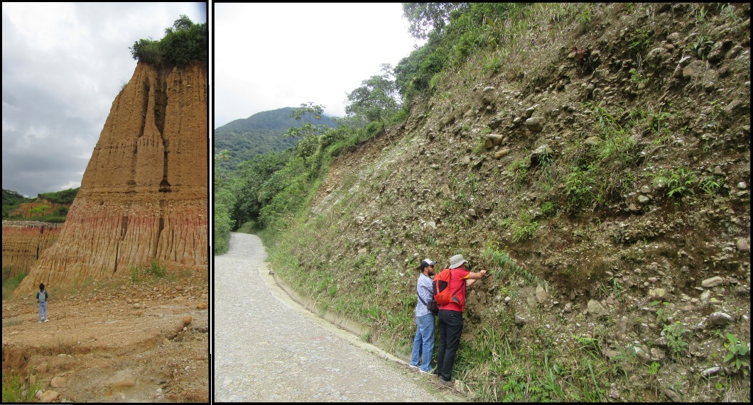Figure 1 Panoramic and detailed view of sampled sedimentary deposits in the Northern Andes of Colombia.*

**What chronometric tool did you employ and why?**

For this project, we applied a specific technique within the broader use of cosmogenic nuclides in geomorphology: burial dating. This method leverages the radioactive decay of cosmogenic isotopes—produced by secondary cosmic rays in rocks or sediments exposed at or near the Earth's surface—that are subsequently buried and shielded from further nuclide production. A key advantage of burial dating is its ability to provide both the burial age and the pre-burial erosion rate, as determining the time of burial also yields the initial concentrations of 10Be and 26Al. This allowed us to infer erosion rates in the adjacent hinterland at the time of sediment deposition. The 10Be and 26Al nuclide pair has proven to be a robust tool for investigating the interplay of climate and tectonics on sediment dynamics, particularly in deposits older than 200,000 years. Accordingly, the new burial age data were compared with paleoclimatic records to explore potential links between sedimentary processes and environmental drivers, such as glacial-interglacial cycles.

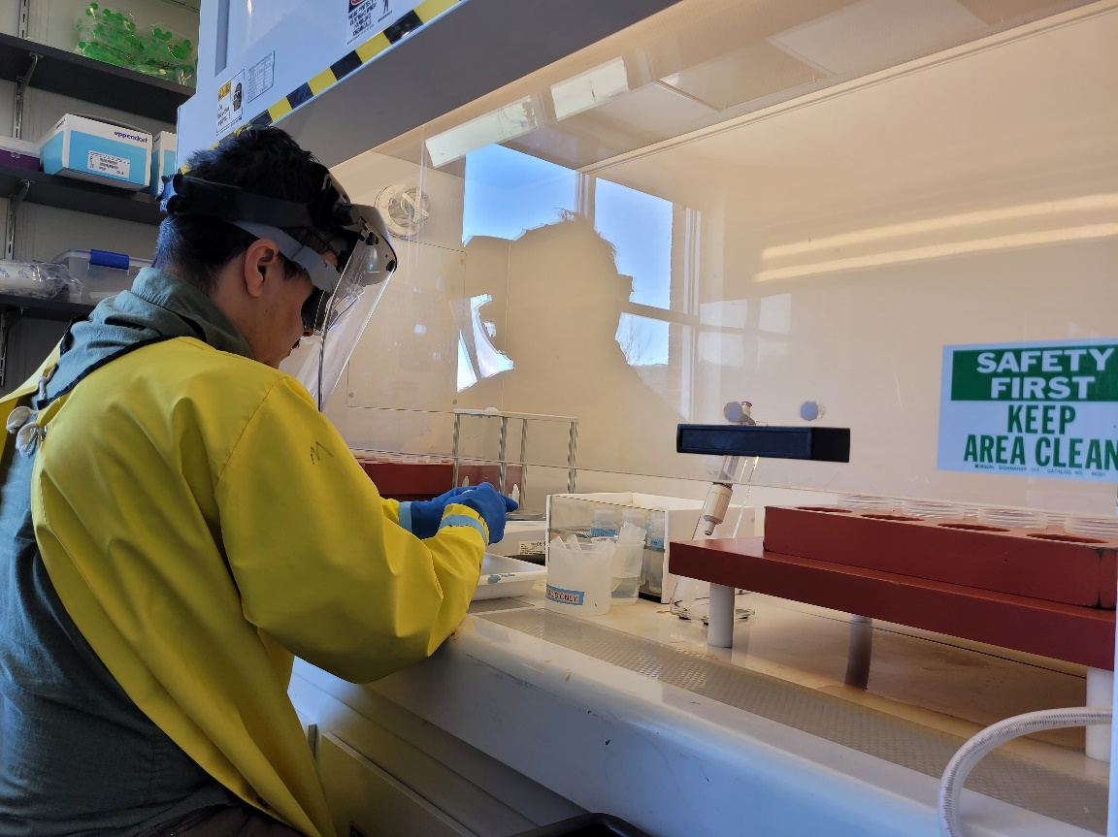

*Figure 2. Samples preparation for ion chromatography at the NSF/UVM Community Cosmogenic Facility.*

**What were some of the key takeaways of your research?**

* Our results for five samples indicated the base of the alluvial infill was deposited 2.39±1.3 Ma while sediments at the top gave a burial age of 1.05±0.28 Ma. Erosion of the studied infill seems to temporally correlate with the mid-Pleistocene transition.
* Sedimentation resumed north of the study area and suddenly ended at 0.59±0.08 Ma matching the onset of global cooling and the transition from MIS15 to MIS14.
* Global cooling events during the Pleistocene seem to enhance sediment transport in mountainous regions of the Northern Andes.

**What new experiences, opportunities, and collaborations did you gain as an AGeS-Grad awardee?**

Spending two weeks working in a state-of-the-art clean lab under the guidance of leading experts in cosmogenic nuclide research was one of the most formative experiences of my academic journey. Participating in every stage of the process—from sample dissolution to running ion chromatography columns—deepened my appreciation for the work behind every cosmogenic nuclide dataset. Dr. Corbett was especially helpful in guiding me through each procedural step and generously took the time to explain the chemistry behind the separation techniques. This hands-on experience not only enhanced my technical skills but also opened the door to new collaborative opportunities with professionals in the field—relationships I look forward to continuing in the near future.

**What is one piece of advice you have for future AGeS-Grad award applicants or awardees?**

Two pieces of advice that could help future awardees are: (i) always having plan B or even a plan C can help make the experience run more smoothly; (ii) maintain close contact with your lab partner. Constant communication can help reduce project time and margin of error.