Step 1: Make an account on [overleaf.com](http://overleaf.com)

Step 2: Click the New Project button on the left hand side of the screen. It should bring out a dropdown, like so:

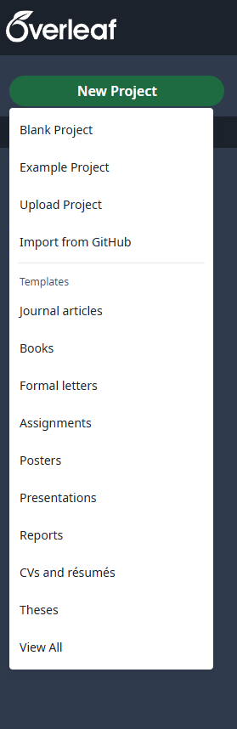

Step 3: Download the PLC CV Template Zip File

Step 4: Select “Upload Project” and Upload the Zip File

Step 5: Adjust the Resume to your needs!