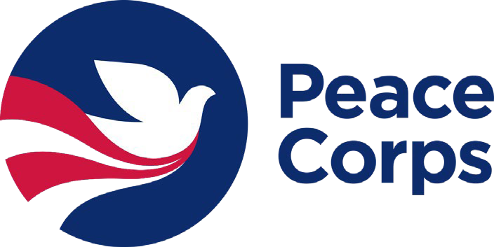
Student Name: University: Peace Corps Prep Coordinator:

Exit Checklist
Below are the Peace Corps Prep certification requirements. If you apply to Peace Corps, please scan and attach this signed form to your application with the name “Peace Corps Prep Checklist.” If you apply to Peace Corps before completing a requirement below, write: “[Activity]: planned [month/year].”

Training and Experience in a Specific Work Sector
https://www.peacecorps.gov/ways-to-serve/our-work-sectors/

Please check the box of the sector in which you have prepared yourself to serve:

  - Education
  - Health
- Environment
- Agriculture
- Youth in Development
- Community Economic Development

- Coursework. List the 3 highest approved sector-aligned course #s and titles you took:

- Hands-on experience in that same sector. Total Hours (must be at least 50). Description of experience:

Intercultural Competence
List your 3 approved courses/experiences that bolstered your intercultural competence:

Substitution Options. Minimum 1 Intercultural Course with either Foreign Language Courses/Proficiency or Intercultural Experience. Provide Substitution Description:

Professional and Leadership Development
- Professional resume feedback:  Yes  No Date: Where:
- Professional interview prep:  Yes  No Date: Where:
- Demonstrated leadership experiences (i.e., student orgs, work, volunteer, etc.) Describe:
- Connected with a Peace Corps Recruiter, Strategic Campus Recruiter, or Returned Peace Corps Volunteer.  Yes  No Date: How:

Signature of Student Date Signature of PC Prep Coordinator Date

