Directions to Pull a Closing Awards Report
- Go to the CU Portal and Login with your credentials
- Scroll over the Reporting & Compliance Tab and then select Public Folders
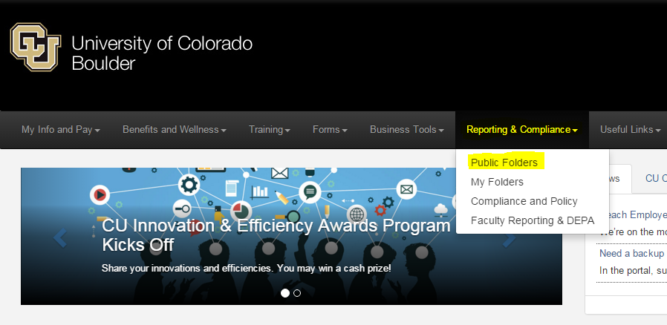
- The screen now shows a variety of Cognos Reports. Next select the eRA folder, then the CU Boulder folder, then the Proposal and Award Tracking folder. This route will show the Closing Awards Report as highlighted below.
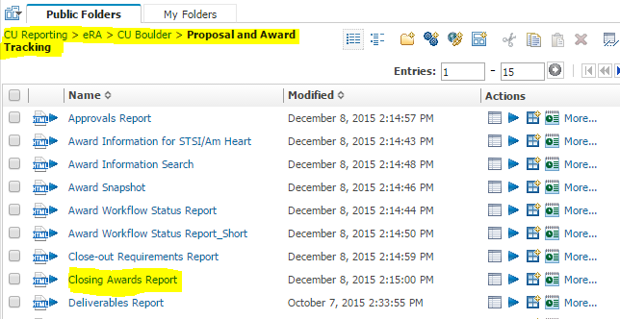
- Select the Closing Awards Report (Click the report name)
- The next screen brings up a list of reporting parameters to choose from on the Prompt Page. In the example below, the reporting parameters selected were to display only awards ending anytime in the month of February, 2016 and specific only to one department, 10340 – Mechanical Engineering.
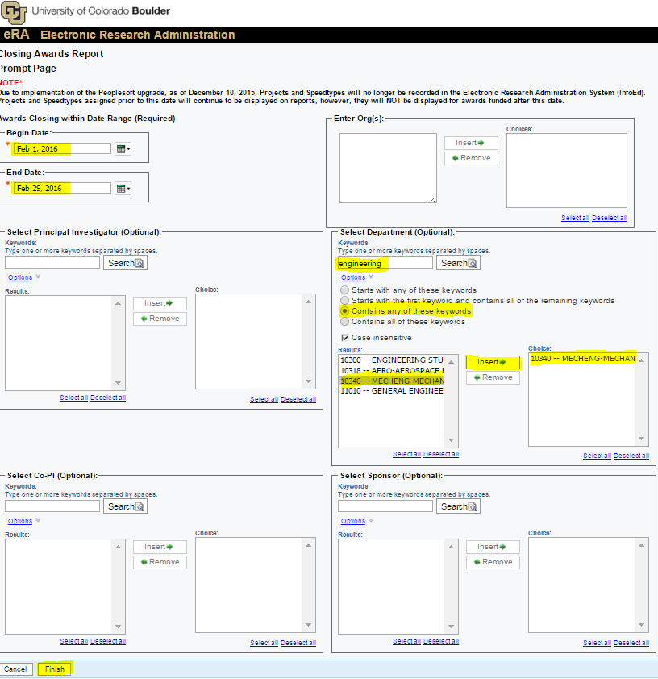
- Once the Finish button is selected on the Prompt Page, the screen below populates. (You can export to Excel if preferred) In this example, there is one award with a Period of Performance (POP) end date of 2/28/2016. Based on the award documents, keep in mind this does not mean the award’s projected POP end date is 2016. In this example, this is an anticipated 3 year award with a projected end date of 2018. Since it is projected to end in 2018, a funding increment/modification is expected to both extend the award from the current date of 2016, as well as increase the total funding. If the modification is not in process yet, check in with the project’s OCG Grant or Contract Officer so OCG can follow up with the Sponsor (ie, Cornell) on the next funding increment or submit the PI’s request for the next funding increment.