1107

MIDN

26FEB25

From: Colorado Meet Officer in Charge, Naval Reserve Officers .

. , Training Corps, University of Colorado

To: All Hands

Subj: COLORADO MEET SHOOTING COMPETITION LETTER OF INSTRUCTION

Encl: (1) Courses of Fire

1. Map of Shooting Competition
2. Operational Risk Management (ORM)
3. Weapons Safety Rules
4. Targets
5. Timeline
6. Shooter Release Form
7. After Action Report
8. Orientation. The shooting competition of the Colorado meet will take place at the CU Police Department Range and will occur on 7-8 Mar 2025.
9. Situation. The University of Colorado Boulder Naval Reserve Officers Training Corps (CUNROTC) Rifle/Pistol team is hosting a rifle/pistol competition. The competition will consist of rifle and pistol courses of fire, which are determined by the National Rifle Association's Competitions Rulebook. The teams competing will travel to Boulder Police Department Range in order to participate in the courses of fire. At the conclusion of the competition, each schools' respective teams will return to CU for awards.
10. Mission. The CU NROTC competition teams will travel from CU Main Campus to Boulder Police Department Range on 7-8 Mar 2025, to compete in the CU NROTC Shooting Competition in order to test military shooting skills in a competitive environment and foster camaraderie between competitors.
11. Execution

# a. Commander's Intent

1. Purpose. The primary objectives of the Colorado Meet are to instill confidence in future Naval and Marine Corps officers, provide an environment for a healthy and challenging competition, as well as strengthen camaraderie between competitors and all working personnel. The Colorado Meet provides an opportunity for all competitors and all personnel to train, demonstrate, and evaluate their leadership skills necessary for performing in The Navy and Marine Corps.
2. Endstate. All participants of the 2025 Colorado Meet will perform in a challenging and safe environment that will be safe, enjoyable, and productive for all who attend.

b. Concept of Operations. Teams will use the time prior to the competition to improve their skills. Upon teams' arrival to CU they will prove their skills during the competition. After all of the shooting teams finish, they will receive feedback and one team will be named the winner.

# c. Scheme of Maneuver

1. Phase I: Preparing for the competition. The rifle/pistol OIC, AOIC, and team captains will be expected to prepare all the spaces, weapons, and schedules in order to prepare for the respective teams.
2. Phase II: The Competition. Over the course of 2 days, all teams will compete at the Boulder Police Department Shooting Range in a graded rifle and pistol competition. Pistol and rifle teams will be limited to 4 members per team. Participants may shoot on either rifle or pistol, or both. **No spotters, coaches, or staff outside of CU NROTC range staff will be allowed on the range.**
3. Phase III: Grading. The grading of the targets will take place on all days of competition. The targets will be graded according to the USPSA Standards. All scoring will take place after firing has ceased and will be available for review and challenging. Each school will be given all scored material after conclusion of the meet.

# d. Tasks

1. All Participants. All participants will be responsible for the safety of themselves and others at the competition. Teams will be responsible for cleaning and reloading the weapons.
2. Rifle Teams. Rifle Teams will be responsible for completing the rifle course of fire. (See enclosure 1) Rifle teams will receive 46 rounds for the graded portion of the competition.
3. Pistol Teams. Pistol teams will be responsible for completing the pistol course of fire. (See enclosure 2) Pistol Teams will receive 46 rounds for the graded portion of the competition.
4. Team Captains. The Team Captains will maintain, train and ensure all weapons safety rules are being followed at all times.
5. Range Safety Officer. The range safety officer (RSO)is responsible for range observation and safety. They have the right to remove competitors if they are deemed unsafe to handle the weapons.
6. Shooting Competition OIC. The OIC will be the liaison between all the competing schools and the University of Colorado, Boulder. The OIC will ensure that the competition runs fairly and safely.
7. Shooting Competition AOIC. The AOIC is responsible for helping the OIC with all assigned tasks and communicating with Team Captains.

e. Coordinating Instructions. All Team Captains will be in

communication at all times with the shooting competition OIC MIDN 1/C Sturckow or AOIC MIDN 3/C Heflin via cell phone in order to maintain accountability for the training and all personnel through the entirety of the event.

5. Administration and Logistics

# a. Administration

1. Transportation. It is the responsibility of each school competing in the shooting competition to transport all personnel and equipment from their hotel to and from the shooting range once the competition is complete. This year the competition will be held at the Boulder Police Department Shooting Range; See Enclosure (3)
2. Medical. In case of any medical emergency, self-aid and buddy-aid will be utilized. Any individual with a medical condition that cannot be handed in such a fashion will be transported to the nearest medical facility for treatment. See Enclosure (4) for the Operation Risk Management sheet. The nearest hospital in Boulder is Foothills Hospital, located at 4747 Arapahoe Ave., Boulder, CO 80303, reachable at: (303) 415-7000. See enclosure 5 for directions from the shooting range to Foothills Hospital. Call 911 in a life-threatening situation.

b. Logistics.

1. Supply. Each pistol shooter will receive 2 standard USPSA targets. Each rifle shooter will receive 2 USPSA half-size targets. Schools must use rifles and pistols from CU NROTC. Schools must use ammunition supplied by CUNROTC.
2. Uniforms. During the event, the uniform will be

NWUs/MARPATs. No removal of blouses is allowed.

1. Gear. Schools can bring their own ear and eye protection. No support systems are allowed. No shooting mats, binoculars, bipods, shooting bags, shooting jackets, etc.
2. Weapons. CU NROTC will supply the weapons for the competition. For the pistol competition the exact model that will be in use is the Walther USA Colt 1911 Pistol .22 LR 5in 10rd and for the rifle competition the exact model that will be in use is the Smith & Wesson 10208 M&P 15-22 Sport Rifle .22 LR 16in 25rd. Teams are not allowed to bring personal weaponry.

# 6. Command and Signal

1. Command. Shooting competition OIC MIDN 1/C Sturckow or AOIC MIDN 3/C Heflin will be present at the range during the competition and will be reachable by cell phone at all times. Any significant emergencies will be reported up to the Staff AMOI, Gunnery Sergeant Mathews.
2. Signal. All communications that cannot be conducted verbally will be conducted over cell phones during the event.

(1) Points of Contact.

1. AMOI Gunnery Sergeant Keziah,

[Brandon.keziah@colorado.edu](mailto:Brandon.keziah@colorado.edu) ,

1. Colorado Meet OIC Midshipman 2/C Culverhouse,

coloradomeet2025@colorado.edu,

1. Colorado Meet AOIC’s SSgt Hillyer

[Andrew.hillyer@colorado.edu](mailto:Andrew.hillyer@colorado.edu)

1. Shooting Competition OIC MIDN 1/C Sturckow,

Travis.sturckow@colorado.edu, (281) 806-8903.

1. Shooting Competition AOIC MIDN 3/C Heflin,

John.heflin@colorado.edu, (224) 221-5082.

T. L. Sturckow

Rifle Course of Fire:

|  |  |  |  |  |  |  |  |  |  |  |  |  |  |  |  |
| --- | --- | --- | --- | --- | --- | --- | --- | --- | --- | --- | --- | --- | --- | --- | --- |
| Stage | | Meter Line | | Engagement | | Rounds  Per  Exposure | | Time | | Position | | Iterations | | Total  Rounds | |
| Zero/Hold  Confirmatio n | | 25m | | Zero/Hold Confirmation | | 10 | | 5min | | Standing,  Kneeling | | 1 | | 10 | |
| "Tower NCO"- SHOOTERS, WITH A MAGAZINE OF 10 ROUNDS, MAKE A CONDITION ONE  WEAPON. THIS IS YOUR 25 METER ZERO CONFIRMATION. YOU WILL HAVE 5 MINUTES TO FIRE 5 ROUNDS IN THE STANDING AND 5 IN THE KNEELING ON THE RIGHT TARGET. SHOOTERS STANDBY, TARGETS. "***Cease fire, Cease fire".*** UNLOAD SHOW CLEAR. | | | | | | | | | | | | | | | |
| Stage 1 | | 15m | | HP  FSH  BDH | | 2  3  6 | | HP 4 Sec  FSH 7 Sec  BDH 14 Sec | | Standing  Standing  Standing | | 2  2  1 | | 16 | |
| "Tower NCO"- SHOOTERS WITH A MAGAZINE OF 16 ROUNDS MAKE A CONDITION ONE  WEAPON. YOUR NEXT DRILL WILL BE A HAMMER PAIR IN A TIME LIMIT OF 4 SECONDS. STAND BY, TARGETS. **"Cease fire, Cease fire"**  SAME DRILL SAME DRILL STAND BY. TARGETS. **"Cease fire, Cease fire".**  SHOOTERS YOUR NEXT DRILL WILL BE A FAILURE TO STOP TO THE HEAD. YOU WILL FIRE  TWO ROUNDS TO THE CHEST AND ONE TO THE HEAD IN A TIME LIMIT OF 7 SECONDS TO DO  SO. STAND BY! TARGETS. **"Cease fire, Cease fire"**  SAME DRILL SAME DRILL STAND BY. TARGETS. **"Cease fire, Cease fire".**  SHOOTERS YOUR NEXT DRILL WILL BE A BOX DRILL, TWO SHOTS TO THE CHEST OF THE  RIGHT TGT, TWO SHOTS TO THE CHEST OF THE LEFT TGT, ONE SHOT TO THE HEAD OF THE LEFT AND THEN THE RIGHT. IN A TIME LIMIT OF 14 SECONDS. STAND BY! TARGETS. **"Cease fire, Cease fire"** UNLOAD SHOW CLEAR. COACHES ONCE THEY ARE CLEAR MOVE TO THE 25M LINE MUZZLES POINTED AT THE DECK. | | | | | | | | | | | | | | | |
| Stage 2 | | 25m | | CP  FSP  BDP  ST-KN CP | | 2  3  6  2 | | 1. Sec 2. Sec   14 Sec  10 Sec | | Standing  Standing  Standing  Std to Kn | | 2  2  1  2 | | 20 | |
| "Tower NCO"- SHOOTERS MAKE A CONDITION ONE WEAPON WITH 20 ROUNDS. IN THE  STANDING POSITION. YOUR NEXT DRILL WILL BE A CONTROLLED PAIR IN A TIME LIMIT OF 6  SECONDS. STAND BY, TARGETS. **"Cease fire, Cease fire"**  SAME DRILL SAME DRILL STAND BY. TARGETS. **"Cease fire, Cease fire".**  YOUR NEXT DRILL WILL BE A FAILURE TO STOP TO THE PELVIS. YOU WILL FIRE 2 SHOTS TO THE CHEST AND ONE TO THE PELVIS IN A TIME LIMIT OF 7 SECONDS. STAND BY, TARGETS.  **"Cease fire, Cease fire"**  SAME DRILL SAME DRILL STAND BY. TARGETS. **"Cease fire, Cease fire".** | | | | | | | | | | | | | | | |
| YOUR NEXT DRILL WILL BE A BOX DRILL, TWO SHOTS TO THE CHEST OF THE RIGHT TGT, TWOSHOTS TO THE CHEST OF THE LEFT TGT, ONE SHOT TO THE PELVIS OF THE LEFT AND THEN THE RIGHT. IN A TIME LIMIT OF 14 SECONDS. STAND BY! TARGETS. **"Cease fire, Cease fire"**  YOUR NEXT DRILL WILL BE A CONTROLLED PAIR FIRED FROM THE STANDING TO THE KNEELING. UPON THE COMMAND SHOOTERS WILL ASSUME THE KNEELING POSITION AND ENGAGE WITH A CONTROLLED PAIR IN A TIME LIMIT OF 10 SECONDS. STANDBY, TARGETS.  **"Cease fire, Cease fire"**  SHOOTERS WEAPONS ON SAFE STAND, THIS WILL BE YOUR LAST AND FINAL DRILL, IT WILL BE THE SAME CONTROLLED PAIR FROM THE STANDING TO KNEELING. STANDBY, TARGETS.  **"Cease fire, Cease fire"** SHOOTERS UNLOAD SHOW CLEAR. | | | | | | | | | | | | | | | |
| Magazine loadouts | | | |  | |  | |  | |  | |  | |  | |
| MAG 1 | | 10 rnds | |  | |  | |  | |  | |  | |  | |
| MAG 2 | | 16 rnds | |  | |  | |  | |  | |  | |  | |
| MAG 3 | | 20 rnds | |  | |  | |  | |  | |  | |  | |
| Total | | 46 rnds | |  | |  | |  | |  | |  | |  | |

1. Scoring: shots that land inside of the "A*"* zone *(*Half-sized USPSA target) will count as 3 points. Shots that land in the "B" zone will count at 2 point. Shots that land in the "C" zone will count at 1 point. Shots outside of the A, B, or C range will count as 0. Shots that occur after the time limit will be counted as 0. A perfect score is 138 points.
2. Alibis will be granted to shooters who demonstrate immediate remedial action. Remedial action is in the form of tapping the magazine, racking the slide, and attempting to fire another shot. No alibis will be granted if no remedial action is taken. For each shot not fired in a course of fire where an alibi is granted, the shooter will be granted one second per shot to fire the remaining shots.
3. RSO will direct the course of fire.

Pistol Course of Fire:

|  |  |  |  |  |  |  |  |  |  |  |  |  |  |  |  |
| --- | --- | --- | --- | --- | --- | --- | --- | --- | --- | --- | --- | --- | --- | --- | --- |
| Stage | | Meter Line | | Engagemen t | | Rounds Per  Exposure | | Time | | Position | | Iterations | | Total  Rounds | |
| Hold Confirmation | | 7m | | 5 rds Chest  5rds Head | | 5  5 | | 5min | | Standing  Standing | | 1  1 | | 10 | |
| *Tower NCO* SHOOTERS WITH A MAGAZINE OF 10 ROUNDS, MAKE A CONDITION 1 WEAPON.  THIS WILL BE YOUR HOLD CONFIRMATION, YOU WILL FIRE 5 ROUNDS TO THE CHEST AND 5 ROUNDS TO THE HEAD IN A TIME LIMIT OF FIVE MINUTES. STANDBY, TARGETS. **"Cease fire, Cease fire".** SHOOTERS UNLOAD SHOW CLEAR! | | | | | | | | | | | | | | | |
| Stage 1 | | 7m | | HP FSH | | 2  3 | | 4 Sec  7 Sec | | Standing  Standing | | 2  2 | | 10 | |
| *Tower NCO* SHOOTERS WITH A MAGAZINE OF 10 ROUNDS, MAKE A CONDITION 1 WEAPON. THIS WILL BE YOUR 7 YARD LINE ITERATION. SHOOTERS YOU WILL FIRE A HAMMER PAIR IN THE TIME LIMIT OF 4 SECONDS. SHOOTERS STANDBY. TARGETS**. Cease Fire. Cease Fire.** SAME DRILL SAME DRILL, STANDBY, TARGETS. **Cease Fire. Cease Fire.**  SHOOTERS YOUR NEXT DRILL WILL BE A FAILURE TO STOP TO THE HEAD. YOU WILL FIRE  TWO ROUNDS TO THE CHEST AND ONE TO THE HEAD IN A TIME LIMIT OF 7 SECONDS. STAND  BY! TARGETS. **"Cease fire, Cease fire"**  SAME DRILL SAME DRILL STAND BY. TARGETS. **"Cease fire, Cease fire".**  SHOOTERS UNLOAD SHOW CLEAR! ONCE YOU HAVE BEEN CLEARED BY YOUR COACH MUZZLE TO THE SKY, FACE ABOUT AND MORE TO THE 15M FIRING LINE AND REMAIN FACING UP RANGE MUZZLE TO THE SKY. | | | | | | | | | | | | | | | |
| Stage 2 | | 15m | | CP  FSP  BDP | | 2  3  6 | | 1. Sec 2. Sec   14 Sec | | Standing  Standing  Standing | | 2  2  1 | | 16 | |
| *Tower NCO* SHOOTERS WITH A MAGAZINE OF 10 ROUNDS, MAKE A CONDITION 1 WEAPON. THIS WILL BE YOUR 15m LINE ITERATION. SHOOTERS YOU WILL FIRE A CONTROLLED PAIR IN THE TIME LIMIT OF 6 SECONDS. SHOOTERS STANDBY. TARGETS**. Cease Fire. Cease Fire.** SAME DRILL SAME DRILL, STANDBY, TARGETS. **Cease Fire. Cease Fire.**  SHOOTERS YOUR NEXT DRILL WILL BE A FAILURE TO STOP TO THE PELVIS. YOU WILL FIRE  TWO ROUNDS TO THE CHEST AND ONE TO THE PELVIS IN A TIME LIMIT OF 7 SECONDS. STAND BY! TARGETS. **"Cease fire, Cease fire"**  SAME DRILL SAME DRILL STAND BY. TARGETS. **"Cease fire, Cease fire".**  SHOOTERS AT THIS TIME CONDUCT A RELOAD WITH A MAGAZINE OF 6 ROUNDS.  SHOOTERS YOUR NEXT DRILL WILL BE A BOX, TWO SHOTS TO THE CHEST OF THE RIGHT  TGT, TWO SHOTS TO THE CHEST OF THE LEFT TGT, ONE SHOT TO THE PELVIS OF THE LEFT  AND THEN THE RIGHT. IN A TIME LIMIT OF 14 SECONDS. STAND BY! TARGETS. **"Cease fire,** | | | | | | | | | | | | | | | |
| **Cease fire"**  SHOOTERS UNLOAD SHOW CLEAR! ONCE YOU HAVE BEEN CLEARED BY YOUR COACH MUZZLE TO THE SKY, FACE ABOUT AND MORE TO THE 25M FIRING LINE AND REMAIN FACING UP RANGE MUZZLE TO THE SKY. | | | | | | | | | | | | | | | |
| Stage 3 | | 25m | | CP  Single | | 2  1 | | 6 Sec  5 Sec | | Standing  Standing | | 3  4 | | 10 | |
| *Tower NCO* SHOOTERS WITH A MAGAZINE OF 10 ROUNDS, MAKE A CONDITION 1 WEAPON. THIS WILL BE YOUR 15m LINE ITERATION. SHOOTERS YOU WILL FIRE A CONTROLLED PAIR IN THE TIME LIMIT OF 6 SECONDS. SHOOTERS STANDBY. TARGETS**. Cease Fire. Cease Fire.** SAME DRILL SAME DRILL, STANDBY, TARGETS. **Cease Fire. Cease Fire.** SAME DRILL SAME DRILL, STANDBY, TARGETS. **Cease Fire. Cease Fire.**  SHOOTERS YOUR NEXT DRILL WILL BE A SINGLE SHOT TO THE CHEST IN A TIME LIMIT OF 5 SECONDS. YOU WILL CONDUCT THIS DRILL 4 TIMES. SHOOTERS STANDBY, TARGETS. **Cease**  **Fire. Cease Fire.**  SAME DRILL STANDBY, TARGETS . **Cease Fire. Cease Fire.**  SAME DRILL STANDBY, TARGETS . **Cease Fire. Cease Fire.**  SHOOTERS THIS IS YOUR FINAL DRILL, SINGLE SHOT, STANDBY, TARGETS . **Cease Fire. Cease Fire.** SHOOTERS UNLOAD SHOW CLEAR. | | | | | | | | | | | | | | | |
| Mag 1 | | 10 rnds | |  | | | | | | | | | | | |
| Mag 2 | | 10 rnds | |
| Mag 3 | | 10 rnds | |
| Reload 1 | | 6 rnds | |
| Mag 4 | | 10 rnds | |
| Total | | 46 rnds | |

1. Scoring: shots that land inside of the "A*"* zone *(*Standard USPSA target) will count as 3 points. Shots that land in the "B" zone will count at 2 point. Shots that land in the "C" zone will count at 1 point. Shots outside of the A, B, or C range will count as 0. Shots that occur after the time limit will be counted as 0. A perfect score is 138 points.
2. Alibis will be granted to shooters who demonstrate immediate remedial action. Remedial action is in the form of tapping the magazine, racking the slide, and attempting to fire another shot. No alibis will be granted if no remedial action is taken. For each shot not fired in a course of fire where an alibi is granted, the shooter will be granted one second per shot to fire the remaining shots.
3. RSO will direct the course of fire

Range card the Tower will be calling:

|  |  |  |  |
| --- | --- | --- | --- |
|  | **Rifle:** | **Pistol:** | Obs TGTs |
| **25**  Obs  TGTs | **25m Line**  Load a Magazine of 10 rounds  Make a condition 1 weapon  5 rounds in the Standing  5 rounds in the Kneeling  TL 5min  Unload show clear  Move to 15m Line  Inspect targets | Make your way down to the 7 Meter line  Load a magazine of 10 rounds Make a condition 1 weapon  5 rounds to Chest  5 rounds to Head  TL 5min  Inspect targets | 7m |
|  |
|  |
|  |
|  |
| 15m | **15m Line**  Load a magazine of 16 rounds  Make a condition 1 weapon  Hammer pair in TL 4sec  Same Drill  Failure to Stop head TL 7sec  Same Drill  Box Drill Head 14sec  Unload show clear  Move to 25m | **7m Line**  Load a magazine of 10 rounds  Make a condition 1 weapon  Hammer Pair TL 4sec  Same Drill  Failure to Stop Head TL 7sec  Unload show clear muzzles to the sky move to the 15m line | 7m |
| 25m | **25m Line**  Load a magazine of 20 rounds  Make a condition 1 weapon  Controlled Pair TL 6 sec  Same Drill  Failure to Stop Pelvis TL 7 sec  Same Drill  Box Drill Pelvis TL 14 sec  Standing to Kneeling Controlled Pair TL 10 sec  Unload show clear | **15m line**  Load a magazine of 10 rounds  Make a condition 1 weapon  Controlled Pair TL 6sec  Same Drill  Failure to Stop Pelvis TL 7sec  Same Drill  Tactical reload of 6 rounds  Box Drill Pelvis TL 14sec  Unload show clear muzzles to the sky move to the 25m line | 15m |
|  |  |
|  |  |
|  |
|  |  | **25m line**  Load a magazine of 10 rounds  Make a condition 1 weapon  Controlled Pair TL 6sec  Same Drill  Same Drill  Single Shot TL 5sec  Same Drill | 25m |
|  |  |
|  |  |
|  |  |
|  |  |

|  |  |  |  |  |  |
| --- | --- | --- | --- | --- | --- |
|  |  | Same Drill  Same Drill  Cease Fire, Unload show clear | | |  |
|  |  | Magazine Loadouts | | |  |
|  | Rifle |  | Pistol |  |
|  | 10 Rounds | 10 Rounds |  |
|  | 16 Rounds | 10 Rounds |  |
|  | 20 Rounds | 10 Rounds |  |
|  |  |  | 6 Rounds |  |
|  | 10 Rounds |  |
|  |  |  |
|  |  |
| 46 Total | 46 Total |  |
|  |  |  | | |  |
|  |  |
|  |  |
|  |
|  |

Map of CU NROTC and Boulder PD Range

White Point: CU NROTC

Red Designator: Boulder Police Department Range

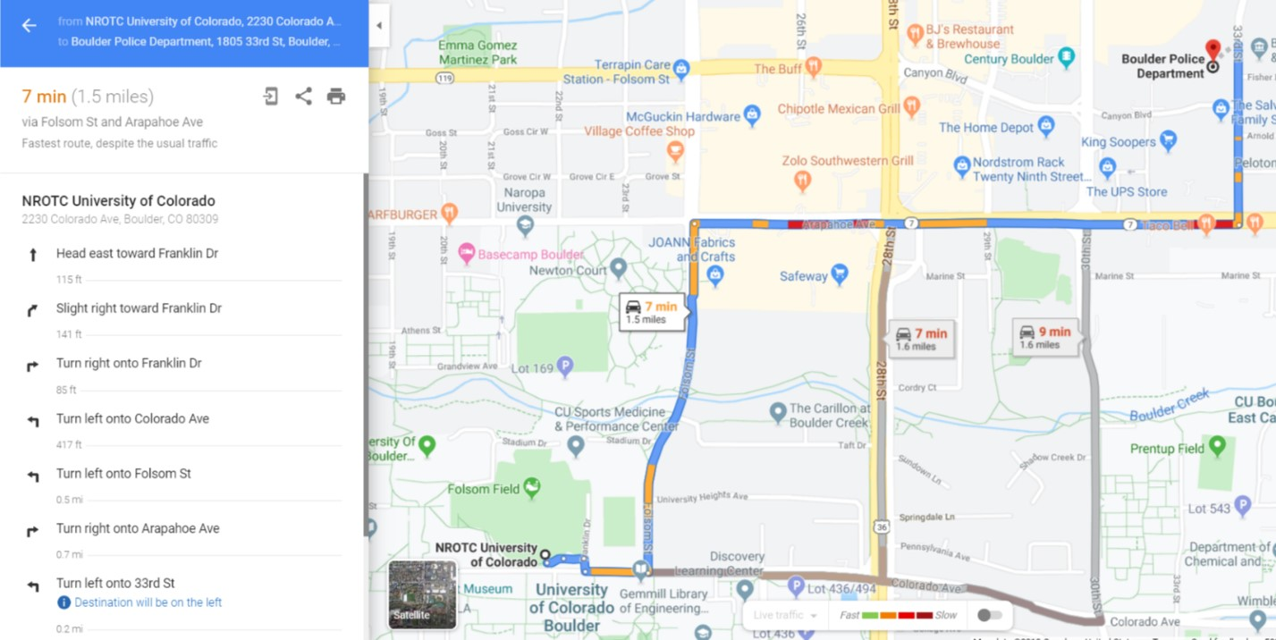

Enclosure (2)

Operational Risk Management

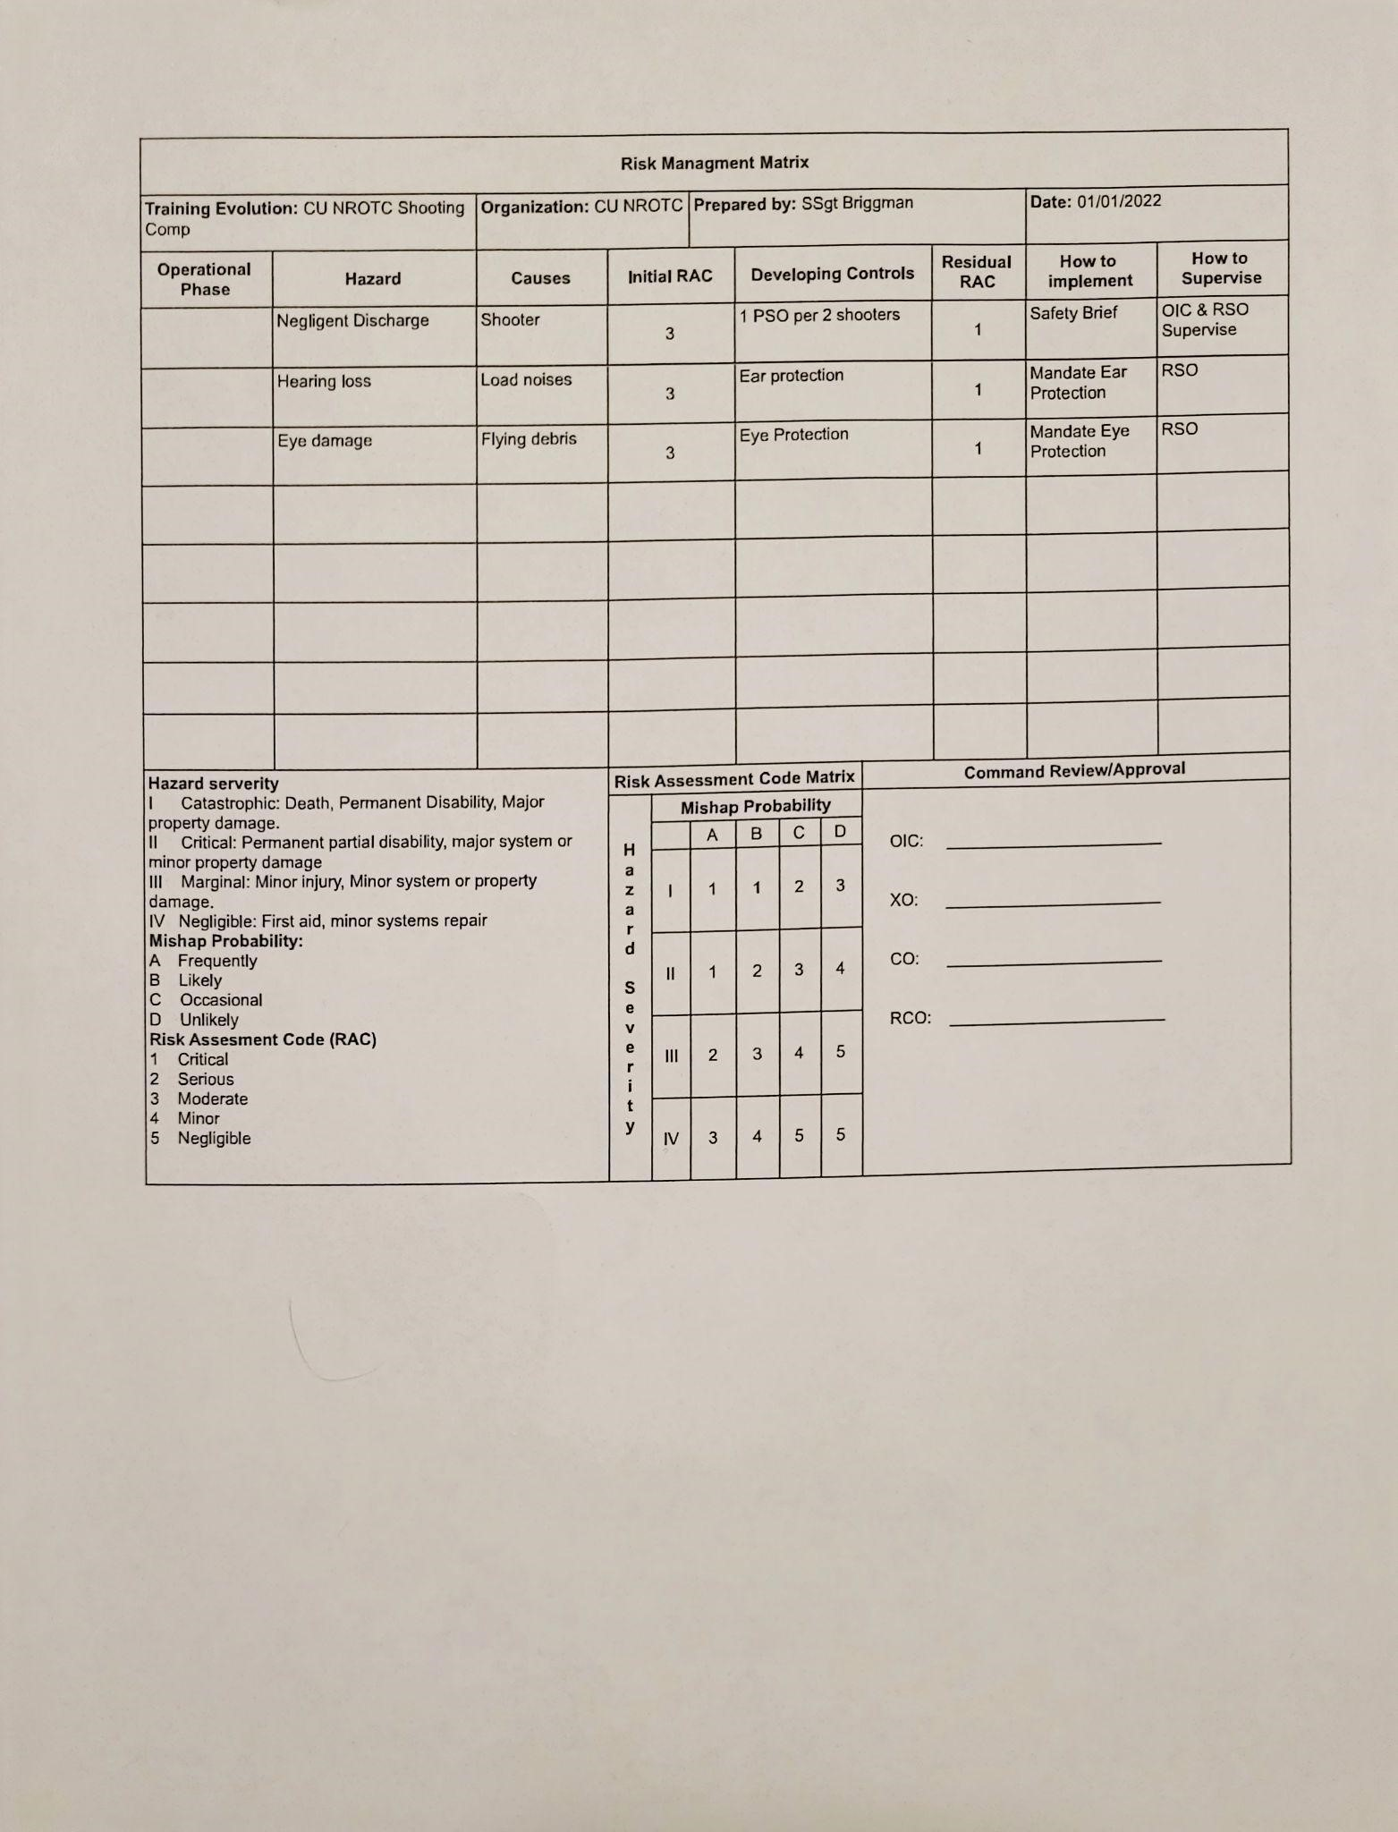

Enclosure (3)

Weapons Safety Rules:

* 1. Treat every weapon as if it were loaded.
  2. Never point a weapon as anything you do not intend to shoot.
  3. Keep your finger straight and off the trigger until you are ready to fire.
  4. Keep the weapon on safe until you intend to fire.
  5. Know your target, and what lies beyond and in between.

Enclosure (4)

Targets

1. Standard USPSA Target:

Enclosure (5)

**Schedule Example:**

**Shooting Times can change due to team registration.**

**Friday 0500-1800**

|  |  |
| --- | --- |
| **Start Time**​ | **School**​ |
| 0500​ | CU NROTC​ |
| 0600​ | USC​ |
| 0700​ | Purdue​ |
| 0800​ | Purdue 2nd Team​ |
| 0900​ | Berkeley ​ |
| 1000​ | Minnesota​ |
| 1100​ | Wisconsin​ |
| 1200​ | Missouri​ |
| 1300​ | Lunch​ |
| 1400​ | New Mexico ​ |
| 1500​ | Chicago NROTC​ |
| 1600​ | Nebraska​ |
| 1700​ | CU AROTC​ |
| 1800​ | Oklahoma ​ |

**Saturday 0500-1430**

|  |  |
| --- | --- |
| **Start Time​** | **School​** |
| **0500​** | **Florida​** |
| **0600​** | **CU AFROTC​** |
| **0700​** | **​CSU** |
| **0800​** | **​** |
| **0900​** | **​** |
| **1000​** | **​** |
| **1100​** | **​** |
| **1200​** | **​** |
| **1300​** | **​** |

Enclosure (6)

# CITY OF BOULDER – COLORADO

BOULDER POLICE DEPARTMENT FIRING RANGE PARTICIPATION FORM

# ADULT 18 YEARS OF AGE AND OLDER

Name: __________________________________________________________________________

Address: _________________________________________________________________________

City, State, Zip: ____________________________________________________________________

Phone: _______________________________

Emergency Information: ________________________________________________

Allergies: ____________________________________________________________

Special medical conditions/medications: _________________________________________________

__________________________________________________________________________________

Health Insurance Co. _____________________________Phone: _____________________________

**EMERGENCY MEDICAL AUTHORIZATION:**

In the event of injury or illness, I give permission to the city of Boulder and its employees and volunteers to obtain emergency medical treatment for me. I agree to pay all reasonable expenses for medical and related treatment obtained and further agree that the City of Boulder is not liable for payment of such expenses.

The City of Boulder may contact the following health care provider for medical treatment or other health care providers if the health care provider below is not available.

Physician or other Health Care Provider ________________________________________________

Address: _________________________________ Phone: _________________________________

Signature: __________________________________ Dated: _______________________

Printed name of party signing ________________________________________________________

PAGE 1/ 2 – CITY OF BOULDER FIRING RANGE WAIVER ‐ ADULT 18 YEARS OF AGE AND OLDER

Enclosure (7)

**ADULT RELEASE, LIABILITY WAIVER AND HOLD HARMLESS STATEMENT FOR PARTICIPATION IN THE BOULDER FIRING RANGE**

I understand that there are certain risks involved with participating in the City of Boulder Firing Range.

I hereby **RELEASE, DISCHARGE AND AGREE TO HOLD HARLMESS THE CITY OF**

**BOULDER, ITS OFFICERS, AGENTS, VOLUNTEERS, ASSISTANTS, AND EMPLOYEES** , from

any and every claim, demand or action of any kind arising due to bodily injury, illness, death and/or property damage resulting from any incident which may occur to me as a result of participating in the

city’s activities. This **RELEASE, LIABILITY WAIVER AND HOLD HARMLESS STATEMENT**

does not apply if such injury, death or damage is caused by the willful, reckless or gross negligence of the City of Boulder, its officers, agents, volunteers, assistants or employees.

Signed: __________________________________________________

Date: __________________________

Printed name of party signing: _______________________________________________

Enclosure (7)

**AFTER ACTION REPORT:**

What did you like about the competition?

What did you not like about the competition?

If you were in charge of this competition, what would you change for next year?

Enclosure (8)