Colorado Meet 2025
Schedule
Updated 27 Feb 2025
The following information is to aid guests as a quick reference sheet for locations, times, points of contact, and event details. All locations mentioned will be listed at the end with both Google and Apple map links.

Thursday, March 6th
Intro Brief (1900-2200)
Schools that have arrived on Thursday are invited to an optional intro brief where the student staff will give a brief overview of the schedule and field questions. This will take place in the Stad 140 classroom. The POC is MIDN 2/C Culverhouse @ brcu8196@colorado.edu (720)-800-2552

Friday, March 7th
Shooting (0500-2000)
Schools will arrive at Gate 6 of Folsom Field 30 minutes prior to their scheduled firing time to be transported by GOV to the Boulder Police Department Range, the UOD is camouflage utilities. The POC is MIDN 1/C Sturckow @ Travis.sturckow@colorado.edu , (281)-806-8903

Opening Ceremony & Field Meet (1400-1730)
All schools will be formed together in 4 mass formations by 1345 on Farrand Field, the UOD is camouflage utilities. Competitors scheduled to compete or attend other meetings during the ceremony are excused. Following the ceremony, we host the Iron 4/C competition. This will be a scored event. The OIC is MIDN 2/C Desousa @ Jacob.desousa@colorado.edu (408)-483-9220 Schools are also highly encouraged to bring their unit flags for photos. A diagram of the formation and your placement is at the end of this document. The POC is SSgt Hillyer @ andrew.hillyer@colorado.edu (603)-370-2476.

E-Race Brief and Gear Issue (1700)
MANDATORY for all E-Race competitors, an introduction brief & gear issue will be held at Gate 6 of Folsom Field. Any team that absolutely cannot attend must coordinate another time with the POC no later than 90 minutes before their scheduled race time. The POC is MIDN 2/C Wiltz @ jewi1870@colorado.edu (719)-428-8298.
Knowledge (1730-2200)
Schools will check in at Math 100 starting at 1645, the UOD is camouflage utilities. All spectators are welcome. The POC is MIDN 3/C Greene @ Cameron.greene@colorado.edu (512)-808-8501.

Erace Pool PT (1900-2200)
Schools will check in at the rec center 30mins prior to the start of their pool time. the UOD is PT gear. The POC is MIDN 2/C Wiltz @ jewi1870@colorado.edu (719)-428-8298.

Optional Events
TDG’s/Cove Showing Fri-(1730-2000) Sat- (0800-1400)
Participate in a TDG using our sand table and practice your tactical and critical thinking. We will also be demonstrating our Cove system. There is no registration required and no price to pay. This will be on a first come first serve basis. The POC for this is MIDN 2/C Desousa @ Jacob.desousa@colorado.edu (408)-483-9220
NSW Brief W/ Seals and EOD Fri-(1130-1330)
This will take place in room KOBL 225. Come talk to members of the NSW community and learn about their mission. The POC for this is MIDN 2/C Culverhouse @ brcu8196@colorado.edu (720)-800-2552

Saturday, March 8th
Drill 0630-1300
Schools will check in at Kittredge Field 15 minutes prior to their start time, the UOD is camouflage utilities. The POC is MIDN 2/C Depue @ gavin.depue@colorado.edu (910)-742-5081.

Shooting (0500-1400)
Shooting will continue on Sat the 8th, the same rules and regulations will apply. The POC is MIDN 1/C Sturckow @travis.sturckow@colorado.edu, (281)-806-8903

E-Race 0500-1500
Schools will check in to race 30 minutes prior to their scheduled time at the Buff Statue. The POC is MIDN 2/C Wiltz @ Jevan.wiltz@colorado.edu (719)-428-8298.

Closing Ceremony 1600
Schools will be seated in Chem 140 by 1545, the UOD is unit polos and khakis, teams finishing events without time to change may stay in their current uniform. The POC is MIDN Huttenhower @ thhu9404@colorado.edu, (970)-230-2479

Locations
Folsom Field/Gate 6/CU NROTC
Apple: https://maps.apple.com/?ll=40.008643,-105.266173&q=Dropped%20Pin&t=h
Google: https://maps.app.goo.gl/pQUtwt9XeZzZwXxg8?g_st=in

STAD 135
Apple: https://maps.apple.com/?ll=40.008444,-105.266488&q=Dropped%20Pin&t=h
Google: https://maps.app.goo.gl/wqZNH1TAUGqxWYcv8?g_st=ic

STAD 140
Apple: https://maps.apple.com/?ll=40.008896,-105.265873&q=Dropped%20Pin&t=h
Google: https://maps.app.goo.gl/AZUVZ6z8Y1JdQCvY6?g_st=ic

Buff Statue
Apple: https://maps.apple.com/?ll=40.008473,-105.267742&q=Dropped%20Pin&t=h
Google: https://maps.app.goo.gl/9snvBHnHYqL3ozBY6?g_st=ic

Farrand Field
Apple: https://maps.apple.com/?address=1669%20Euclid%20Ave,%20Boulder,%20CO%2080309,%20United%20States&auid=5547008713780892227&ll=40.005967,-105.267492&lsp=9902&q=Farrand%20Field&t=h
Google: https://maps.app.goo.gl/tGYRExhc8NCfRVj4A?g_st=ic

Kittredge Field
Apple: https://maps.apple.com/?ll=40.002921,-105.259550&q=Dropped%20Pin&t=h
Google: https://maps.app.goo.gl/zrGZfxVuLrS3SyZd7?g_st=ic

Math 100
Apple: https://maps.apple.com/?address=2200%20Colorado%20Ave,%20Boulder,%20CO%20%2080310,%20United%20States&auid=16975063652771134056&ll=40.007955,-105.265887&lsp=9902&q=Jerry%20Crail%20Johnson%20Earth%20Sciences%20%26%20Map%20Library&t=h
Google: https://maps.app.goo.gl/UPC4FjuJ9dpdz1mc7?g_st=ic

Chem 140
Apple: https://maps.apple.com/?address=1606%20Central%20Campus%20Mall,%20Boulder,%20CO%20%2080310,%20United%20States&auid=3840364318887417945&ll=40.007402,-105.271093&lsp=9902&q=Cristol%20Chemistry%20%26%20Biochemistry&t=m
Google: https://maps.app.goo.gl/ziPVmQmeJuLXPkxeA

Balch Fieldhouse
Apple: https://maps.apple.com/?ll=40.009071,-105.267920&q=Dropped%20Pin&t=h
Google: https://maps.app.goo.gl/c7ocbgBM5PXWwWQ5A?g_st=ic

Humanities 150
Apple: https://maps.apple.com/?ll=40.009345,-105.271817&q=Dropped%20Pin&t=h
Google: https://maps.app.goo.gl/3DYMFp9LzxFA3uZT8?g_st=ic

Glenn Miller
Apple: https://maps.apple.com/?address=1669%20Euclid%20Ave,%20Boulder,%20CO%20%2080310,%20United%20States&auid=4087275592270180196&ll=40.006735,-105.271568&lsp=9902&q=Glenn%20Miller%20Ballroom&t=h
Google: https://maps.app.goo.gl/TbDaJMSep3iDSmQ18?g_st=ic

CU Recreation Center
Apple: https://maps.apple.com/?ll=40.009603,-105.269662&q=Dropped%20Pin&t=h
Google: https://maps.app.goo.gl/PEf7e15hBVq9xadQ9?g_st=ic

Recommended Parking Garage (Folsom Parking)
Apple: https://maps.apple.com/?address=2200%20Stadium%20Dr,%20Boulder,%20CO%20%2080310,%20United%20States&auid=8015085631275187599&ll=40.010463,-105.264414&lsp=9902&q=Parking&t=h
Google: https://maps.app.goo.gl/mMkApTRtbeuqvnsLA?g_st=ic

Chautauqua Park
Apple: https://maps.apple.com/?address=900%20Baseline%20Rd,%20Boulder,%20CO%20%2080302,%20United%20States&auid=3328881260573032957&ll=39.998886,-105.281031&lsp=9902&q=Chautauqua%20Park&t=h
Google: https://maps.app.goo.gl/QmTeEc9ucLE2Ecie6?g_st=ic

Foothills Hospital
Apple: https://maps.apple.com/?address=4747%20Arapahoe%20Ave,%20Boulder,%20CO%20%2080303,%20United%20States&auid=9001308314184469967&ll=40.016456,-105.236291&lsp=9902&q=Foothills%20Hospital&t=h
Google: https://maps.app.goo.gl/zvbq6YEVn9arGEbN7?g_st=ic
KOBL 225
Apple: https://maps.apple.com/?address=995%20Regent%20Dr,%20Boulder,%20CO%20%2080310,%20United%20States&auid=1670858549990058645&ll=40.005446,-105.263513&lsp=9902&q=Koelbel%20Building%20-%20Leeds%20School%20of%20Business&t=m

Google: https://maps.app.goo.gl/37hWR9vH3des9LYg8

Opening Ceremony Formation
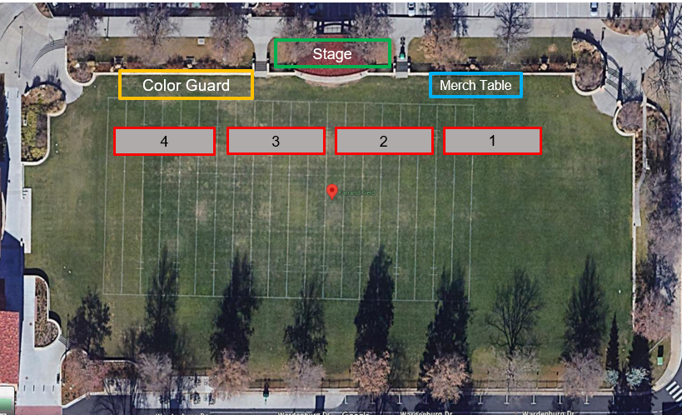

Unit
CU NROTC
University of South California
Purdue University
University of California, Berkeley NROTC
University of Minnesota NROTC
University of Wisconsin
University of Missouri NROTC
University of New Mexico
Chicago NROTC Consortium
University of Nebraska-Lincoln NROTC
Army ROTC Golden Buffalo battalion
University of Oklahoma NROTC
Marine Officer Selection Office, Denver
University of Pennsylvania NROTC
University of Florida NROTC
University of Texas NROTC
AFROTC Detachment 105
University of Arizona NROTC
The Ohio State University
Arizona State University
CSU Army ROTC
TOTAL 21

