20 FEB 2025

From: Colorado Meet Officer in Charge, University of Colorado Naval Reserve Officers Training Corps Unit, Boulder, Colorado

To: All Hands

Subj: COLORADO MEET 2025 DRILL COMPETITION LETTER OF INSTRUCTION

Encl: (1) Squad Drill Cards / Indoor Drill Cards

(2) Squad Drill Scoring Sheets

(3) Color Guard Drill Card and Scoring Sheet

(4) Operational Risk Management

(5) CU Boulder Campus Map

(6) Map to Foothills Hospital

(7) Drill Events Timeline, Gear List, and Volunteer Roles

(8) After Action Report

1. Orientation. The drill competition and color guard competition will be taking place on the Kittredge Fields. In case of inclement weather, squad drill and color guard will remain at the Kitt Fields, and volunteers associated with CU will clear the drill decks of snow. See Enclosure (5) for a map of the facilities.

2. Situation. To host a challenging and fair drill competition between the participating battalions across the nation at the University of Colorado Boulder on 8 March 2025.

3. Mission. The NROTC Unit at CU Boulder will host the annual Colorado drill competition to allow schools to compete in squad drill and color guard.

4. Execution.

a. Concept of Operations. The concept of operations will be conducted in 4 phases.

(1) Phase I: Preparation.

(a) The Drill OIC and AOIC will prepare for the competition, the venue, and any other logistical considerations to ensure the event proceeds smoothly. They will meet with the Colorado Meet OIC and active-duty staff to plan for the event. They will also meet with participating battalion members to train them for the competition.

(2) Phase II: Execution.

(a) At 0600, all judges, runners, and necessary personnel for the squad drill and color guard events will arrive at their assigned location.

(b) Squad drill event teams may practice before their report time on available space on the main competition field at Kitt Fields, or on any adjacent open fields. Color guard teams may practice on any available space on Kitt Fields. Rubber rifles will be available for the on-deck teams to practice if they wish. In case of weather that interferes with the competition, CU volunteers will work to clear the field of snow, and teams will be notified to wear warming layers and gloves. In the event of severely inclement weather, the competition will be cancelled. No teams will be permitted to practice with drill rifles. Rifles will be issued prior to a team's go time. See enclosure (5) for a labeled map of the CU main campus, see enclosure (7) for team schedule.

(c) All teams will be present at their corresponding competition area no later than 20 minutes before their start time to check in, prepare equipment and ensure accountability. If a team member cannot make it 20 minutes prior due to competing in another event, that is acceptable if they are ready to begin at the team’s designated start time.

(d) The competition will commence at 0630. Squad teams will compete in 30-minute time slots. Color guards will compete in 30-minute time slots. These time slots include time for the senior judge of the event to debrief teams on their scores.

(e) Upon the completion of each team’s squad drill and color guard event they will have 30 minutes to review and contest their score. Any contentions will be brought directly to the Drill OIC. Any changes made to the score will be made in accordance with the MCO 5060.20. All scores will be final after the 30-minute contention window.

(3) Phase III: Evaluation. As each team finishes their competition, the runner will receive the score sheet from the senior judge and transport it to Headquarters.

(4) Phase IV: Clean Up. The OIC and AOIC will make sure that Kitt Fields are clean and secure. All gear used at any locations will be returned to their respective places back at the NROTC unit.

c. Tasks.

(1) Drill OIC. The Drill OIC is responsible for all email correspondence and communication with teams. The Drill OIC is responsible for planning a fair and effective competition.

(2) Drill AOIC. The Drill AOIC will assist the Drill OIC with all email correspondence and communication with the teams. The Drill AOIC is also responsible for gear accountability. Drill AOIC will assist in ensuring that CUNROTC drill team is prepared for competition.

(3) Judges. The judging will be done by the visiting unit AMOIs. There will be a suitable number of judges at each event to ensure no AMOI is judging their own school. Squad drill and color guard will be judged by 2 AMOIs. Each judge will grade the team individually. The score for the team will be the average of all scores from the judges. See enclosure 7 for AMOI judging schedule.

(4) Runners. The runners are responsible for transporting score sheets from Kitt Fields to Headquarters.

(5) Competing Members. The competing members are responsible to show up on time to their designated event with the proper uniform and equipment ready to execute movements from the drill card. Drill cards must be memorized, reading off a physical card is not authorized. Unit leaders should contact the Drill OIC in case of any changes the day of. In past years, teams have chosen to go before their original time slot due to the event moving quickly. This is optional but unit leaders may be contacted by the Drill OIC to inform them they can compete ahead of schedule if they wish.

(6) Rifle Handlers. The rifle handlers will maintain accountability for all rifles on hand and on deck. They will log the number of rifles, the time they have been checked out, and the name of the school. There will be rifle handlers at Kitt Fields.

d. Coordinating Instructions.

(1) The Drill OIC and AOIC will be available to contact prior to the event via email and cell phone. During the event cell phones will be the singular means of communication with the Drill OIC and AOIC. Radios may be used for intra-event comms.

(2) The competition will commence at 0630 for squad

drill and color guard competitions. Each team will be given an individual start time, which is when their individual event will commence. Teams are required to arrive 20 minutes prior to this given start time to check in, prepare equipment, and ensure accountability. Any team arriving after their designated start time will be disqualified from the event. See enclosure (7) for the competition timeline.

(3) Squad drill decks will be 50 yd x 50 yd. The color guard drill deck will be 30 yd x 30 yd.

(4) Squad drill and color guard will each be given one drill card to practice prior to the competition. Teams will perform that drill card at the event.

(5) Active duty (MECEPs and OCs) will be prohibited

from competing in all drill events.

(6) All drill movements will be executed in accordance with

MCO 5060.20.

(7) All pre-competition practice for all drill events will take place in the available space at or adjacent to the corresponding competition location. Rubber rifles may be available, drill rifles will not be authorized or available.

(8) At the completion of each squad drill and color guard performance, the head judge will debrief the competing team (unit leader) on their score.

(9) Unit Leader Instructions. At the scheduled time,

the unit leader will wait with the members of their squad. Upon start time and readiness of judges, the unit commander will take a position in the drill area and command the squad to fall in.

(a) Upon issuance of the command “fall-in”, all movements by the squad and commands given by the unit commander will be graded.

(b) The procedure for forming the squad is as follows:

1. FALL IN

2. REPORT

3. INSPECTION ARMS

4. PORT ARMS

5. ORDER ARMS

(c) The unit commander will then execute an about-face and report to the Senior Judge. When reporting to the Senior Judge, the unit commander will say **“Good Morning (Rank of Senior Judge, MIDN (last name), (school name) formed for the conduct of drill.”**

(d) Once the Senior Judge receives the report, cuts his/her salute, and steps off, the unit commander will cut his/her salute and immediately assume the Senior Judges previous position by taking three paces forward and executing an about-face. The unit commander will execute all stationary drill movements from this position (six paces distance from the squad and centered).

(e) After the squad has been formed, the unit commander has reported, and the Senior Judge has given the verbal signal, the unit and unit commander will execute the drill card. The drill card must be executed from memory.

(f) To use a “Free Movement” (any movement deemed necessary by the unit commander to legally complete the drill card), the unit commander must clearly raise his/her left hand high above his/her head before and while executing this movement. If the hand is not raised, it will be considered an added movement and be penalized as such. Unit commanders are allowed one (1) “Free Movement”.

(g) Following the last command on the drill card and completion of their competition, the unit commander will return to their CU NROTC liaison for further instruction.

(e) Color guard teams will not be required to professionally report into the judges or request permission to use the drill pad. When the team is ready to begin, they will form up in a professional manner where they wish to begin on the drill pad and execute the drill card.

(10) Evaluations. AMOIs of schools participating in the competition will serve as judges. Judges will not be allowed to judge their own school and must switch off when their school begins to compete. See enclosure (7) for the judging schedule.

(a) The unit leader will also be evaluated in addition to the members of the squad. Unit leaders will be evaluated on every command that is given, with points being deducted for giving improper commands, commands given on the wrong foot, commands given in the wrong sequence, and failure to make obvious corrections.

(b) Every point deduction will be made for failure to properly comply with MCO 5060.20.

(c) Upon completion of the drill card, unit leaders will wait for feedback from the judges with their squad/platoon.

(11) Scoring. Each judge will have a copy of the score sheets and will fill out the score sheet based on the performance of the team they are judging. The final score for the team will be calculated by averaging the scores of all judges.

(a) Squad drill will be judged by 2 AMOIs and color guard will be judged by 2 AMOIs.

(b) If a unit leader disputed a call by the judges, the unit leader must bring it to their attention during the Unit Leader Debrief. If a discrepancy is not brought up during the Unit Leader Debrief, the right to challenge shall be forfeited.

(12) The use of tape or any form of a marker during squad drill and color guard is prohibited.

4. Administration and Logistics.

a. Administration.

(1) Squad drill. The teams will be composed of 1 unit leader and a minimum of 6 and a maximum of 12 midshipman squad members. The only rifles allowed in squad drills are demilitarized M16 rifles. The unit leader can carry a rifle or a sword, while each squad member carries a rifle. No guide will be used in squad drill. All movements will be performed as though the team is “2nd Squad” within a platoon to demonstrate the movements.

(2) Color Guard. Teams will only be composed of 5 midshipmen: right rifle, National Ensign, Marine Corps Colors (carried by a Marine option), Navy Colors (carried by a Navy option), and left rifle. The only rifles allowed in Color Guard are demilitarized M16 rifles or demilitarized M1 rifles.

(3) Unnecessary Noises. There will be no loud noises from the spectators to allow a fair, respectful, and quiet environment for the rest of the teams competing in the drill competition. Point deductions for noise will be deducted at the judges’ discretion.

(4) Judges. Score sheets will be shown to the teams after their performance and judges will explain their reasoning for all point deductions.

(5) Drill Manual. Squad drill and color guard will be judged according to the Marine Corps Manual (MCO 5060.20). All movements will be judged based on the criteria in the manual. The Marine Corps Manual (MCO 5060.20) is available online at all times for reference but will also be available to be referenced on the day of the competition through drill personnel.

(6) Tie Breaker. In the event of a tie for squad drill or color guard, the unit leader’s score will be used for a tiebreaker. The team with the highest team leader average will win the tiebreaker.

b. Logistics.

(1) Uniform.

(a) The uniform for all drill events will be NWU Type III/MARPAT utilities (no ribbons/rank insignia).

(b) NWU Type III/MARPAT utilities are authorized to be worn on CU Campus for the Colorado Meet as well as to and from the hotel or accommodations visiting teams choose to stay in. Boots and utilities is also an authorized uniform for the Colorado Meet, however, it is not allowed for competing in drill events.

(2) Rifle Check Out. CU Boulder NROTC will provide **all** M16 service rifles for squad drill. These rifles will be checked out from the rifle handlers to each team prior to their competition, and then checked back in to the rifle handlers immediately after their event is over. **If a school wishes to use its own rifles for squad and platoon drill**, they may do so, but **CU NROTC will not be responsible for any missing rifles**.

(3) **It is up to the discretion of color guard teams if they would like to bring their own M1s/M16s or use CU Boulder NROTC’s.** **If they choose to use CU Boulder NROTC’s, the team must email the Drill OIC ASAP, an absolute minimum of two weeks before the competition.** On the day of the drill competition, there will be designated rifle handlers at each location. However, if you are bringing your own rifles, your unit is responsible for accountability for them. CU NROTC will not provide colors for color guard, nor swords or guide ons for squad and platoon drill.

(4) Warming Areas. The Kittredge Commons center will be open for teams to utilize as a warming area and for access to restrooms. CU personnel will help direct team members to the Commons, which is in the middle of the Kittredge dormitory buildings. See Enclosure (5) for a map of the area.

5. Command and Signal.

a. Command. Points of contact for all drill-related questions can be referenced below.

b. Signal. Cell phones and/or radios will be used by all event staff to reach the COC and all checkpoints as deemed necessary.

6. Points of Contact.

a. MIDN 2/C Culverhouse (Meet OIC):

[brandon.culverhouse@colorado.edu](mailto:brandon.culverhouse@colorado.edu)

b. MIDN 2/C Huttenhower (Meet AOIC):

[teddy.huttenhower@colorado.edu](mailto:teddy.huttenhower@colorado.edu)

c. MIDN 2/C DePue (Drill OIC):

[gade3973@colorado.edu](mailto:gade3973@colorado.edu)

+1(910)–742-5081

d. MIDN 2/C Thayer (Drill AOIC):

[owen.thayer@colorado.edu](mailto:owen.thayer@colorado.edu)

**SQUAD DRILL CARD**

|  |
| --- |
| 1. FORM THE PLATOON AT CLOSE INTERVAL  2. EXTEND ON LINE  3. PORT ARMS  4. LEFT SHOULDER ARMS  5. ORDER ARMS  6. PRESENT ARMS  7. PARADE REST  8. COLUMN RIGHT FROM THE HALT  9. COLUMN RIGHT  10. LEFT OBLIQUE/MARK TIME  11. RIGHT FLANK RETURN TO COLUMN  12. COLUMN LEFT (REPEAT)  13. LEFT FLANK RETURN TO COLUMN  14. MARCH TO THE REAR (REPEAT)  15. COLUMN HALF LEFT (REPEAT)  16. MARCHING MANUAL (PORT, LEFT SHOULDER, RIGHT SHOULDER)  17. COLUMN LEFT  18. PASS IN REVIEW  19. FALL OUT |

**SQUAD DRILL SCORING SHEET**

|  |  |  |  |
| --- | --- | --- | --- |
| SCHOOL: | PLT OR SQD: | EVALUATOR: | SCORE:  /100 |

|  |  |  |
| --- | --- | --- |
| MOVEMENT | REMARKS | SCORE |
| 1. FORM THE PLATOON/SQUAD (AT CLOSE INTERVAL) | EXECUTION(0.5), DIST(0.5), ALIGN(0.5), REPORT(0.5), COVER(0.5) IA 7COUNT (1.0), SIZING(0.5) | /5 |
| 2. EXTEND ON LINE | EXECUTION (0.5), T-ARMS(0.5), ALIGN(1.0), COVER(0.5), ARMSWING(0.5), GUIDE/SQ LDRS(0.5), FINGERTIPS (0.5) | /5 |
| 3. PORT ARMS | EXECUTION/SNAP & PRECISION(0.5/0.5), WRIST(0.5), R-FOREARM(0.5), ANGLE(0.5), 4INCHES (0.5), L-HAND PLACEMENT(0.5), QTC (0.5) | /5 |
| 4. LEFT SHOULDER ARMS | EXECUTION/SNAP & PRECISION(0.5/0.5), CARRIAGE (0.5) ANGLE(0.5) WRIST (0.5) FOREARM(0.5) HEELS VISIBLE(0.5) QTC (0.5) | /5 |
| 5. ORDER ARMS | EXECUTION/SNAP & PRECISION(0.5/0.5),3"(1.0), T-SEAM(0.5), TOE TO TOE(1.0), QTC (0.5) | /5 |
| 6. PRESENT ARMS | EXECUTION/SNAP & PRECISION(0.5/0.5),L-UPPER ARM(0.5),L-WRIST(0.5), L-FOREARM(0.5), R-HAND PLACEMENT(0.5),SLIP RING (0.5), QTC (0.5) | /5 |
| 7. PARADE REST | EXECUTION/SNAP & PRECISION(0.5/0.5), CARRIAGE (0.5) ANGLE(0.5) WRIST (0.5) FOREARM(0.5) HEELS VISIBLE(0.5) QTC (0.5) | /5 |
| 8. COLUMN RIGHT FROM THE HALT | EXECUTION(1.0), DISTANCE(0.5), COVER(0.5), ALIGN,(0.5) 30”STEP(0.5), INT(1.0) | /5 |
| 9. COLUMN RIGHT | EXECUTION(1.0), DISTANCE(0.5), COVER(0.5), ALIGN,(0.5) 30”STEP(0.5), INT(1.0) | /5 |
| 10. LEFT OBLIQUE/MARK TIME | EXECUTION(0.5), #STEPS(1.0), COVER(0.5), INT(0.5), ALIGN(0.5), 15”-30”(0.5), 30”-15”(0.5) | /5 |
| 11. RIGHT FLANK RETURN TO COLUMN | EXECUTION(0.5), #STEPS(1.0), COVER(0.5), INT(0.5), ALIGN(0.5), 15”-30”(0.5), 30”-15”(0.5) | /5 |
| 12. COLUMN LEFT (REPEAT) | EXECUTION(0.5), #STEPS(1.0), COVER(0.5), INT(0.5), ALIGN(0.5), 15”-30”(0.5), 30”-15”(0.5) | /5 |
| 13. LEFT FLANK RETURN TO COLUMN | EXECUTION(0.5), #STEPS(1.0), COVER(0.5), INT(0.5), ALIGN(0.5), 15”-30”(0.5), 30”-15”(0.5) | /5 |
| 14. MARCH TO THE REAR (REPEAT) | EXECUTION(1.0), 15”STEP(1.0), INT(0.5), ALIGN(0.5),  COVER (0.5), ARMSWING (0.5) | /5 |
| 15. COLUMN HALF LEFT (REPEAT) | EXECUTION(0.5), ATB(1.0), 30"STEP(1.0), 1/2 STEPS(1.0), INT(0.5) | /5 |
| 16. MARCHING MANUAL(PORT, LEFT SHOULDER, RIGHT SHOULDER) | EXECUTION(1.0), DISTANCE(0.5), COVER(0.5), ALIGN,(0.5) 30”STEP(0.5), INT(1.0) | /5 |
| 17. COLUMN LEFT | EXECUTION(1.0), DISTANCE(0.5), COVER(0.5), ALIGN,(0.5) 30”STEP(0.5),  INT(1.0) | /5 |
| 18. PASS IN REVIEW | EXECUTION(0.5), ALIGN(1.0), WPNS ANGLE(0.5), ARMSWING(0.5), DIST(0.5), COVER (0.5), GUIDE (0.5) | /5 |
| 19. FALL OUT | HESITATION (1.0) DROP IN PLACE (1.0), RUN (1.0),  PORT ARMS(1.0) | /5 |
| 20. UNIT LEADER | PERSONAL APPEARANCE, SALUTE, REPORTING, POSITION, COMMANDS, CADENCE/PROJECTION, CORRECTIONS/JUDGEMENT, RIFLE/SWORD CARRIAGE, FOLLOWING CARD, MILITARY PRESENCE. | /5 |

Enclosure (1)

**Color Guard Drill Card**

1. Attention
2. Carry Colors
3. Forward March
4. Left About
5. Forward March
6. Left About
7. Forward March
8. Eyes Right
9. Ready Front
10. Right Wheel
11. Forward March
12. Right Wheel x2
13. Forward March
14. Left Wheel
15. Forward March
16. Halt
17. Present Colors
18. Order Colors
19. At Ease
20. Dismissed (not graded)

Enclosure (2)

**COLOR GUARD DRILL CARD AND SCORING SHEET**

|  |  |  |  |  |  |  |  |
| --- | --- | --- | --- | --- | --- | --- | --- |
| University: | | | |  | | | |
| Judge: | | | |  | | | |
| Movement | | Score | | | | | Comments |
| 1 | Attention | 1 | 2 | 3 | 4 | 5 |  |
| 2 | Carry Colors | 1 | 2 | 3 | 4 | 5 |  |
| 3 | Forward March | 1 | 2 | 3 | 4 | 5 |  |
| 4 | Left About | 1 | 2 | 3 | 4 | 5 |  |
| 5 | Forward March | 1 | 2 | 3 | 4 | 5 |  |
| 6 | Left About | 1 | 2 | 3 | 4 | 5 |  |
| 7 | Forward March | 1 | 2 | 3 | 4 | 5 |  |
| 8 | Eyes Right | 1 | 2 | 3 | 4 | 5 |  |
| 9 | Ready Front | 1 | 2 | 3 | 4 | 5 |  |
| 10 | Right Wheel | 1 | 2 | 3 | 4 | 5 |  |
| 11 | Forward March | 1 | 2 | 3 | 4 | 5 |  |
| 12 | Right Wheel x2 | 1 | 2 | 3 | 4 | 5 |  |
| 13 | Forward March | 1 | 2 | 3 | 4 | 5 |  |
| 14 | Left Wheel | 1 | 2 | 3 | 4 | 5 |  |
| 15 | Forward March | 1 | 2 | 3 | 4 | 5 |  |
| 16 | Halt | 1 | 2 | 3 | 4 | 5 |  |
| 17 | Present Colors | 1 | 2 | 3 | 4 | 5 |  |
| 18 | Order Colors | 1 | 2 | 3 | 4 | 5 |  |
| 19 | At Ease | 1 | 2 | 3 | 4 | 5 |  |
| 20 | Unit Leader Score | 1 | 2 | 3 | 4 | 5 |  |
| **21** | **Total Score:** |  |  |  |  |  | **/100** |

**OPERATIONAL RISK MANAGEMENT**

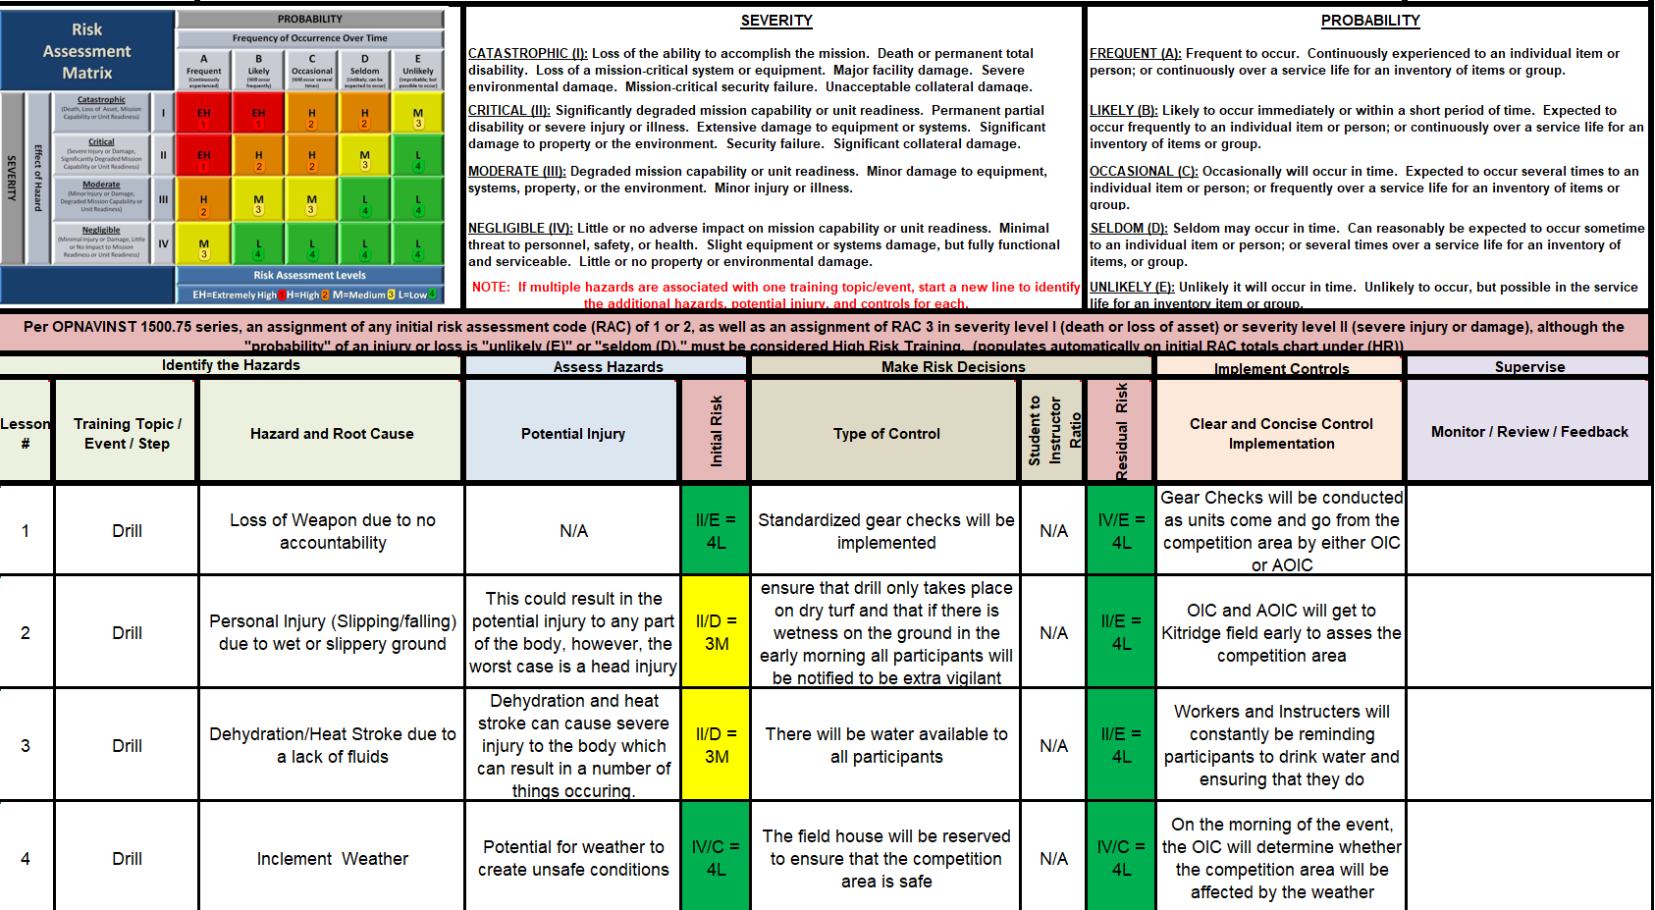

Enclosure (4)

In event of dangerous weather, competition will be cancelled

Kittredge Commons (warming area/restrooms)

Kittredge Fields (Drill & Colorguard)

CU NROTC Battalion Spaces

(Gate 6, Folsom Field)

**CU BOULDER CAMPUS MAP**

1. Gate 6. The entrance to the CU NROTC battalion spaces, which are located inside the stadium of Folsom Field.

2. Kittredge Fields. The location of the color guard and squad drill competition.

3. Kittredge Commons. The location of the warming areas and restrooms for teams to utilize during the day.

**MAP TO FOOTHILLS HOSPITAL**

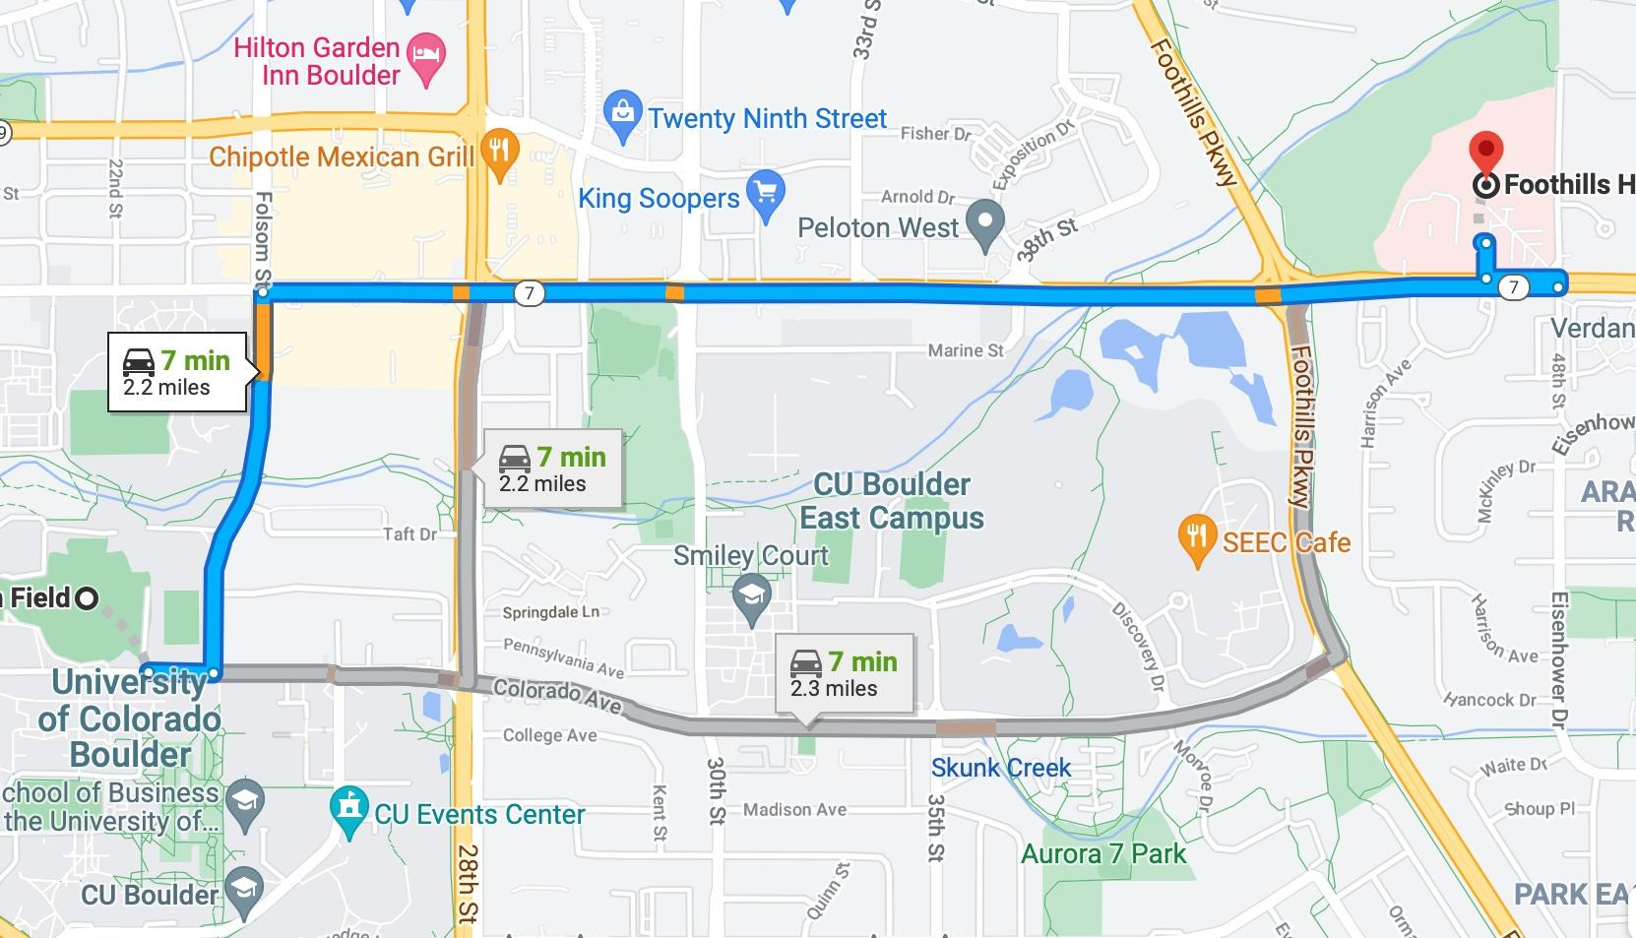

* + - 1. Start at the CU Boulder football stadium/NROTC unit.
      2. Go East on Colorado Avenue and then turn North onto Folsom St.
      3. Follow Folsom St. until Arapahoe Ave, then turn East.
      4. Make a U-Turn at 48th St. and then turn right into the parking lot.

Enclosure (6)

**DRILL EVENT TIMELINE**

|  |  |  |
| --- | --- | --- |
| **Time** | **Squad Drill** | **Squad Drill Judges** |
| 0630-0700 | CU NROTC |  |
| 0700-0730 | Univ of Minnesota |  |
| 0730-0800 | Purdue |  |
| 0800-0830 | AFROTC Det 105 |  |
| 0830-0900 | Univ of Southern California |  |
| 0900-0930 | Univ of Oklahoma |  |
| 0930-1000 | Chicago NROTC |  |
| 1000-1030 | Univ of Nebraska-Lincoln |  |
| 10 30-1100 | Univ of Missouri |  |
| 1100-1130 | Univ of New Mexico |  |
| 1130-1200 | Arizona State |  |
| 1200-1230 | Chicago NROTC Squad 2 |  |
| 1230-1300 |  |  |
| 1300-1330 |  |  |
| 1330-1400 |  |  |

|  |  |  |
| --- | --- | --- |
| **Time** | **Color Guard** | **Color Guard AMOI Judges** |
| 0630-0700 | UC Berkeley |  |
| 0700-0730 | CU NROTC |  |
| 0730-0800 | AFROTC Det 105 |  |
| 0800-0830 | Chicago NROTC |  |
| 0830-0900 | Univ of Oklahoma |  |
| 0900-0930 | Univ of Nebraska-Lincoln |  |
| 0930-1000 | Univ of New Mexico |  |
| 1000-1030 | Purdue Univ |  |
| 1030-1100 | Univ of Minnesota |  |
| 1100-1130 | Univ of Missouri |  |
| 1130-1200 | Univ of Southern California |  |
| 1200-1230 | Arizona State |  |
| 1230-1300 |  |  |
| 1300-1330 |  |  |
| 1330-1400 |  |  |

Enclosure (7)

**VOLUNTEERS AND GEAR**

Gear List

1. Drill rifles – 30 M16A1 rifles, 4 M1 Garands
2. Colors (1 American, 1 USMC, 1 USN) and harnesses
3. Printed scoresheets (30 SQD, 30 CG)
4. Clipboards (5)
5. USMC Drill Manual (MCO 5060.20)

Volunteers needed - EST 14 PAXs (with inclement weather, 24 needed)

1. check-in (4)
2. score runners (4)
3. Rifle handlers (6)
   1. 1-2 MECEP’s preferred, 1 minimum
4. Pre-meet working party - clean and lubricate rifles
   1. 10+ PAX the day before (Friday)
5. Snow duty volunteers (10+) – pulled from other groups as necessary

**AFTER ACTION REPORT:**

What did you like about the competition?

What did you not like about the competition?

If you ran this competition, what would you change for next year?

Other comments, concerns, or suggestions:

Enclosure (8)