Goals of Focus Group/Course Interview:
Evaluate student attitudes and perceptions of core undergraduate Mechanical Engineering courses. Courses will be evaluated every third academic year by a minimum of one faculty member, who is not teaching the course within the semester of evaluation, and one undergraduate advisor staff member.

Course Interview Procedure

Prior to Course Interview:

- Set up an associated survey in Qualtrics. Sample is included on pgs 3-4. Use bit.ly or a similar site to shorten the link, so that it can be easily shared with students during the Interview. Print several paper copies of the survey for students without smart phones.

- Print enough copies of the course interview worksheet (see pg 5) that you’ll have one for every 3 students. Print the learning objectives for the course on the back of the worksheet.

- Ask the course instructor for any particular feedback related to the course that they would like. For example, do they want suggestions for improving the labs? Or for making lectures more interactive?

During Course Interview:
- Introduce yourself and your partner (again, including one faculty member not currently teaching the course and one undergraduate advisor).
- Explain that you are there to conduct an interview about the course with the goal of improving the course for future terms. Specific points to mention include:
  - Each core undergrad course is evaluated once every three years as part of our regular internal assessment of every core MCEN course. Through this process, we aim to keep course material updated and relevant to the current engineering environment.
  - A task force will be held during the following semester that students participating in the focus group will also be invited to participate in. During the task force, we consider outcomes from the Course Interview and discuss potential changes for this course in future semesters.
  - All feedback is anonymous and will not be shared with the course instructor until after grades are submitted.
- Explain the process for the course interview:
  - Work in groups of 3-4 to fill out a group feedback form that we provide. List strengths and potential improvements related to the course, with a focus on providing clear, specific, actionable recommendations. For example, feedback like “appreciated being asked to explain our results at the end of each lab report” is more helpful than “liked lab report structure.”
  - For this process, we request feedback on the course itself rather than on the instructor or their teaching methods. Our goal is to collect feedback that could help us to make the class more informative, more engaging, or more relevant to you as students for any instructor of this course.
  - The learning outcomes for the course are printed on the back of the group worksheets. Please review those outcomes and keep them in mind as you’re talking about strengths and improvements. Other items to consider are [list items that the instructor wanted specific feedback on] which are listed at the top of each worksheet.
  - After about 10 minutes, ask groups to share strengths and improvements from their lists. Write responses on the board, then students are asked to fill out a survey that rates their agreement with each statement.
- Break students up into groups of 3-4 to complete the group feedback form. Give them about 10 minutes to work, or until groups start losing focus.
- While the students are compiling their lists, write on the board (or project on a screen) with space for 15 strengths and 15 potential improvements. Write the URL for the associated web survey on the board, somewhere that it’s easily viewable but not the center of attention.
- Call the class back to attention and ask for volunteers to share strengths from their list. Ask for clarification as needed, while facilitation partner writes the strengths on the board. When the class starts to run out of strengths, switch to improvements.
- Once you have a complete list (minimum of 10 for each category), ask the students to read back through the list and speak up if anything on either list is confusing or unclear.
- Direct the students to the provided weblink and hand out paper copies of the survey to any students without a smartphone or computer. Ask them to fill out the survey, rating the extent to which they agree with each statement on the board. Remind them that they’re welcome to submit comments in the box at the end of the survey, but that they should be framed in a constructive manner.
- Thank the class for their help and let them know that the survey is the last thing they have complete for the day. Collect group worksheets as they leave.
- Take photos of the lists from the board to transcribe them later.
After Course Interview:
- Input strengths and improvements into Qualtrics, so that they’re associated with the correct survey items. Close the survey and download a copy of the results. Save a copy at R:\Groups\Undergraduate Committee\ABET\Course Interviews.
- Share copy of data with course instructor after grades are submitted for the term.
- Update task force report for following semester with course interview data.

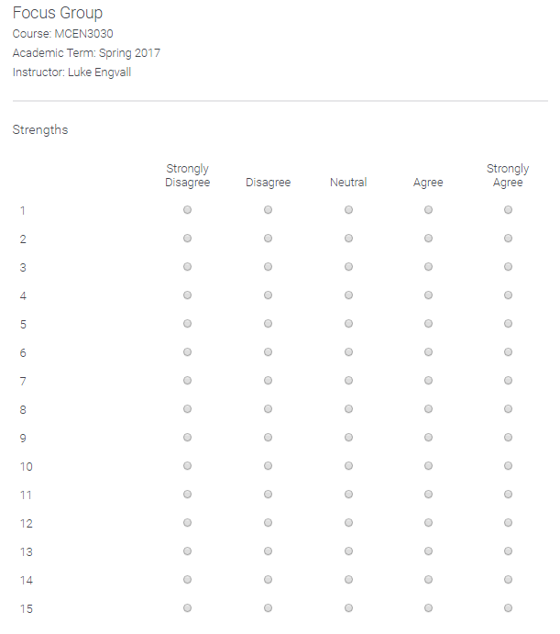

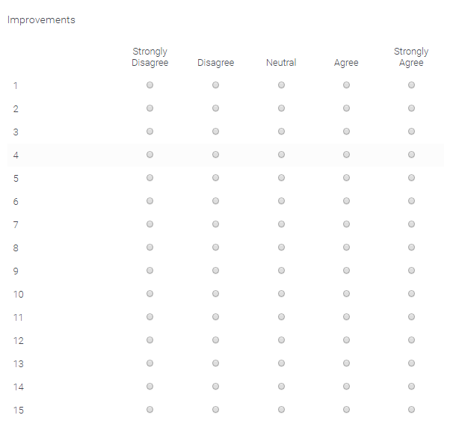

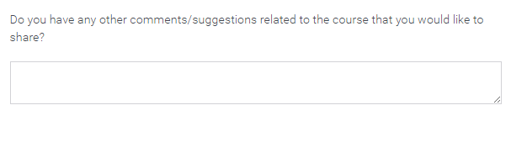

Course Interview Group Feedback Form
[course number] – [semester]

Items to consider, in answering the questions below:
- Course learning objectives (see reverse)
- [anything else the instructor wanted feedback on]

What are the strengths of this course?

What suggestions do you have for improving this course?

