

colorado.edu/mcdb

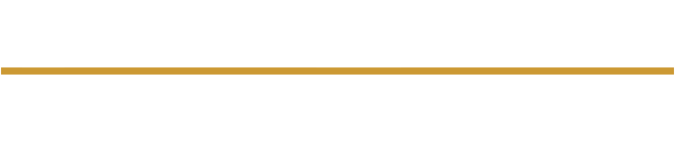
Molecular, Cellular, and Developmental Biology

Winter Recognition Ceremony
10:00 am Saturday December 13, 2025
Gold Biosciences Room A2B70

Ceremony Program Commencement 2025

Processional Please Remain Seated

Welcome Dr. Lee Niswander
Chair, MCD-Biology

Commencement Speaker Dr. Lee Niswander
Chair, MCD-Biology

Doctoral Candidates announced by Dr. Lee Niswander
Chair, MCD-Biology
MCDB Advanced Degree Recipients

Jack Gugel Advisor: Dr. Leslie Leinwand
Thesis: “Striated muscle protein turnover in health and disease”

Benjamin Nebenfuehr Advisor: Dr. Nausica Arnoult
Thesis: “Uncovering Genetic Interactions in the DNA Repair Network: Responses to Endogenous Damage and Ionizing Radiation”

Mika Nevo Advisor: Dr. Justin Brumbaugh
Thesis: “Selective RNA sequestration in biomolecular condensates directs cell fate transitions”

Raquel Ortega Advisors: Dr. Nausica Arnoult and Dr. Benjamin Bitler
University of Colorado Anschutz
Thesis: “ARP1 and PARP2 are dispensable for DNA repair by microhomology-mediated end-joining during mitosis”

Bruce Allen Proctor III Advisor: Dr. Nausica Arnoult
Thesis: “Function of Telomere Heterochromatin in the Alternative Lengthening of Telomeres”

MCDB Honors Degree recipients announced by Dr. Christy Fillman
Professor, MCD-Biology
MCDB Honors Degree Recipients

Olivia Neilly, summa cum laude Advisor: Dr. Zoe Donaldson
Thesis: “Investigating the Necessity of Accumbal Interneurons for Social Attachment in Prairie Voles.”
Additional Honors: Outstanding Undergraduate of the College of A&S for Fall 2025

Beiyi Xu, summa cum laude Advisor: Dr. Michael Stowell
Thesis: “Scaling Undergraduate Research Training: Course Design and AI Innovations in the MCDB Skills Center.”

Undergraduates presented by Dr. Jenny Knight
Professor, MCD-Biology

Closing Remarks Dr. Lee Niswander
Chair, MCD-Biology

Candidates for Bachelor’s in Molecular, Cellular & Developmental Biology
William Francis Ballard ◊  Jack Altland Blackstock  Ashley Marie Bundy  Phoebe Simone Chaffee ○  Anne Morris Earthman ₼ ◊ ~  Angela Catherina Eyde ◊  Yazmin Sade Falero ○  Micheal Fitzpatrick  Morgan Candice Fritzler ○ ◊  Genevieve Michelle Hargrove  Keaton Riley Kley ○  Lily-Anne Legleiter  Jacob Michael Masterson ~  Sunanda Mitra  Olivia E Neilly ◊ ₼ ~  Charles John Offerdahl □ *  Riley Davis Pennell ◊  Nyla Prasad ◊  Julissa Menjivar Rosa  Musa Lee Ryan  Michaela Schoen  Jada Lucille Sherrill ○◊ *  Kara Elizabeth Shockley ○  Zebulon James Trovinger ○ ~  Aris Moab-Rain Wertin  Andrew Michael Wheelock ○*  Beiyi Michael Xu ○₼ ~ | Key  ○ Additional Minor(s)  ◊ Additional Major(s)  ● Cum Laude  □ Magna Cum Laude  ₼ Summa Cum Laude  * High Distinction (3.75-4.0)    ~ Chancellor’s Recognition (4.0+)    IPHY Special Guest Graduate
Refreshments are located at the entrance of the ceremony location.

