Guide to Compiling and Running ISAT Cases in Linux
- Before beginning, the following libraries need to be installed: gcc, gfortran, lapack and blas.
  - To check if gcc is installed, run gcc --version from a linux terminal. Similarly, you can check if gfortran is installed by running gfortran --version from the terminal.
  - To install gcc and gfortran (if needed) run sudo apt-get install gcc and/or sudo apt-get install gfortran from a linux terminal.
  - To install the lapack and blas libraries, run sudo apt-get install libblas-dev liblapack-dev from a terminal.

- After installing the necessary libraries, cd to the ISAT source code directory in Buildings/Resources/src/ISAT.
- Next, type make into the terminal to compile the ISAT library using the makefile. The library should be generated in the correct linux folder as shown below.
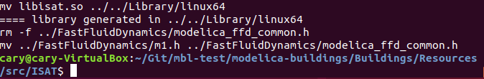
- Open Dymola. From Dymola, open the package in the Buildings folder by clicking File>Open and selecting the package.mo in the Buildings folder.
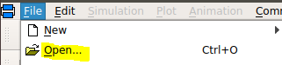
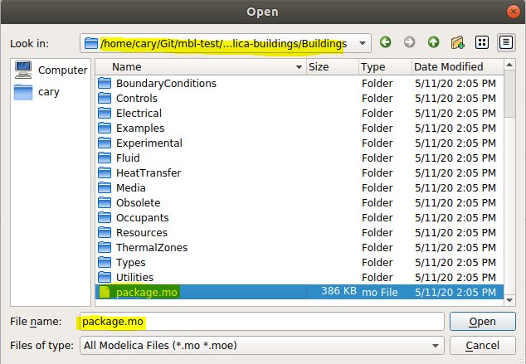
- Under the Buildings package in the tree, navigate to the ISAT folder by clicking ThermalZones>Detailed>Examples>ISAT. Double click on the model ForcedConvection.

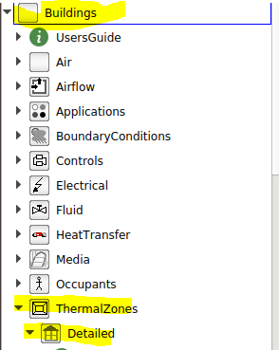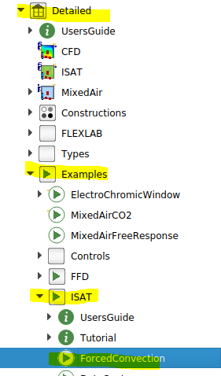

- Click on the Simulation tab in the lower right-hand corner to navigate to the simulation window.

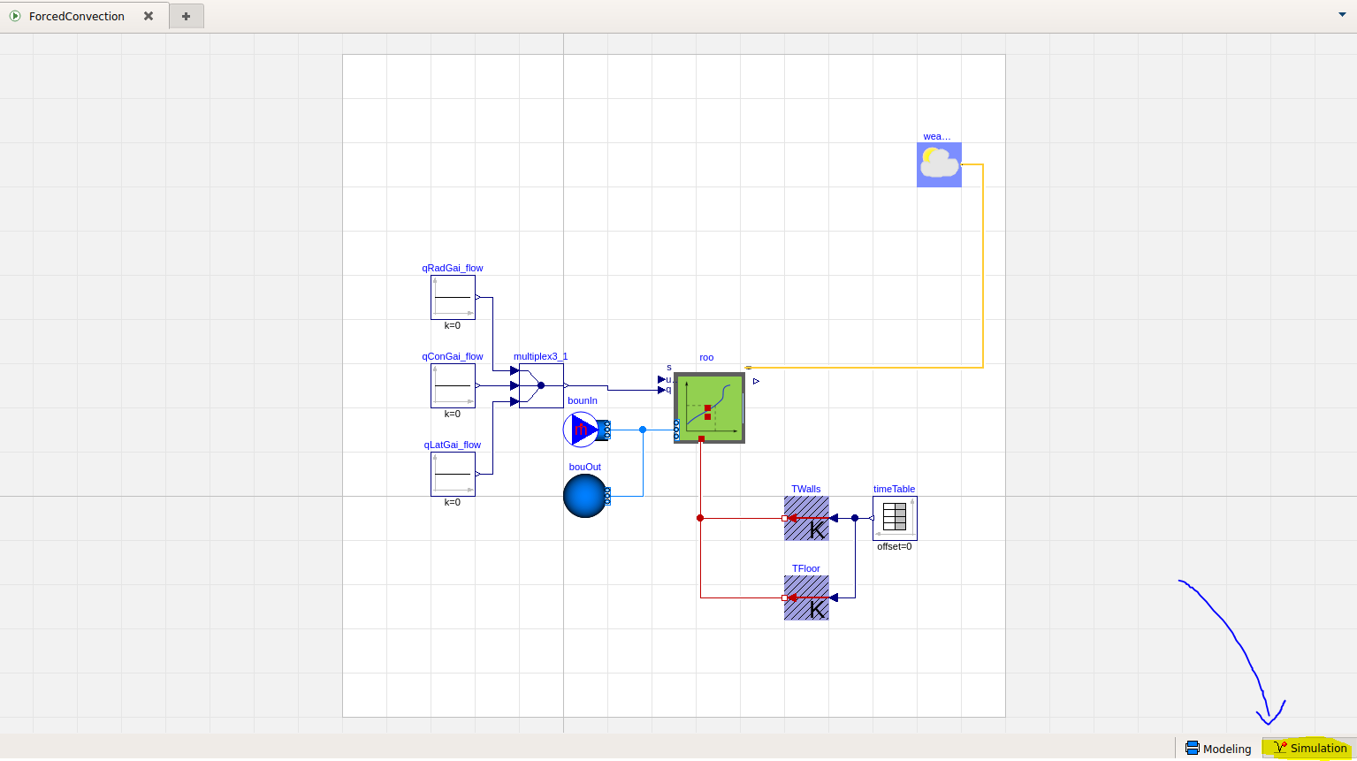

- Click Commands>Simulate and plot, located in the top menu as shown below. This will run a script that compiles and simulates the model and plots the results.
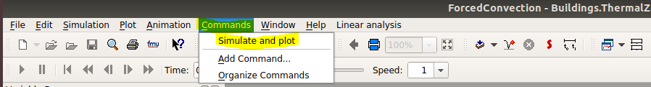

- The model should simulate successfully, and the plots should be displayed as below.
