 **2014 Law & Politics Colloquium: Race in America**

**Thursdays, 3:45 to 5:00, Wolf Law Building Room 207**

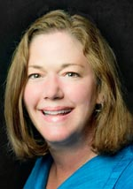**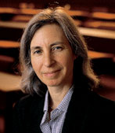 January 30, 2014**

**Martha Minow**

In *Brown’s* Wake: Legacies for School Choice (videoconference)

Martha Minow is the Morgan and Helen Chu Dean and Professor at Harvard Law School. She is an expert on the civil and human rights of racial and religious minorities.

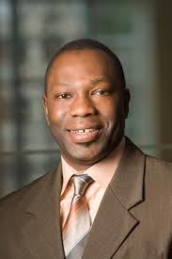**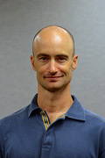Feb. 6, 2014**

**Joshua Correll**

Racial Bias in the

Decision to Shoot

Joshua Correll is a Professor of Social Psychology at the University of Colorado Boulder.

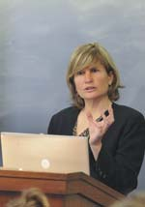**Feb. 13, 2014**

**Helen Norton**

The Equal Protection Implications of Government’s Hateful Speech

Helen Norton is a Professor of Law and Associate Dean of Academic Affairs at the University of Colorado Boulder Law School.

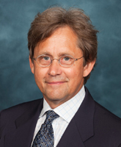**Feb. 20, 2014**

**Don Kinder**

Affirmative Action, Racial Balkanization, and the Equal Protection Clause

Don Kinder is the Phillip Converse Collegiate Professor with the Center for Political Studies, Political Science and Psychology Departments at the University of Michigan.

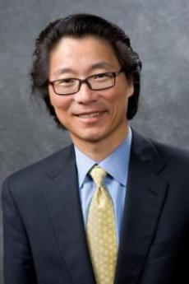**Feb. 27, 2014**

**Taeku Lee**

Race, Immigration and The Failure of Political Parties to Engage the Electorate

Taeku Lee is a Professor of Political Science and Professor of Law at the University of California Berkeley.

All interested faculty and students are encouraged to attend the public lecture.

An affiliated graduate seminar is cross-listed as LAWS 8645/PSCI 7191.

Contact for more information:

Ming Hsu Chen –CU Law School- [ming.h.chen@colorado.edu](mailto:ming.h.chen@colorado.edu)

John Griffin – CU Political Science – [john.griffin@colorado.edu](mailto:john.griffin@colorado.edu)

**Mar. 6, 2014**

**Melissa Hart**

Class, Race, and Equal Opportunity in Education

Melissa Hart is Director of the Byron R. White Center and Professor at the University of Colorado Law School.

**Mar. 13, 2014**

**Guy-Uriel Charles**

Voting Rights after *Shelby County v. Holder*

Guy-Uriel Charles is Director of the Duke Law Center on Law, Race & Politics and a Professor at Duke Law School.

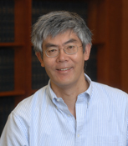**Mar. 20, 2014**

**Hiroshi Motomura**

Are Unauthorized Migrants Americans in Waiting? Legalization and the Rule of law

Hiroshi Motomura is Susan Westerberg Prager Professor at the University of California Los Angeles Law School.

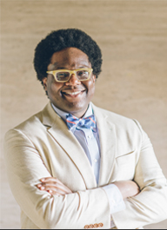**Apr. 3, 2014**

**Osagie Obasogie**

How do Blind People Understand Race and What Can they Tell Us About Colorblindness

Osagie Obasogie is a Professor at the University of California Hastings Law School and UC San Francisco Department of Social and Behavioral Sciences.

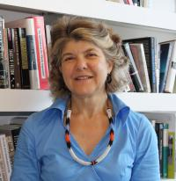

**Apr. 10, 2014**

**Jennifer Hochschild**

To Test or Not? Singular or Multiple Heritage? Genomic Ancestry Testing & American Racial Identity

Jennifer Hochschild is the Henry LaBarre Jayne Professor of Government and Professor of African and African American Studies at Harvard University.