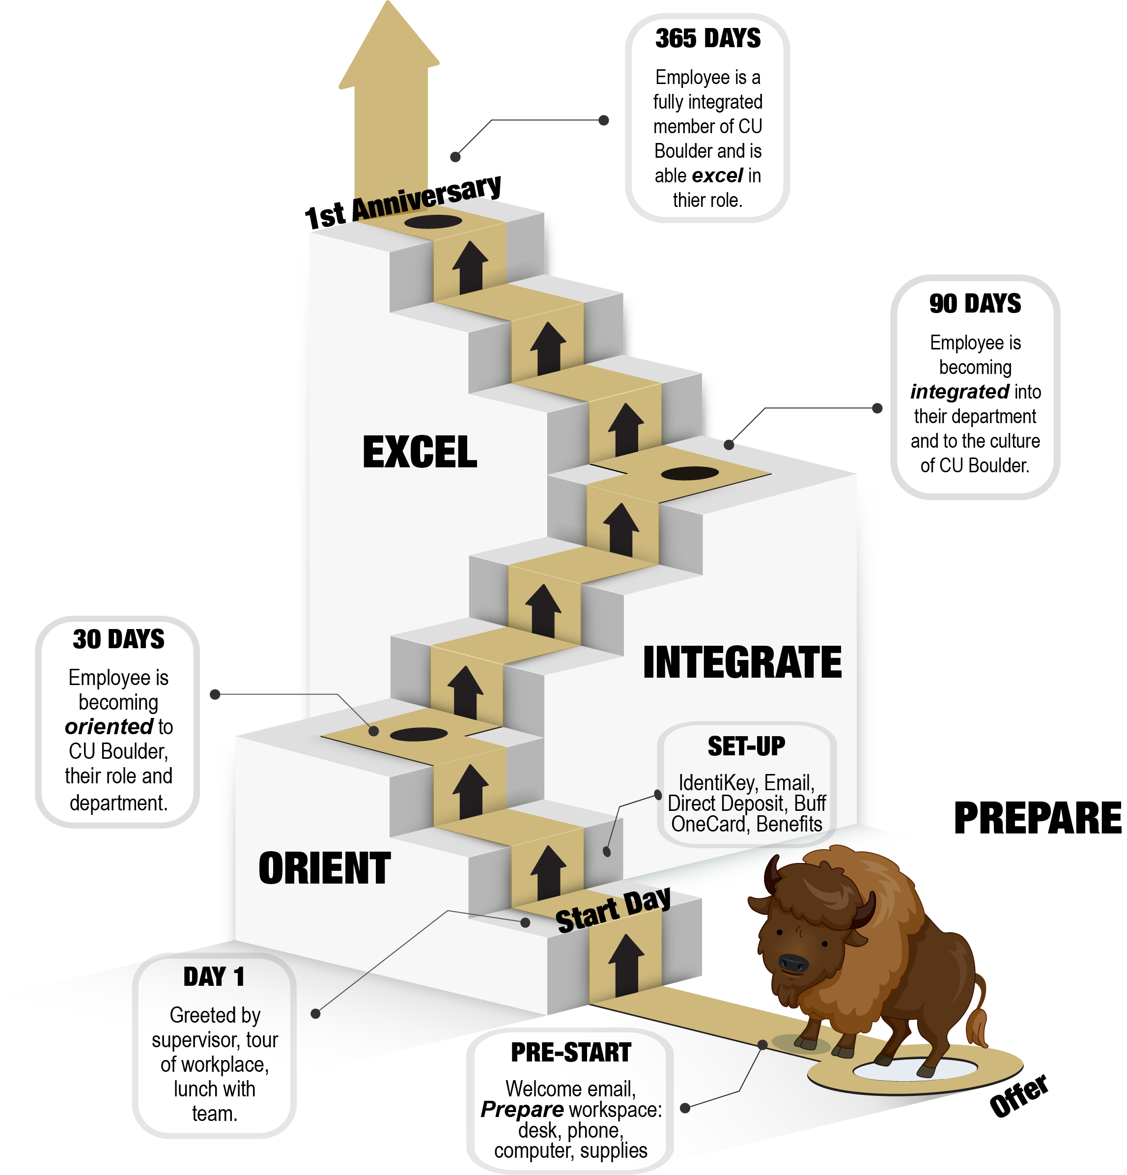
SUPERVISOR CHECKLIST FOR ONBOARDING NEW HIRES

How to Use This Guide

Onboarding at CU Boulder is a yearlong process by which new hires become fully integrated members of the institution. Phases of onboarding at CU Boulder are: activation, orientation and integration. The checklist items have been created to provide guidance to you as you work with your new hire for each phase.
Follow this guide when you meet with your new hire:
- Complete checklist items daily for the first week
- Complete a few checklist items each time you meet with your new hire over the subsequent months
Activation
- Before Your New Hire’s First Day
- First Day/ First Week
- New Hire Orientation Programs - register for NEW-X, Benefits Orientations
Orientation
- First 30-90 Days
- New Hire Orientation Programs – attend NEW-X, Benefits Orientations
Integration
- 90-365 Days - Tips for a successful first year, attend CU Discover Lunch/Learns

BEFORE YOUR NEW HIRE’S FIRST DAY

Prepare for your new hire’s arrival

- Create an itinerary for the first week: use 1st Week Itinerary Template from Onboarding Toolkit (www.colorado.edu/HR)
- Order computer and any technological tools as far in advance as possible
- Arrange for phone setup (can take up to two weeks)
- Arrange for your departmental IT or OIT Dedicated Desktop Support professional to meet with the new hire on the first day to ensure email accounts and any necessary software are up and running
- Arrange the workspace and ensure all supplies are available:
  - Order nameplate
  - Obtain information for business cards, order cards
  - Provide necessary office supplies (pens, paper, etc.)
  - Obtain information for uniforms or required gear
- Arrange for Key/ Building Access – with department Key Liaison

Communicate with your new hire

- Send a personal welcome email, or letter: use Welcome Email Template from Onboarding Toolkit (www.colorado.edu/HR)
- Explain first day logistics: what time to arrive/work schedule, where to park, transportation options, what to wear, etc. Let them know if they should bring lunch or if you have made other plans such as lunch at the C4C Dining Hall. It is helpful to have this conversation via telephone.
- Attach itinerary for first day or first week- use 1st Week Itinerary Template from Onboarding Toolkit (www.colorado.edu/HR)
- Provide guidance about getting to campus - campus map, bus, and parking: www.colorado.edu/pts. Connect with your department’s parking liaison if the new hire wishes to purchase a permit.
- IdentiKey: Provisioned within 24 hours of hire approval in HCM. New hires will receive an email from OIT with instructions on how to activate IdentiKey which can be done prior to the first day of work. This email is sent to the new hire’s home email address provided when they applied to the job.

Communicate with your department and team
- Send an email to the team/department announcing the new hire:
  - Name of new hire
  - Position/Title of new hire
  - Start Date
  - Pertinent information about the new hire’s background
  - Details about any welcome events (lunch, breakfast, meet and greet, etc.)

Notes/ To-Do Items:

FIRST DAY/ FIRST WEEK

Welcome
- Greet and show new hire to their office space/meeting area
  - Show them where to put personal items - coat, lunch, etc.
- Go over agenda for the day so they know what to expect
- Tour of office building, lab, shop, workplace
  - Meet co-workers (official or unofficial welcome)
  - Show location of break room, kitchen, restrooms, supply room, printer/copier, etc.
- Buff OneCard – it’s helpful to have someone take the new hire in person to get their card. Every new hire receives a free meal pre-loaded on their card
- Keys/Building Access – ensure new hire has building access. Work your with department’s Key Liaison for key or card access. If the new hire must pick up key from Access Services, it’s helpful to have another team member go with the new hire to get the key
- Explain whom the new hire may go to with questions/concerns to when supervisor is not present (informally arrange this with a co-worker of the new hire)
- Share new hire’s work contact information – phone, email, employee ID number

Information Technology
- Department’s IT professional to meet with the new hire to go over the following (or another department representative as appropriate):
  - Computer – appropriate use and security
  - IdentiKey: Provisioned within 24 hours of hire approval in HCM. New hires will receive an email from OIT with instructions on how to activate IdentiKey which can be done prior to the first day of work.

Information Technology - continued
  - Portal: MyCUinfo (access to pay advice, benefits, training, etc.)
  - IT Help Desk, 5-HELP, help@colorado.edu
  - Computer/internet use policies
  - Email lists – add new hire
  - Office printer/copier use codes
  - Introduction to department Intranet
  - Introduction to campus Virtual Private Network (VPN)
  - Access to shared drives, shared email accounts
- Supervisor to go over the following topics with new hire:
  - E-mail policies – use, etiquette, expectations, out of office – what to say in an out-of-office responder
  - Scheduled meetings and events – add new hire to ongoing or upcoming meetings/events
  - Share your “Favorites” website information as it makes sense for the position (myCUinfo portal, www.colorado.edu, etc.)

Telephone
- Telephone Procedures: dial 8 to call out, campus extensions using 2+last four digits/5+last four digits
- Online Campus Directory through www.colorado.edu
- Department-specific directory
- Voicemail Procedures – greetings, expectations, how to set an out of office message and what to say in the message

New Hire Orientation Programs

Programs through Boulder Campus HR and Benefits Offices

- Register new hire for the New Employee Welcome Experience (NEW-X): Full-day campus introduction and tour presented by
Boulder Campus HR
  - Optional, but strongly encouraged
  - Recommended attendance within first 90 days - may attend through first year anniversary
  - Register in SkillSoft in the MyCUinfo portal
  - For assistance, call the Department of Human Resources
    - Training Coordinator 303-492-8103
  - Please make arrangements in your new hire’s schedule so they may attend for the full day
- Register for a Benefits Orientation Session (NBO)
2-hour benefits overview presented by Employee Services, the office in Denver that administers benefits for all four campuses
  - Optional –
    - One-to-one assistance available via phone (303) 860-4200
  - Attend within first 30 days of benefits eligibility
  - Register through the Employee Services website https://www.cu.edu/employee-services/benefits/new-employee-benefits-orientations
  - Benefits Enrollment through MyCUinfo Portal – due 31 days from start date for benefits-eligible employees

FIRST 30 DAYS – Setting Expectations

First Steps in the Performance Management Cycle
- Expectations of position and job responsibilities
- Go over position description with the new hire (if applicable)
- Explain their position in relation to other co-workers/team
- Explain their position in relation to other units within department
- Department norms and expectations
- Preferences for communication with supervisor and colleagues –phone, email, one-on-one meetings
- Written/unwritten rules - e.g., what does “on time” to a meeting look like, checking work email or working from home
- Create Performance Plan within 1st 30 days, meet with new hire to go over the plan (if applicable)
- Explain acceptable and unacceptable performance behaviors
- Review required campus trainings – found through MyCUinfo portal (SkillSoft) : Discrimination and Sexual Misconduct, Performance Management Training (required for supervisors of classified staff)
- Systems Access to HCM (HRMS), FIN, Campus Solutions (CU-SIS), Concur, Marketplace, or any other department-specific systems
- Visits to FSAP, Ombuds, HR, Benefits/Retirement seminars, Conference on World Affairs, etc. are considered work time.
- Explain methods for informing supervisor about desired attendance at CWA, FSAP, Ombuds, and HR Trainings as these are considered work time. Provide guidance and expectations for these events.
- Tuition Waiver – explain department policies for attending classes during the work day

FIRST 30- 90 Days – Orienting your New Hire

Department and College/Division/Institute

Department/Lab-Specific Information
- A brief history of the department/lab
- Organizational chart (with pictures if possible)
- Vision, mission, core values, goals
- Website, newsletter, social media channels, etc.
- Department/Lab’s growth- past and future
- Industry awards and recognitions, explain areas where the department/lab excels in the field
- Acronyms and symbols related to the department/lab
- Employee Recognition Programs (star award, spot awards, annual awards)
- Department culture, norms and expectations – the unwritten ways of working for the unit, for example- keeping office doors open/ closed, saying hello/goodbye, taking time to socialize with co-workers. The “insider tips and tricks” you wish were shared with you when you started.
Other/Notes: ________________________________________________________________________________

Departmental/Lab Commitment to Constituents
- The department/lab’s primary constituents - students, families, faculty, staff, vendors, etc.
- Departmental partners—on and off campus
- The services provided by the department
- The departments’ commitment to its constituents and the importance of being a good representative for the department (the importance of first impressions and potential consequences for not being a good representative)
Other/Notes:

Department/Facility Tour and Welcome Activities
- Conduct tours of office, laboratories, plants, facilities, remote office locations – as appropriate
- Plan team-building and icebreaker exercises
- Prepare taped or live director and/or dean, asst. vice chancellor, or vice chancellor presentation
Tour Notes:

College/Division/Institute - Specific Information
- College/Division/Institute vision, mission, goals, and core values
- College/Division/Institute website
- Register new hire for division’s or college’s new employee orientation if applicable

Logos, Letterheads, Marketing and Communications
- Department/college/division/institute logos and marketing plan
- Consult guidelines and templates for using CU Boulder and Be Boulder branding as defined by the Office of Strategic Relations and Communications: https://www.colorado.edu/strategicrelations

Networking
- Introduce the new hire to individuals inside and outside of the department with whom they will need to interact and work
- Provide a list of individuals who may serve as resources
- Provide a list of locations of other colleagues’ offices
- Provide a list of contact information of vendors and contractors if applicable
- Groups/unofficial office clubs – connect new hire with the people who organize events such as running, walking, lunch clubs, after-hour social events, community service

FIRST 30- 90 Days – Orienting your New Hire

Policies and Procedures

Attendance and Leave - Guidance at www.Colorado.edu/HR
- Work hours/work schedules
- Attendance and tardiness policies
- Leave policies and procedures for requesting leave (sick, vacation, etc.)
- Campus closure information
- Overtime – if applicable
- Flextime – if applicable
- Payroll schedule/pay frequency
- Timesheet procedures
- Breaks and meal periods
- Holiday schedule
- Paid volunteer/charity time
- Inclement weather policy
- Bereavement leave
- Family and Parental Leave
- Jury duty

Health, Safety, Sanitation, Confidentiality

- Department’s health and safety procedures, as they apply
- Confidentiality policies
- Emergency procedures and evacuation routes
- Location of emergency exits
- Locations of fire extinguishers
- Accident reporting procedures and how to report on-the-job-injuries
- Campus Emergency Alerts
http://alerts.colorado.edu/
- Add new hire to department emergency phone tree, if applicable
- No Smoking Policy – campus is non-smoking
- Work area/specific safety procedures, if applicable (e.g., shops, labs)
- Video(s) and other materials on safety
- Ergonomics products/services
- Security services and policies
- Sick bay area and first aid supplies
- Recycling and trash policies
- Environmental issues
- Weapons policy
- Security services and contact information

Procedures and Operations

- Reserving a conference room
- Supplies and furniture requests
- Sending inter-campus and U.S. mail
- Suggestion box
- Break room locations/policies
- Visitor policies
- Solicitation policies
- Recycling, compost, zero waste
- Office supplies/ equipment for position or work assignments
- Department’s intranet site – if applicable
- Events – retreats, group functions, bring your child to work day, bike to work day
- Alcohol and Drug Abuse Policies

Ethical Behavior, Professional Behavior and Dress

- CU Code of conduct
https://www.cu.edu/ope/aps/2027
- Policy/guidelines for personal devices in the workplace
- University property policies
- Dress/uniforms/dress-code guidelines
- Intellectual property/proprietary information policies
- Email and voicemail salutations and out-of-office responses
- Amendment 41 –employee shall receive gifts in excess of $50 per year from external sources https://www.sos.state.co.us/pubs/info_center/laws/COConstitution/ArticleXXIX.html

Travel, Purchasing and Expenses - if applicable

- Travel policies and procedures
- University credit card policies
- University travel services
- Expense report procedures
- Purchasing policies/procedures
- Purchasing forms and procedures
- Business travel accident insurance
- Online trainings required for access to travel and procurement cards through SkillSoft

Committee Opportunities and Assignments

Professional Development Opportunities

- Department/ College/ Divisional workshops and conference
- Boulder Campus HR employee learning programs
  - www.Colorado.edu/HR
- SkillSoft – through MyCUInfo Portal
  - Campus required trainings – online courses
  - Campus trainings – registration system for in-person training and development opportunities
  - Books 24x7
  - Self-guided learning modules on many topics
- Lynda.com – through MyCUInfo Portal
  - Self-guided learning modules on many topics

Tips for a Successful First Year with Your New Hire

Helping your new hire achieve success in their role:

One-on-one meetings, communication, consistent feedback and engagement from you will help the new hire reach higher levels of productivity faster. Your new hire will be quickly become a fully integrated member of your area.
- Meet with hire at the end of each day during the first week of work – check in and see how they are doing
- Complete and review performance plan with new within 30 days (if applicable for position)
- Schedule check-in meetings at 30, 60, 90 days, and regular one-on-one meetings (bi-weekly is recommended, but this will depend on the position)
- Provide ongoing feedback, personally engage with your new hire and recognize their contributions
- Around 90 days from the hire date, ask your new hire how their role compares with what was described during the initial interview process.
  - Ask the new hire to share their own feedback on improvements and share who has been helpful during their transitional process; make adjustments as needed
- First Anniversary: Acknowledge this milestone; take the time to thank and congratulate the new hire

