# **A Quick Guide to Processing Waitlisted Applicants**

Select the Query tool in the main Slate view, then click on the department folder on the right side menu, then click on GRAD.



Click on the [Applications Ready for Faculty Review – Copy Me!](https://grad.apply.colorado.edu/manage/query/query?id=3578b5b6-a625-4aae-9455-fe1d508a7ee5) query. Hit Edit Query, and then save a copy to your folder. Change the degree level filter as needed. **Note: You only have to do this step once! Then this query will always be ready for you in your folder!**

If you want to add any other appropriate filter(s) (i.e. subplans, etc.), you can do so here. When you are satisfied with your exports and filters, click the breadcrumb to go back to the main query page.

  
Then hit the ‘Run Query’ button.

Since we are moving files to a new bin, set the ‘Output’ to ‘Bin’ as shown below, and then hit ‘Export’:

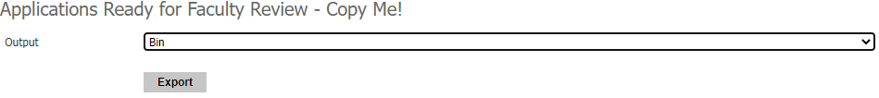

This Bin Management screen is where the GPA can add/remove readers, and move these applications to a new bin:

Set Workflow to ‘Graduate Admissions.’ Set ‘Bin Action’ to ‘Set Bin.’

**Set ‘Bin’ from F. Decide to ‘**G. Waitlist’** for applicants you intend to **WAITLIST**.

‘Queue Action’ is automatically set to ‘Add Readers’.   
Change this to ‘Clear Readers’ to remove these applications from your faculty members queues at this time.

Now, you need to add the Waitlist decision and letter, to notify the applicant that they have been waitlisted. This is done in the Student Record View (within the Slate Database at grad.apply.colorado.edu/manage) on the Application tab. Scroll down to Decisions:



Set the Code to Waitlist.

Set the Reason to Waitlist.

Select your department’s waitlist letter from the dropdown menu.

Click the ‘Confirm’ button.

Click the ‘Released’ button to release the decision (send it to the applicant’s status page). You can set the date and time of the release if you want the letter to be released in the future – for example, if you wanted all letters released at the same time/date. **Do not use ‘Expires,’ ‘Notification,’ or ‘Merge Fields.’**

The ‘Comments’ box is available if you have any comments to record at this time – this is not displayed to the applicant.

# **Exiting the Waitlist – Deny or Admit**

IF you decide to **DENY** the Waitlisted applicant, you’ll need to run a query to move them to the K. Deny bin, and then you can proceed with the denial, adding and releasing the Deny letter.

IF you decide to **ADMIT** the Waitlist applicant, you’ll need to run a query to move them to the F. Decide bin so you can fill out a decision form (Remember, a Decision Form is required for ALL Admits).

To move the file to the F. Decide Bin, run your query, set the ‘Output’ to ‘Bin’ as shown below, and then hit ‘Export’:



This Bin Management screen is where the GPA can add/remove readers, and move these applications to a new bin:

Set Workflow to ‘Graduate Admissions.’ Set ‘Bin Action’ to ‘Set Bin.’

Set ‘Bin’ to F. Decide and enter the name of the individual making the final decisions (GPA, Graduate Director, etc.) in the ‘Add Reader’ box to add these files to their queue. The readers added at this stage will be the ones who fill out the Decision Form in the Reader for each application in the **F. Decision** bin. ***The Decision Form is required for all applicants you are admitting.***

Select either ‘Update Selected’ or ‘Update All’ as needed to move the applications to the **F. Decide** bin and appropriate queue.

Once these applications have been moved into the **F. Decide** bin, the GPA/Graduate Director will need to select an application from their queue to open it in the Reader. Then, they will click on the ‘Review Form / Send to Bin’ button in the bottom right side of the Reader:

This will open the Decision Form on the right side of your screen. You will see that the first four fields will be auto-filled for you with the applicant’s information.

**ONLY ONE DECISION FORM SHOULD BE FILLED OUT PER APPLICANT!**

‘Next Bin’ should read **F. Decide** (this should be the only bin available).

Hit the ‘Send’ button to complete the form and remove this application from the queue. The form auto-saves as well, but you must hit Send to finish!

*Check the box here if you wish to admit the applicant to a different plan/subplan.*

*

Enter the Decision Recommendation here: Admit or Provisional. If Provisional, please see main Slate Manual.

For Admit decisions (including Provisional), the application will automatically move into the **I. Admissions Check** bin.

* + The Graduate Processing team performs the final check of each application and will then move them to the next bin, **J. Admit**.

When the application has reached the **J. Admit** bin, a letter can be released.

**Reminder! No decision letters should be sent until the application is in the Admit bin!**

**DO NOT send any unofficial admit notifications outside of Slate!**

# **Sending Letters**

The GS Admit letter is the official admit letter and should be used every time. In addition, the GPA may upload a specific departmental letter for each applicant, to be displayed at the same time the GS Admit letter is shown.

This is done in the Student Record View (within the Slate Database at grad.apply.colorado.edu/manage) on the Application tab. Scroll down to Decisions:



Click ‘New Decision’ to enter the Decision screen:

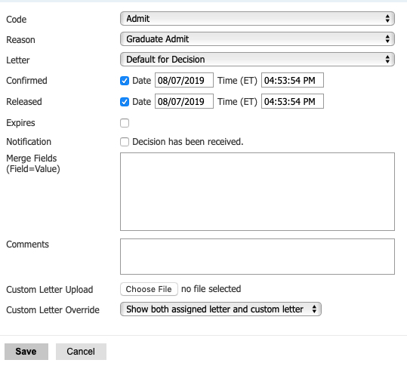

The screen should look similar to this (for an Admit) before you hit save.

On this screen, set the code to Admit.

The ‘Reason’ selection will appear when you select the Admit Code. Select ‘Graduate Admit.’

Letter should be set to ‘*Date* – Admit – GS Admit Letter.’ This is the default letter for all admits (pay no attention to the date listed, this is when the default letter was created). You may also select ‘Default for Decision.’

Click the ‘Confirm’ button to confirm the admit decision.

Click the ‘Released’ button to release the decision (send it to the applicant’s status page). You can set the date and time of the release if you want the letter to be released in the future – for example, if you wanted all letters released at the same time/date. **Do not use ‘Expires,’ ‘Notification,’ or ‘Merge Fields.’**

The ‘Comments’ box is available if you have any comments to record at this time – this is not displayed to the applicant.

Use the ‘Custom Letter Upload’ by selecting the Choose File button and selecting your customized departmental letter to this applicant. Note: if you offering funding, you must use the [Admit Letter with Offer of Aid](https://www.colorado.edu/graduateschool/content/letter-acceptance-offer-aid) (download). The template is also on the Graduate School site under ‘[Faculty and Staff](https://www.colorado.edu/graduateschool/faculty-staff/admission-information-staff).’

‘Custom Letter Override’ should always be set to “Show both assigned letter and custom letter.” Hit ‘Save’!

* If your new Decision looks like this, the letter was released! Note: it will display three green bars when the update has been viewed by the applicant.



* If your new Decision looks like this (or any other “non-green” variety), you may have forgotten a step and should reopen the letter to review and correct, or email us with questions. Please do not add another decision!



# **YOU DID IT! What Happens Next?**

Once the decision is released, an email will automatically be sent to the applicant notifying them of a status update and prompting them to log in to their status page. The admit letter and custom letter will show together on the applicant status page under a “Status Update” link.

For an admit, after the applicant views the letter(s), the Reply to Offer of Admission form automatically populates on their status page. The applicant uses that form to confirm their intent to enroll.

* If the applicant chooses to *decline* their offer of admission, they are automatically moved from the **H. Admit** Bin to the **L. Decline Admission Bin**.
* If the applicant *confirms* his/her intent to enroll, they are then prompted to pay the $200 confirmation deposit on their status page. Once the deposit is paid, the application moves from the **J. Admit Bin** to the **N. Accept Admission Bin**. Matriculation follows.
* If the applicant is an international student, they will be prompted to provide any extra materials needed for visa purposes before the confirmation deposit is due. Once they submit their intent, but before they pay the deposit, they will move from the **J. Admit Bin** to the **M. Awaiting Confirmation Deposit Bin**. Once the deposit is paid, the application moves to the **N. Accept Admission Bin**. Matriculation follows, and the file will move into the   
  **Q. Matriculated Students Bin.**