Step 1: Creating a Transfer Shell
Although you will be on the home tab when you sign in you will do 99.9% of your work from the Transfers tab. Best practice is to click there as soon as you log in!
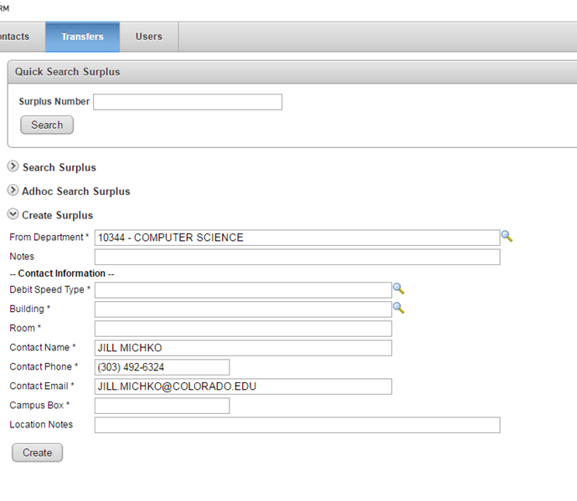
* Denotes a required field

Defaults to view of fields required to create a new transfer, update as needed & click Create.

- From Department*: Auto populates to your department unless you are set up to process transfers for more than one ORG/Department

- Notes: Free form - for your use, Surplus Property does not automatically see this field

- Debit Speed Type*: Select a speed type to charge cost of fridge pick up or specialized pick up costs to.
Note: We don’t normally charge for surplus property pickups however, fridges we do recoup cost to dispose of a fridge based on freon reclamation charges.
  - Cost for rental of specialized equipment may result in an extra cost however the surplus property supervisor will contact you regarding any additional cost outside of a fridge pick-up.
  - We do auto bill fridge costs via a JE when the fridge is dropped off.

- Building*: Select your building from list associated with department, contact us to add/update buildings.

- Room*: Freeform – enter room/office where the contact person is located

- Contact Name*: Auto populates based on login, update as needed. This should be the best person to contact with questions regarding the assets on the transfer.

- Contact Phone*: Auto populates based on login, update as needed

- Contact Email*: Auto populates based on login, update as needed

- Campus Box*: Freeform - where the asset labels will be mailed. (e.g. 39 UCB)

- Location Notes: Freeform - any additional Location notes

