Logging into the AssetWorks
AssetWorks is not tied to the HCM system which means you don’t automatically have a logon as a university employee. You’ll need to complete the basic training modules before we can provide a logon to the software!

AssetWorks Login Page: http://ams5.incircuit.com/eams3/f?p=1055:101
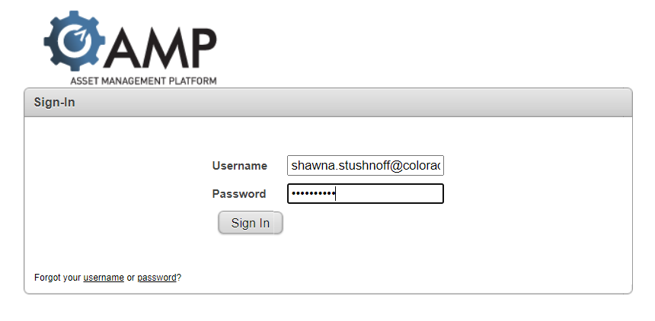

Logon is your University e-mail address i.e. Jilliandra.Michko@colorado.edu
Default password Test12345
When you log into the system for the first time, or request a password change, you will need to update your password.
--------------------------------------------------------------------------------------------------------

Software Overview
When logging in you will land on the Home page, here’s an overview of navigating in AssetWorks.

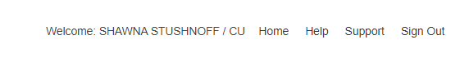

The menu bar: top, right corner of the screen
Home - returns you to this main welcome page
Help - opens a window with additional help about the current screen
Support - opens a window that allows you to send a message or question to technical support staff
Sign Out - signs you out of the application when you are finished

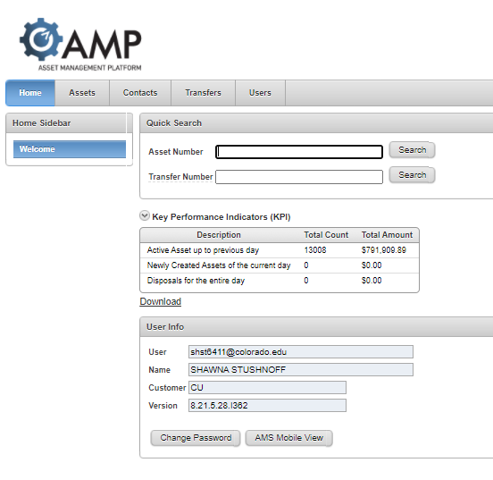
Tabs:
Home – search for a transfer here if you know the transfer number
Assets – of little value to us here at CU Boulder as we do not manage assets cradle to grave
Contacts – look here to see system users, departments, speed types, buildings, registered users
Transfers – create a transfer or look existing transfers
Users – lists users assigned to your department profile

gp
System Notes
- Asterisk Fields - required fields
- Magnifying Glass - search for or select from a list of choices for fields
- Drop Down - select from a list of choices
- CU Tag Numbers – add for all assets with a CU tag ensure Property Accounting removes the asset from the department’s accountable inventory
- Serial numbers – required for items that hold memory: hard drives, computers, servers, tablets, laptops, etc.
- Passwords & lock codes – required in the notes field of assets that are Apple products, if not provided we can not wipe to DOD standards and sell
- EH&S forms - for refrigerators used anywhere except a breakroom and select other items as advised by Surplus Property supervisor

