Surplus Property Management System (SPMS) Guide for:
Campus Users
Updated 12/2017
SMS User Guide
Table of Contents

Logging into the system 3
Surplus Transfers (Transfers Tab) 5
How to search for a Surplus Transfer 5
How to create a Surplus Transfer 6
Surplus Header / Surplus Detail 7
Adding Asset/Property to a Surplus 8
Importing Asset/Property to a Surplus from a .csv file 9
How to add a document or image to an asset 11
Correcting Asset Information in a Surplus Transfer 12
Completing a Surplus Transfer 13
What Happens Next . . . 14

Logging into the system
First time users:
Please log into the Surplus Property Management System site using this link:
http://www.assetworks.com/login/
The Customer is: CU
The Service is: AMS Asset Management

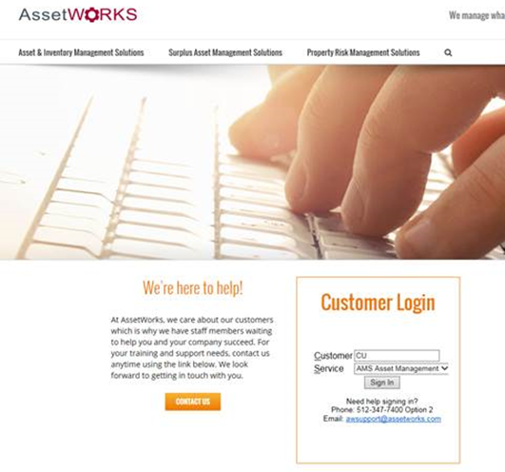
For users who have already accessed the system, you may use the direct link:
http://ams5.incircuit.com/eams3/f?p=1055:101
After pressing “Sign In” you will be taken to the login screen where you will use your usual login details.
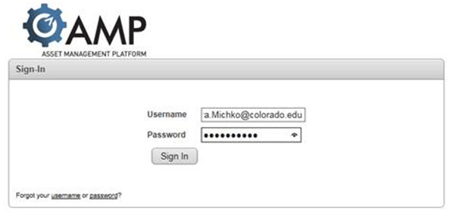
Your log in will be your University e-mail address i.e. Jilliandra.Michko@colorado.edu and you will be given a default password.
Upon logging in, you should be prompted to change your password.
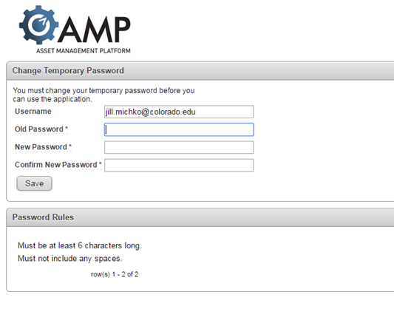
Users are, then, taken to the Welcome Screen.

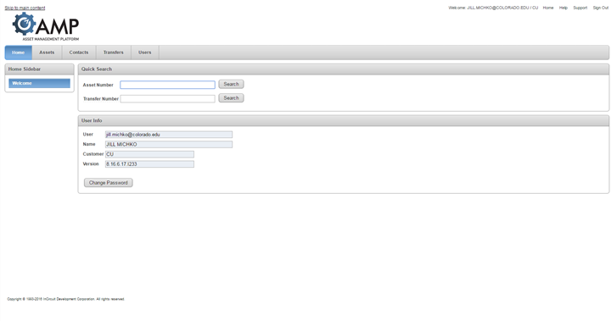
The top, right corner of the screen contains the following links:
Home - returns you to this main welcome page
Help - opens a window with additional help about the current screen
Support - opens a window that allows you to send a message or question to technical support staff.
Sign Out - signs you out of the application when you are finished

Surplus Transfers (Transfers Tab)
When using the system, you will ALWAYS want to be working under the Transfers Tab. This is where you will be creating and researching all Surplus Transfers.

How to search for a Surplus Transfer
To perform a more advanced search of existing surplus transfers, click the arrow icon on the Search Surplus region. This will open up the region and allow you to specify additional criteria.

To search for your Surplus Transfers:
- Log in to AssetWorks
- Click on the Transfers tab at the top.
- Expand the “Search Surplus” section by clicking on the plus sign to the left of “Search Surplus”
- Enter the name or number of your department and select it when it comes up in your choices
- In the “Status” field, select the blank option from the drop down menu so that it doesn’t say “waiting for receipt”.
- Click on the “Search” button at the bottom of the section.
- You should be able to see the Surplus Transfers that your department created.
To view each individual transfer, click on the pencil and paper icon to the left of the Surplus Number.

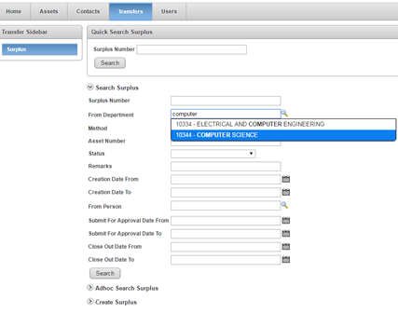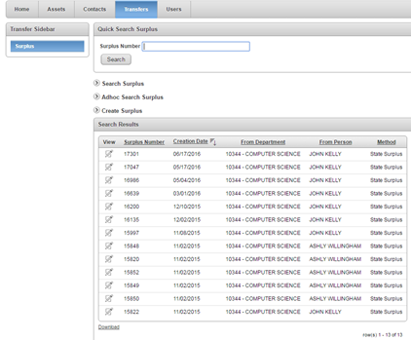

To quickly search for an existing surplus transfer by its Surplus Number, enter a Surplus Number into the field and press the Enter key or click the Search button

How to create a Surplus Transfer
To initiate a new surplus transfer of one or more assets, click the arrow icon in the Create Surplus region, enter the header information relevant to the transfer, then click the Create button. This will create the transfer header and then take you a new screen where you specify the assets you are placing onto the transfer.
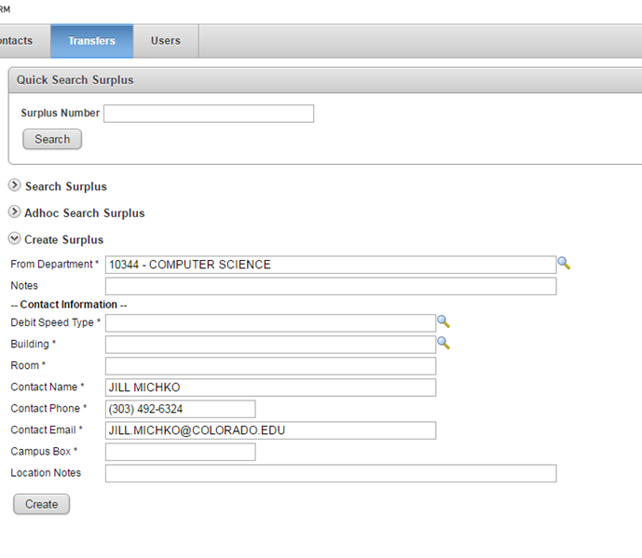
Enter at a minimum the required fields in the Create Surplus region:
Required fields have an * next to them.
From Department*: Users enter the From Department. Note this will default if you are setup with access/scope to only one Department. If you have multiple, you will have to use the lookup option by typing in the name or clicking on the magnifying glass.
Notes: Enter any notes into this field.
Debit Speed Type*: Enter the Speed Type associated with the department.
Note: We don’t normally charge for surplus property pickups, unless we need to recycle a refrigerator. Property Services needs to cover the cost for freon reclamation.
Building*: Enter the Building where the contact person is located.
Room*: Enter the Room where the contact person is located.
Contact Name*: Enter the Contact Name of the person who is the best person to contact regarding this surplus.
Contact Phone*: Enter the Contact persons Phone Number for this surplus.
Contact Email*: Enter the Contact persons email address for this surplus.
Campus Box*: This is where the asset labels will be mailed. (e.g. 39 UCB)
Location Notes: Add any additional Location notes.
Once all data has been entered, click the Create button.

Surplus Header / Surplus Detail
Once a Surplus Header is created, you’ll be taken to the Surplus Detail screen. At the top is the Surplus Header/Detail. It shows the data that was just entered to create the Surplus as well as the Surplus Number (every time a Surplus is created, it’s given a unique number for tracking) and the Creation Date of the Surplus. This area is called the Surplus Transfer Header.
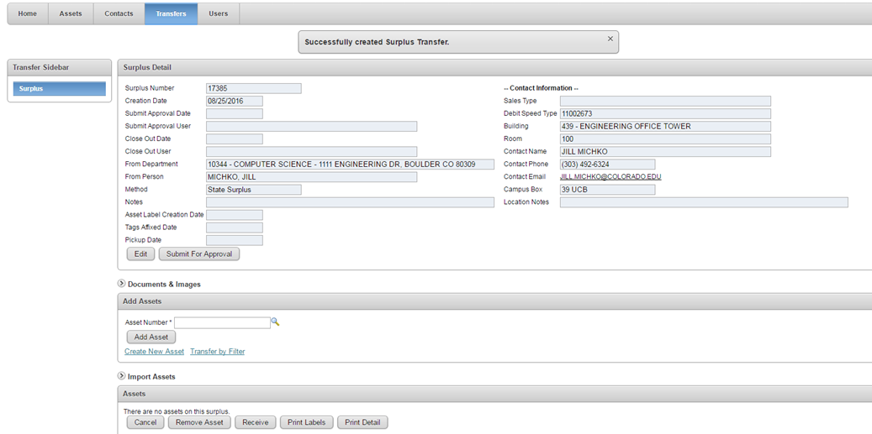
If the Surplus Transfer Header/Detail needs to be updated, you can use the Edit button to make those changes.

Adding Asset/Property to a Surplus

Click on the Create New Asset line from the Surplus Detail.

This will bring up a new window where a non-tagged asset can be created.
Any field with an * next to it is a required field.
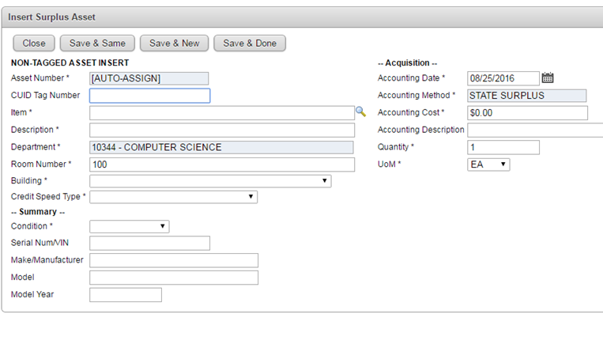
Once all require data has been entered, users can choose Save & Same to duplicate the entire non-tagged asset. Save & New brings up new non-tagged asset page and Save & Done returns the users to the Surplus Detail. Remember to type over the room number field and enter the room where the surplus assets are located.

Importing Asset/Property to a Surplus from a .csv file

- You may find a copy of our Asset Import spreadsheet on our website here:
- https://www.colorado.edu/fm/node/246/attachment
- Columns A through H are required fields
- Column I (Serial Number/VIN) is required if you are entering the following
  - COMPUTER/DESKTOP CPU
  - COMPUTER/LAPTOP
  - HARD DRIVE
  - SERVER
  - Vehicle
- Enter in information for each asset until all assets have been entered.
- Delete the header row from the spreadsheet as well as the * notes at the bottom of the spreadsheet.
- Save the file as a CSV (MS_DOS) file, and remember where you saved it.
- Upload the file to your transfer
Click on the Import Assets arrow icon in the middle of the Screen.
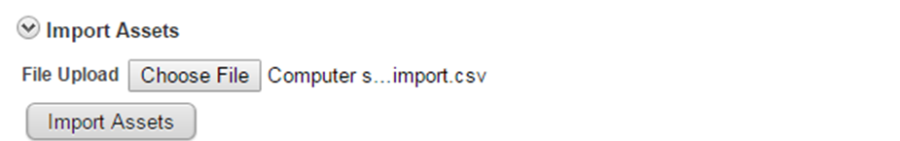

Click on the browse button and find the CSV. File you have created for import. Once you have found the file click on the Import Assets Button.

Important Note: The CSV file layout must include placeholder or actual data for the following fields: Item Description, Description, Department Number, Building Number, Room Number, Credit Speed Type, Condition, CUID Tag, Make/Manufacturer, Model, Quantity, UoM, and the Accounting Date. For Accounting Cost, if the cost is anything over than zero enter that value, if not it can be left blank. For fields such as CUID Tag Number, if the value is not known just leave blank. The following are all standard validated data that MUST match the data in AMS: Item Description, Department Number, Building Number, Credit Speed Type, Condition and UoM. See below for exact data layout.
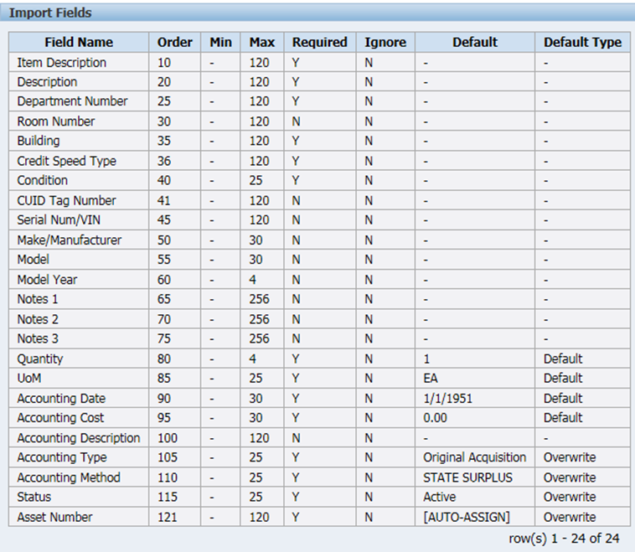
If there are issues with any part of the surplus asset data you will see an error at the top of the Surplus header screen and none of the assets will be imported. You will find specific error messages in error files on the CU ftp site. Access to the ftp requires a login/PW: ftp.incircuit.com. See the system administrator at CU for access information.

How to add a document or image to an asset
To add Documents and/or Images to an asset, users click the 0 and/or any number under the Documents/Images section of the asset. THIS IS OPTIONAL.
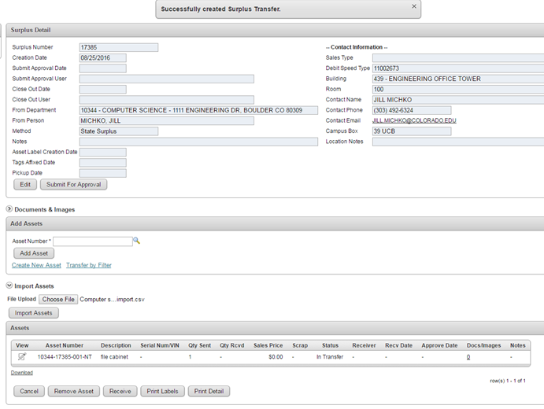
The Attachment Insert screen will appear.
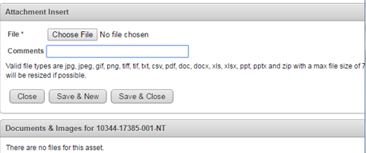
Use the Choose File button to browse out to the location(s) of the images of the asset. Double click on the image or document.
Users can label the image in the comments field. If there is more than one image it upload, then click, the Save & New button to upload more images. Click Save & Close to return to the Surplus Detail.
Users will know that documents and images are attached as there will be a number that is not a 0 listed under Documents and Images.
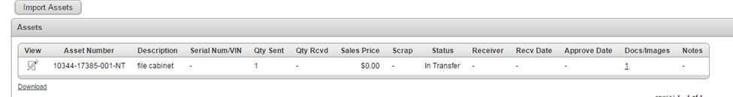

Correcting Asset Information in a Surplus Transfer
If a mistake is made when entering asset information to a Surplus Transfer, the best thing to do is to remove that asset and create a new one with correct information.
To do this, click on the Remove Asset button at the bottom of the Surplus Transfer.
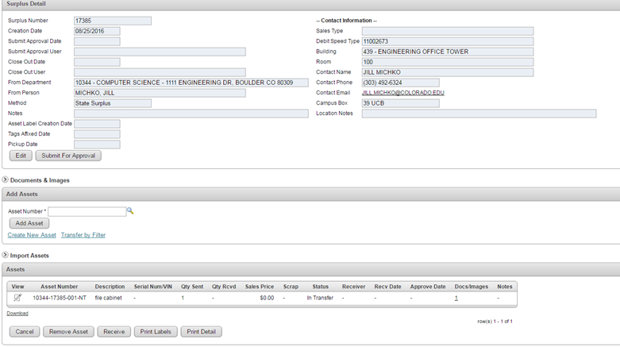
When you click on that button, a Remove Assets area will appear. Next to Asset To Remove is a field with a drop down arrow. Click on that arrow and find the asset you would like to remove from your Surplus Transfer.
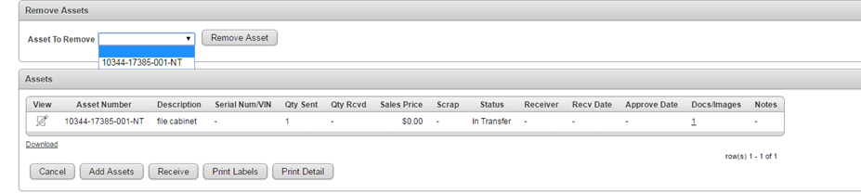
Select the Asset Number and click on the Remove Asset button to the right of the field to complete the removal.
Then, enter new asset information by clicking on “Create New Asset” and filling out the required fields.

Completing a Surplus Transfer

Once all assets are entered, the Surplus can be submitted for approval.
Note: You cannot make any more changes to the Surplus Transfer once it has been submitted for approval.
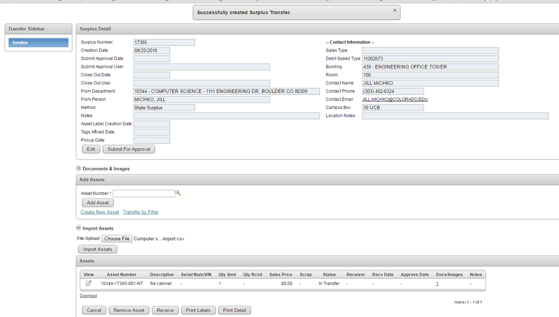

Click on the Submit For Approval below the header of the Surplus Transfer.
Congratulations! You have created your surplus transfer. Now, Property Services staff will process your request.

What Happens Next . . .

After your disposal request has been entered and authorized in the Surplus Property Management System, property services staff will email the contact person with instructions.
Labels will be sent to the disposal request contact person through campus mail with a note instructing them to contact Steve Marvel when the labels have been affixed to all surplus items.
When Property Services has been notified that the items are ready, they will schedule the crew to come and remove your surplus.
On average, it takes Property Services six calendar days to pick up a disposal request from the date the department notifies us the tags have been affixed and the items are ready for pick up.
Property Services completes approximately 150 disposal requests each month. The scope of one disposal request can range from a single item to a multiple-truck pick-up.
Property Services is Generally Funded to pick up surplus property on the CU Boulder campus. That means, your surplus items will be picked up at no charge to your department. An exception to this, is our $95 charge for refrigerant reclamation to cover our hazardous materials disposal costs.
Denise Flack, Denise.Flack@colorado.edu (303-492-7207) and Jilliandra Michko, Jilliandra.Michko@colorado.edu (303-492-6324) are available to help you with the process of registering your department and creating disposal requests.

