Unifier Suggestion Log – Questions and Responses

Question: Would like to see the project tab start with the UCB project number rather than the project name.

Response: This is not configurable. Solutions are 1) hover over the tab with your mouse, and you can see the full “Project Number – Project Name” or 2) utilize bookmarks to reduce the number of tabs you keep open.

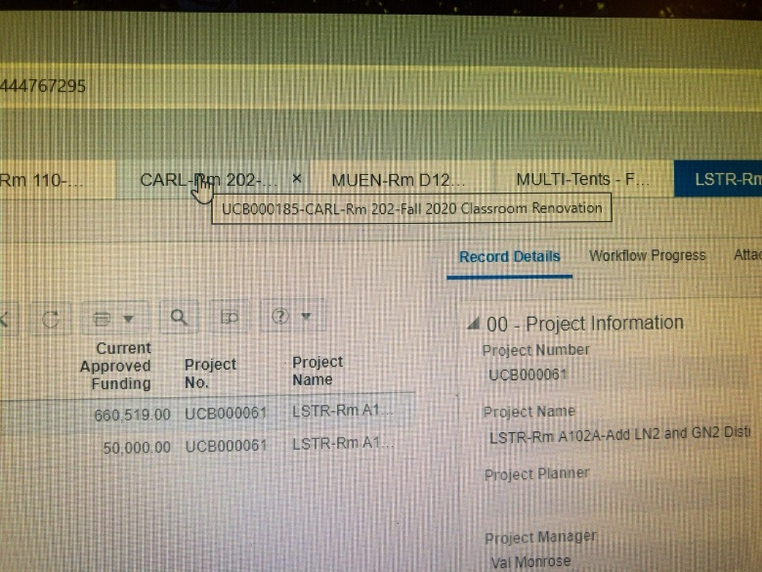
Example: Hover over tab

Example: Bookmarks – recommend to be on the project home page before “Adding” the bookmark.
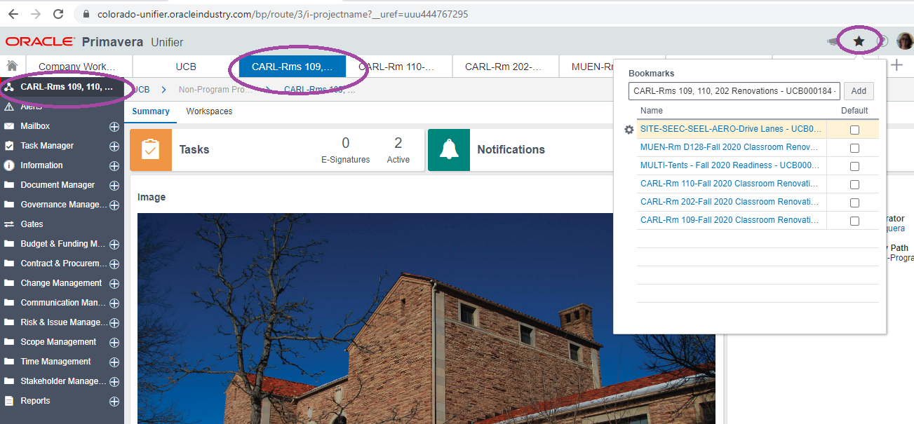

Question: Would be great if the Home screen or Company home screen would provide a full list of our projects with a hyperlink to a project, project status or next step.

Response: The Home screens are not configurable. However, the Home-Home screen shows the list of all your projects that have an open task. Clicking on the task bar will “hyperlink” to the task menu in your project. Should you want to see all of your projects, even those without an Active Task, you could assign yourself a task that remains open for the life of the project so it will appear on the Home-Home screen.

Home-Home Screen – solution for hyperlinking to your projects
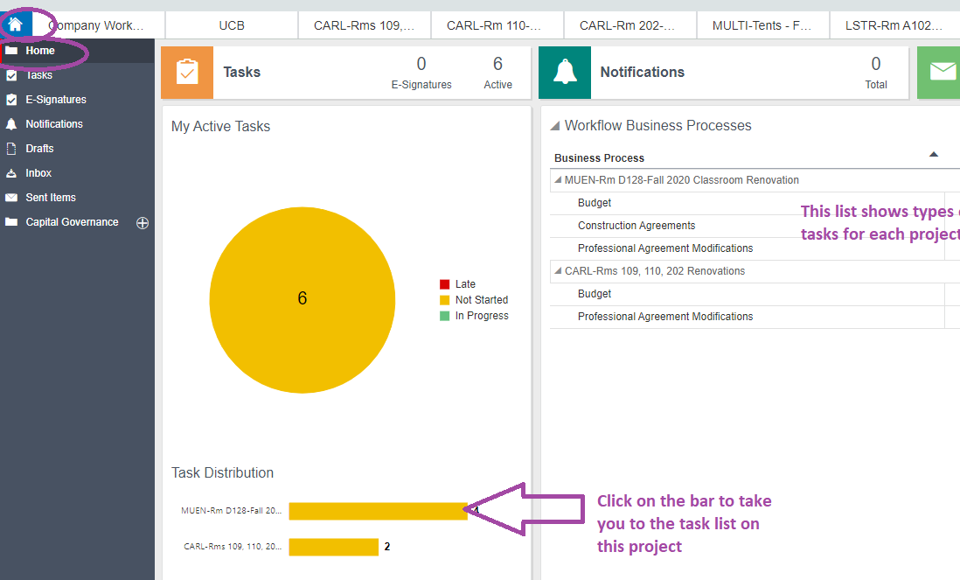

Regarding a particular project’s status, you can currently click on “Gates” in the left-hand menu, and see the current project phase in the view. (The team will look at creating a report that can provide some desired information across all of your projects.)
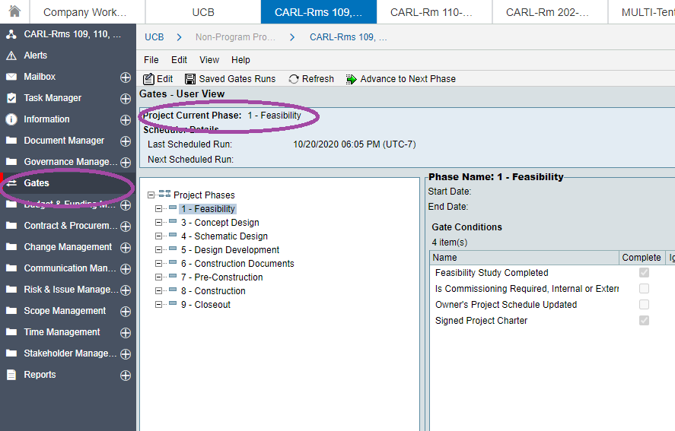
Question: Would like to be able to see the full project name, and have available for copying and pasting.

Response: First a reminder, the project name and number auto-populate all business processes in Unifier. There should not be a need to copy and paste within Unifier. However, you can resize the Details window on the project home screen to see the full project name.

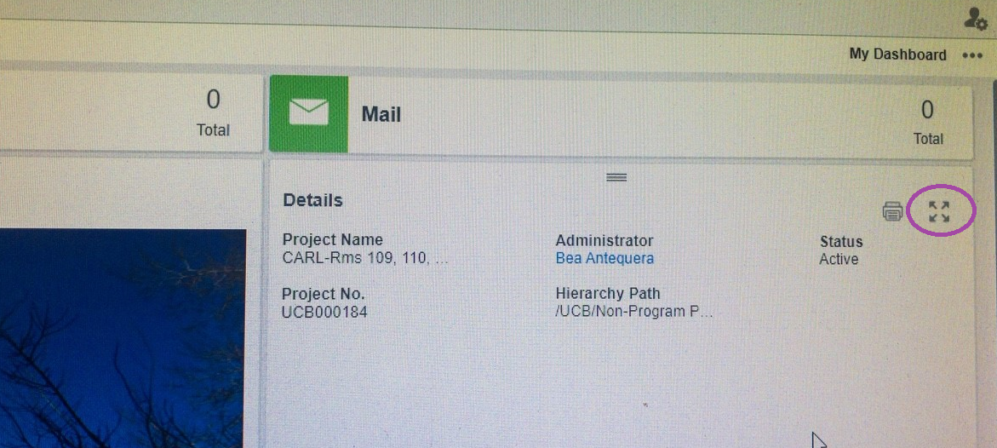
Which gives you this:
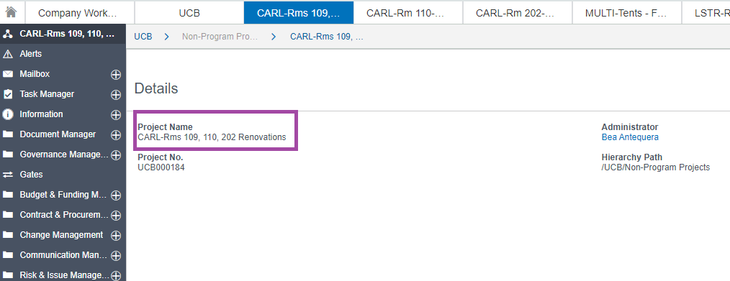

Questions: Could the budget populate a portion of the screen while working on a Budget Change or Budget Transfer? Could you choose codes from a list to add to the Budget Change or Budget Transfer?

Response: This is not possible. It is an Oracle limitation. If you have performed a previous budget transfer on the project that uses similar cost codes, you can select that via the Actions > Consolidate Line Items and select the previous Budget Transfer, then edit costs.

Or, See the Unifier Tip sent out on 9/22/2020 on how to duplicate a tab in Chrome. This allows you to have a view of the cost sheet or other business process in a separate window.

Question: Would be great to have cost codes already used on a project, readily available to select from when creating a contract or amendment.

Response: This is not possible. It is an Oracle limitation. Two options are 1) view the current SOV for an amendment or 2) duplicate a tab in Chrome.

Once you start an amendment, the Schedule of Values (SOV) for the agreement is available for viewing via the “hamburger” menu.
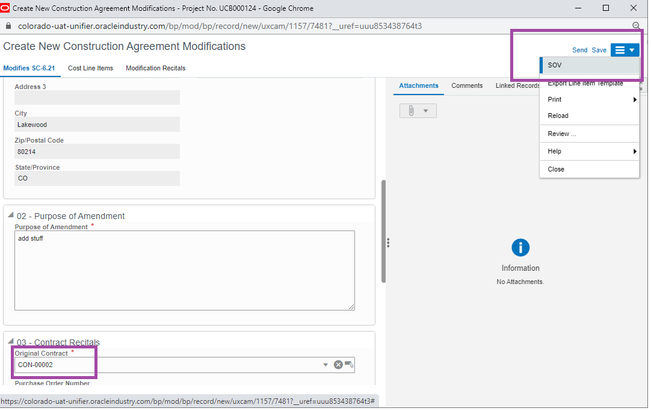

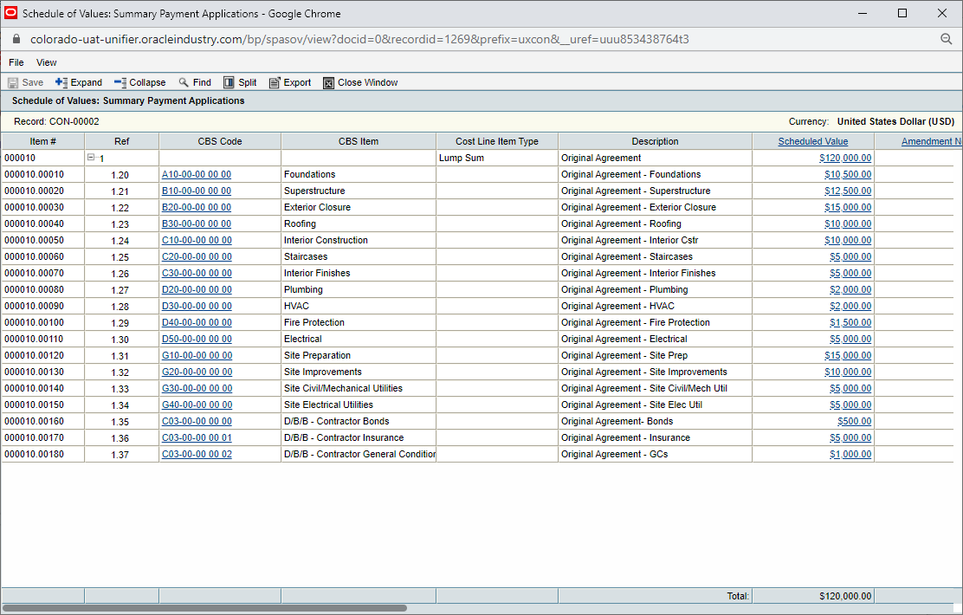

See the Unifier Tip sent out on 9/22/2020 on how to duplicate a tab in Chrome. This allows you to have a view of the cost sheet or other business process in a separate window.

Question: After having entered an invoice and it has reached the end step, why does “Amount of This Invoice” field show the total invoiced to date, rather than truly the amount of this invoice?

Response: This is the result of project information being shown for any particular record, including all possible options for all invoice types. Applicable information can be seen further down in Block 03.
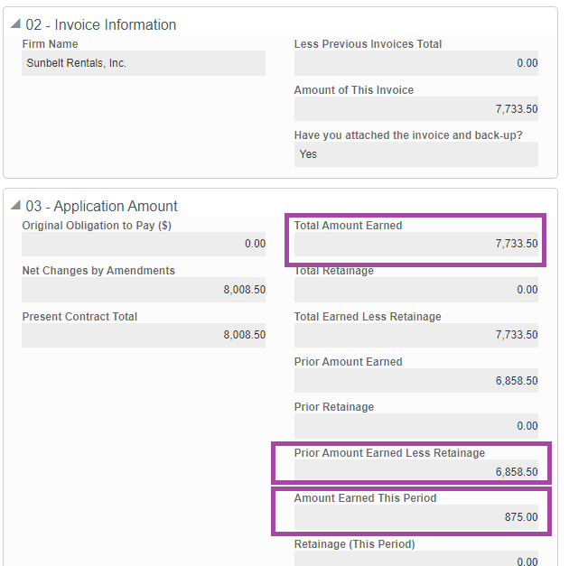

Question: The PM, PC, and Planner information does not update in the Locations, Gates Checklist, of Financial Closeout forms when update in Project Information.

Response: This is true as each of those is a static record created at the time the project is initially created. The team will be looking to hide the PM, PC, and Planner fields in these documents, so this won’t be confusion information.

Question: Why is PO creation now by the PM and not the PC?

Response: Because the creation step requires line item cost allocation for which the PM has the information. PM will enter TBD for the PO #. The Help File is being updated to acknowledge the changes. In general:
- PM received vendor proposal, reviews, and once acceptable
- PM “creates” PO and attaches the proposal (items 2a through 2c will be edited later by the PC)
  - Enters “TBD” for PO number
  - Enters yesterday’s date for Effective Date
  - Enters today’s date for Expiration Date
- PM “Sends” to PC
- PC obtains PO in Marketplace
  - Accepts task
  - Fills in actual PO number
  - Enters actual Effective Date
  - Enters actual Expiration Date
  - Replaces the attached proposal with the final PO/Proposal/CCIA/NTP document (application sections)
- PC “Sends” which copies FM Accounting

