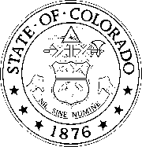
STATE OF COLORADO

OFFICE OF THE STATE ARCHITECT
STATE BUILDINGS PROGRAM

NOTICE OF FINAL ACCEPTANCE (Work < $150,000)

Date of Notice of Acceptance:
 |  |  | Date to be inserted by A/E after consultation with the Principal Representative
Institution/Agency: |  | University of Colorado Boulder
Project No./Name:

TO: Contractor Firm Name
Address

Notice is hereby given that the State of Colorado, acting by and through the Regents of the University of Colorado, accepts as complete* the above numbered project.

By Date

*When completely executed, this form is to be sent by certified electronic mail to the Contractor by the Principal Representative or delivered by any other means to which the parties agree.

