Internal jobs are job postings only CU employees can see.

**To find the internal jobs website:**

1. 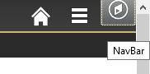Log into MyCUInfo with username and identikey.
2. Click left on time on NavBar.
3. Click left one time on CU Resources.
4. Click left one time on Business Tools.
5. Click on CU Careers - Search Jobs/Apply.

**To find other jobs on the CU jobs website:**

1. Go to the internet.
2. In search bar, type in this website address: https://www.cu.edu/cu-careers
3. Scroll down the page. You will see 2 black buttons to find CU Boulder jobs and to find CU jobs at other campuses.

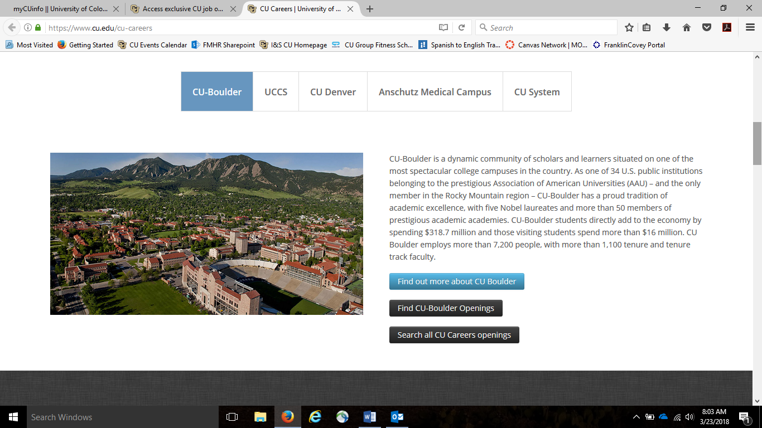

Click left one time to look at job openings at all CU campuses

Click left one time to look at job openings at CU Boulder

**To find the Facilities Management website:**

1. Go to the internet.
2. In search bar, type in this website address: https://www.colorado.edu/fm/internal
3. On this website you can see news for employees in Facilities Management.

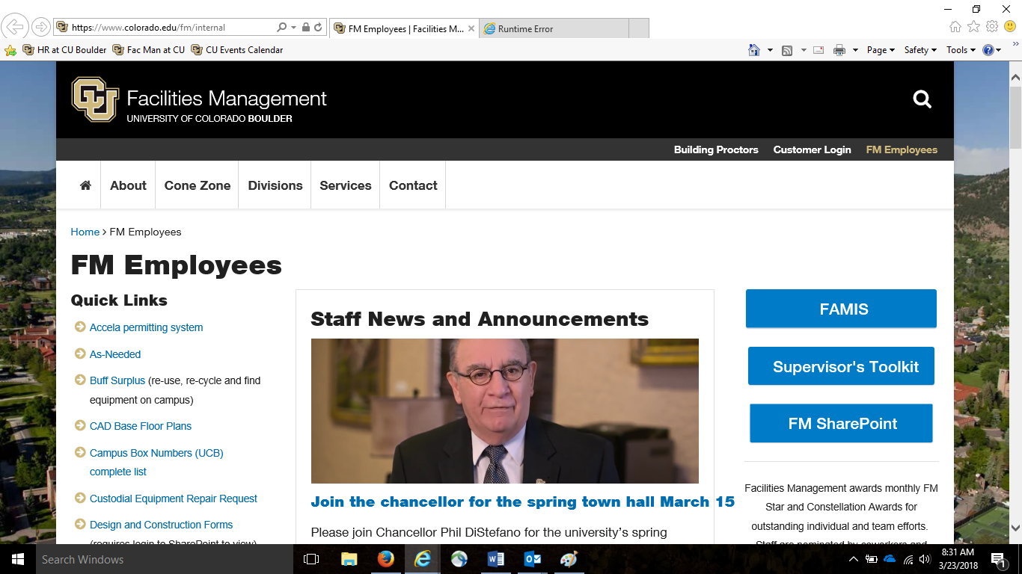

On our website, employees can find information about PERA, town hall meetings. You can even nominate a coworker for an award!

**To find the HR website and the Frontline Worker website:**

1. Go to the internet.
2. In search bar, type in this website address: https://www.colorado.edu/hr/
3. 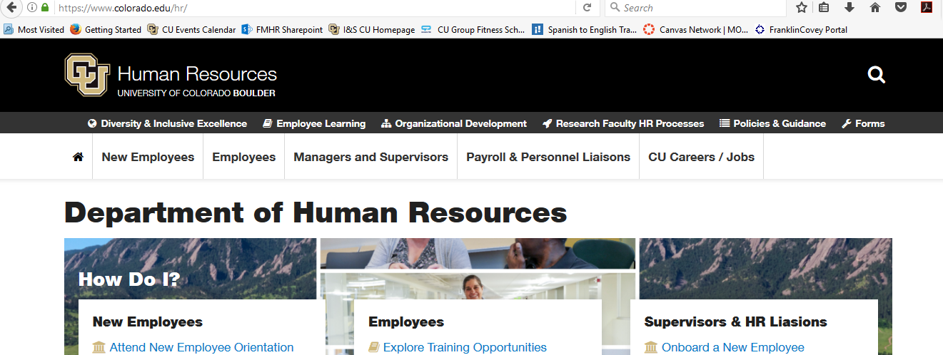On this website, you can see information about employee development. You can find the frontline service worker program and information about English classes.

Click left one time to go to the Diversity and Inclusive Excellence website. You will find the frontline worker page here.

