What is Clickbait?

“Clickbait” are advertisements on the internet that trick a person to click on the wrong link. Clickbait links look like the right link. When a person clicks on clickbait with their mouse, they go to the wrong website.

Example 1
Clickbait is circled with this symbol
To find the clickbait, look for words like “ad” and “advertisement”
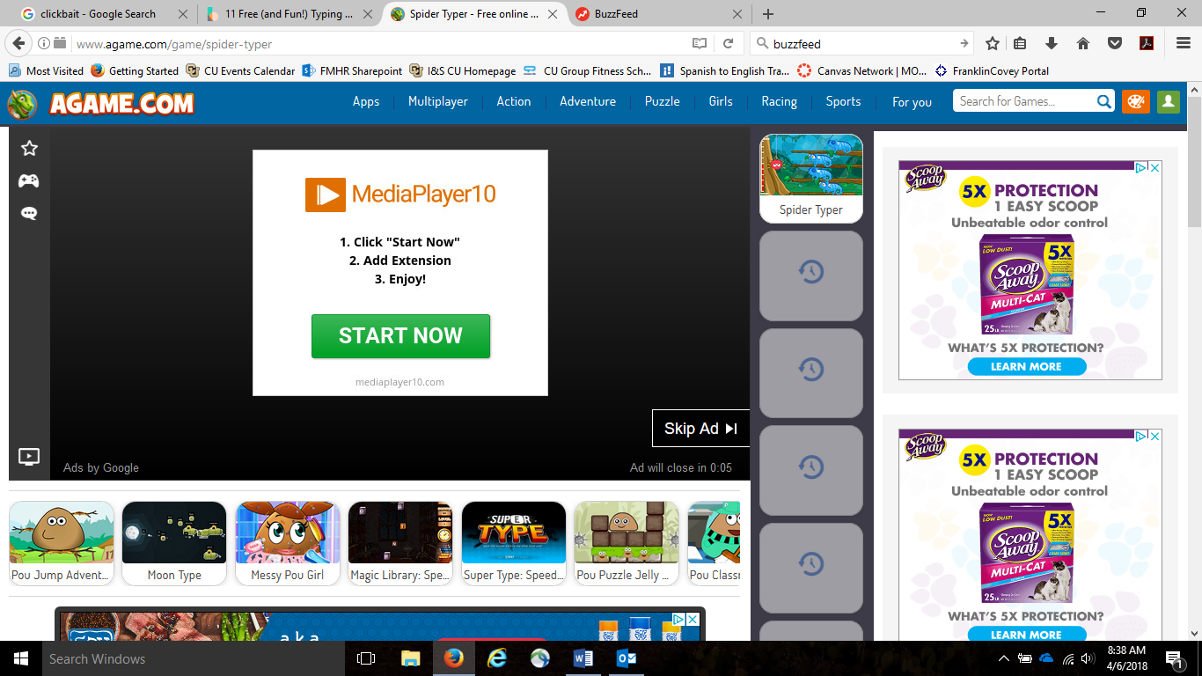
Click left one time on “skip ad” to get away from the clickbait
Example 2
Clickbait tricks you with advertisements about how to make a lot of money, how to look younger, shocking stories, and stories about famous people:
Websites like Facebook can have clickbait ads. Clickbait ads look like a normal video or a Facebook link that you want to click on. The purpose of clickbait is to trick you to go to to the wrong website. Advertisers get paid when you click on clickbait.
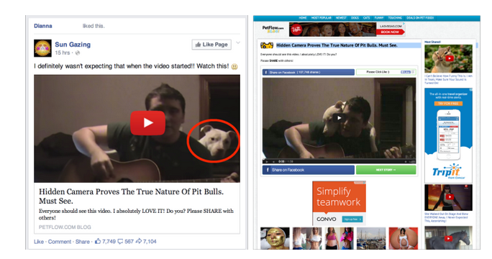
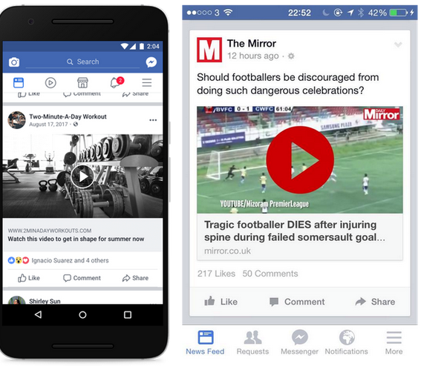

When you use the computer alone, at your supervisor’s office, or at your house, be very careful to look for clickbait.

