FIRST ANNOUNCEMENT
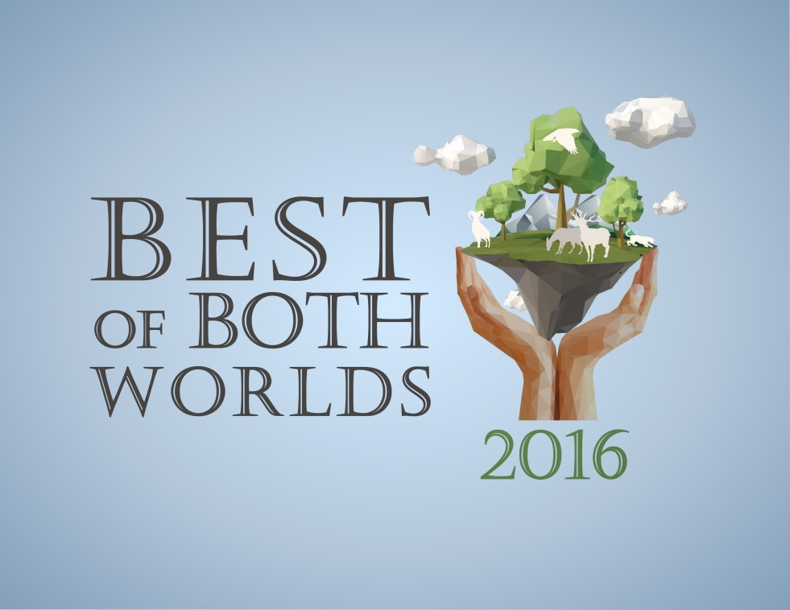
International Conference on Environmental Education and Sustainability: Strengthening Global Networks in a Common Vision for a Sustainable World
Organized by: GO3 Project and Estes Institute
September 26-28 2016
Venue: YMCA of the Rockies, Estes Park, Colorado, USA
www.bobw2016.com

Dear Colleague,
We are pleased to announce the 1st Call for Papers for the Eighth Best of Both Worlds Conference. The organizers would like to take this opportunity to extend an invitation to all practitioners of Environmental Education (EE) and Education for Sustainable Development (ESD). The conference seeks to engage educators from K-12 schools, school districts, universities, community colleges, non-traditional educational centers, nature centers, and many more, along with government officials, non-profits, researchers, protected area and resource managers, environmental tour agents, and anyone else playing a role in EE and ESD.
We are pleased to host the Best of Both Worlds conference this year at the YMCA of the Rockies in Estes Park, Colorado. The venue borders Rocky Mountain National Park (RMNP) and is located at 8,010 feet in the Colorado Rocky Mountains. The large campus has many activities including an 800 foot zip line, climbing wall, and many hiking trails. There is an abundance of wildlife, plants, streams, and high altitude lakes in the area. RMNP contains 72 named peaks above 12,000 feet and is split East-West by the Continental Divide. Trail Ridge Road traverses RMNP and is the highest continuous paved road in the USA.
In addition to two internationally renowned keynote speakers, Dr. Paula J. Ehrlich and Prof. Jimmy Adegoke, the conference will also include paper presentations, four interactive workshops, field excursions, roundtable discussions, and colloquia submitted by practitioners, teachers, and researchers. Please refer to the website http://bobw2016.com/call-for-papers.html for abstract submission guidelines.
Visit our website for more information about the conference, the abstract submission process, registration, and lodging. The deadline for the first round of the call for papers (a title and short abstract) is May 1st, 2016.
We look forward to receiving your proposal and hope you will join us in the United States in September 2016.
With Regards,
BoBW Organizers
Email: staff@bobw2016.com
Website: www.bobw2016.com

