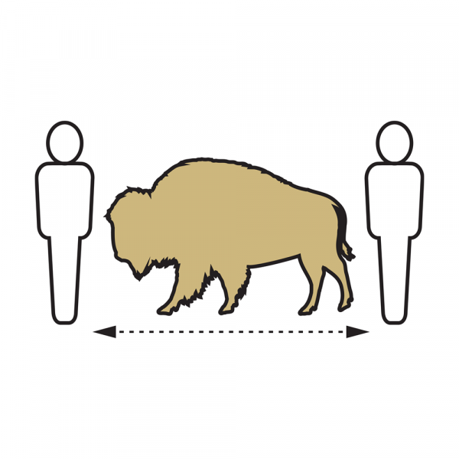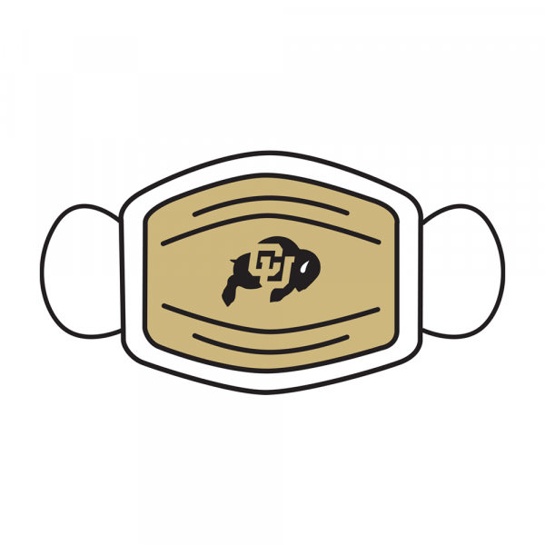

COVID-19 Operational Risk Mitigation Plan
Remote Work Measures

- If you are caring for a child whose school or place of care is closed, or the childcare provider is unavailable due to COVID-19, you may be eligible for leave. More information can be found here. You will need to complete the FFCRA form (also attached) and email to FMLA@colorado.edu.
- If you are experiencing symptoms of COVID-19 and are seeking a medical diagnosis or have been diagnosed with COVID-19 or have been advised by a health care provider to self-quarantine because of COVID-19 or you are caring for a family member diagnosed with COVID-19 subject or advised to quarantine or isolation, you should not return to campus at this time. You must be free of ANY symptoms potentially related to COVID-19 before returning to work on campus. If you are experiencing symptoms and seeking leave, please complete the FFCRA form attached and email to FMLA@colorado.edu.
- If you have a medical condition that prevents you from being able to return to campus including being defined as high risk as defined by the CDC, please contact ADA Compliance directly at adacoordinator@colorado.edu. Please be aware that you may need to provide medical documentation as a part of their process so it is recommended you contact them as soon as possible to ensure they have time to assess your request prior to the return to campus date.
- Leave under the Family Medical Leave Act (FMLA) may be a resource. Please contact Human Resources at FMLA@colorado.edu to inquire if you would be eligible for FMLA and how FMLA can be used.
- If you are experiencing other concerns or questions about returning to campus, the Faculty and Staff Assistance Program is a free and confidential resource for employees, and we encourage you to connect with them to discuss your specific situation and navigate your options.
- In your return to campus, it is required that you follow appropriate health and safety protocols, including social distancing, face coverings, and hand-washing/sanitizing. CDC guidelines are available here. Please contact your department HR or Employee Relations with any questions.

