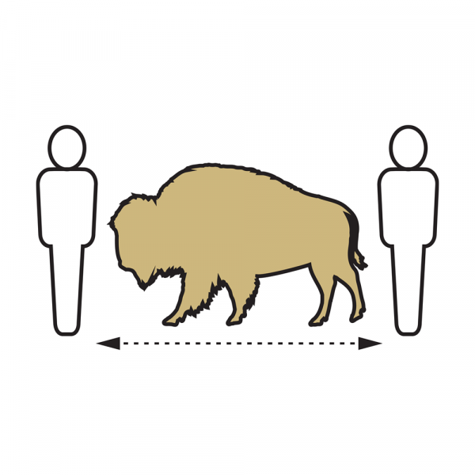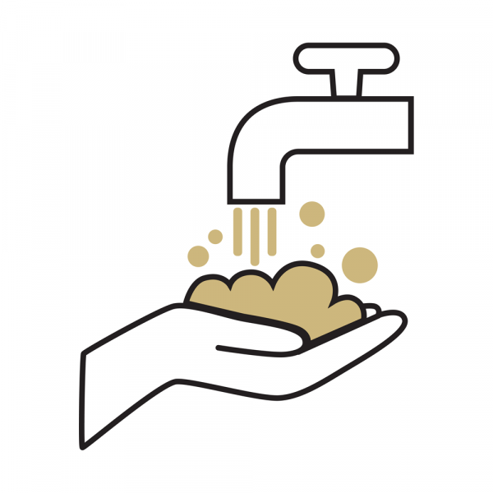

COVID-19 Operational Risk Mitigation Plan

Common Areas

Manage conference rooms and break rooms
Conference rooms and break rooms may be designated for classroom teaching. If conference rooms are available for other purposes, proper signage will be posted to ensure limits of occupancy
- Identify areas that can remain closed off or partitioned if there are no activities taking place. This could reduce the need for custodial services.
- If conference rooms are to be used consider setting up a reservation system allowing for passing periods between reservations.
- Consider identifying Entrance and Exit doors when possible to establish traffic flow and place signage on each door.
- Provide disinfecting wipes in each shared conference room. Each user should wipe all areas and items accessed or utilized BEFORE and AFTER every use.

Limit sharing other employees' desk, phones, etc. sanitize between uses
Individual offices will not be cleaned or sanitized by contract services.

Evaluate shared and high touch items to eliminate or replace with no touch items
- Each user should wipe all areas and items accessed or utilized BEFORE and AFTER every use. The areas include keyboards, mice, desk surface, knobs, levers, and other any touched areas.
- For shared devices (printers, tools), a resource scheduler (google calendar etc) should be set up to reserve the resource and a buffer time between each usage should be included.
- In cases where the shared items or instruments are in an enclosed room, a limited space occupancy based on the size of the room must be enforced at all times.
- Consider replacing high touch shared items such as milk jar, coffee carafe in shared kitchen with automated dispensers.

Evaluate adjustments to in-office catering and meal service
Campus guidelines and recommendations on dining services can be found at the following link https://www.colorado.edu/protect-our-herd/guides#navigate. In addition, units should
- Suspend in-office catering and meal service entirely.
- Avoid communal food trays, salad bars, buffets, etc. and consider switching to individual packaged containers and sealed utensils for each employee.

