CEAS Staff Feedback Report
Deans, Chairs, and Directors Supervisor/Management Training Survey
May 1st 2020, 9:37 am MDT
QID14 - Your name and e-mail address (optional):

Your name and e-mail address (optional):
Robin McClanahan, robin.mcclanahan@colorado.edu
janet.yowell@colorado.edu
Stephanie L. Prokop, stephanie.prokop@colorado.edu
molly.riddell@colorado.edu
Joanne.Uleau@Colorado.EDU
Alex Voorhees alexandra.voorhees@colorado.edu

Q1#1 - Rank the order of importance for the following types of training: - Click one rank for each item.
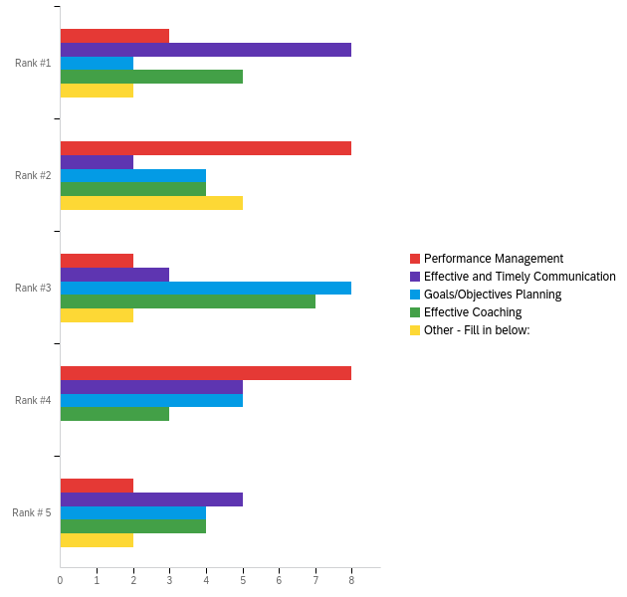

# | Field | Minimum | Maximum | Mean | Std Deviation | Variance | Count
1 | Performance Management | 1.00 | 5.00 | 2.91 | 1.25 | 1.56 | 23
2 | Effective and Timely Communication | 1.00 | 5.00 | 2.87 | 1.60 | 2.55 | 23
3 | Goals/Objectives Planning | 1.00 | 5.00 | 3.22 | 1.18 | 1.39 | 23
4 | Effective Coaching | 1.00 | 5.00 | 2.87 | 1.36 | 1.85 | 23
5 | Other - Fill in below: | 1.00 | 5.00 | 2.55 | 1.30 | 1.70 | 11

# | Question | Rank #1 |  | Rank #2 |  | Rank #3 |  | Rank #4 |  | Rank # 5 |  | Total
1 | Performance Management | 13.04% | 3 | 34.78% | 8 | 8.70% | 2 | 34.78% | 8 | 8.70% | 2 | 23
2 | Effective and Timely Communication | 34.78% | 8 | 8.70% | 2 | 13.04% | 3 | 21.74% | 5 | 21.74% | 5 | 23
3 | Goals/Objectives Planning | 8.70% | 2 | 17.39% | 4 | 34.78% | 8 | 21.74% | 5 | 17.39% | 4 | 23
4 | Effective Coaching | 21.74% | 5 | 17.39% | 4 | 30.43% | 7 | 13.04% | 3 | 17.39% | 4 | 23
5 | Other - Fill in below: | 18.18% | 2 | 45.45% | 5 | 18.18% | 2 | 0.00% | 0 | 18.18% | 2 | 11

Q2 - What do you see as the most important trait(s) an effective supervisor/manager should have?

What do you see as the most important trait(s) an effective supervisor/manager should have?
Leadership
An effective manager should put the employee first by communicating regularly, acknowledging positive behaviors and recognizing/rewarding employees, being a great coach/mentor, being a good listener, empowering employees, being flexible and creative, being understanding, and trusting employees.
Good listening, communication and trouble-shooting skills.
Brings higher knowledge to their team. Identifies team members' strengths and weaknesses and leverages abilities to best support the team and college goals .
Communication, transparency, clear department/unit goals and expectations
1. Investing time and resources towards the team/individual by tying professional development strategies with individual strengths; ask people what their goals are and help them get there. 2. Good management skills include the ability to communicate effectively. This ability isn't just about delegating. It also encompasses efforts to actively let employees know they are valued and how they're making a contribution to the mission. 3. Conflict management skills to foster a team dynamic of accountability. Be clear and proactive about setting reasonable expectations, invest time in performance management before a small issue turns into a bigger problem for you and others.
1. Complete transparency and excels at communicating goals and objectives 2. Not micromanaging and allow their employees to make decisions 3. Being decisive
Listening, then collating the ideas and concerns of multiple stakeholders
--All leaders MUST have some high-quality subconscious bias training to understand how known biases (especially sexism) play out subtly on a daily basis in STEM especially. --Delegation: The ability to purposefully empower people with appropriate authority to make decisions, escalating to your approval only when necessary, without micromanagement (these boundaries should be defined) --Team Structuring: How to efficiently structure a team, delegating responsibility to avoid redundancies and inefficiencies Prioritization: How to intake and triage requests appropriately (workflow/traffic management) --Process Management: How to create efficient processes and avoid redundancies (too many cooks in the kitchen) and analysis paralysis --Coaching and accountability: How to create positive, collaborative environments that hold people accountable for 'values' such as cooperation, collaboration, and being a team player
Culturally sensitive communication skills given that the faculty and administrators are primarily white, and mostly men and the staff are much more diverse, but predominantly women. Empathy - in our new normal, some supervisors will be more caring than others. That's a given. But people need to realize that everyone is in NOT in the same boat regarding accommodations and ability to "be productive" during this pandemic.
Good communication and clear expectations. They should be encouraging and supportive. Also they should realize that their team is made up of human beings and be flexible. There are often behind the scenes things that staff do that the supervisors never even realize, or don't know how time consuming they can be
Don't micromanage or be a Laissez-faire manager. Foster collaboration and honest communication.
communication skills
Good communication skills. Someone who always expresses appreciation to his/her employees for working hard/job well done. In addition, if a supervisor feels that a situation wasn't handled well by an employee, I would like the information to be communicated in person instead of expressing anger through emails as well as done in a way to not shame the employee but to help the employee learn from the experience. Also a supervisor who communicates in advance when taking (day/days) off instead of leaving it to the employee to figure it out.
They should be able to communicate effectively and in a timely manner so that they can help answer questions and provide necessary guidance and feedback for new staff without leaving the new employees in the dark for extended time frames. They should also have a general familiarity with the responsibilities of the staff that they oversee and be responsible for ensuring that the staff receive the training, resources, and guidance they need in order to succeed at their job. If the supervisor isn't able to provide the training themself, then they should able to guide the staff toward the resources and other personnel who can help them learn and develop the skills and knowledge they need in order to be successful. Especially during the beginning of new staff employment, supervisors should set up a clear plan of training and what is expected of the new staff member(s)within the first month/6-months/year. A supervisor should definitely encourage independent functioning, but in order to make new staff confident and independent in their role, the supervisor needs to be supportive and help provide new staff with a solid foundation to build upon (in regards to knowledge, understanding, and skills). While there is no need to be the best of friends, there is also the hope that a new supervisor will get to know and understand their new staff and how they function as a person. They need to also help foster a mutual sense of respect between new staff and themselves so that a healthy, beneficial, and productive professional relationship can be fostered.
I don't think this question should be posed as "traits" but rather behaviors or practices. I believe it's important for a supervisor to support their employees - their main goal should be to help their employees achieve their tasks and goals.
Listening to all employees, understanding their role, how to positively manage a group of people, helping the employees input come to life.
Emotional Intelligence and accountability
Tailoring coaching and mentoring sessions to be strength based vs. weakness based.
Communication, patience, flexibility, having your back.

Q4 - Additional Comments:

Additional Comments:
They need to have the skills to performance manage and coach their employees when needed but also be able to professionally develop as well. CEAS is losing really good employees because management fails to help them become great.
This is a fabulous idea and one that I have advocated for a long time. I think it should go a step further and require supervisory training for any faculty member that supervises anyone, including students. Faculty should have supervision as a key performance objective as part of their service. I also think it would be good for the employees supervised to be able to have input to the faculty member's evaluation/review for this objective.
Do college a-deans/directors attend leadership retreats as a group? Facilitating such activities for college leaders could be beneficial for improved cross-team collaborations.
As an institution of education, we need to develop managers and leadership skills internally. We have excellent managers who can mentor others, and we also have poor managers who are lacking accountability of their own impact as one. Regardless of whether someone has formal supervision experience, it's important to understand how an individual has made a contribution in developing others as it relates to hiring and promotion decisions - otherwise, they're not management material and may negatively infect the entire organization.
They treat others as they would like to be treated.
This initiative seems very valuable, as people often reach leadership roles after strong achievements in their domain or field, but having little or no training in the competencies listed above. Leadership is a human science and related skills must be treated as key competencies that merit training (and evaluation), not assumed to be a given once a person has reached a certain tenure or expertise level in a topical field. Happy to provide more feedback and thank you for surveying!
I have seen too many recent situations where staff members' jobs are being reorganized or eliminated without their knowledge for extended periods of time. Honest communication, even when difficult, is important for trust maintenance.
It would be nice to have more female leadership in general. It would also be nice to have leaders of other diversities such as race, orientation, etc.
NCWIT can help with supplying content for how to be an inclusive supervisor. Research suggests that supervisory relationships are at the heart of why most women leave tech in the corporate sector.
I also would like a supervisor who is organized and doesn't keep dropping the ball. And finally, I would like supervisors (who are not faculty) to be accountable for work hours as it seems like my supervisor takes an excessive number of days off as well as often leaves during the workday for personal errands, leaving me as a part-time worker not fully understanding his work priorities for me and/or with an excessive amount of work.
there could be some differentiation between supervisors of other staff members and supervision of student staff. for student staff, supervision includes supporting academic success as well as success on the job.
A manager should not put hierarchy first, a manager should know and understand that all positions are equally important to make the entire team run smoothly.
I would like to see program directors take a more active roll in coaching their managers within their programs to think more critically about the approaches and care of their staff and faculty. If effective coaching came from the top-down, I think departments overall would thrive and produce better environments for all stakeholders.

