

Breathing and Relaxation Techniques

Please review this section for a variety of recommendations and suggestions for developing your own routines involving breathing, relaxation, meditation, and recovery.

Breathing or other relaxation techniques are great ways to relax the body and take a simple break from your normal routine, reduce stress, and provide a mind-body reset. They can help the body and mind calm down after a day’s work and can also be beneficial to perform anytime in your day-to-day routine.
Examples include meditation, breathing exercises, mindfulness routines, and routines to reduce stress and anxiety.

Sections:
- Breathe & Relax 101– Back Breathing Pg. 2
- Breathe & Relax 102– Inhale/Exhale Pg. 3
- Breathe & Relax 103– Progressive Relaxation Pg. 4

Breathing & Relaxation 101– Back Breathing
Breathing techniques are great ways to relax the body, provide meditative focus, and take a simple break from your normal routine.
Remember to sit and stand up slowly after performing breathing techniques. If you stand up quickly you may experience lightheadedness.
Guide:
- To perform, lay on your back. Place one hand on your chest and one hand on your abdomen.
- Slowly take a deep breath in and focus on trying to get your abdomen to rise while your chest remains relatively still.
- As you breathe in, the hand on your stomach will rise. When you breathe out, the hand on your stomach will lower.
- Inhale for a count of 4 and exhale for a count of 8.
Remember you should not feel out of breath while performing this activity, if you do, please stop, and breathe at your normal pace until recovered.
Try and perform this task a few minutes at a time. This is a great technique to perform prior to falling asleep at night, as it can help you clear your mind and prepare your body for rest.

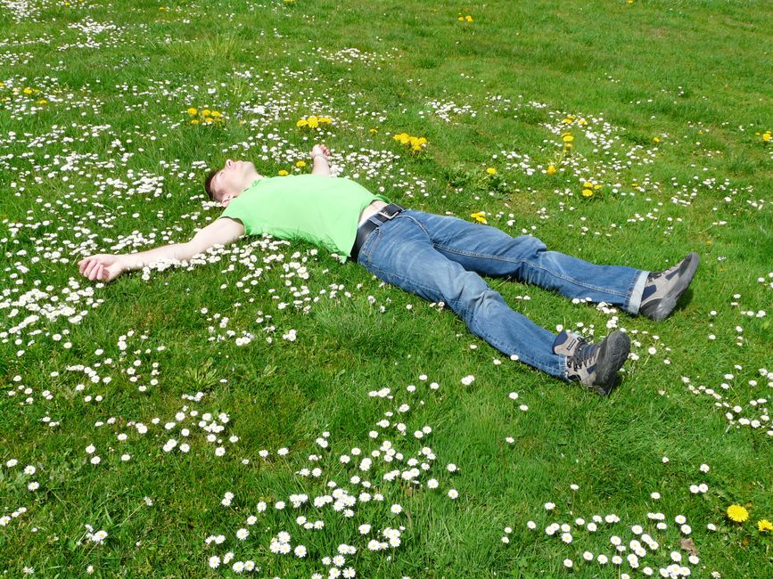

Breathing & Relaxation 102– Inhale/Exhale Mindfulness
Breathing techniques that involve practicing your inhalation and exhalation are fundamental to health, wellness, and recovery from physically demanding activity. Additionally, it provides a great way to relax the body, as a meditative reset, and take a simple break from your normal routine.

Guide:
- Place tip of tongue to the roof of your mouth, slightly open your mouth. Eyes can be open or closed.
- Exhale until you reach the bottom of your breath and complete the exhale.
- Close mouth and quietly inhale through your nose for a count of 4.
- Hold your breath for a count of 7 and then exhale slowly for a count of 8. (Or for however long is most comfortable)
- Repeat 2-3 times and focus on your personal comfort level.

A technique such as this one is a common strategy to reduce the symptoms of stress and anxiety and can help with any routine to focus or relax.

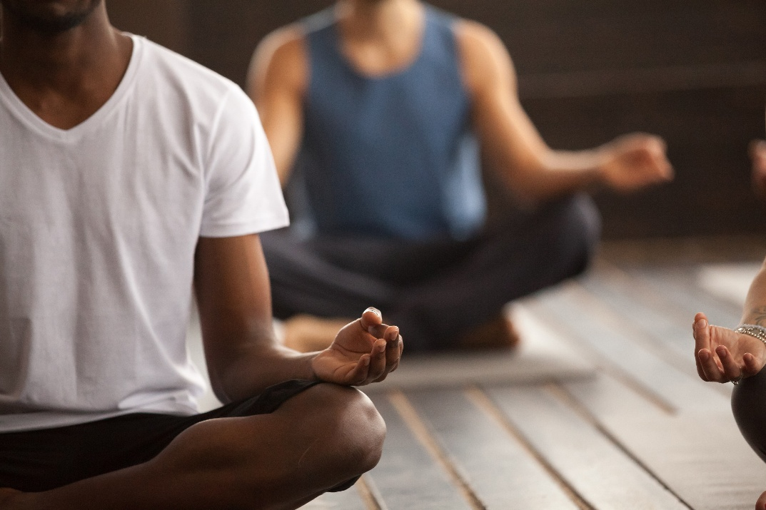
Breathing & Relaxation 103– Progressive Relaxation
Progressive muscle relaxation is a technique that involves tensing and relaxing muscles one by one. It can help reduce physical tension, reduce stress, and is helpful for identifying areas of your own body that may be causing you discomfort or pain.
You can perform this technique anytime throughout the day! Seated, standing, or on the go!

Guide:
- First clench your jaw and scrunch your face for 3 seconds.
- Relax all the muscles you just tensed for a few seconds and breathe.
- Then squeeze your hands for 3 seconds. Again, relax and breathe.
- Next hunch your shoulders towards you ears and tighten your chest for 3 seconds. Take a breath and relax.
- Finally pull up your toes and tense the muscles in your legs. Hold for 3 seconds.
- Shake it out, breathe, and feel the tension leave your body.
Feel free to go through the cycle as slowly or quickly as you feel is comfortable.
Remember to breathe throughout the activity, if you feel lightheaded at any point stop, relax, and breathe normally.
If any muscle still feels tense, you can progress through the sequence one more time.

Progressive muscle relaxation is a great way to relax the body, clear the mind, and take a simple break from your normal routine.

