Creating a Homemade Foam Roller
Self-massage techniques promote muscle elasticity and increase blood flow, which aids in muscle recovery and decreases muscle tightness and pain. Self-massage tools allow you to apply greater force and leverage while practicing these techniques and can help you access difficult to reach areas of the body!
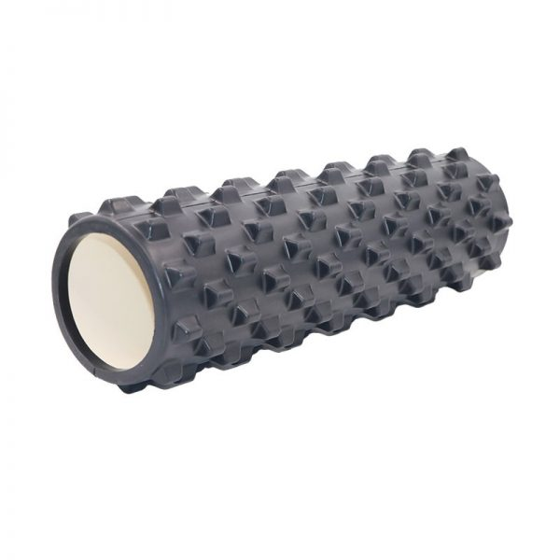
A massage stick is functionally a thick foam cylinder that you use on your own muscles to achieve this affect! Foam Rollers can be found at most major in-person and online retailers that carry sporting or athletic goods, or you can find the supplies to create your own!
This Photo by Unknown Author is licensed under CC BY-NC-ND
There are many different methods and guides to creating your own self-massage tools; find the ones that work best for you!
An example of a commercial foam roller with a hollow plastic tube.

Supplies:
Method 1:
- A 2 ft. length of PVC pipe or other hollow lightweight pipe that is 4-6 inches thick.
- Yoga Mat or other strip of dense foam to serve as the outer liner.
- Tape or strong adhesive.

Method 2:
- Large pool noodle cut to approximately 2 ft. long.
- Wooden dowel, PVC pipe, or other supporting material cut to fit the pool noodle. (Should be something that fits snug through the hollow pool noodle)
- Tape or strong adhesive.

Instructions:
Method 1:
- Take the PVC pipe/cylinder that will serve as the supportive core of your foam roller and make sure that it isn’t too heavy to manipulate when practicing self-massage techniques. Check it for any sharp edges or damage before use, sand away or replace if needed.
- Roll the yoga mat or other covering out on the floor and place the pipe at one end. Roll the PVC until it is completely covered with the mat and mark this point. Cut your mat to fit, completely covering the internal cylinder.
- Tape or glue the mat into place around the cylinder. Duct tape is ideal!
- Use tape on the ends to prevent your foam cylinder from sliding off the core.
- Congratulations you’ve made a foam roller!

Method 2:
- Take the PVC pipe/cylinder that will serve as the supportive core of your foam roller and make sure that it isn’t too heavy to manipulate when practicing self-massage techniques. Check it for any sharp edges or damage before use, sand away or replace if needed.
- Cut your pool noodle to fit the length of the cylinder/pipe that is serving as the core.
- Thread the length of pipe through an old pool noodle, it should be snug with the edges to provide a dense supportive core.
- Use tape to cover the ends to prevent the core from sliding out of the pool noodle.
- Excellent, you’ve just made another DIY foam roller!

