

Creating a Homemade Massage Stick

Self-massage techniques promote muscle elasticity and increase blood flow, which aids in muscle recovery and can decrease muscle tightness and pain.

Self-massage equipment allows you to apply force and leverage with less effort and can help you access areas of the body that are difficult to reach!

A massage stick is functionally a rolling pin that you use on your own muscles. A massage stick can be found at most major in-person and online retailers that carry sporting or athletic goods.

Or you can create your own; there are many different methods and guides to creating and using self-massage tools; find the ones that work best for you!

Example Homemade Massage Stick:

Supplies:
- One approximately 2 ft. in length wooden dowel, PVC pipe or other lightweight cylinder that is no more than 2-3 inches in diameter.
- KT Tape/duct tape, or other protective coating to cover the pipe and guard against sharp edges and to protect the surface of the cylinder from damage or splintering.
  - Self-adherent gauze wrap or other basic compression tapes can be used as well.

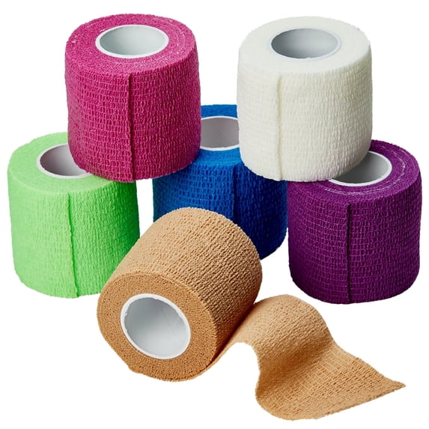

Instructions:
- Take the cylinder and make sure that it isn’t too heavy to manipulate when practicing self-massage techniques.
  - Check the ends and sides for any sharp edges, damage, or splinters which might irritate you when in use.
  - You should be able to comfortable roll the cylinder along major muscle groups such as; calves, thighs, lower back, etc.
- Cover the entire cylinder in your protective coating of choice such as KT Tape or other tape. Make sure the ends are capped off, and no edges will bother you or cause injuries while using the massage stick.

