Creating a Reusable Heat Pack

Reviewing Heat: Self-Care 101
Heat loosens muscles by increasing blood flow relieving muscle stiffness and tightness. Applying heat can be an important and extremely beneficial aspect of your daily life and recovery routines. Helping you to relax and stay warm even if you aren’t trying to recover from any injuries or pain.

Commercial heat packs can be found in a variety of forms reusable microwavable gel/water packs, one time usage chemical heaters such as hand warmers that can be held or applied to the body even on the go, and electric heating pads or blankets.
Please note that it is only recommended to apply heat for 15-20 minutes as needed. DO NOT place a heat source directly on skin or any other sensitive areas. Place the heating pad or other heat source in a towel and drape over the area you desire to heat.

Remember:
- It is recommended to avoid the usage or application of heat on the back or abdomen if pregnant.
- Avoid use of heat over new or open wounds and injuries sustained within the last 72 hours, as heat increases blood flow to the area and can cause an increase in discomfort on new injuries or bruises.

Method 1: Microwaved Dishcloth Pg. 2
Method 2: Heated Towel Pg. 3
Method 3: Cloth Bag and Rice Pg. 4

Method 1: Microwaved Dishcloth
Supplies:
- A wet clean dishcloth. (Damp, doesn’t need to be soaked through
- Microwave safe sealable plastic bag.
- Microwave.

Guide:
- Take your wet dish cloth and place it into the microwave safe sealable bag.
  - Make sure your microwave is clean of any other contaminants.
- Heat in the microwave for 1-2 minutes at a time to create a usable hot pad.
  - Remember to always be careful when moving a newly heated hot pack with bare hands or onto your skin. (Wrap in another dry cloth to protect your skin.
- Apply to affected area.
- Remove the washcloth and repeat whenever needed!

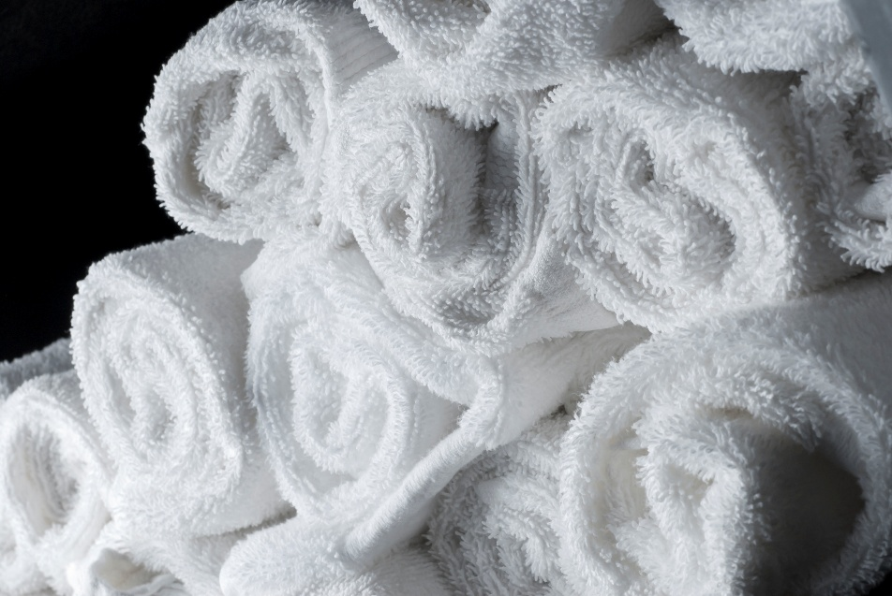

Method 2: Heated Towel
Supplies:
- A towel or kitchen towel. (This is an ideal method to create larger heating pads as multiple towels, or towels of different sizes can be heated at once on the same tray)
- Clean baking tray or sheet.
- Oven.

Guide:
- Take towels and get them damp and roll/fold tightly to place on your baking tray.
- Place the towel tray in an oven that is set to 300 °F or lowest heat setting.
- Let the tray sit in the oven for 5-10 minutes, return it to the oven if it hasn’t reached a comfortable temperature. Set a timer so you don’t forget about your towels!
- Remove tray from oven and wrap the hot towel in another dry cloth to protect your skin and apply to affected area.
  - Remember to always be careful when moving a hot object, with your hands or onto your skin. Use oven mitts to handle your towels and tray.
- Clean and reuse your towels again as needed!

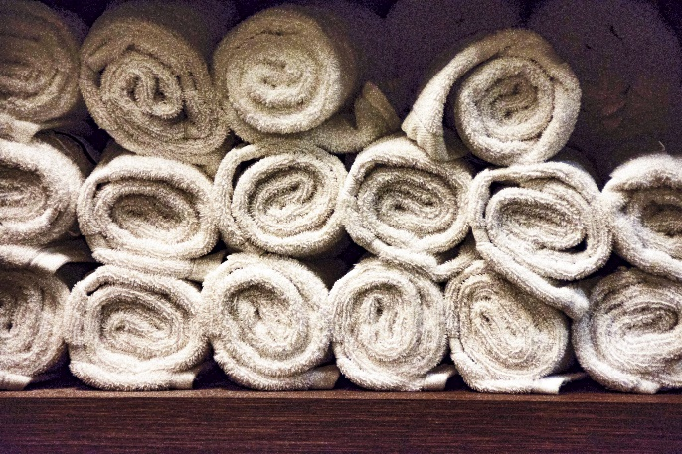

Method 3: Cloth Bag and Rice
Supplies:
- A large piece of old, but freshly cleaned fabric, that can be sealed or tied shut. (A sock works great for this method, as it can be knotted closed at the end)
- Uncooked rice or uncooked dry bulk oatmeal.
- Microwave.

Guide:
- Take your fabric bag or sock, ensure it is undamaged.
- Fill the bag approximately three quarters full of uncooked rice or oatmeal.
- Seal the cloth by knotting the fabric or sewing it shut.
- Heat in the microwave for 1-2 minutes at a time to create a usable hot pad.
  - Make sure your microwave is clean of any other contaminants.
  - Remember to always be careful when moving a newly heated hot pack with bare hands or onto your skin.
- Store for reuse in a sealable plastic bag to prevent damage.

