Stretching- Start of Day Warm Up
A period of Warm-Up stretching exercises to start your day can be a key part of readying your body for physically demanding work, increase flexibility, and promote relaxation.
- A gradual warmup via a stretching routine gets your blood circulating and reduces the physical stress of starting physically demanding work.
- Starting the day with a Warm-Up allows your body temperature, blood pressure, and heart rate to prepare for normal work-related activity levels. All of which help to reduce fatigue and physical discomfort at the start of work!
- Taking the time to complete a Warm-Up routine can help to reduce lactic acid build up, reducing your chance of muscle cramps and stiffness!
- Stretches lead to better flexibility! They help to elongate the connective tissue, increase mobility, improve range of motion, and recognize areas of your body that might be experiencing pain and need further rest and recovery.

Remember! Stretching should never cause you to experience any additional pain or discomfort, and if so, stop immediately.
Recognize your own limits and build your own personalized routine that helps you to address areas of discomfort, provide relaxation and recovery benefits, and improve your energy levels throughout the day!

Warm-Up stretching routines can improve your well-being at the start of your workday but can also be included before or after long breaks, or when switching from sedentary work back to more physically demanding tasks.
Never hesitate to increase the amount of time spent stretching and working to improve your own health and wellbeing!

Find new exercises and mix your stretching routine up by varying the number, order, or finding new stretching and active warm up activities to mix into your routine. An example guide is below!

Example Guide:
1. Shoulder Rolls
Roll your shoulders up, back, and around. 10-15 rotations.
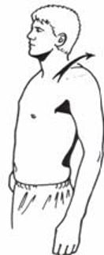

2. Forward Arm Swings
Standing upright, swing arms forward and backward in an alternating fashion. 10-15 rotations.
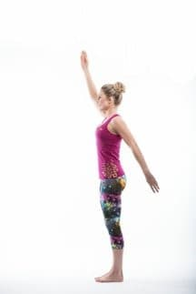

3. Arm Swings Out
Swing your arms across the body and then away/out to the side of your body. Swing 10-15 times.
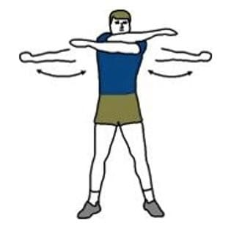

4. Open and Close Hands
Open your hands, spreading your fingers wide. Next, bring your fingers back together again. Repeat 10-15 times per hand.
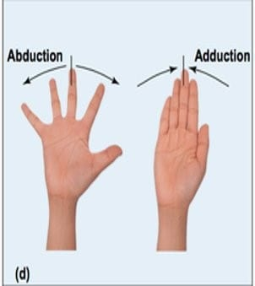

5. Finger Tendon Glides
Start with your fingers straight up, curl them into a fist one joint at a time. Next, bring your fingers out into a tabletop position. Finally, from the tabletop position bend your fingers at the middle joint. Repeat 10-15 times per hand.
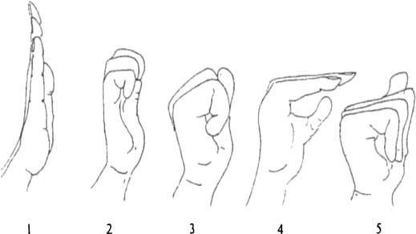

6. Wrist Circles
Rotate your wrists in a full circle clockwise 10 times and repeat counter-clockwise 10 times.
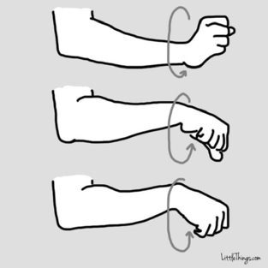

7. Neck Rotations
Rotate your neck to the right and then left. That is one repetition, repeat 10-15 times.
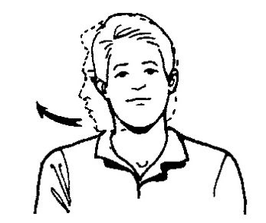

8. Neck Side Bends
Touch your right ear to your right shoulder and then repeat on the left side. That is one repetition. Repeat 10-15 times.
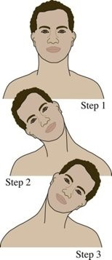

9. Windmills
Starting with your arms out to the side, bend down and touch your right foot with your left hand. Stand up and then touch the left foot with your right hand. That is one repetition. Repeat 5-10 times.
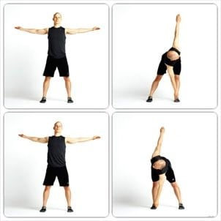

10. Butt Kickers
Bend the knee and touch foot on buttocks and switch legs in an alternating fashion. Repeat 10-15 times.
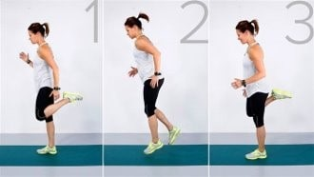

11. Front Lunge
Lunge forward with the right leg. Stand up and lunge forward with the left knee. That is one repetition. Repeat 5-10 times. Only step forward to your comfort level, start slow!
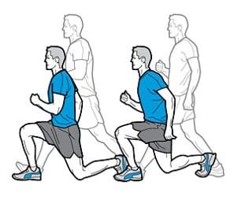

12. Side Lunge
Lunge to the right side and then return to standing. Repeat on the left side. That is one repetition. Repeat 5-10 times. Only step to the side to your own comfort level, start slow!
