

Stretching- For Seated, Office, & Desk Workers

Stretching can be an integral part of improving your health and wellbeing in the workplace, and developing an ongoing routine can also help to fight against the negative side effects of sedentary office jobs.

Remember! Stretching should never cause you to experience any additional pain or discomfort, and if so, stop immediately.

Recognize your own limits and build your own personalized routine that helps you to address areas of discomfort, provide relaxation and recovery benefits, and improve your energy levels throughout the day!

Never hesitate to increase the amount of time spent stretching and working to improve your own health and wellbeing!

Find new exercises and mix your stretching routine up by varying the number, order, or finding new stretching and active warm up activities to mix into your routine. An example guide is below!

Stretching, or any form of active body movement, is critical for workers who remain seated for most of their days.

The routine below is a brief cycle that can be performed every hour to help reduce the health risks of sedentary work, while providing the benefits of stretching and moving your body.

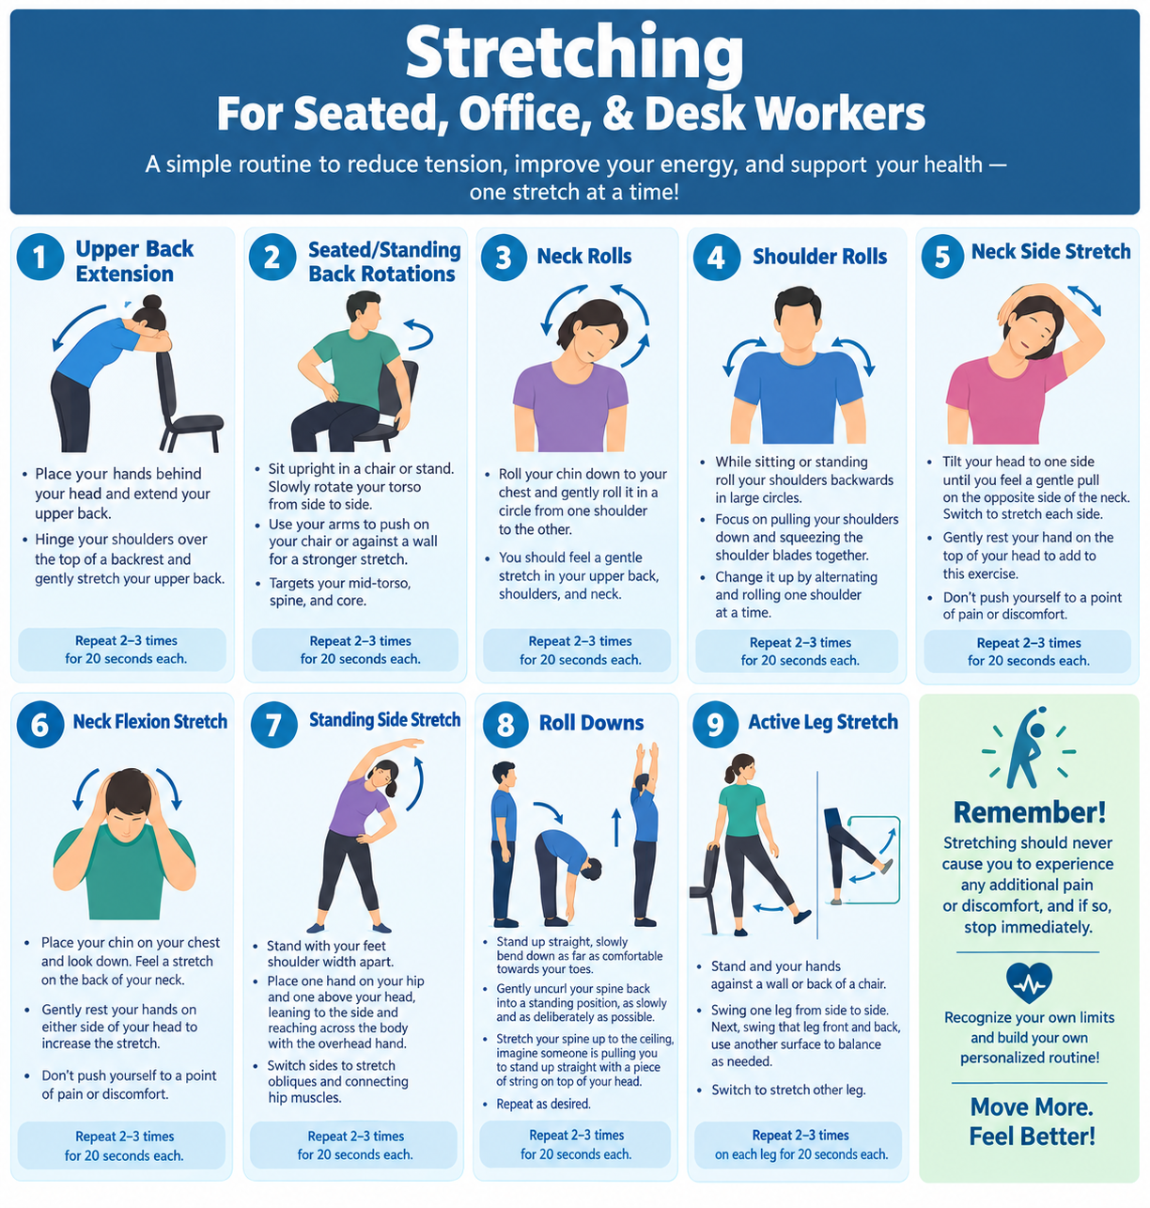

Guide:

Upper Back Extension: Repeat 2-3 times for 20 seconds each.
- Place your hands bend your head and extend your upper back.
- Hinge your shoulders over the top of a backrest and gently stretch your upper back.

Seated/Standing Back Rotations: Repeat 2-3 times for 20 seconds each.
- Sit upright in a chair or stand. Slowly rotate your torso from side to side.
- Use your arms to push on your chair or against a wall for a stronger stretch.
- The stretch targets your mid-torso, spine, and core.

Neck Rolls: Repeat 2-3 times for 20 seconds each.
- Roll your chin down to your chest and gently roll it in a circle from one shoulder to the other.
- You should feel a gentle stretch in your upper back, shoulders, and neck.

Shoulder Rolls: Repeat 2-3 times for 20 seconds each.
- While sitting or standing roll your shoulders backwards in large circles.
- Focus on pulling your shoulders down and squeezing the shoulder blades together.
- Change it up by alternating and rolling one shoulder at a time.

Neck Side Stretch: Repeat 2-3 times for 20 seconds each.
- Tilt your head to one side until you feel a gentle pull on the opposite side of the neck. Switch to stretch each side.
- Gently rest your hand on the top of your head to add to this exercise. Don’t push yourself to a point of pain or discomfort.

Neck Flexion Stretch: Repeat 2-3 times for 20 seconds each.
- Place your chin on your chest and look down. Feel a stretch on the back of your neck.
- Gently rest your hands on either side of your head to increase the stretch. Don’t push yourself to a point of pain or discomfort.

Standing Side Stretch: Repeat 2-3 times for 20 seconds each.
- Stand with your feed shoulder width apart.
- Place one hand on your hip and one above your head, leaning to the side and reaching across the body with the overhead hand.
- Switch sides to stretch obliques and connecting hip muscles.

Roll Downs: Repeat 2-3 times for 20 seconds each.
- Stand up straight, slowly bend down as far as comfortable towards your toes.
- Gently uncurl your spine back into a standing position, as slowly and as deliberately as possible. Strech your spine up to the ceiling, imagine someone is pulling you to stand up straight with a piece of string on top of your head. Repeat as desired.

Active Leg Stretch: Repeat 2-3 times on each leg for 20 seconds each.
- Stand and your hands against a wall or back of a chair.
- Swing one leg from side to side. Next, swing that leg front and back, use another surface to balance as needed. Switch to stretch other leg.

