

Stretching- End of Day Cool Down
- A gradual cooldown via a stretching routine keeps your blood circulating and prevents the abrupt changes switching to rest, for example going directly from work to sitting down to commute in your car, which can cause you to feel lightheaded or dizzy.
- Cooling down allows your body temperature, blood pressure, and heart rate to return to their normal levels. All of which help to promote relaxation and recovery!
- Stretching your muscles while they’re still warm can help to reduce lactic acid build up, reducing your chance of muscle cramps and stiffness!
- Stretches lead to better flexibility! Helping to elongate the connective tissue, increase mobility, improve range of motion, and recognize areas of your body that might be experiencing pain and need further rest and recovery.
All these benefits work to improve your body’s overall function and flexibility, allowing you to feel better, perform at a higher level, and reduce your chance for injury.

Remember! Stretching should never cause you to experience any additional pain or discomfort, and if so, stop immediately.
Recognize your own limits and build your own personalized routine that helps you to address areas of discomfort, provide relaxation and recovery benefits, and improve your energy levels even after you finish the workday!

Never hesitate to increase the amount of time spent stretching and working to improve your own health and wellbeing!
Find new exercises and mix your stretching routine up by varying the number, order, or finding new stretching and active warm up activities to mix into your routine. An example guide is below!

Guide:
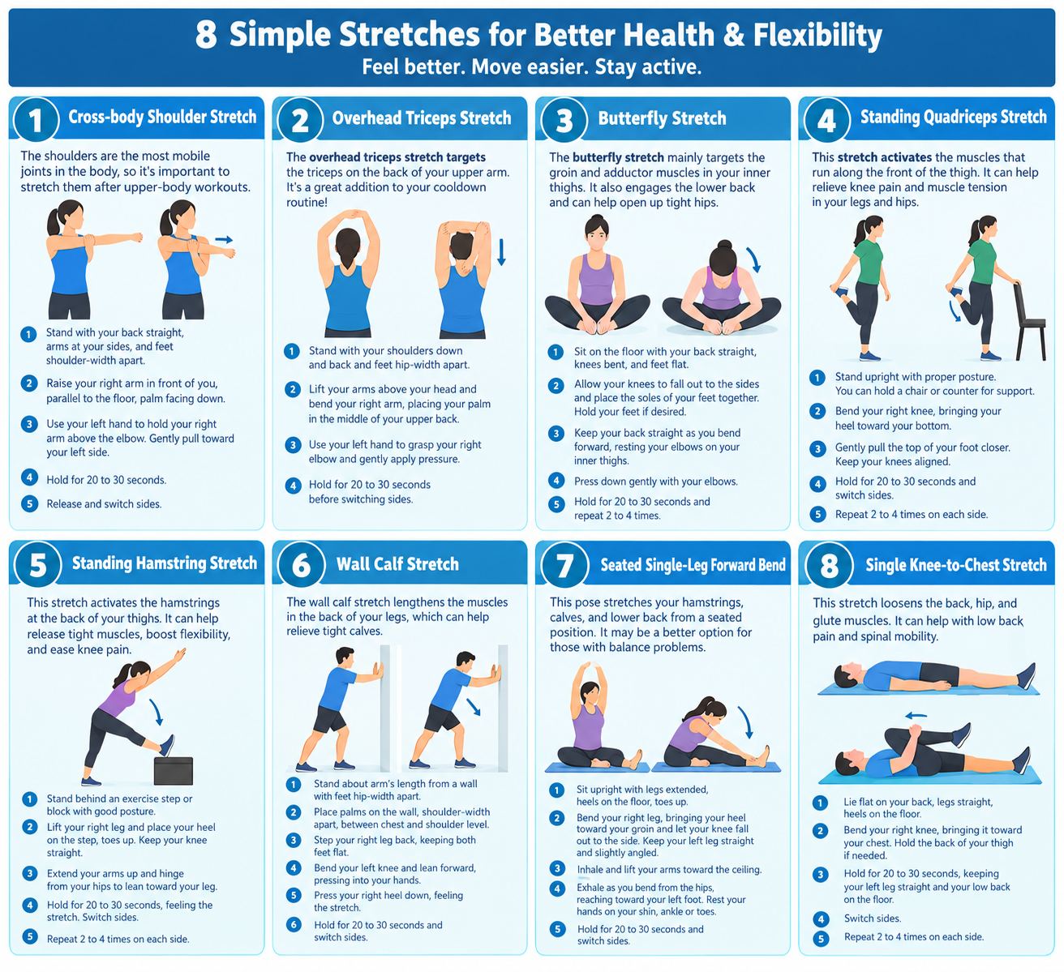

1. Cross-body shoulder stretch
The shoulders are the most mobile joints in the body, so it's important to stretch them after upper-body workouts.
- Step 1: Stand with your back straight, arms at your sides, and feet shoulder-width apart.
- Step 2: Raise your right arm in front of you, bringing it parallel to the floor with your palm facing down.
- Step 3: Use your left hand to hold your right arm above the elbow. Gently pull your right arm toward your left side to deepen the stretch.
- Step 4: Hold for 20 to 30 seconds.
- Step 5: Release the stretch and then switch sides.

2. Overhead triceps stretch
As the name suggests, the overhead triceps stretch targets the triceps on the back of your upper arm. It's a great addition to your cooldown routine!
- Step 1: Stand with your shoulders down and back and your feet hip-width apart.
- Step 2: Lift your arms above your head and bend your right arm, placing your palm in the middle of your upper back.
- Step 3: Use your left hand to grasp your right elbow and gently apply pressure to deepen the stretch in your right tricep.
- Step 4: Hold for 20 to 30 seconds before switching sides.

3. Butterfly stretch
The butterfly stretch mainly targets the groin and adductor muscles in your inner thighs. It also engages the lower back and can help open up tight hips.
- Step 1: Sit on the floor with your back straight, knees bent, and feet flat.
- Step 2: Allow your knees to fall out to the sides as you place the soles of your feet together in front of you. You can hold your feet together with your hands.
- Step 3: Keep your back straight as you bend toward your feet, resting your elbows on your inner thighs.
- Step 4: Press down gently with your elbows to deepen the stretch.
- Step 5: Hold for 20 to 30 seconds and repeat 2 to 4 times.

4. Standing quadriceps stretch
With the standing quadriceps stretch, you activate the muscles that run along the front of the thigh. It can help relieve knee pain and muscle tension in your legs and hips.
- Step 1: Stand upright with proper posture. You can hold the back of a stable chair or counter for support.
- Step 2: Bend your right knee to bring your heel toward your bottom.
- Step 3: Gently pull the top of your foot to bring your heel closer and deepen the stretch. Try to keep your knees aligned with one another.
- Step 4: Hold for 20 to 30 seconds and then switch to the left side.
- Step 5: Repeat 2 to 4 times on each side.

5. Standing hamstring stretch
This stretch activates the hamstrings at the back of your thighs. The standing hamstring stretch can help you release tight muscles, boost flexibility, and ease knee pain.
- Step 1: Stand behind an exercise step or yoga block with good posture.
- Step 2: Lift your right leg and place your heel on the step with your toes pointing toward the ceiling. Keep your right knee straight.
- Step 3: Extend your arms straight up and hinge from your hips to lean toward your right leg.
- Step 4: Hold for 20 to 30 seconds, feeling the stretch in your right hamstring.
- Step 5: Switch to the left side.
- Step 6: Repeat 2 to 4 times on each side.

6. Wall calf stretch
The wall calf stretch lengthens the muscles in the back of your legs, which can help relieve tight calves.
- Step 1: Stand about arm's length away from a wall with your feet hip-width apart and arms at your sides.
- Step 2: Place your palms flat against the wall, shoulder-width apart, between chest and shoulder level.
- Step 3: Step your right leg back, keeping both feet flat on the floor.
- Step 4: Bend your left and lean forward as you press your weight into your hands.
- Step 5: Press your right heel down, feeling the stretch in your right calf.
- Step 6: Hold for 20 to 30 seconds and then switch sides.
7. Seated single-leg forward bend
A regular yoga practice helps keep your muscles flexible. This beginner-friendly pose allows you to stretch your hamstrings, calves, and lower back from a seated position. It may be a better option for those with balance problems.
- Step 1: Sit upright with your legs extended, heels on the floor, and toes pointing toward the ceiling.
- Step 2: Bend your right leg, bringing your heel toward your groin and allowing your knee to fall to the side. You can rest your right foot on your left thigh. Keep your left leg straight and angle it slightly to the side as if forming one side of the letter V.
- Step 3: Inhale as you lift your arms toward the ceiling.
- Step 4: Exhale as you bend from the hips, leaning toward your left foot. Rest your hands on your left shin, ankle, or toes, depending on your flexibility.
- Step 5: Hold for 20 to 30 seconds and then switch sides.

8. Single knee-to-chest stretch
The single knee-to-chest stretch loosens the back, hip, and glute muscles. It can help with low back pain and spinal mobility.
- Step 1: Lie flat on your back, keeping your legs straight and your heels on the floor.
- Step 2: Bend your right knee, bringing it as close to your chest as you can. You can hold the back of your right thigh to gently pull your knee closer.
- Step 3: Hold for 20 to 30 seconds, keeping your left leg straight and your low back pressed into the floor.
- Step 4: Switch sides.
- Step 5: Repeat 2 to 4 times on each side.

