BOO!
“BOOM! The Physics of Sound & Music!”
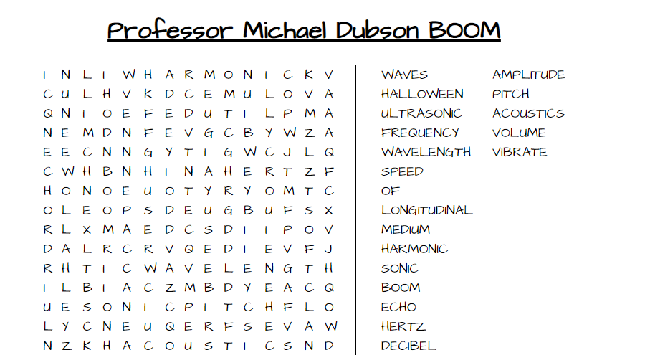

Info: For Zoom Viewing, please go to www.colorado.edu for link to Zoom meeting.

Join Zoom Meeting
https://cuboulder.zoom.us/j/94343157506
Meeting ID: 943 4315 7506

For in-person meeting on Saturday, October 30, 2021 9:30 – 10:30 am
Please arrive 15 – 20 minutes early to allow time for safe seating in pods.

Socially Distanced Pod Seating – please sit anywhere but be sure you leave at least one seat (6 feet) between your pod and the next pod over in all direction.

All audience members MUST WEAR A MASK AT ALL TIMES during the entire program. Please ensure that all children are masked so that noses and mouths are covered!
Maximum Room Capacity 220 persons.
Thanks for your cooperation to ensure safest space
possible for today’s young viewing audience

CU WIZARDS 2021-2022
Show virtual toolkit for at-home viewing audience and for extension activities.

- PBS Series “Physics in Motion”
Welcome to Physics in Motion – a new digital series for high school physics from Georgia Public Broadcasting! The series is comprised of seven units of study divided into segments. Under each segment, you will find support materials designed to provide practice and reinforce concepts. A teacher toolkit is available and can be requested using this form.
https://www.gpb.org/physics-in-motion/unit-6/sound-diffraction-and-interference

- PhET Interactive Simulations ~ Science Learning Fun!
PhET provides fun, free, interactive, research-based science and mathematics simulations. The simulations are written in Java, Flash or HTML5, and can be run online or downloaded to your computer. All simulations are open source. Multiple sponsors support the PhET project, enabling these resources to be free to all students and teachers.
https://phet.colorado.edu/en/simulations/filter?subjects=sound-and-waves&type=html&sort=alpha&view=grid

- Seven ways for kids to “see” sound
Today we share science experiments to help kids “see” sound: How is sound generated? Why there are so many different sounds? Many people know sound is certain types of waves. These science activities visualize sound waves for kids to “see” the sound. They can be built in units for sound and light and any music class.
https://igamemom.com/science-experiments-for-kids-about-sound/

Can you carve an ocarina from a butternut squash?

