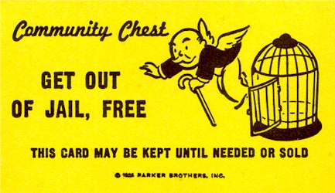
Exit Ticket

Oops! Something went wrong in today’s lab.
It happens.

Your grade for today’s lab will only be based on the work

you were able to complete, and your feedback on this form.

Your name:

Today’s Date: Lab section:

Title of Lab:

You are responsible for completing today’s lab up until section:
(Complete this from information given by your TA)

Describe briefly what you think went wrong today:

How do you suggest we fix this for the future?

Any other comments?

