ZOOM OVERVIEW INSTRUCTIONS
Focused on presenting online + audience engagement

Go to https://support.zoom.us/ for more
Note: If you have not yet downloaded the Zoom application, please visit the Zoom Download and Setup tutorial.

- Participant-focused instructions: pp 1-5
- Presenter-focused instructions: pp6-13

SETTING UP ZOOM
Get Started: All CU Boulder students, faculty, and staff have access to a Pro account by using Zoom's login with Single Sign-on (SSO) functionality (this includes CU Boulder group or secondary accounts, by request).
Download the Zoom application
- Click Sign In with SSO
- Enter "cuboulder" and click continue
- A browser window will open prompting you for your Federated Identity Service identikey and password credentials. Click Continue.
- This will automatically create your account and log you in.
Please note: Zoom Pro accounts that have not logged in one year will be removed on a routine basis. When logging back in, you will regain access to Zoom Pro functionality automatically.
*Find more detailed documentation and help resources on the Zoom Help and Zoom FAQ pages.
Cost: Zoom web conferencing is provided at no cost to CU Boulder affiliates.
Who can get it: All campus affiliates have access to a Pro Zoom account which is automatically provisioned the first time you login using SSO through the Zoom application. For installation help, use the Zoom - Download and Login tutorial.

Class presentation settings:
- Audience members will, by default, be muted with the video off to help ensure smooth streaming and minimal background noise.
  - Presenters and instructors can still see who is present, and can even note when you are busy doing other things on your computer rather than prioritizing the meeting.
- Presenters will have audio + video.
  - When not actively presenting, their mics should be muted.
  - If streaming becomes sketchy or sound starts going out, video will be turned off, leaving only the presentation slides on screen.

PARTICIPATING - Being a meeting attendee

Overview - Joining a meeting from desktop
- Need this version of joining to take part in breakout meetings
- Each meeting has a unique 9, 10, or 11-digit number called a meeting ID that will be required to join a Zoom meeting
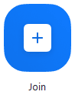
- If you are joining via telephone, you will need the teleconferencing number provided in the invite.
- Open the Zoom desktop client.
- Sign in to Zoom then click Join.

- Enter the meeting ID number and your display name.
  - If you're signed in, change your name if you don't want your default name to appear.
  - If you're not signed in, enter a display name.
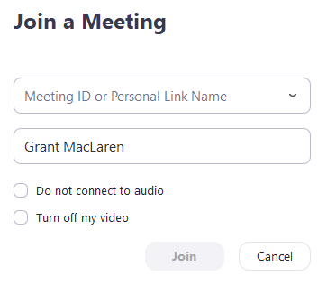
- Select if you would like to connect audio and/or video and click Join.

Phone Call into a Zoom Meeting
If computer audio is not working, Zoom has functionality allow participants to join a meeting via telephone audio (+ having visuals up on the computer)

To join a Zoom meeting via audio conference (telephone) the meeting will need to be started and the host or participant needs to provide the meeting ID.
The meeting ID can be found at the top of the Zoom window:
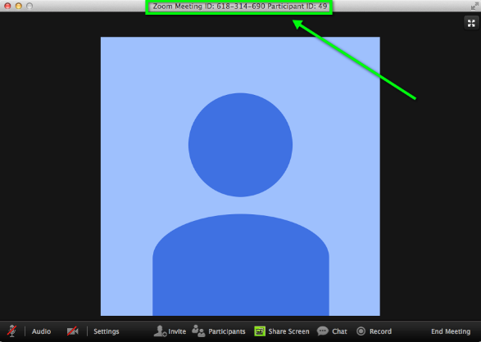
Step 1: Audio conferencing participant will need to call: (415) 762-9988 or (646) 568-7788 AND follow the verbal instructions.
Step 2: Enter the meeting ID you wish to join followed by the # key.
Step 3: You will be asked to enter your participant ID. If you do not know your participant ID, simply press the # key

You have now joined the Zoom meeting.

Overview - Attendee Controls in a Meeting
When you join a Zoom meeting hosted by another user, you are considered an attendee. The instructor and presenters will have host controls.

Attendees have access to these features:
- Mute / Unmute: Mute and unmute your microphone.
Audio Controls (click the ^ arrow next to Mute / Unmute): Allows you to change the microphone and speaker that Zoom is currently using on your computer, leave computer audio, and access the full audio settings.
  - Tip: Use the following keyboard shortcuts to mute or unmute yourself. You can also use push to talk if you want to unmute yourself by holding the spacebar.
    - Windows: Alt + A
    - Mac: Shift + Command + A
- Start Video / Stop Video: Turns your camera on or off.
Video Controls (click the ^ arrow next to Start Video / Stop Video): Change cameras if you have multiple cameras, select a virtual background (if enabled), or access your full video settings.
- Participants: See who's currently in the meeting. The Participants list also gives you access to these options:
  - Rename: Hover over your name and click Rename to change your screen name displayed to other participants.
  - Non-verbal feedback icons (if enabled by the host): Places an icon beside your name to quickly notify the host. For example, Raise Hand places the raise hand icon beside your name and simulates a hand raise.
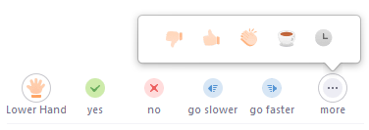
- Share Screen: Start a screen share (if the host allows). You will be able to select the desktop or application you want to share. Learn more.
- Chat: Access the chat window to chat with the participants. Learn more.
- Leave Meeting: Leave the meeting while it continues for the other participants. Only the host can end the meeting.

Overview - In-Meeting Chat

The in-meeting chat allows you to send chat messages to other users within a meeting. You can send a private message to an individual user or you can send a message to an entire group. As the host, you can choose who the participants can chat with or to disable chat entirely.
In-meeting chat can be saved manually or automatically. Auto-save chat will automatically save your in-meeting chat locally on your computer. You can also manually save your chat when you start local or cloud recording.

Accessing the Chat in Meeting from a Desktop Device

- While in a meeting, click Chat in the meeting controls.

- This will open the chat on the right. You can type a message into the chat box or click on the drop down next to To: if you want to send a message to a specific person.
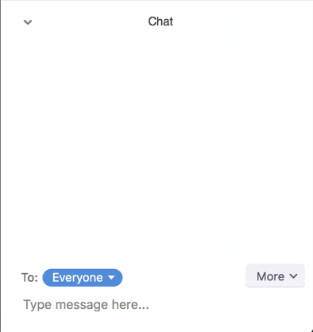

- When new chat messages are sent to you or everyone, a preview of the message will appear and Chat will flash orange in your host controls.

While Screen Sharing
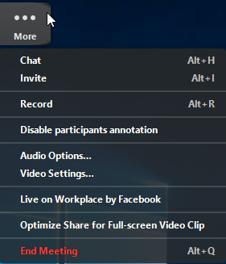
- While screen sharing, click More in the meeting controls. Choose Chat.
- A floating chat window will appear.
- If you receive new chat messages while screen share, the more button will flash orange to indicate the incoming message. You can click on More, then Chat to open the window.

Overview - Participating in Breakout Rooms
Breakout rooms are sessions that are split off from the main Zoom meeting. They allow the participants to meet in smaller groups, useful for collaboration and discussion in the meeting.

Break Out Room Prerequisites
- Join the meeting by the Zoom desktop client, mobile app, phone, or H.323/SIP device
- Invitation to join breakout rooms from the meeting host
Note: Users joined into the Zoom meeting from the Zoom Desktop Client, Zoom Mobile App, or H.323/SIP devices can participate in breakout rooms. Users joined via the web client, Chromebooks/Chrome OS or Zoom Rooms are unable to join Breakout Rooms, but the main room can be used as an alternative session for these users.

Joining a Breakout Room
- The host will need to invite you to join the breakout room.
- Click Join.
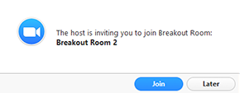

- If you choose Later, you can join by clicking the Breakout Rooms option in your meeting controls.

- Click Join Breakout Room.
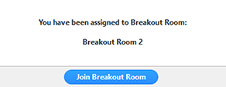

Participating in the Breakout Room
Once you've joined the breakout room, you will have full controls similar to the meeting. You can:
- Mute/Unmute to speak
- Start/Stop Video
- Participants - view the Participants list
- Share screen - read more about screen sharing
- Chat - type messages to the other participants in your breakout room
- Record - you can record the Breakout Room locally if the host gives you recording permission. Read more about local recording.
- Ask for Help - request help from the meeting host

Asking for Help from Instructor while in breakout room
If you click Ask for Help, it will notify the meeting host that you need assistance and they will be asked to join your breakout room.
- Click Ask for Help in the meeting controls.
- Confirm that you would like assistance by clicking Invite Host.
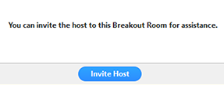

Recording while in a Breakout Room
- The host needs to allow recording before opening the breakout rooms. If the host has already open the breakouts rooms, they can join your breakout room to allow you to record.
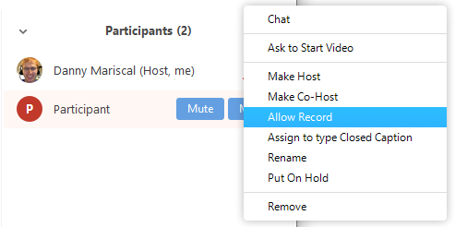
- Click Record in the meeting controls to start a local recording.
- The host will need to invite you to join the breakout room.
- Click the pause or stop icon in the meeting controls to pause or stop the recording.
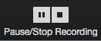
The recording can also be stopped or paused by clicking the indicator in the top left corner.

Leaving the Breakout Room

You can leave the breakout room and return to the main meeting session at any time, or you can leave the meeting entirely from the breakout room.
- Click Leave Breakout Room.
- Choose if you want to leave the breakout room or the entire meeting.
- When the host ends the breakout rooms, you will be notified and given the option to return to the main room immediately, or in 60 seconds.

PRESENTING

Overview – Co-Hosting a Meeting
FYI: Your instructor is the “host” who will: Send the meeting invitation link, start the meeting, open the breakout discussion rooms at the presenters’ prompting, record the presentation, end the meeting, and trouble-shoot issues throughout.

All members of a presenting group will be “Co-hosts”
The co-host feature allows the co-host to manage the administrative side of the meeting, such as managing participants or starting/stopping the recording. There is no limitation on the number of co-hosts you can have in a meeting or webinar.

NOTE TO INSTRUCTOR: In order to invite students to be co-hosts (through the meeting advanced settings), you need to use their identikey@colorado.edu email address. Pro-tip – this is actually easier to do through the phone app, where their identikey is listed. For students this doesn’t work for, you can make them a co-host when you are in the meeting space together by selecting them in the “manage participants” window

The host controls will appear at the bottom of your screen when not currently screen sharing.

- Mute/Unmute: This allows you to mute or unmute your microphone.
  - Audio Controls (click ^ next to Mute/Unmute): The audio controls allow you to change the microphone and speaker that Zoom is currently using on your computer, leave computer audio, and access the full audio options in the Zoom settings.
- Start/Stop Video: This allows you to start or stop your own video.
  - Video controls (click ^ next to Start/Stop Video): If you have multiple cameras on your computer, you can select which Zoom is using, access the full video controls, and select a Virtual Background.
- Manage Participants: Opens the Participants window.
- Polling: Allows you to create, edit, and launch your polls. The options to create or launch polls will open up the Zoom web portal in your default browser.
  - Only the meeting scheduler can build the poll Qs
- Share Screen: Start sharing your screen. You will be able to select the desktop or application you want to share.
- Screen Share controls (click ^ next to Share Screen): Select who can share in your meeting and if you want only the host or any participant to be able to start a new share when someone is sharing.
- Chat: Access the chat window to chat with the participants.
- Record: Start or stop a cloud or local recording.
- Closed Caption (only available to the host): If you have enabled closed captioning for your account, click here to access the closed caption options.
- Breakout Rooms (only available to the host): Start breakout rooms.
- More: Clicking on More will give you access to additional options.
  - Live on Workplace by Facebook: Broadcast your meeting live on Workplace by Facebook.
  - Live on Custom Live Streaming Service: Broadcast your meeting live on a custom streaming platform.
- End Meeting (only available to the host): This will end the meeting for all participants. If you want to have the meeting continue, you should give another participant host control before leaving the meeting.

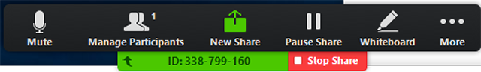
When screen sharing, controls will appear at the top of your screen, but can be moved elsewhere. Sometimes you need to move the mouse over them to reveal the control panel.

Overview – SCREEN SHARING
Zoom allows for screen sharing on desktop, tablet and mobile devices running Zoom.
- The host and attendee can screen share by clicking the Share Screen icon.
- The host does not need to "pass the ball" or "make someone else a presenter" to share.
- The host can "lock screen share" so no attendee can screen share.

Sharing your Screen
- Click the Share Screen button located in your meeting controls.
- Select the screen you want to share. You can also choose an individual application that is already open on your computer, the desktop, a whiteboard, or an iPhone/iPad.
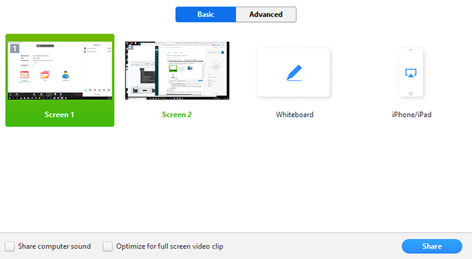
- (Optional) Enable these features:
  - Check Share Computer Sound: If you check this option, any sound played by your computer will be shared in the meeting.
  - Check Optimize for full screen video clip: Check this if you will be sharing a video clip in full screen mode. Do not check this otherwise, as it may cause the shared screen to be blurry.
- Click Share.

Share Screen Menu
When you start sharing your screen, the meeting controls will move into a menu that you can drag around your screen.
- Mute/Unmute: Mute or unmute your microphone.
- Start/Stop Video: Start or stop your in-meeting video.
- Participants/Manage Participants: View or manage the participants (if the host).
- New Share: Start a new screen share. You will be prompted to select which screen you want to share again.
- Pause Share: Pause your current shared screen.
- Annotate / Whiteboard: Display annotation tools for drawing, adding text, etc.
- More: Hover over more for additional options.
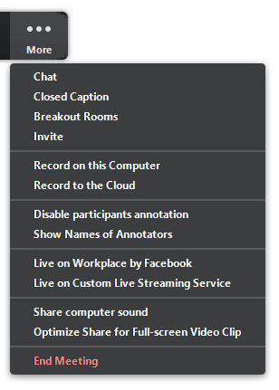
  - Chat: Open the chat window.
  - Invite: Invite others to join the meeting.
  - Record: Start recording locally or to the cloud.
  - Allow/Disable participants annotation: Allow or prevent the participants from annotating on your shared screen.
  - Show/Hide Names of Annotators: Show or hide the participants' name when they are annotating on a screen share. If set to show, the participant's name will briefly display beside their annotation.
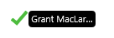
  - Live on Workplace by Facebook: Share your meeting or webinar on Workplace by Facebook. Learn more about live-streaming a webinar. Learn more about live-streaming a meeting.
  - Optimize Share for Full-screen Video Clip: Start optimizing for a video clip in full screen mode.
Note: Do not enable this setting if you are not sharing a full screen video clip, as it will blur your screen share.
  - End Meeting: Leave the meeting or end the meeting for all participants.

Overview – Sharing + annotating a “white board”

The whiteboard feature will allow you to share a whiteboard that you and other participants (if allowed) can annotate on.

Sharing a whiteboard
- Click the Share Screen button located in your meeting tool bar.
- Click Whiteboard.
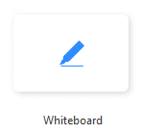
- Click Share.
- The annotation tools will appear automatically, but you can press the Whiteboard option in the meeting controls to show and hide them.
- Use the page controls in the bottom-right corner of the whiteboard to create new pages and switch between pages.
Note: Only the participant or host that started sharing the whiteboard has access to create and switch pages.

Accessing annotation tools if you started screen sharing
After sharing your screen or whiteboard, annotation controls will display. If you don't see the annotation tools, click Annotate (if you are sharing your screen) or Whiteboard (if you are sharing a whiteboard). More about annotating: https://support.zoom.us/hc/en-us/articles/115005706806
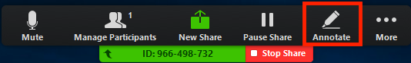

Accessing annotation tools if you are viewing a shared screen
While viewing a shared screen or shared whiteboard, click View Options > Annotate at the top.
- When you are done, click Stop Share.

Overview - Polling for Meetings
(a good option for engagement during presentations!)
The polling feature for meetings allows you to create single choice or multiple choice polling questions for your meetings. You will be able to launch the poll during your meeting and gather the responses from your attendees. You also have the ability to download a report of polling after the meeting. Polls can also be conducted anonymously, if you do not wish to collect participant information with the poll results.
Note: Only the original meeting host can edit or add polls during a meeting. If the host or co-host role is transferred to another user, that user will only be able to launch polls already created.

Creating a Poll
NOTE: A poll can only be created by the main meeting scheduler (Your instructor, in this case).
- Go to the Meetings page and click on your scheduled meeting. If you do not have a scheduled meeting, schedule a meeting now.
- From the meeting management page, scroll to the bottom to find the Poll option. Click Add to begin creating the poll.
- Enter a title and your first question.
  - (Optional) Check the box to make the poll anonymous, which will keep the participant's polling information anonymous in the meeting and in the reports.
  - Select whether you want the question to be single choice(participants can only choose one answer) or multiple choice question(participants can choose multiple answers).
- Type in the answers to your question and click Save at the bottom.
- If you would like to add a new question, click Add a Question to create a new question for that particular poll.
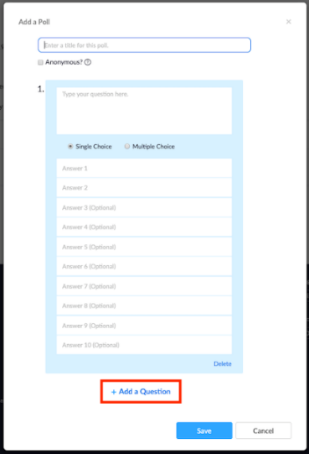
- You can add more polls by repeating Step 2.
You can also create a poll by clicking Polling during the meeting. This will open up your default web browser where you can add additional polls or questions.
Note: You can only create a max of 25 polls for a single meeting.

Launching a Poll
This is can be done by whoever is listed as the primary session host (not co-host)
- Start the scheduled Zoom meeting that has polling enabled.
- Select the Polling option in the menu bar.
- Select the poll you would like to launch.

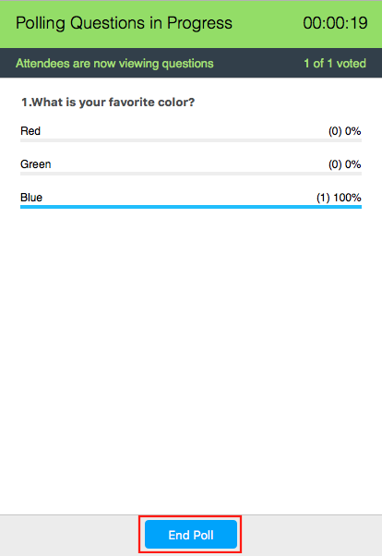
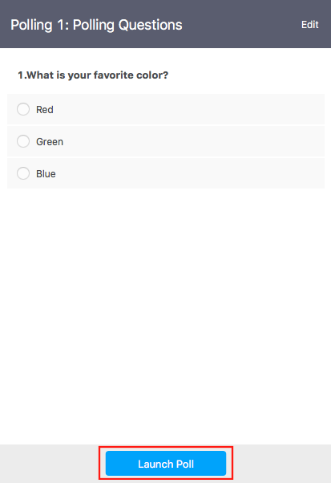
- Click Launch Poll. 5. The participants in the meeting will now be prompted to answer the polling questions. The host will be able to see the results live.

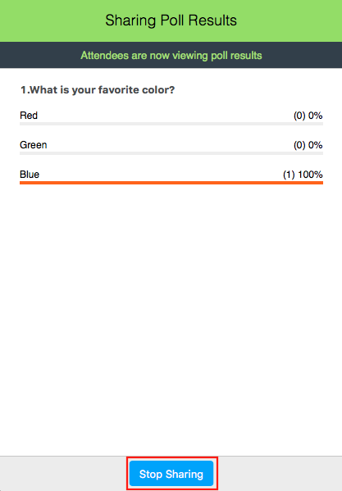
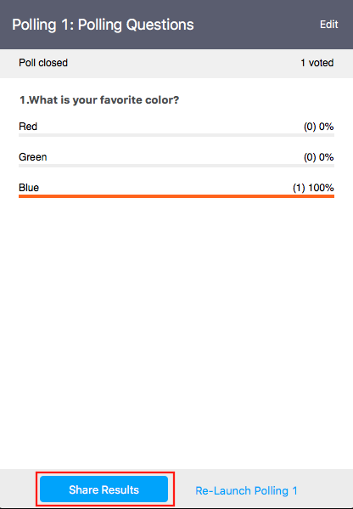
6. Once you would like to stop the poll, click End Poll + share the results to the participants in the meeting, click Share Results.
7. Participants will then see the results of the polling questions.

Overview - Hosting Breakout Rooms

Information about setting up breakout rooms is here (including a handy video): https://support.zoom.us/hc/en-us/articles/206476093-Getting-Started-with-Breakout-Rooms

NOTE: I have not found a way to get the pre-set rooms to work during the meeting itself, despite attempting to follow directions. Instead, while group members present, I quickly sort class members into what # of groups, and move one of the presenting group members in to each group to facilitate discussion. They will each need a copy of the discussion questions to share; what was shared on screen in the main room does not appear in the individual rooms.
FYI1: only the person listed “host” rather than “co-host” can initiate the meeting breakout rooms.
FYI2: Your instructor can pre-assign people to meeting rooms, otherwise it’s very time-consuming to do mid-meeting. However, if participants join a meeting after the host does (which is likely to be the case), the pre-assignment doesn’t kick in.

Here are the directions to get pre-assigned the breakout rooms working (which I have not successfully accomplished):
After starting the breakout rooms, you can revert to the breakout room assignment you specified.
- Click Close All Rooms to end all breakout rooms.
- Click Recreate > Recover to pre-assigned rooms.
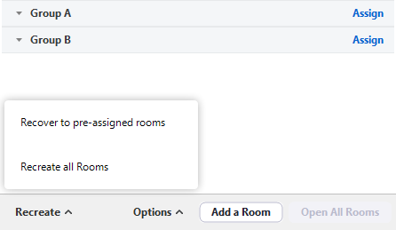
Participants will be re-organized into the breakout rooms you specified when scheduling the meeting.

