Faculty Fellows Project Report

AI-Conscious Assignment Design for an Asynchronous STEM Writing Course

1. Project Overview

Challenges
The emergence of generative AI tools created significant challenges for writing instruction, particularly in asynchronous online courses where traditional assumptions about authorship, drafting, and assessment have become increasingly difficult to maintain. As an instructor of an upper-division STEM writing course (WRTG 3030: Writing for Science and Society), I faced a growing tension between assignments designed for a pre-AI environment and the realities of contemporary student writing practices.
Additional challenges included:
- Designing assignments that remain meaningful whether students choose to use AI or not, especially to support students with disabilities, students who have ethical concerns about using AI, and students who may need to use AI in current or future work/research settings–and others who for various reasons do or do not wish to use AI.
- Teaching ethical and effective AI literacy alongside writing and research skills.
- Supporting students with varying levels of AI experience and access.
- Maintaining authentic learning outcomes while acknowledging that AI tools are now part of many professional workplaces.
Rather than treating AI solely as a threat to academic integrity, I approached it as a pedagogical challenge that required rethinking assignment design itself. I set up student-centered spaces where students could discuss AI usage and concerns, and let their feedback guide assignment design, along with insight from other colleagues, and was influenced by the framework presented in the book The Opposite of Cheating–Teaching for Integrity in the Age of AI, by Tricia Bertram Gallant and David A. Rettinger.
This project was developed alongside a complementary fellowship project with Continuing Education AI Literacy Ambassadors that focused on alternative assessment practices in an AI-rich educational environment. That parallel project explored approaches such as portfolio assessment, student self-reflection, self-assessment, labor-based grading, and narrative feedback as alternatives to traditional point-based evaluation. Together, the two fellowships sought to align both assignments and assessment practices with authentic learning, student agency, and the realities of generative AI in higher education.

Goals
The primary goal of this project was to redesign course assignments to function effectively in an AI-rich environment while preserving core writing and critical thinking outcomes. I matched the project with a second fellowship, which allowed me to also redesign my assessment practices in concert. (*A brief presentation on the assessment side of this dual project can be found HERE.)
Specific objectives for the Assignment Redesign side of the project included:
- Developing assignments that emphasize process, reflection, student-to-student interaction and rhetorical decision-making, and increasing student engagement, retention and participation in an asynchronous, online course.
- Creating parallel pathways that allow students to complete assignments either with or without AI tools.
- Increasing student AI literacy, including ethical, critical, and reflective use of generative AI.
- Strengthening authentic communication skills for STEM students writing for public and professional audiences.
- Creating adaptable assignment models that could be shared with other instructors.
I expect these changes to improve student learning by focusing attention on decision-making, audience awareness, revision, and metacognition rather than solely on the final written product. I am tracking the results and so far (two courses in, one spring course and one Maymester course) I see evidence of the project meeting objectives and challenges in surprising ways.

Breaking a Rule
Historically, writing assignments often assume that students produce work independently and that the final text serves as evidence of learning. This project challenged that assumption.
Instead of attempting to prohibit AI use or design "AI-resistant" assignments, I intentionally designed AI-conscious assignments that make the writing process visible. Students are encouraged to document choices, evaluate outputs, reflect on their reasoning, and critically assess the strengths and limitations of AI-generated content.
Breaking the norm that writing assignments must ignore or exclude AI allowed me to focus on the skills that remain uniquely valuable: judgment, ethical reasoning, audience awareness, research literacy, and rhetorical decision-making. It is allowing students to make more thoughtful/ethical choices about AI, and to lean into peer discussions on how AI is and isn’t impacting their lives.
Students had varying levels of experience with AI tools. Some had ethical issues with using AI; I thought of them as digital vegans, and sought to accommodate their ethical stances. This actually complicated the issue in a few ways, but I took it as just another aspect of the overall challenge. First, this added complication because it prevented me from assigning AI tasks outright. Instead, I created multiple paths for each assignment that students could choose from. It also added layers of complication because it created a loophole for students who may want to use AI, but not report it–which is the exact problem that sparked this project in the first place.
So, I realized that I needed to begin this project by placing trust back in my students–and asking them in return to read, think about, discuss, and write about their own integrity, and how it shapes their academic pursuits and AI usage.

Audience
This project primarily impacts undergraduate students enrolled in WRTG 3030: Writing for Science and Society, an upper-division writing course serving science, engineering, and other STEM majors.
Students in this course are preparing for professional and public-facing communication and increasingly encounter AI tools in academic and workplace settings.
Secondary audiences include:
- Writing instructors
- Academic librarians
- STEM faculty
- Curriculum developers
- Faculty interested in AI-integrated teaching

Key Stakeholders
Key stakeholders include:
- Students enrolled in WRTG 3030
- The Program for Writing and Rhetoric
- The University Libraries
- Faculty Fellows program staff and participants
- Instructional designers and educational developers
- Faculty exploring AI-related pedagogical innovations

2. Project Implementation

Process
The project unfolded over several stages:
- Review of emerging literature on AI and writing pedagogy.
- Identification of assignments most impacted by generative AI.
- Redesign of major assignments using AI-conscious principles.
- Development of parallel AI and non-AI pathways.
- Integration of reflection, process documentation, and ethical reasoning components.
- Alignment of assignments with course learning objectives and AI literacy competencies.
- Creation of supporting materials, prompts, guidelines, and instructional resources.
Several assignments were redesigned to include explicit opportunities for students to evaluate AI-generated content, compare AI and human-authored approaches, and reflect on their own decision-making processes.

Pivots
The original project focused largely on responding to concerns about AI-generated writing. As the project developed, the focus shifted toward a broader framework of AI literacy and authentic learning.
Rather than asking, "How do I prevent students from using AI?" the project increasingly asked, "How do I support student learning when AI is available?"
This shift resulted in greater emphasis on reflection, process, creativity, ethical reasoning, and student discourse.

3. Assessment & Results

Results
The most significant outcome was the creation of a fully redesigned assignment framework that aligns writing instruction with contemporary AI realities.
Key successes included:
- Development of AI-conscious assignment models.
- Creation of parallel AI and non-AI pathways.
- Improved alignment between assignments and learning outcomes.
- Increased emphasis on metacognition and rhetorical awareness.
- Creation of materials that may be adapted across disciplines.
Lessons learned included the importance of flexibility, transparency, and student choice. Students benefit when AI is addressed openly rather than treated as an invisible or prohibited technology. Areas requiring continued development include long-term assessment of student learning outcomes and continued refinement of AI literacy instruction as technologies evolve.
One of the central arguments from the book The Opposite of Cheating is that educators often focus too much on preventing misconduct and too little on cultivating the conditions under which students genuinely want to learn. Gallant and Rettinger argue that academic integrity is a teaching and learning problem, and seek to steer teachers away from policing students and toward cultivating a rich learning environment (Gallant and Rettinger). I sought to implement this throughout the project.
Although this project is still ongoing, several positive outcomes have already emerged.
Most notably, I observed:
- Increased student participation throughout the semester.
- Improved student retention and course completion rates.
- More substantive and meaningful discussion board interactions.
- Increased reports of student satisfaction and enjoyment of the course.

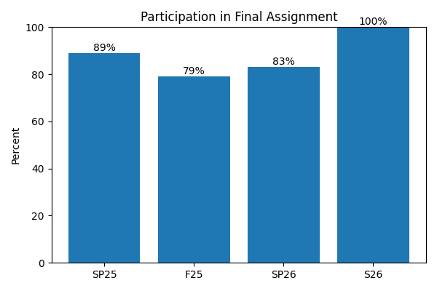
This chart shows student participation in the final course assignment, over time: (Sp25 = Spring 2025, F25 = Fall 2025, *Sp26 = Spring 2026, and *S26 = Summer 2026. *Spring and Summer 2026 reflect implementation of this project; Spring and Fall 2025 are prior to project implementation.)
One unexpected outcome was the quality of student interaction. By redesigning assignments to emphasize authentic communication, reflection, creativity, and personal decision-making, discussion board participation became less performative and more conversational. Students engaged more frequently with one another's ideas, asked follow-up questions, and demonstrated greater investment in course topics.
I also observed increased student willingness to discuss their learning processes, including how and why they chose to use (or not use) AI tools during assignments. This created opportunities for richer conversations about writing, research, ethics, and professional communication.
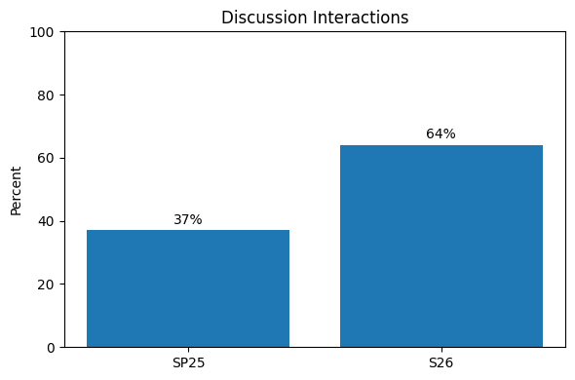
This chart shows student interactions with another student in course Discussions: (Sp25 = Spring 2025 and *S26 = Summer 2026. *Summer 2026 reflects implementation of this project; Spring 2025 was prior to project implementation.)
Perhaps most encouragingly, students reported enjoying the course more than in previous semesters. While enjoyment alone is not a measure of learning, increased engagement often correlates with greater persistence, participation, and willingness to take intellectual risks.
Students also reported that they felt they met the assignment objectives and their own personal learning goals (in my Spring, 2026 semester class.) I don’t have anything to measure this against, as it is the first time I have ever measured this, but I did mark their progress over the course of the semester. Overall, students reported that they fully met assignment objectives 83 percent of the time, and that they partially met assignment objectives an additional 16.5 percent of the time. Students reported not meeting an assignment objective only less than half a percent (.45 percent) of the time. Students also identified Personal Learning Goals at the start of the semester, and reported higher attainment of these goals over time:
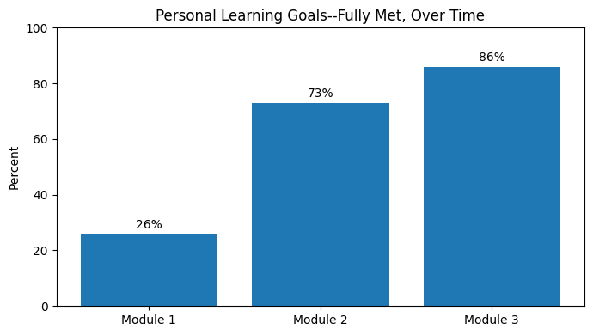
This chart shows the percent of students who reported “fully” meeting their Personal Learning Goals over the course of the Spring 2026 semester, after implementation of this project.
Preliminary evidence suggests that designing assignments around authenticity, choice, and reflection may help students feel more connected to both the course material and one another.
Quantitative measures of participation and retention will be included in the final version of this report.

Assessment Methods
Project success was evaluated through:
- Assignment design analysis
- Alignment with learning outcomes
- Faculty Fellow feedback and discussion
- Student reflections and informal feedback
- Review of student work products
- Comparison of revised assignments and student retention, participation and engagement levels against previous course materials.
Future assessment will include more formal collection of student perception data and analysis of student learning outcomes over multiple semesters.

4. Artifacts
Examples of project artifacts include:
- Redesigned assignment sheets
- AI and non-AI assignment pathways
- Reflection Forms (link leads to a real sample)
- AI-use documentation templates
- Course learning objective maps
- Rubrics aligned with revised assignments
- Canvas course materials
- AI literacy instructional resources
- Student work examples (with permission)
- Assessment tools developed in concert with second fellowship

Example of Reflection Form
This is an example of the message that greets students in the assignment:
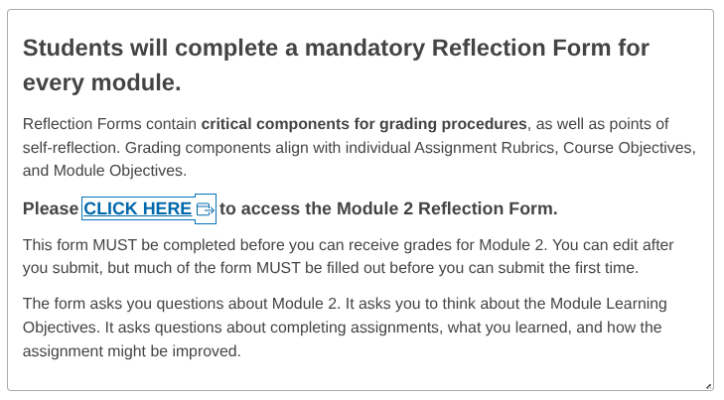
Here is an example of a real Reflection Form
These are some of the components of the example Reflection Form:
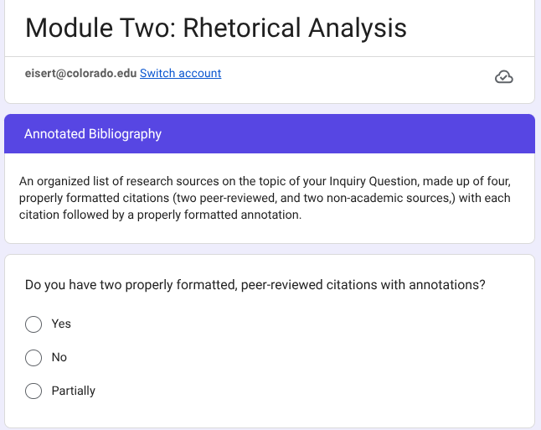
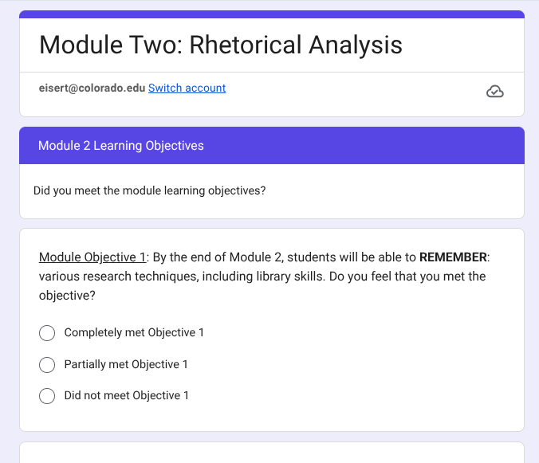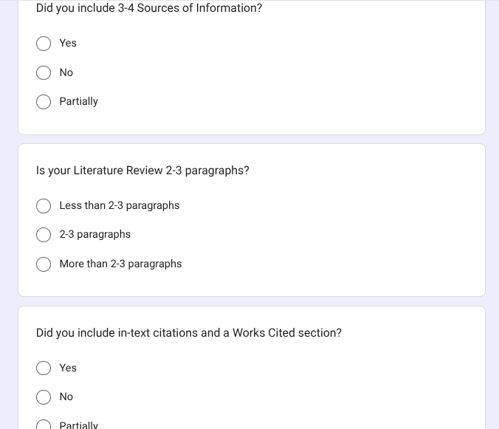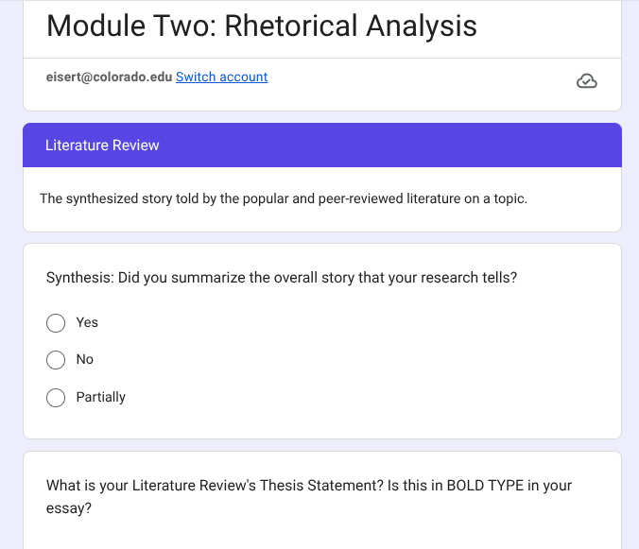

(*Continues on the next page)

Example Assignment: (Sci-Fi Module)
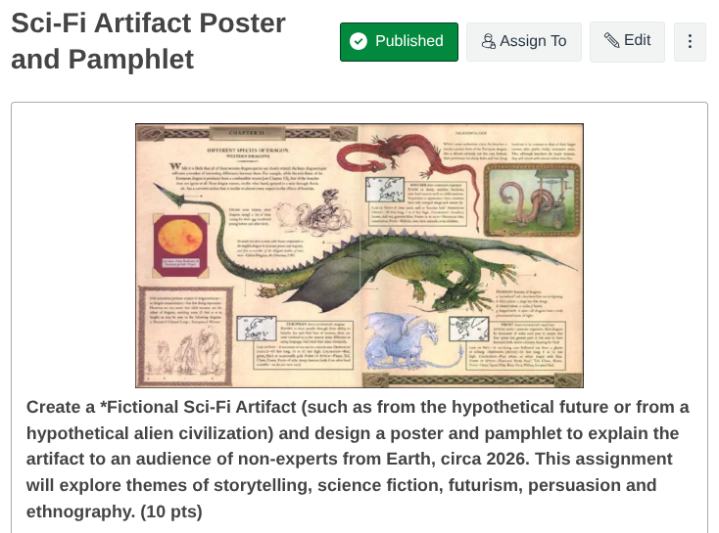
(*Continues on the next page)
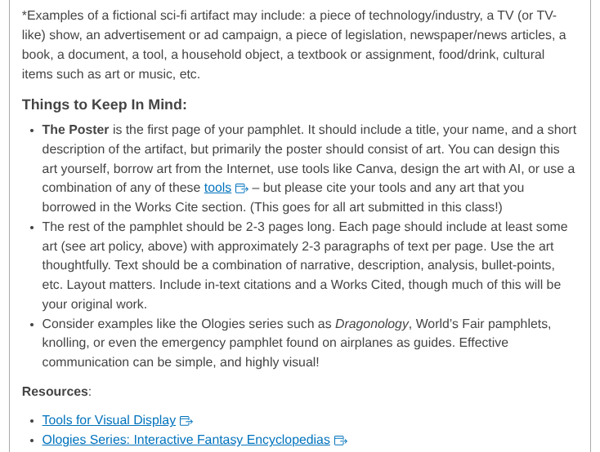

(*Continues on the next page)

Assignment Readings
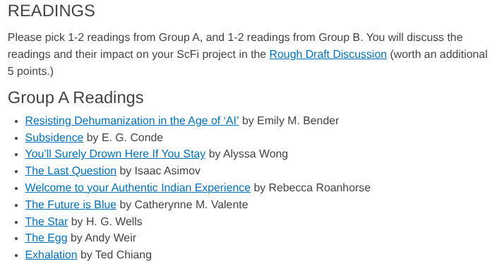
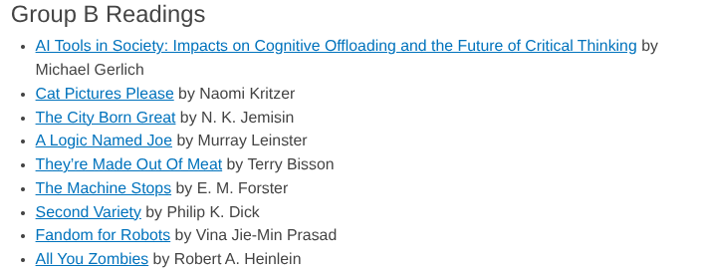
(*Continues on the next page)

Example of Student Work Based on Redesigned Assignment (for Sci-Fi Module):
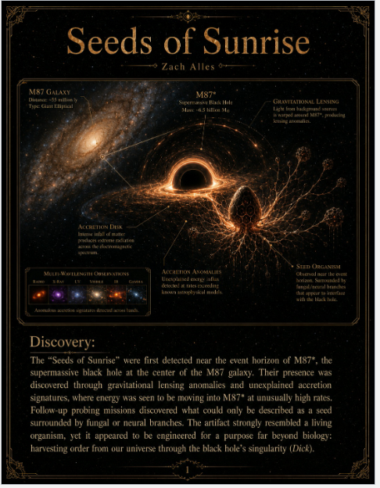
(*Continues on the next page)
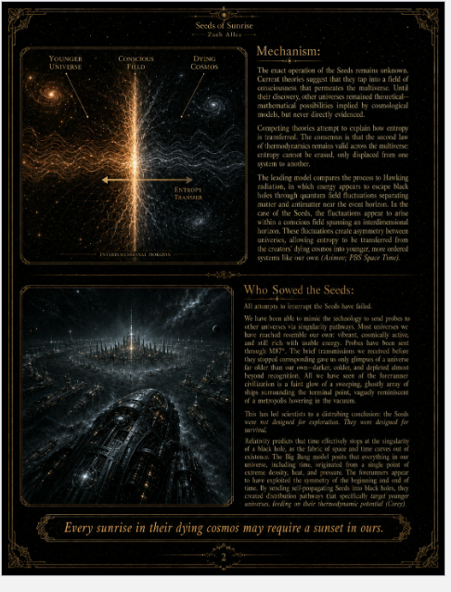

5. Reflection

Project
This project reinforced the idea that writing instruction should focus on thinking, communication, and decision-making rather than solely on text production.
I learned that AI is not simply a technological challenge but a pedagogical one. The experience encouraged me to rethink what evidence of learning looks like and how writing assignments can support authentic intellectual engagement.
The project has already influenced my teaching by making learning objectives more explicit and by encouraging greater transparency about how students use tools during the writing process. If I were beginning again, I would incorporate more structured student feedback throughout the redesign process.
One of the most surprising lessons from this project was that assignment redesign affected not only student writing, but also student engagement. My original goal was to create assignments that remained meaningful in an AI-rich environment. However, I found that assignments emphasizing authentic decision-making, reflection, and student choice also appeared to increase students' sense of ownership and enjoyment. The result was not simply different assignments, but a different classroom dynamic—one characterized by greater participation, more meaningful peer interaction, and stronger student investment in learning.
Another unexpected outcome of this project was an apparent increase in student engagement with course readings. Preliminary/anecdotal evidence suggests that students are reading more closely and incorporating course readings more frequently into discussion board posts, assignments, and informal class conversations. Students regularly reference assigned texts without prompting and often make connections between course readings and contemporary issues involving AI, technology, ethics, and society.
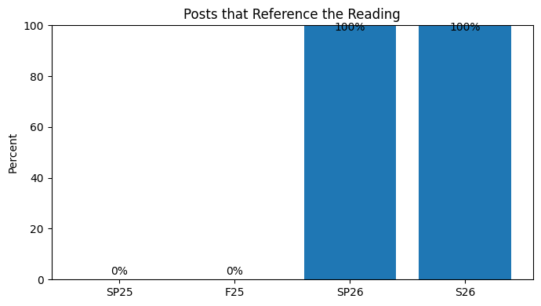
This chart shows student posts in class discussions that reference the assigned reading, over time: (Sp25 = Spring 2025, F25 = Fall 2025, *Sp26 = Spring 2026, and *S26 = Summer 2026. *Spring and Summer 2026 reflect implementation of this project; Spring and Fall 2025 are prior to project implementation.)
Particularly successful was the inclusion of science fiction literature as a vehicle for exploring emerging technologies and ethical questions. Students engaged enthusiastically with classic science fiction authors such as Isaac Asimov and demonstrated an ability to connect speculative futures to current developments in artificial intelligence and their own lived experiences. My students went from not mentioning the readings at all in 2025 Discussions that I measured, to making references to the readings in 100 percent of the 2026 Discussions I measured. This jump is extraordinary, and deserves further consideration.
This outcome was not an explicit goal of the project. The original intention was to redesign assignments for an AI-rich educational environment. However, the combination of AI-focused topics, ethical inquiry, and speculative fiction appears to have increased student curiosity and investment in course content.
Students frequently moved beyond summary and began using readings as tools for analysis, comparison, and reflection. In many cases, they drew sophisticated parallels between historical science fiction predictions and contemporary technological developments.
This suggests that thoughtfully selected readings paired with authentic, future-oriented assignments may increase student motivation to read and engage critically with course materials.
I did not anticipate the continued power of reading in an AI-saturated environment. Much public discussion about AI focuses on what students may stop doing—writing, researching, or reading independently. Yet I found that students often became more interested in reading when the readings felt relevant to questions they were already asking about technology, work, ethics, creativity, and the future. Science fiction proved especially effective because it provided a shared language for discussing possibilities and consequences that students were already encountering through AI. Rather than competing with AI, these readings helped students think more critically about it.

Faculty Fellows Program
The Faculty Fellows program provided valuable time, structure, and community for sustained pedagogical experimentation.
Conversations with colleagues across disciplines broadened my perspective and helped me see that AI-related challenges are shared across higher education.
The program encouraged a more reflective and evidence-based approach to course redesign than would have been possible within the constraints of ordinary teaching responsibilities.

6. Future Directions

Next Steps
Future work will focus on:
- Continued implementation and refinement of redesigned assignments.
- Collection of more systematic student learning data.
- Sharing assignment models with colleagues and campus partners.
- Presentations and workshops on AI-conscious assignment design.
- Exploration of how assignment redesign intersects with alternative assessment practices.
- Investigation of discipline-specific AI literacy competencies for STEM communication.
- Integration into my other courses.
Long-term, this work may contribute to broader conversations about writing instruction, academic integrity, AI literacy, authentic assessment, and student engagement in higher education. Future research may explore whether AI-conscious assignment design can help foster deeper participation, reading engagement, and reflective learning across disciplines and instructional modalities.

Works Cited
Gallant, Tricia Bertram, and David A. Rettinger. The Opposite of Cheating: Teaching for Integrity in the Age of AI. University Press of Colorado, 2024.

*My personal data is preliminary and at this point, merely anecdotal.

