CTL Fellows Final Report
Academic Year 2025-2026

CTL Fellows Final Report: Cultivating Student Agency and Metacognitive Engagement in Canvas

I. Project Abstract and Goals
This fellowship project sought to investigate the intersection of Learning Management System (LMS) architecture and student 'ownership' of the learning process. Drawing on the 'Slow Professor' model (Berg & Seeber, 2016), the project aimed to resist the corporate university's culture of speed by utilizing Canvas not merely as a repository for files, but as a site for metacognitive orientation. The core goal was to transition from passive syllabus acknowledgment to active agency, asking students to consciously choose their 'success path' through course deliverables and deep reading exercises.

II. Implementation: The Midterm Reflection Pivot
While the initial proposal included a 'Language Ownership' track, the actual execution focused on a hybrid of Parts I and II. The intervention evolved into a 'Midterm Reflection and Mastery' module—a midterm 'reflection' on course goals intended to reorient students to learning goals, methodology, and classroom activities as project-based learning opportunities. This resulted in an 'in situ' project-based 'deep' reading exercise, mixed with metacognitive questions regarding student well-being and strategy.
Figure 1: Canvas LMS Tool Interface - Metacognitive Inquiry Section
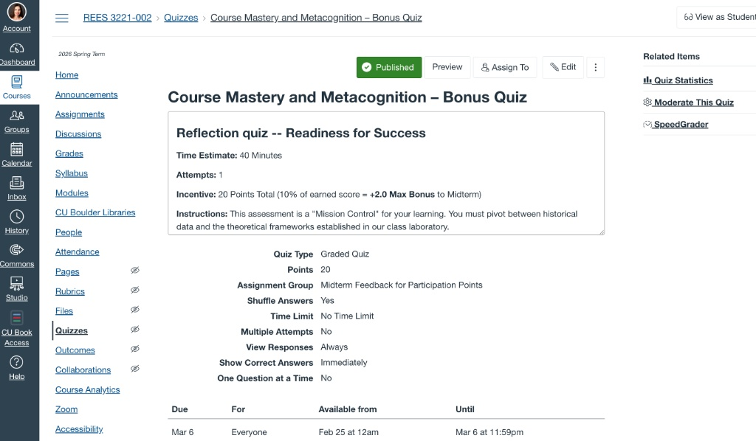

Figure 2: Clarifying the Path to Success (Readings vs. Narratives)
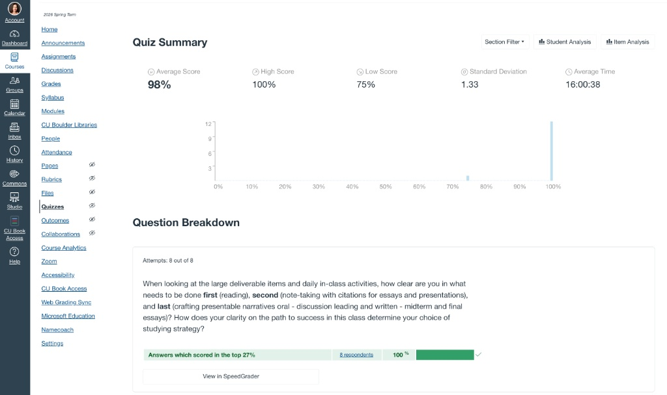

Figure 3: Project-Based 'Deep' Reading Exercise Prompts
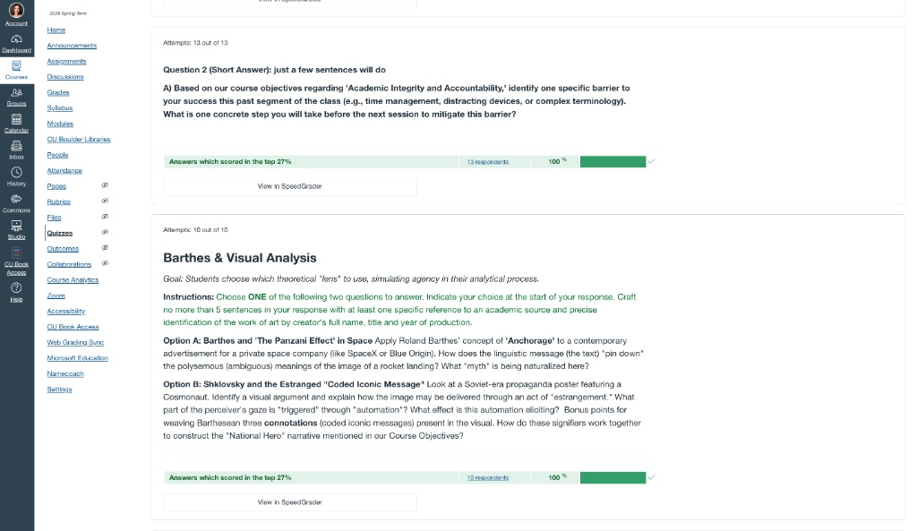

Figure 4: Student Self-Assessment of Analytical 'Lenses'
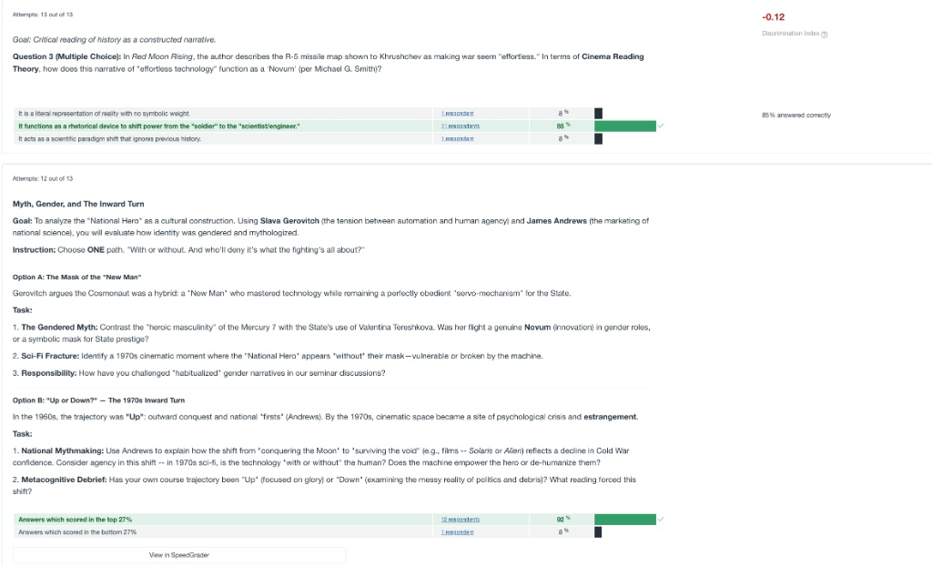

Figure 5: Identifying Barriers to Success and Academic Accountability
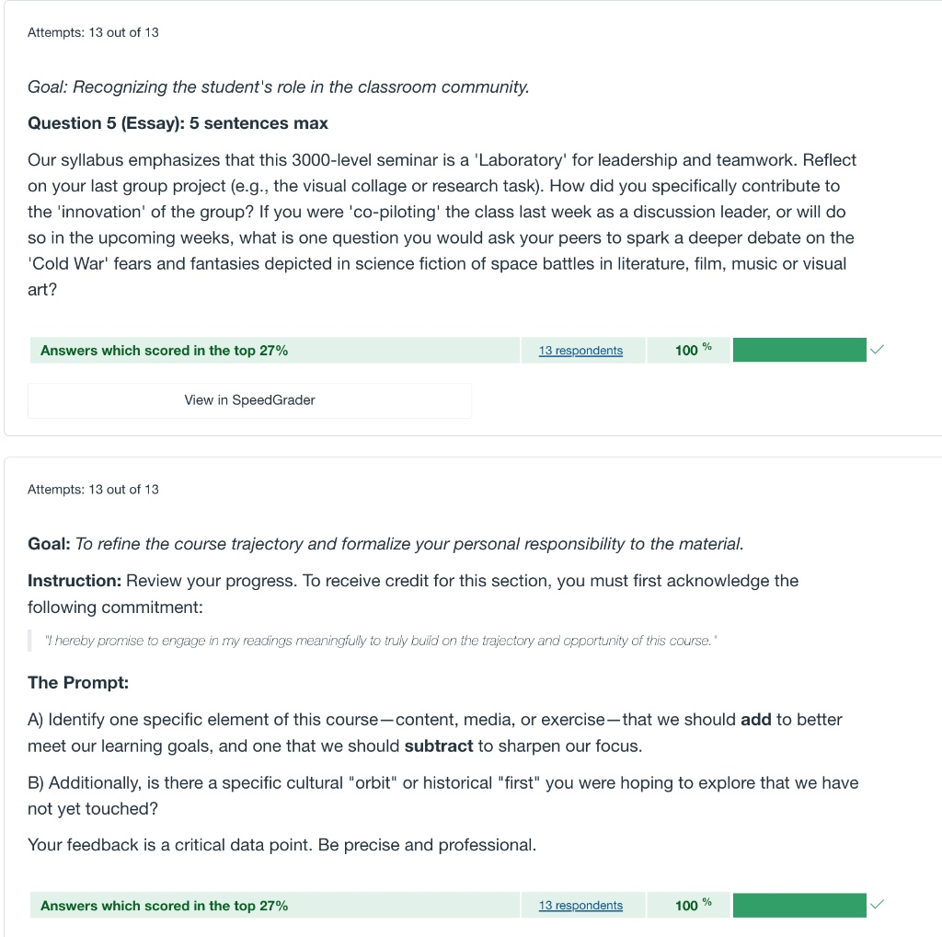

Figure 6: Evaluating Academic Integrity and AI Engagement
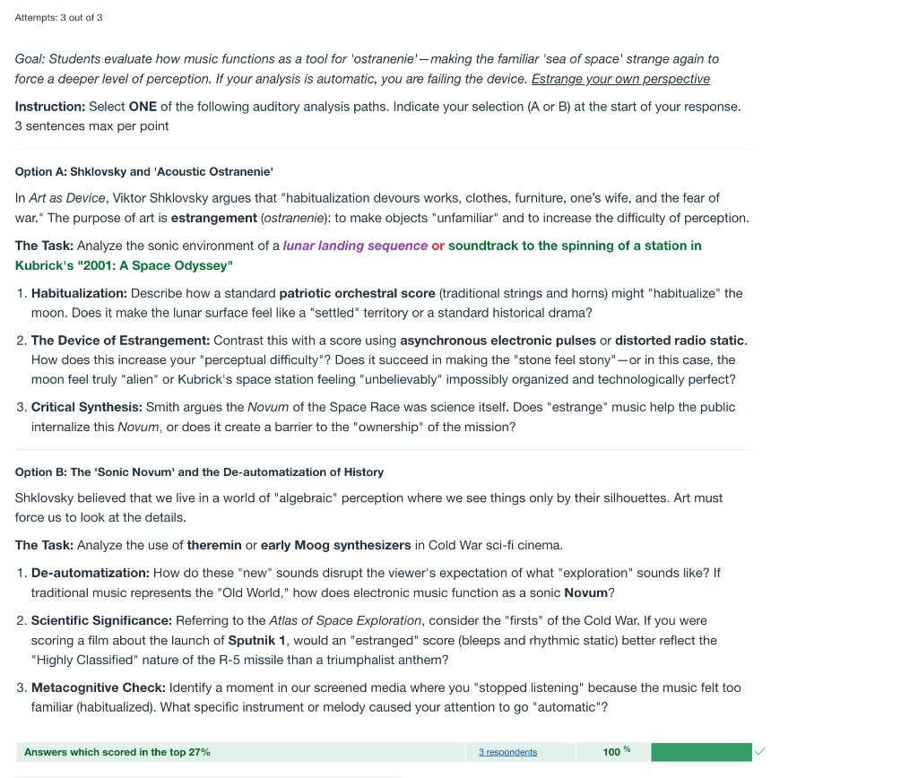

Figure 7: Final Reflection Submission and Ownership Confirmation
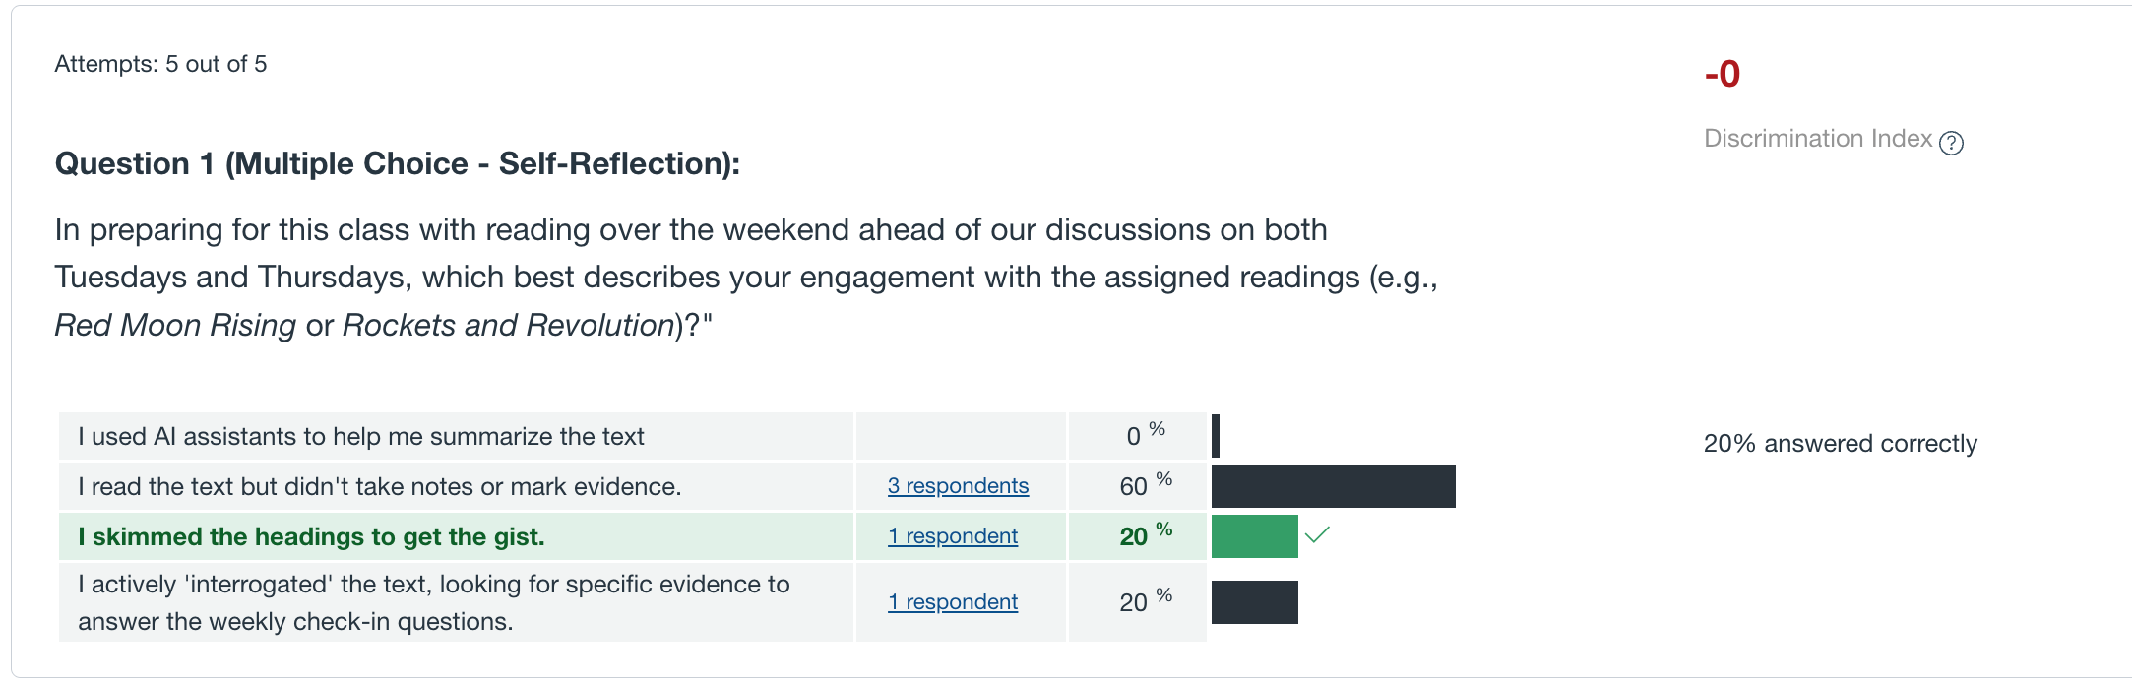

III. Pedagogical Framework & Strategic Outcomes
By implementing this tool, I observed an immediate 'vitality' in the classroom. The 'immediacy of results' allowed for an instant pivot in class design. After receiving precise hints from students regarding course design—specifically the need to break down film analysis and provide pre-reading questions—the classroom was visibly enlivened. Announcing the plan of the class before proceeding to PPT presentations allowed students to feel more anchored in the methodology.

Student Reflections
When asked about the clarity of the path to success and their study strategy, one student noted:
"I believe I have a good understanding of what needs to be done for class deliverables and activities. The readings are very well labelled, so it is easy for me to know what to read and prepare for class accordingly. After writing the midterm paper, I wish I had taken more notes on some of the texts in class, as some applied directly to my research topic, and I had to spend a little extra time re-evaluating them. I do believe I am doing well in terms of crafting presentable responses across all my assignments. I will say that now that I have done just about every type of assignment in this class, a proper studying strategy will be easier to implement for completing future deliverables."
Addressing specific barriers to success (Time Management and Accountability):
"I believe time management is a big barrier to my success and efficiency during the last portion of the class. I have struggled with it for a while, and I do not believe I can ever be perfect with managing my time, but rather just take more and more steps to improve. In the past segment, I found myself struggling to find time to complete all the readings and required films, something I will have to improve my time management to accomplish in the second part of this class."

IV. Lessons Learned: Benefits and Detriments
- Benefits:
- Immediacy of results allowing for instant class pivots; enlivened classroom culture; high student engagement with metacognitive prompts.
- Detriments:
- The +2 bonus point system is difficult to assign administratively on top of perfect scores. Canvas is a 'limiting media' where multiple 'correct' answers cannot be programmed for subjective reflection, making the experience mildly 'stressful' for students despite being extra credit.
In future iterations, I am considering whether assigning this reflection in class and leaving the room to allow students the space to work in groups might be more optimal, though the individual accountability component remains a vital part of the study.

V. Reflection: The LMS as a Site of Emergent Strategy and Slow Pedagogy
The redesign of the Canvas architecture from a static repository to an "in-situ" metacognitive tool represents more than a functional adjustment; it is an enactment of "Slow Pedagogy" within a digital framework often optimized for high-speed consumption. By modulating the course to fall between the "Readiness Check" (Part I) and the "Project-Based Deep Reading" (Part II), I transformed the Canvas Quiz tool into a site for what Adrienne Maree brown calls "Intentional Adaptation" (brown, Elements 1).
Resisting the Culture of Speed In The Slow Professor, Berg and Seeber argue that the corporate university prioritizes the "rapid transfer of knowledge," which effectively "contemptuous[ly] attitude[s] toward the particular case" (1). My quiz design challenged this "flattening effect of speed" by requiring students to pause and evaluate their own "success path." Instead of a rote syllabus check, the questions forced a "deliberation and reflection" (Berg and Seeber 57) on their specific barriers, such as time management or the temptation of AI-assisted summarization. This creates what the literature describes as a "space of vulnerability and uncertainty," allowing students to "embrace their own beings" as academic citizens (Blackie et al., qtd. in Berg and Seeber 1).
The Classroom as a Living System Utilizing the principles of Emergent Strategy, I approached the midterm intervention as a way to "move at the speed of trust" (brown, Elements 1). The quiz functioned as a communication system similar to a coral reef, which relies on a "response system... to recalibrate, reshape and recover" (brown, Elements 6). By asking students for "precise hints" on course design—such as the need for daily film breakdowns and pre-reading questions—the project moved away from a top-down hierarchy toward "Interdependence and Decentralization" (brown, Elements 1).
The result was a "Fractal" success: small changes in the Canvas interface (the small) reflected and created a more enlivened classroom culture (the large). As brown notes, "the large is a reflection of the small" (Elements 1). When students were given the agency to identify their own hurdles, they moved from being passive recipients of information to "owning their learning," a core tenet of the Empower framework (Spencer and Juliani).
In-Situ Practice and Critical Literacy The "in-situ" project-based exercises within the quiz served as a defense of the "local, specific and particular" (Brabazon, qtd. in Berg and Seeber 1). By asking students to apply theoretical lenses—like Barthes or Shklovsky—directly within the reflection tool, the assessment became an active learning event rather than a post-mortem of past work. This mirrors the goal of "humanizing schooling by facilitating space for connection, curiosity and reflection" (brown, Unlearning 1).
Conclusion: The Ethical Tension of the Interface Despite these successes, the project revealed a critical tension. While I aimed to create a "space of grace" (Palmer, qtd. in Project Proposal), the "limiting media" of the Canvas Quiz—where I could not program multiple "correct" answers for subjective truths—remained "mildly stressful." This highlights the ongoing challenge for the "Slow Professor": how to utilize high-speed, binary corporate tools to foster nonlinear, iterative growth. However, the "visible vitality" of the enlivened classroom proves that even within these limitations, we can "see every crisis as an opportunity" to move toward a more just and engaged pedagogical relationship (Boggs, qtd. in brown, Unlearning 5).

Works Cited
Berg, Maggie, and Barbara K. Seeber. The Slow Professor: Challenging the Culture of Speed in the Academy. Toronto: University of Toronto Press, 2016.
brown, adrienne maree. Elements of Emergent Strategy. Detroit: Emergent Strategy Ideation Institute, 2017.
---. "Emergent Strategy and Unlearning." Education Week. Detroit: Emergent Strategy Ideation Institute, 2018.
Spencer, John, and A.J. Juliani. Empower: What Happens When Students Own Their Learning. Spencer Education, 2017.

