ASSETT Advisory Board Meeting
January 6, 2021 | 8:30-10:00am | ZOOM

In attendance:
Mark Werner, Blair Young, Jacie Moriyama, Beth Osnes, David Brown, Janet Casagrand, Jen Lewon, Joy Adams-O’Brien, Kavya Kannan, Kira Hall, Leila Gomez, Michael Schneider, Nathaniel Bala, Rachel Bowyer, Sara Rose Myers, Sebastian Schmidt, Shane Schwikert, Vija Hulden, Cheryl Graham

Outcome for the Meeting
Help the board better understand what ASSETT is doing so that they can be well equipped ambassadors for ASSETT.
Roles
- Minute-taker (Cheryl)
- Time Keeper (Janet)
Materials
- Minutes from last meeting
- Slide Deck for the Meeting
- Handout for the meeting
- Next Meeting Day/Time
  - If it works for everyone: Wednesday, April 7th from 8:30 to 10:00 a.m. seems to be a good time for the calendars we can see.
    - Wednesday, April 7 is agreed
    - This is the meeting where we will review the budget
  - If not, please fill out the Doodle poll.
Agenda
8:30 to 8:35 — Settle in. (Mark and Janet)
Decision for DateTime of Spring 2021 Meeting: April 7, 2021| 8:30-10:00am | ZOOM
8:35 to 8:55 — Introductions of the new board members + ASSETT Staff. (Mark)
- New Grad Assistant: Rachel Bowyer from APS. Mark introduces Rachel Bowyer as the new graduate representative
- 1 minute each: Name, Department/Role, Animal mood (see slide 2 from the Google Slides deck). (Mark)
  - Mark uses the Meme Check-In for our mood check today

8:55 to 9:00 — Approval of the minutes and pick the next meeting time (Janet)
- Comments: Questions
  - A motion was made to approve
  - Beth Seconds
  - Vote is passed with unanimous poll

9:00 to 9:10 — Warm Up Activity (Beth)
- Beth shares some fun warmup activities from her community performance toolbox. A few Warmup Activities to increase student engagement for remote classes. The Workshop took place in the Fall 2020 Semester.
- Each student published their ideas – on this site we were able to publish their ideas. One warm up we did together was the “mirror” exercise.

9:10 to 9:15 — Revisit Postcard Activity from Last January’s Meeting (Blair)
- As a reminder – this activity included easy commitments that we have made to promote ASSETT on campus as well as the reflection of sitting back and thinking about why we are on the ASSETT board.
- You are invited to go into the Goggle form card to articulate your “why”
- Blair asks that members add this to their email signature line to bring further awareness to ASSETT: “Member of the Board of Directors for ASSETT (Arts & Sciences Support of Education through Technology) https://www.colorado.edu/assett/ “

9:15 to 9:40 — ASSETT Staff and Board Activities (Blair, Jacie, Joy, Sara, Shane)

Blair
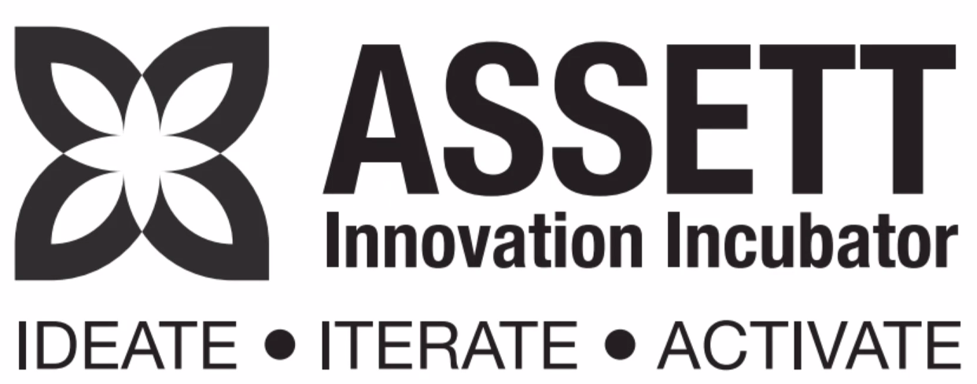

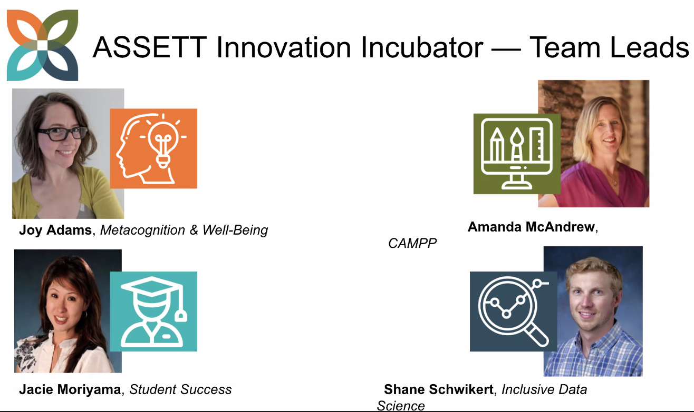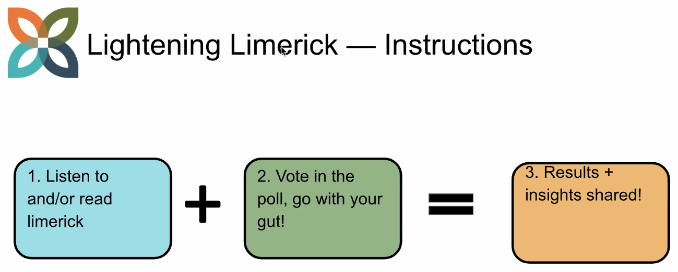

Some great discussions have come out of the question, “How can we be innovative and face the feeling of failure when failing our student’s learning needs?”
Looking at student involvement with undergrad students asking students to share ideas of how we can stay connected during the remote learning environment. We currently have three (3) interns that will be supporting faculty during the semester.
Scale – teaming are scaling with inclusive data science for all in Fall 2021. Looking for support across the entire campus. Look for a student creation of OER and the modules created based on feedback.
We are thinking about institutionalize as these projects proved themselves how do we sustain them? We wan to be ready to make sure they endure for the long term.

Jacie


Using the poll page Jacie took feedback: “What do you know about our Student Technology Consultants?” Jacie then introduces each of her phenomenal Student Technology Consultants that have been supporting ASSETT.
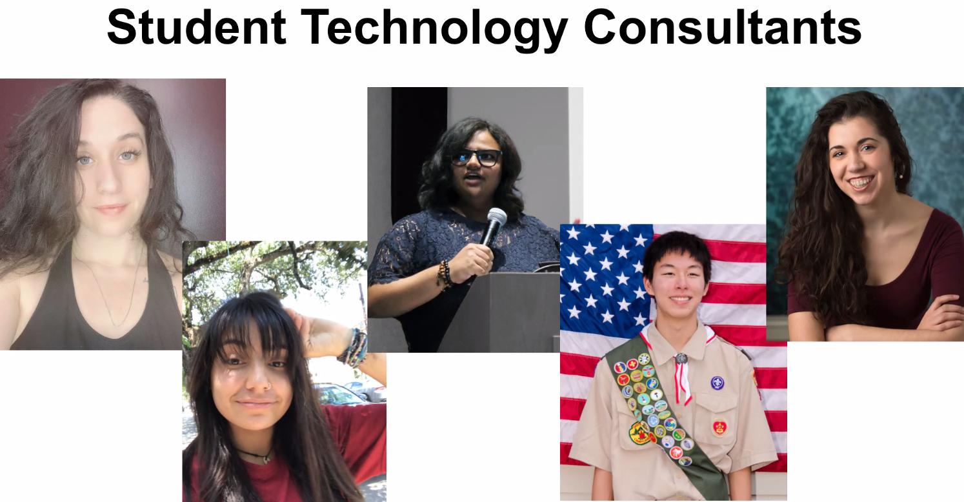
During COVID – there was a shift to more videos, podcasts and articles while at the same time providing technical support for faculty members and their students who want to implement an innovative technology or pedagogy into their course

Jacie then asks for feedback to the question, “How might we advertise these resources?”
Suggestions Shared:
• Reach out to Kathy Noonan and other associate chairs
• emails to faculty
• personal outreach
• repeat the communications regularly
• networking through word of mouth
• advertise through the book fair.
Jacie has linked all the resources through the chat: https://www.colorado.edu/assett/resources/strategies-student-success

Joy
ASSETT Strategic Course Design Workshops Summer 2020 Debrief
Worked in pivoting faculty to remote learning by expanding to a week presentation rather than one day.
High level outcomes are shared:
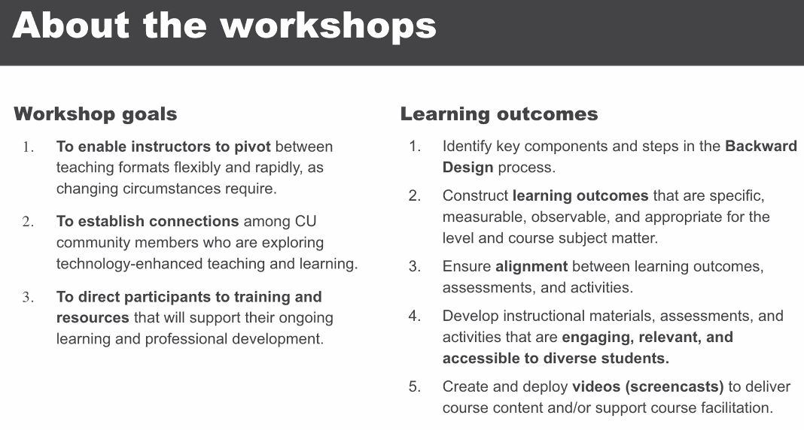

Results:
Joy shares some results from the workshop
- 120 faculty and staff participated with 45 departments represented
- The top 10 dpeartments = 50% of the registrants (SLHS, ENGL, PSYC, PWR, AAH, FRIT, GEOL, ENVS, GEOG, HIST
- Prior to the workshop the faculty felt least confident with having contact outside their home department who are interested in online/hybrid teaching.
- There have been significant positive changes seen across the board. The top 3 are: Knowledge of online active learning strategies (+60%); Awareness of UDL (+57%); Confidence in pivoting among course format (+40%).
- Participant Satisfaction increased to 96%. Improvement occurred as we gave participants more awareness of the workshop content. By session 4 all participants rated the workshop as “Excellent”

Some Feedback:
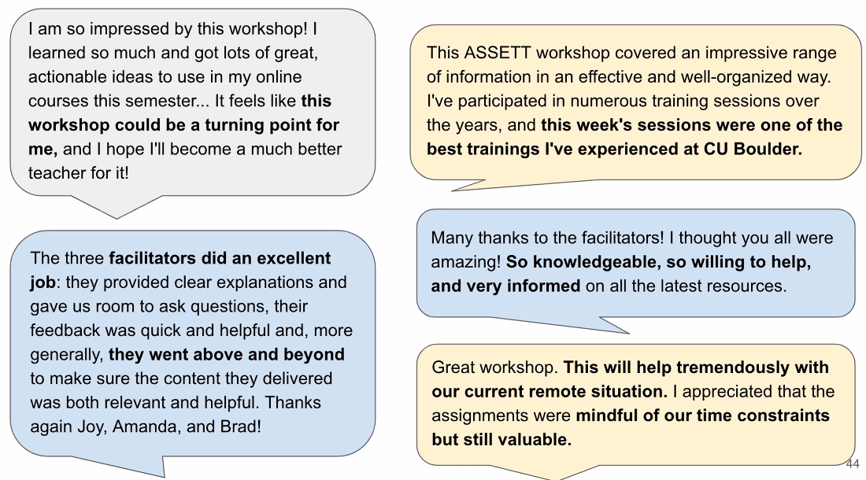

Sara
Shared a team jeopardy exercise: as an example of interactive team games that you can play
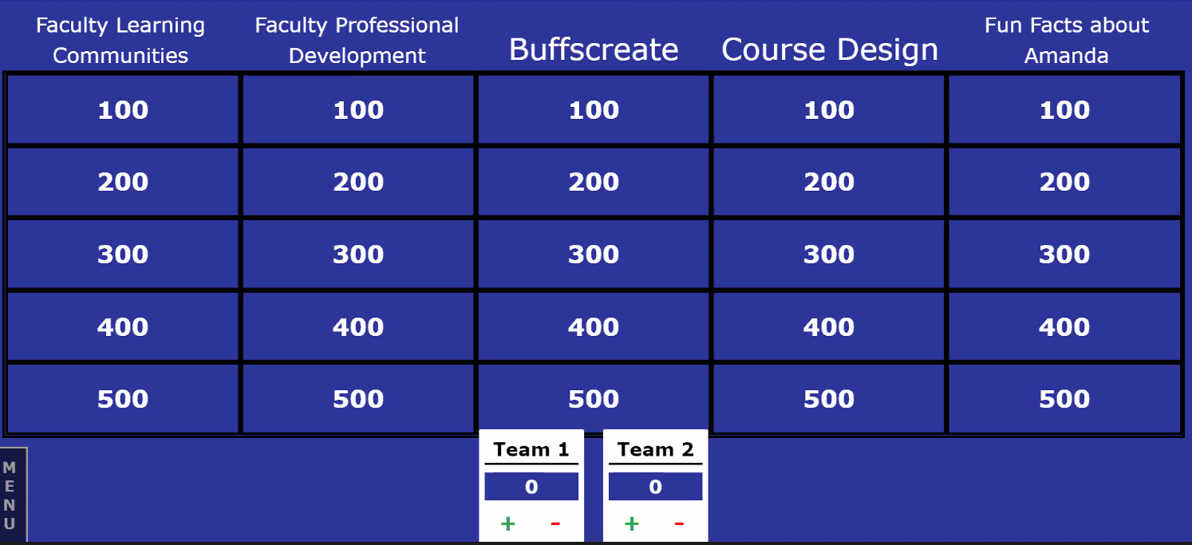

Shane
- Update on the work that we do in ASSETT around assessment with different tools and how it impacts student learning. We are collecting data from faculty and a wide range of undergraduate students.
More information about ASSETT-supported surveys can be found on the website at https://www.colorado.edu/asset/about/assessment-reports

- One example of an academic Technology Survey asked the question: “If CU Boulder could solve one problem related to your college experience during the COVID-19 pandemic, what would that be?
Themes that emerged included:
- Help with tuition, fees, cost of living
- Improve communication/planning
- Return to in-person
- Provide more/better student support

- ASSETT was able to get involved with faculty being better prepared to teach online and also wanted faculty to have better access to technology. Students also struggled with technology access. So, we worked to adopt more universal remote learning policies. This helped in keeping the faculty more consistent with their expectations.
  - An example being the use of the “Mad-Lib” survey helping faculty to put themselves more into the student’s situation and change their perspective.
Compassion and Empathy was the answer heard most often from students.

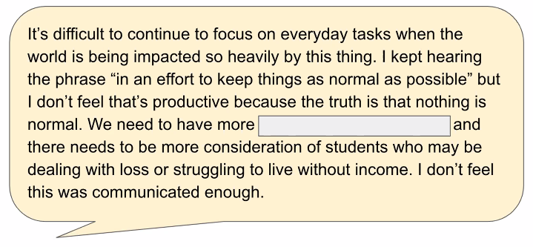

Another Survey Question: Faculty assumed answers to be “waiting tables, delivery food, uber, pizza, driving”. However, the correct answer was “working horses at funerals and doing burials at sea”. This could help us to understand our perceptions of our students. We think we know how they are struggling – but we may not understand fully at all. Helping the faculty to understand there is a lot of pain and struggle for our students right now.

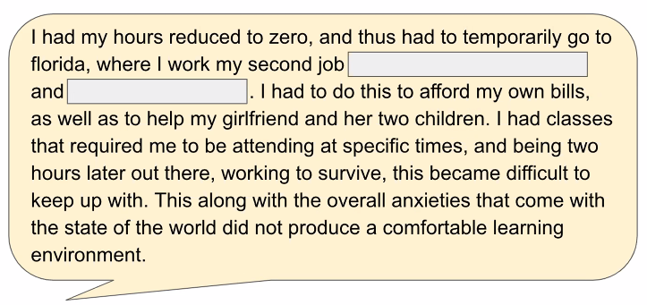

** Link to the 2018 Survey Results: http://bit.ly/ASSETT_2018ATSurvey **

9:40 to 9:55 — Questions and Answers + open discussion (Mark)

9:55 Adjourn.

Chats log from today:
08:34:45 From Jacie Moriyama [she, her] to Everyone : I will volunteer to be your personal tour guides
08:35:03 From Jen Walentas Lewon to Everyone : Absolutely!!
08:36:14 From Blair Florence Young to Everyone : Welcome, Rachel! Thanks for joining the ASSETT board!
08:47:50 From Joy Adams-O'Brien (she/hers) to Everyone : My kids are 3 and 7 but they are cats so very low-maintenance!
08:57:11 From Michael Joseph Schneider to Everyone : Definitely feel more awake now!
08:57:23 From Cheryl M. Graham to Everyone : Love this site!!
08:57:27 From Sebastian K. Schmidt to Everyone : Me too, that was great!
08:58:03 From Shane Schwikert to Everyone : It was definitely worth being outed as wearing sweatpants - thanks Beth!
08:58:16 From Blair Florence Young to Everyone : Ha, Shane!
08:58:36 From Joy Adams-O'Brien (she/hers) to Everyone : HAAA!
09:00:06 From Jen Walentas Lewon to Everyone : So wonderful and timely Beth!
09:00:23 From Sebastian K. Schmidt to Everyone : I will use this in my first class next Thursday!
09:01:11 From Joy Adams-O'Brien (she/hers) to Everyone : Awesome project, Beth!
09:01:20 From Jen Walentas Lewon to Everyone : Me too, and I am excited to share with my department.
09:01:57 From Jacie Moriyama [she, her] to Everyone : Here’s the url for quick reference: http://communityperformancetoolbox.org/
09:02:04 From Blair Florence Young to Everyone : Thanks, Jacie!
09:04:23 From Rachel Bowyer to Everyone : Great stuff!
09:04:31 From Michael Joseph Schneider to Everyone : Love all the Zoom movement
09:05:17 From Cheryl M. Graham to Everyone : excellent! thank you
09:05:30 From Kira Hall to Everyone : Fun !thank you!
09:08:58 From Mark Werner (he/him/his) to Everyone : Member of the Board of Directors for ASSETT (Arts & Sciences Support of Education Through Technology)
09:09:16 From Mark Werner (he/him/his) to Everyone : https://www.colorado.edu/assett/
09:09:37 From Blair Florence Young to Everyone : https://docs.google.com/forms/d/e/1FAIpQLSfrMXf5TnfYNICCzKdxMAA_RKJfL4fULYr-ZUm-3qK3DrNlMg/viewform?usp=sf_link
09:16:07 From Janet Casagrand to Everyone : One minute remaining. :)
09:17:10 From Janet Casagrand to Everyone : That's six minutes.
09:20:20 From Jen Walentas Lewon to Everyone : Go RhymeZone! Great activity Blair!
09:20:49 From Blair Florence Young to Everyone : Sorry team! I went way over time.
09:21:04 From Sebastian K. Schmidt to Everyone : This was great, I was glad you took the time :-)
09:21:26 From Jacie Moriyama [she, her] to Everyone : http://www.pollev.com/Jacie
09:26:25 From Janet Casagrand to Everyone : One minute remaining. :)
09:27:43 From Jacie Moriyama [she, her] to Everyone : https://www.colorado.edu/assett/resources/strategies-student-success
09:29:33 From Jen Walentas Lewon to Everyone : Thanks Jacie!
09:29:45 From Janet Casagrand to Everyone : We're running a bit behind.
09:29:52 From Jacie Moriyama [she, her] to Everyone : Thanks for keeping time, Janet
09:30:23 From Blair Florence Young to Everyone : Thanks for keeping time, Janet! We have a 15-minute buffer at the end of the meeting so we’ll be ok.
09:30:33 From Janet Casagrand to Everyone : Thanks!
09:30:46 From Jacie Moriyama [she, her] to Everyone : Smart thinking, Blair. We all have so much to share :)
09:31:24 From Blair Florence Young to Everyone : We’re busy… in a good way!
09:32:31 From Vilja Hulden to Everyone : B -27
09:32:31 From Beth Osnes to Everyone : c
09:32:37 From Sebastian K. Schmidt to Everyone : C
09:32:37 From Jen Walentas Lewon to Everyone : b
09:32:41 From Rachel Bowyer to Everyone : D
09:33:14 From Blair Florence Young to Everyone : Go SLHC!!!
09:33:24 From Jen Walentas Lewon to Everyone : Yay—thanks!
09:33:28 From David S Brown to Everyone : Yay SLHS!
09:34:15 From Vilja Hulden to Everyone : C
09:34:32 From David S Brown to Everyone : AAAAAAAAAA
09:34:32 From Rachel Bowyer to Everyone : C
09:34:32 From Kira Hall to Everyone : c
09:34:39 From Beth Osnes to Everyone : d
09:34:42 From Jen Walentas Lewon to Everyone : A
09:36:38 From Nathaniel Bala to Everyone : D
09:36:38 From Jen Walentas Lewon to Everyone : D
09:36:39 From Sebastian K. Schmidt to Everyone : D
09:36:41 From Beth Osnes to Everyone : c
09:36:42 From Vilja Hulden to Everyone : C
09:36:46 From Kavya Kannan to Everyone : C
09:38:34 From Blair Florence Young to Everyone : Thanks, Joy! We’re all taking extra time (;
09:38:51 From Joy Adams-O'Brien (she/hers) to Everyone : Thanks, Blair! I really tried... :)
09:40:34 From Joy Adams-O'Brien (she/hers) to Everyone : Rachel, come chat with me. I've auditioned a couple of times... :)
09:43:19 From Beth Osnes to Everyone : Impressive, Blaire!!
09:43:24 From Beth Osnes to Everyone : Blair!
09:44:57 From Blair Florence Young to Everyone : Going big, Beth!
09:45:42 From Blair Florence Young to Everyone : This is really fun. Shane are you follow?
09:45:52 From Blair Florence Young to Everyone : Shane, are you ready to follow?
09:48:47 From Mark Werner (he/him/his) to Everyone : SERU = Student Experience in the Research University
09:52:27 From Sebastian K. Schmidt to Everyone : empathy
09:52:34 From Blair Florence Young to Everyone : It’s still an effective exercise in empathy, Shane.
09:52:36 From Jacie Moriyama [she, her] to Everyone : Compassion
09:52:52 From Janet Casagrand to Everyone : flexibility
09:52:53 From Rachel Bowyer to Everyone : support
09:52:55 From David S Brown to Everyone : flexibility
09:52:58 From Jen Walentas Lewon to Everyone : flexibility
09:53:01 From Vilja Hulden to Everyone : leniency
09:53:05 From Kira Hall to Everyone : understanding
09:53:11 From Beth Osnes to Everyone : empathy
09:54:14 From Beth Osnes to Everyone : Waiting tables, delivery food
09:54:37 From Jacie Moriyama [she, her] to Everyone : Driving for uber
09:54:39 From Jen Walentas Lewon to Everyone : Making pizza, driving for Uber
09:54:54 From Vilja Hulden to Everyone : Wow!
09:55:55 From Vilja Hulden to Everyone : That was really useful, thanks!
09:56:59 From Sebastian K. Schmidt to Everyone : I wonder if you found out the students’ preferences regarding synchronous vs. asynchronous teaching
09:57:03 From Blair Florence Young to Everyone : Thanks, Shane!
09:57:13 From Janet Casagrand to Everyone : Thanks, everyone!
09:57:31 From David S Brown to Everyone : This has been great! Well done ASSETT!
09:57:35 From Jen Walentas Lewon to Everyone : I enjoyed the active learning demos-thanks!
09:57:44 From Shane Schwikert to Everyone : Great question Sebastian! That’s definitely something we’d like to better understand in the survey
09:57:56 From Kira Hall to Everyone : Thank you!
09:57:57 From Blair Florence Young to Everyone : Thanks, everyone! Great to see you and thanks for participating!
09:58:03 From Sara Rose Myers to Everyone : Thank you!

